**DESIGN**

* **SDLC Model Used:**

In this application we used the Iterative Water Fall SDLC Model. We implemented the different points of the Iterative Water Fall SDLC Model sequentially,

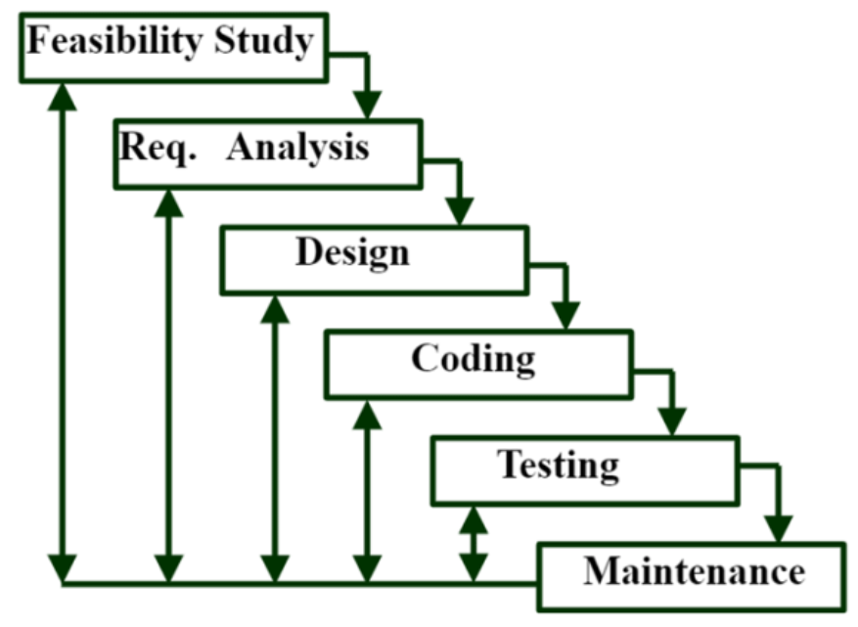

1. **Feasibility Study** : Done the study related to different fitness tracking application and got the right
2. **Requirements** : Analysed the requirements of the applications, like tech stacks, various input needed.
3. **Design** : Designed the Structural and Behavioural Data Flow Diagram on the process in which the application is running.
4. **Coding & Implementation** : After Design, application is implemented using python language.
5. **Testing** : After Implementation, testing is done for certain different inputs and got the reliable outputs.
6. **Maintenance** : This application or Software can be updated, or modified based on the users or customers need. Software Maintenance includes correcting issues or bugs, improving software overall, adding new features, and more.

* **Structural Diagram:**

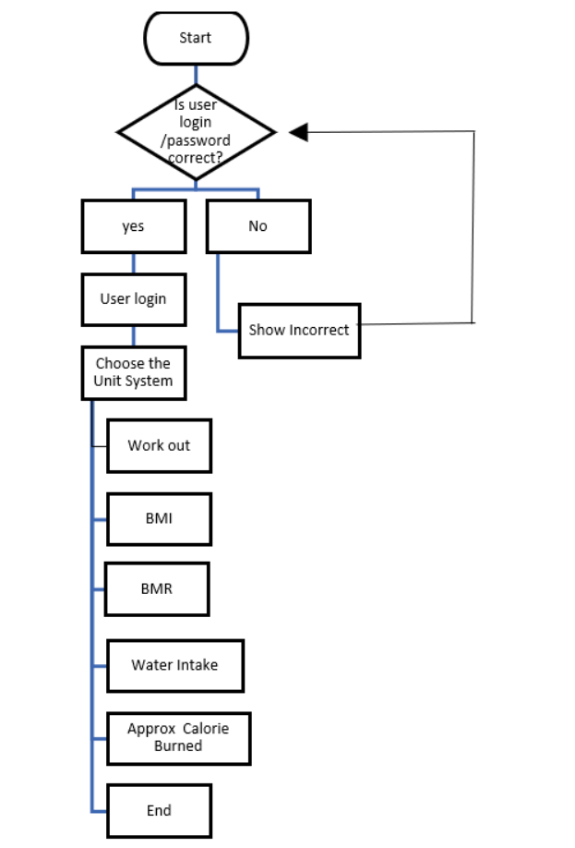

* **Behavioural Diagram:**

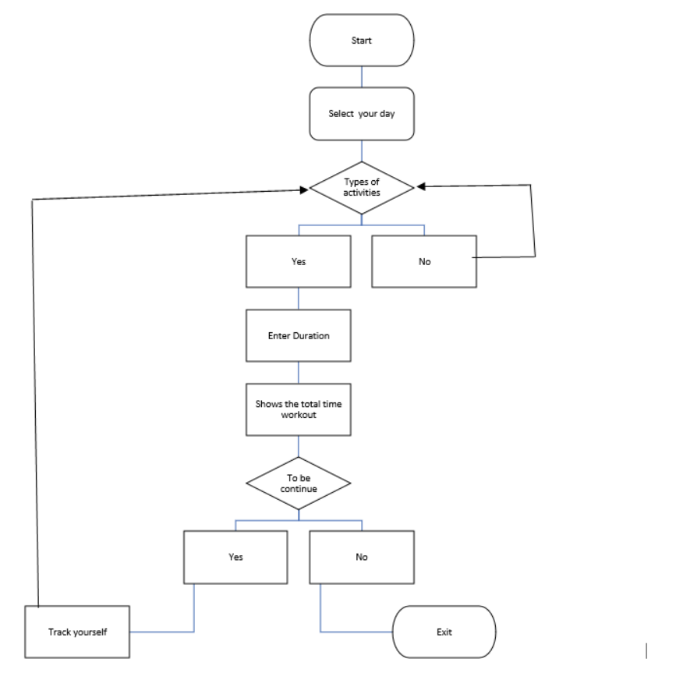

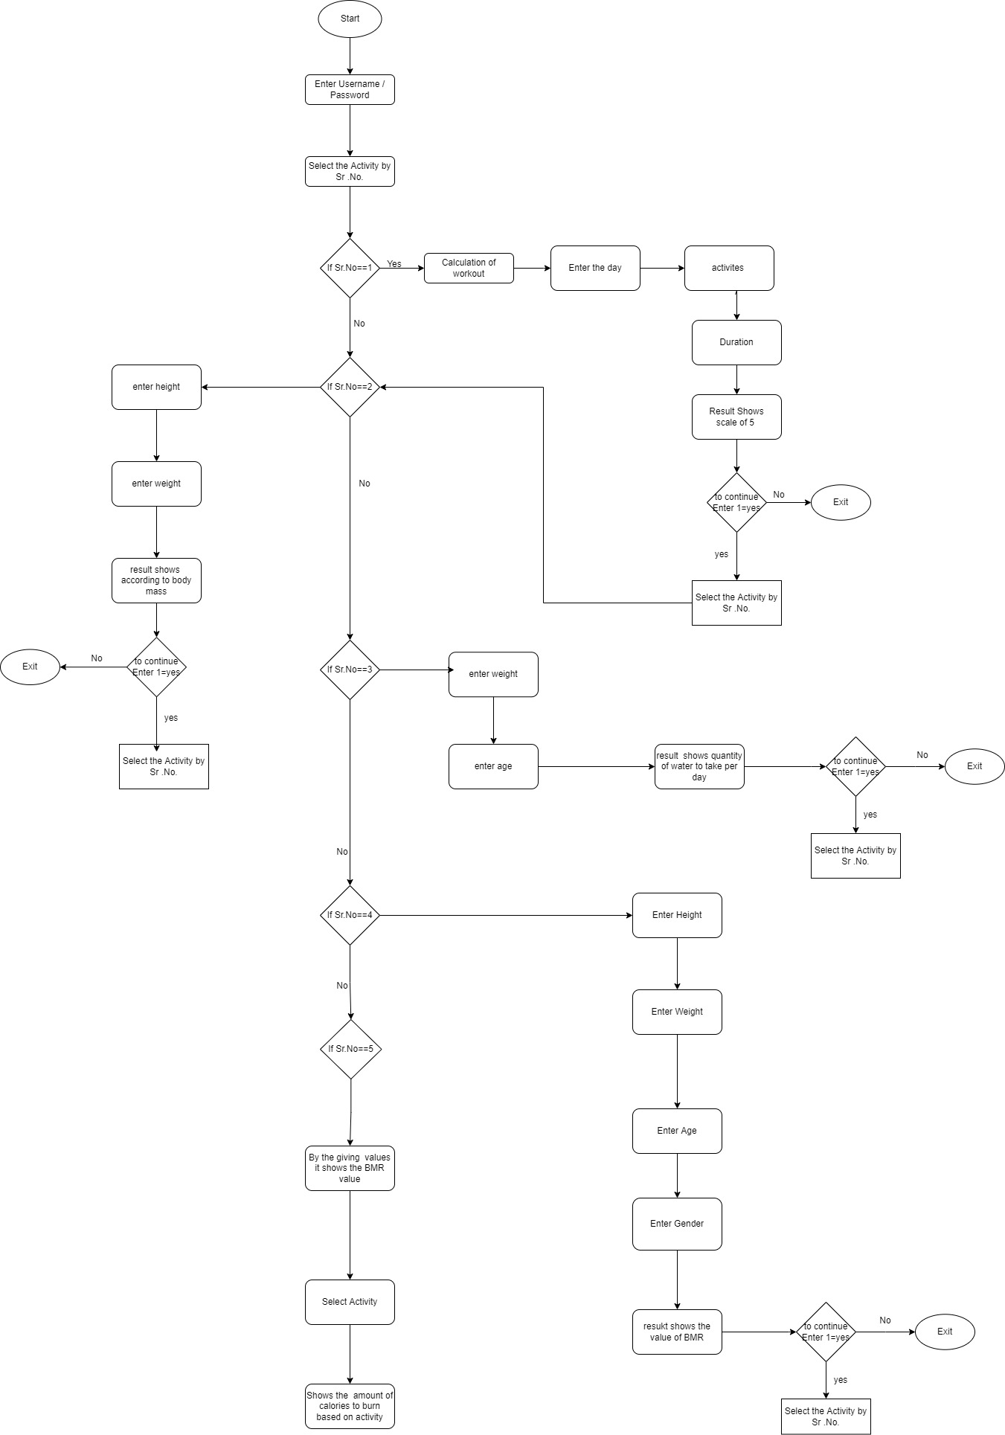

* **Use Case Diagram:**

