**TESTING**

* **Software Testing:**

Testing is done on each of the features implemented in the model. And following are the outputs:

1. **Work Out:**

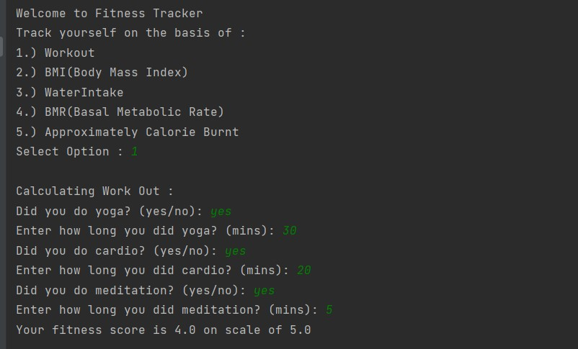

1. **BMI(Body Mass Index):**

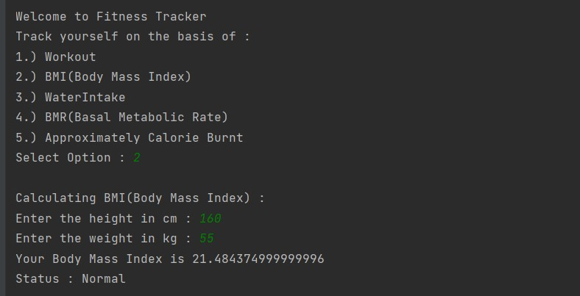

1. **Water Intake:**

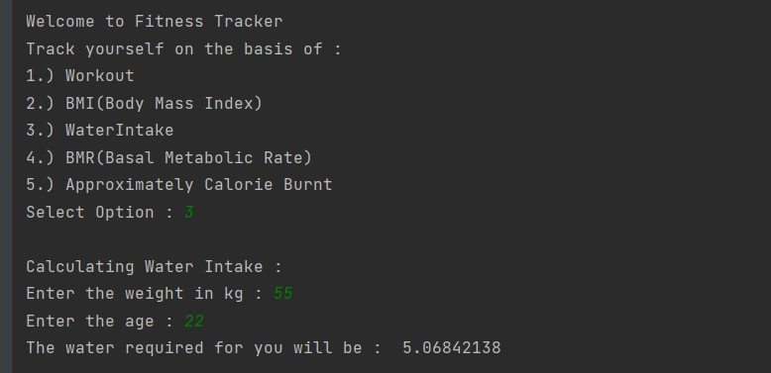

1. **BMR(Basal Metabolic Rate):**

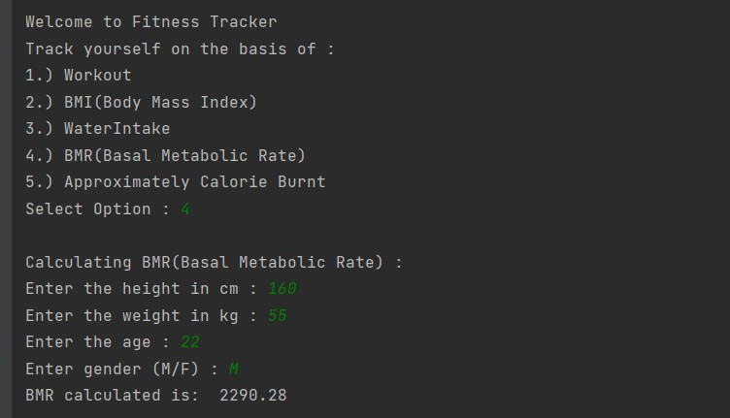

1. **Approximate Calorie Burnt:**

