Lab Worksheet 02

CTEC 22043 Object Oriented Programming

Faculty of Computing and Technology

University of Kelaniya

Student Number – CT/2021/065

Q1.

Code

public class Q01_a {  
 public static void main(String[] args) {  
 int A = 4;  
 int B = 5;  
 int C = 6;  
  
 float Ans = (float)Math.*sqrt*(B + 4 * A * C);  
 System.*out*.println(Ans);  
  
 }  
}

public class Q01_b {  
 public static void main(String[] args) {  
 int X = 4;  
 int Y = 5;  
  
 float Ans = (float)Math.*sqrt*(X + 4 * Math.*pow*(Y, 3));  
 System.*out*.println(Ans);  
  
 }  
}

public class Q01_c {  
 public static void main(String[] args) {  
 int X = 4;  
 int Y = 5;  
  
 float Ans = (float)Math.*cbrt*(X * Y);  
 System.*out*.println(Ans);  
  
 }  
}

public class Q01_d {  
 public static void main(String[] args) {  
 int r = 7;  
  
 float Ans = (float)(Math.*PI* * r*r);  
  
 System.*out*.println(Ans);  
  
 }  
}

Output

Q2.

Code

package Q02;  
  
import java.util.*;  
  
public class Q02 {  
 public static void main(String[] args) {  
 Scanner scanner = new Scanner(System.*in*);  
  
 System.*out*.print("Enter value in cm: ");  
 double cm = scanner.nextDouble();  
  
 double totalInches = cm / 2.54;  
 int feet = (int) (totalInches / 12);  
 double inches = totalInches % 12;  
  
 System.*out*.println(feet + " ft " + String.*format*("%.2f", inches) + " in");  
  
 scanner.close();  
  
  
 }  
}

Output

Q3.

Code

package Q03;  
  
import java.util.*;  
  
public class Q03 {  
 public static void main(String[] args) {  
 Scanner scanner = new Scanner(System.*in*);  
  
 System.*out*.print("Enter temperature in Celsius: ");  
 double celsius = scanner.nextDouble();  
  
 double fahrenheit = (1.8 * celsius) + 32;  
 System.*out*.println("Temperature in Fahrenheit: " + fahrenheit);  
  
 scanner.close();  
 }  
}

Output

Q4.

Code

package Q04;  
  
import java.util.*;  
  
public class Q04 {  
 public static void main(String[] args) {  
 Scanner scanner = new Scanner(System.*in*);  
   
 System.*out*.print("Enter your weight in pounds: ");  
 double bodyWeight = scanner.nextDouble();  
   
 double calories = bodyWeight * 19;  
   
 System.*out*.println("You need " + calories + " calories per day.");  
 scanner.close();  
 }  
}

Output

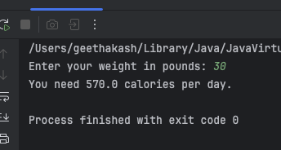

Q5.

Code

package Q05;  
  
import java.util.*;  
  
public class Q05 {  
 public static void main(String[] args) {  
 Scanner scanner = new Scanner(System.*in*);  
  
 System.*out*.print("Enter temperature in Fahrenheit: ");  
 double fahrenheit = scanner.nextDouble();  
  
 double celsius = (5.0 / 9) * (fahrenheit - 32);  
 System.*out*.println("Temperature in Celsius: " + celsius);  
  
 scanner.close();  
 }  
}

Output

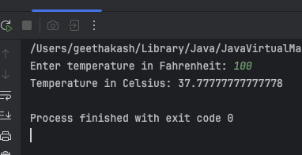

Q6.

Code

package Q06;  
  
import java.util.*;  
import java.time.*;  
  
public class Q06 {  
 public static void main(String[] args) {  
 Scanner scanner = new Scanner(System.*in*);  
 System.*out*.print("Enter born year: ");  
 int birthYear = scanner.nextInt();  
 int currentYear = Year.*now*().getValue();  
 int age = currentYear - birthYear;  
  
 System.*out*.println("You were born in " + birthYear + " and will be " + age + " this year.");  
 scanner.close();  
 }  
}

Output

Q7.

Code

package Q07;  
  
import java.util.*;  
  
  
public class Q07 {  
 public static void main(String[] args) {  
 Scanner scanner = new Scanner(System.*in*);  
  
 System.*out*.print("Enter weight in kg: ");  
 int weight = scanner.nextInt();  
  
 System.*out*.print("Enter height in cm: ");  
 int height = scanner.nextInt();  
  
 double bmi = weight / Math.*pow*(height / 100.0, 2);  
  
 System.*out*.printf("Your BMI is: %.2f%n", bmi);  
  
 if (bmi >= 20 && bmi <= 25) {  
 System.*out*.println("Your BMI is normal.");  
 } else {  
 System.*out*.println("Your BMI is outside the normal range.");  
 }  
  
 scanner.close();  
 }  
}

Output

Q8.

Code

package Q08;  
  
import java.util.*;  
  
public class Q08 {  
public static void main(String[] args) {  
 System.*out*.print("Enter the radius of the sphere: ");  
 Scanner scanner = new Scanner(System.*in*);  
 double radius = scanner.nextDouble();  
 scanner.close();  
 double pi = 3.14;  
 double volume = (4.0 / 3.0) * pi * Math.*pow*(radius, 3);  
  
 System.*out*.println("The volume of the sphere: " + volume);  
}  
}

Output

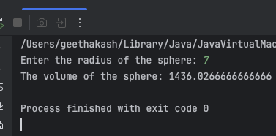

Q9.

Code

package Q09;  
  
import java.util.*;  
  
public class Q09 {  
 public static void main(String[] args) {  
 Scanner scanner = new Scanner(System.*in*);  
  
 System.*out*.print("Enter the principal amount: ");  
 double principal = scanner.nextDouble();  
  
 System.*out*.print("Enter the annual interest rate in percentage: ");  
 double rate = scanner.nextDouble();  
  
 System.*out*.print("Enter the number of years: ");  
 int years = scanner.nextInt();  
  
 double amount = principal * Math.*pow*(1 + (rate / 100), years);  
  
 System.*out*.printf("The amount of money earned after" +years+ " years is: %.2f%n dollars", amount);  
  
 scanner.close();  
 }  
  
}

Output

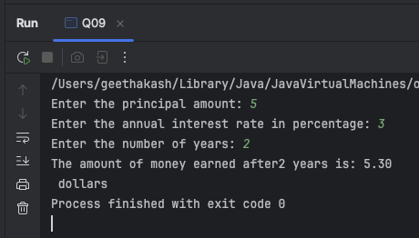

Q10.

Code

package Q10;  
  
import java.util.*;  
  
public class Q10 {  
public static void main(String[] args) {  
 final int MONTHS_IN_YEAR = 12;  
  
 Scanner scanner = new Scanner(System.*in*);  
   
 System.*out*.print("Enter loan amount: ");  
 double loanAmount = scanner.nextDouble();  
  
 System.*out*.print("Enter annual interest rate (in %): ");  
 double annualInterestRate = scanner.nextDouble();  
  
 System.*out*.print("Enter loan period (in years): ");  
 int loanPeriod = scanner.nextInt();  
  
 double monthlyInterestRate = annualInterestRate / 100.0 / MONTHS_IN_YEAR;  
  
 int numberOfPayments = loanPeriod * MONTHS_IN_YEAR;  
  
 double monthlyPayment = (loanAmount * monthlyInterestRate) /   
 (1 - Math.*pow*(1 / (1 + monthlyInterestRate), numberOfPayments));  
  
 double totalPayment = monthlyPayment * numberOfPayments;  
  
 System.*out*.printf("Monthly Payment: %.2f%n", monthlyPayment);  
 System.*out*.printf("Total Payment: %.2f%n", totalPayment);  
  
 scanner.close();  
}  
}

Output

