NCERT Prep
System architecture: admin-managed content, students as consumers
Version | 1.0
Date | 22 September 2026
Status | Draft for review
Related | docs/ARCHITECTURE.md (scaling and cost), docs/PROJECT_SPECIFICATION.md (FRD, SRS, sheet contract)

1. Purpose
This document describes how NCERT Prep works once admins run everything from a connected Google Sheet and the admin console, and students only consume. It covers the services involved, how content travels from the sheet to a student's screen, how live updates and notifications work, and what happens when something goes wrong.
It is written against the current codebase, which already has Firebase Auth, Firestore, Cloud Functions and an Apps Script sync. Most of what follows extends that setup. Nothing here needs a custom server.

2. Who does what
There are two kinds of user and the line between them is strict. Admins produce, students consume. Every write a student can make is about themselves: their profile, their progress, their doubts. Nothing a student does can change what another student sees.
Capability | Admin | Student
Attach or change the content sheet | Admin console | No
Edit lessons, chapters, video links | In the sheet | No
Hide a lesson, mark it premium | Admin console | No
Upload chapter notes | Admin console | Read published notes
Doubts | Answer, close | Ask, read own
Announcements | Post to a class | Read for own class
Students | Disable, change class, view progress | Own profile only
Progress, streaks, saved lessons | Read (analytics) | Own only
Notification preferences | No | Own only

Admin rights come from an admin custom claim on the Firebase Auth token. The current rules also accept users/{uid}.role == "admin", which costs an extra document read on every admin check. Once every admin has the claim, drop the fallback so there is one source of truth.

3. System architecture
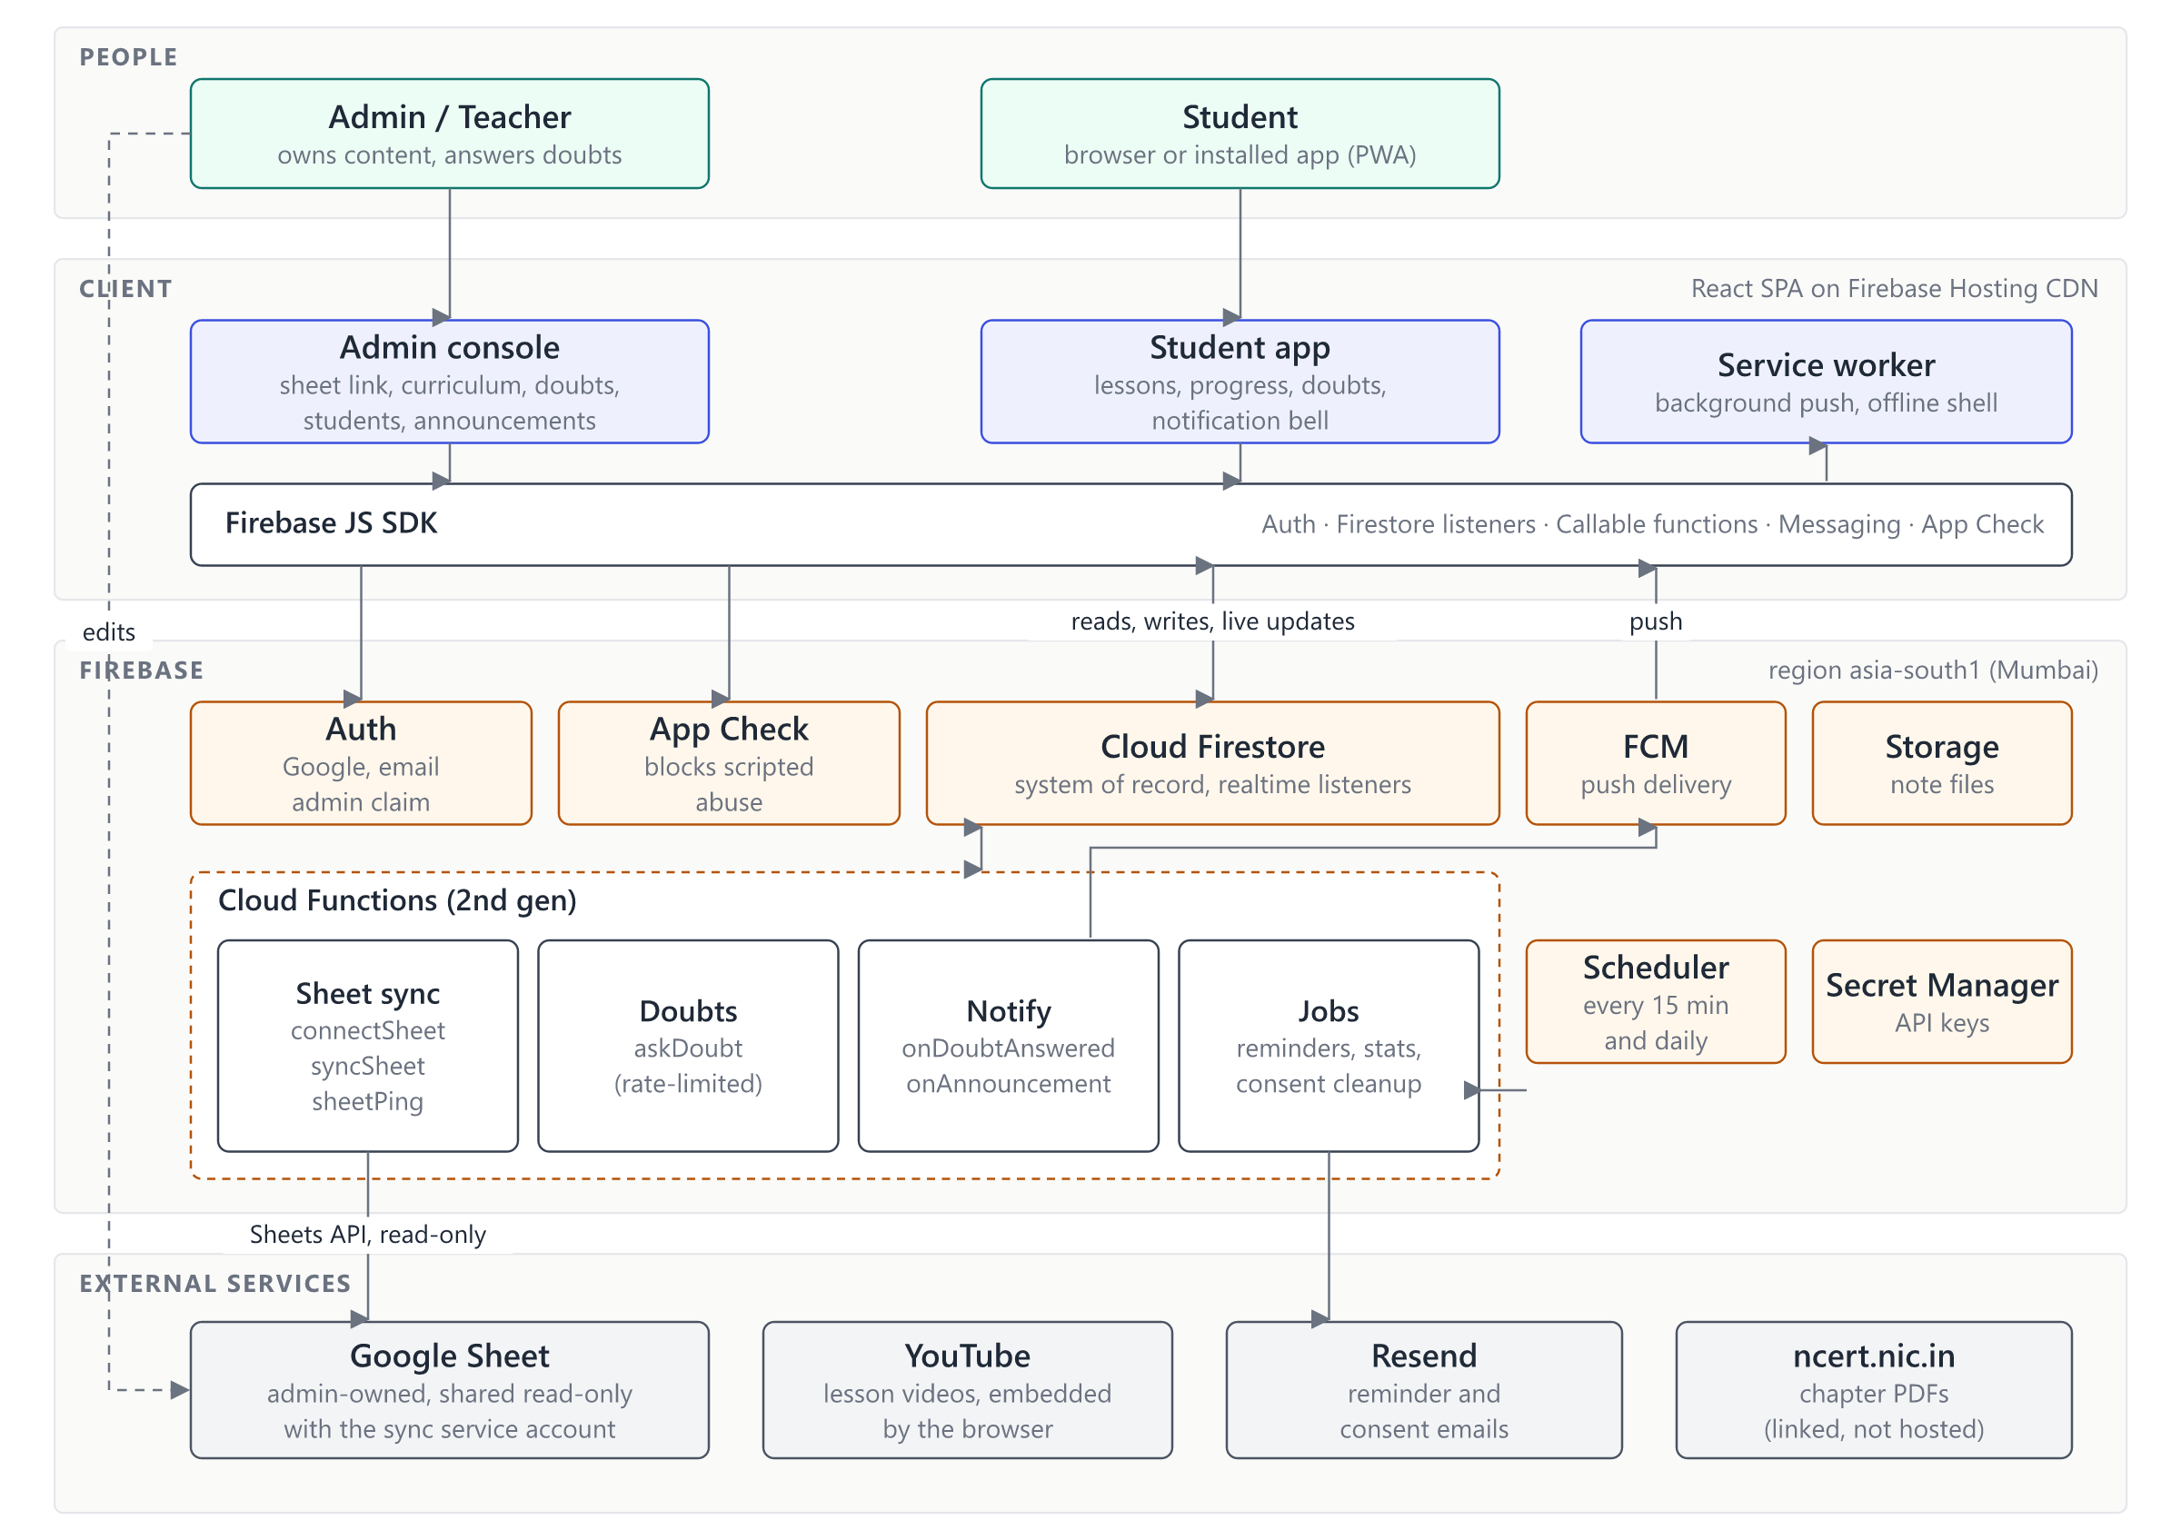
Figure 1. Services and how they connect
The system has four layers. People use one React app, which shows the admin console or the student app depending on the claim. The app talks only to Firebase through its SDK. Admin edits are checked by security rules; anything a student does that touches shared data, and anything that talks to an outside service, runs in Cloud Functions. External services sit at the edge: the Google Sheet is read by a function, never by a browser, and YouTube videos are embedded directly so no video traffic passes through us.
The main rule: the sheet is where admins edit content, but the app never reads it. Firestore is what the app reads. The app stays fast and keeps working while the sheet is being edited, is half-broken, or has been unshared by mistake.
Component | Job in this system | Status
Firebase Hosting | Serves the app from a CDN. index.html is never cached, hashed assets are cached for a year. | Move from Vercel optional
Firebase Auth | Google and email sign-in; carries the admin claim. | In place
App Check | Rejects requests that do not come from our app. | In place on callables
Cloud Firestore | The only system of record. Pushes changes to open apps. | In place
Cloud Functions | Sheet sync, doubts, notifications, scheduled jobs. Students never write shared data directly. | Extend
Cloud Scheduler | 15-minute sync, daily reminders and cleanup. | In place for reminders
Cloud Messaging (FCM) | Push notifications to browsers and the installed app. Free. | New
Cloud Storage | Notes attachments. | In place
Secret Manager | Resend key, sheet ping secret. | In place
Google Sheets API | Read-only access to the connected sheet through a service account. | New
YouTube, Resend, ncert.nic.in | Video playback, email, chapter PDFs. | In place

4. Attaching the Google Sheet

4.1 What the admin does
- Open Admin console → Content source. The page shows the sync account address, sheet-sync@<project-id>.iam.gserviceaccount.com, with a copy button.
- In Google Sheets, choose Share and add that address as Viewer.
- Paste the sheet link into the console and press Connect.
- The console shows either Connected, with a row count per tab, or a list of what to fix: no access, missing column, duplicate video IDs.
- Press Sync now for the first import. From then on syncs run by themselves.
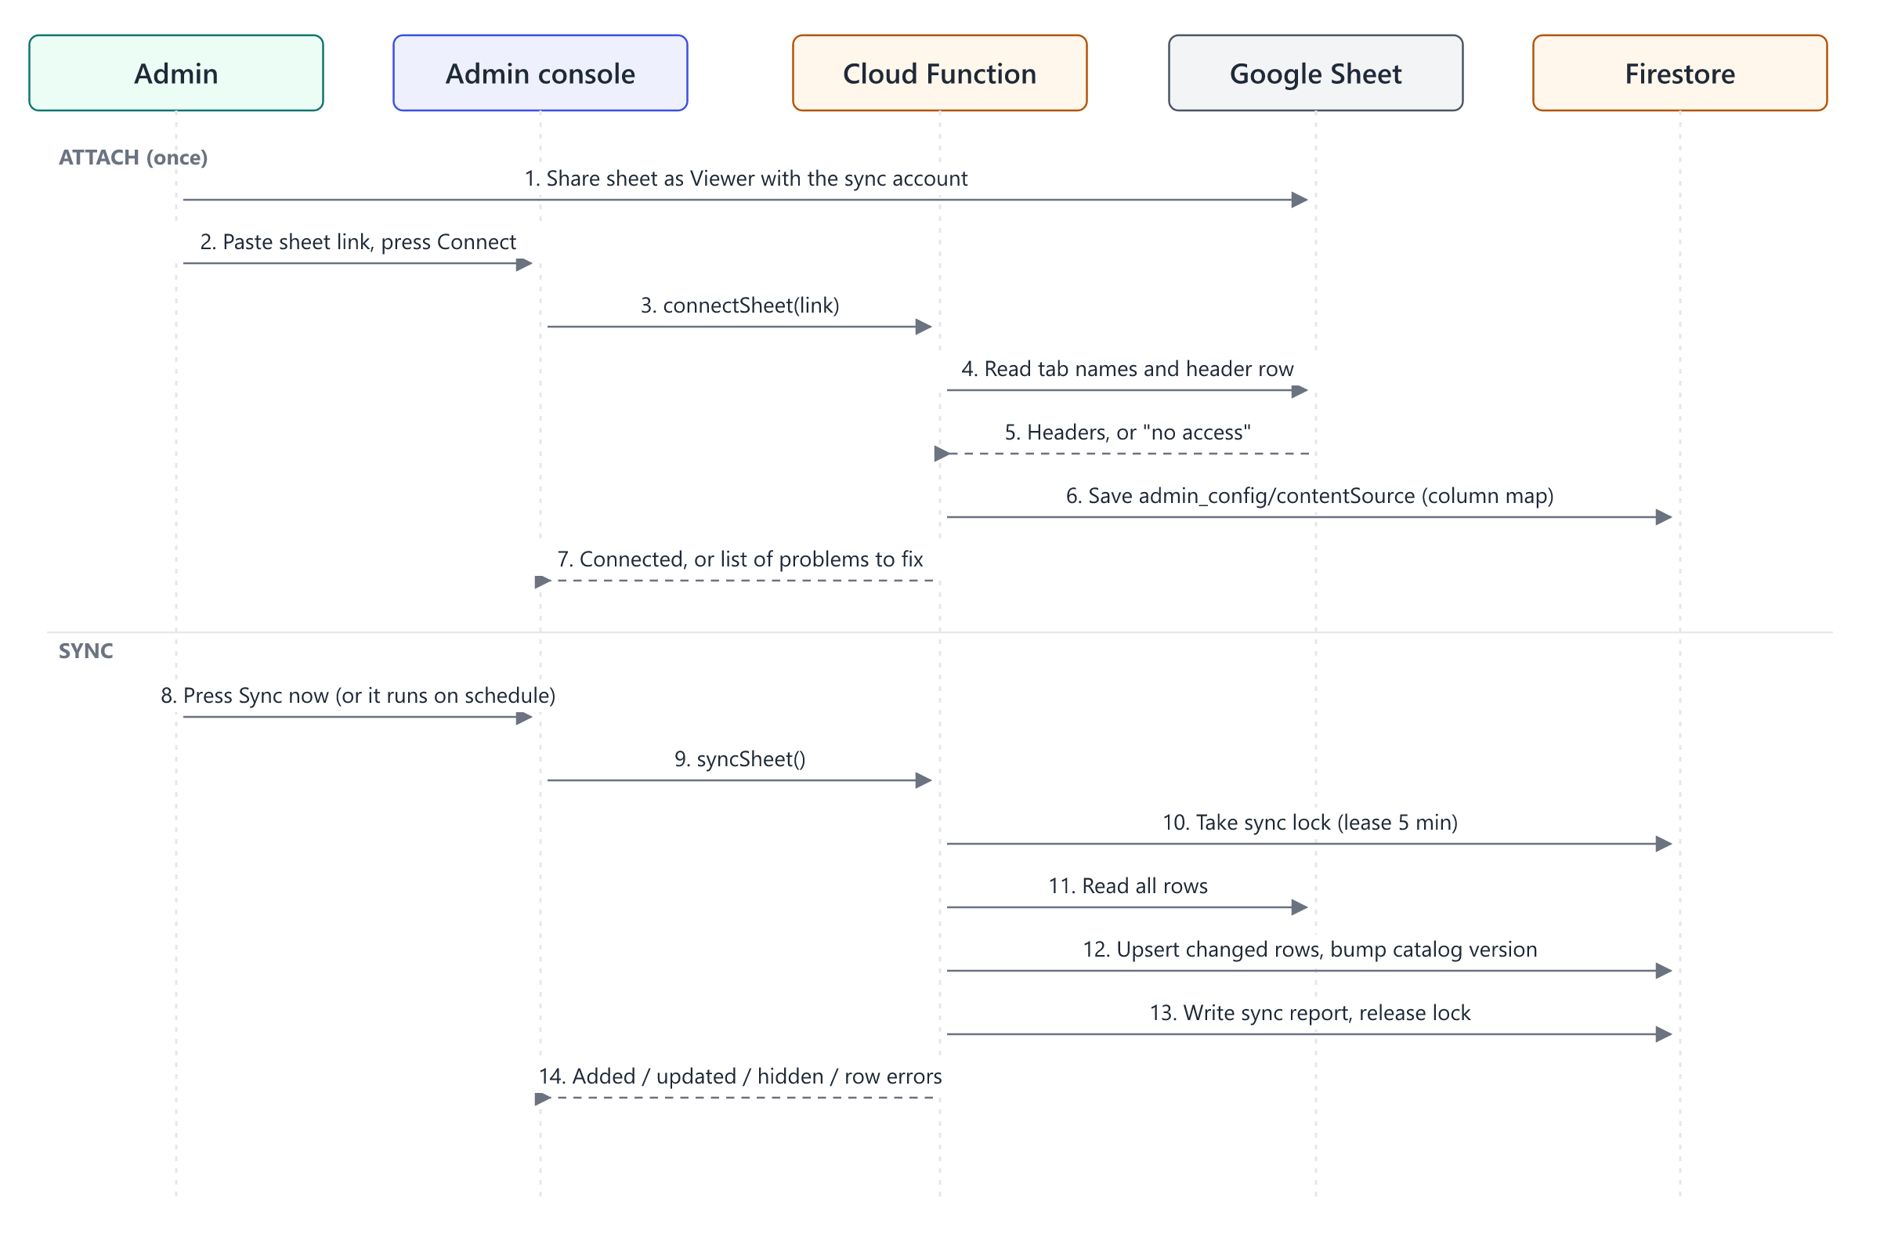
Figure 2. Connecting a sheet and running a sync

4.2 Why a service account
The alternative is to sign in with the admin's own Google account. We avoid that for three reasons. The connection survives staff changes, because it does not depend on one person's login. It only ever has Viewer access, so the app cannot modify the sheet even by accident. And it avoids Google's verification process for the Sheets OAuth scope.

4.3 Sheet layout
The sheet needs one tab of lessons, one row per video. Headers are matched ignoring case and order. Extra columns are ignored, so the content team can keep working columns next to the real ones.
Column | Required | Stored as | Notes
YT Vid ID | Yes | youtube_id (document ID) | The key. 11 characters, letters, digits, - and _.
class | Yes | class_display | For example "Class 10".
Class Numeral | Yes | class_sort | Used for ordering.
subject | Yes | subject
book | Yes | textbook
chapter | Yes | chapter_id | "Chapter1" is stored as "Chapter 1".
Chapter Title | Yes | chapter_name | Falls back to English Chapter Name.
YT Vid Title | Yes | video_title | Text after the first " | " is dropped.
YT Vid Published | No | yt_public | Only "PUBLISH_OK…" makes a lesson visible.
url | No | pdf_url | Must be an https link.
Timestamps | No | timestamps | "mm:ss - topic" per line.

4.4 Who owns which field
Each field has exactly one owner, so the sheet and the console never fight.
- The sheet owns titles, class, subject, book, chapter, video ID, PDF link, timestamps and the published flag. These are overwritten on every sync and are read-only in the console.
- The console owns hidden, premium and notes. Sync never touches them.
- A row deleted from the sheet hides the lesson (inSheet = false). It is not deleted, so student progress and doubts linked to it survive. If the row comes back, so does the lesson.

4.5 When a sync runs
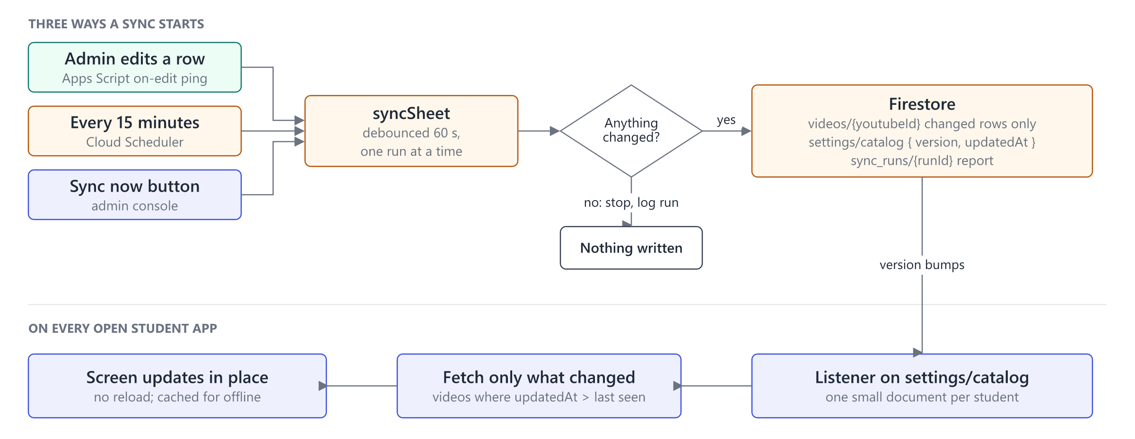
Figure 3. Sync triggers and how open apps pick up the change
A sync starts in one of three ways: an admin edits the sheet, the 15-minute schedule fires, or someone presses Sync now. The edit trigger is a short Apps Script bound to the sheet. On edit, it calls the sheetPing endpoint with a shared secret. The function only marks a sync as due and runs it 60 seconds later, so a burst of fifty edits produces one sync, not fifty.
This changes one thing from today. The current Apps Script writes to Firestore itself, using a service account private key stored in Script Properties. In the new design that logic moves into syncSheet, and the Apps Script keeps only the ping, which can ask for a sync but cannot write anything. Keep the old script until the new sync has run cleanly for two weeks, then delete it and revoke the key.

5. Realtime sync
Firestore already pushes changes to any open listener, and the app uses this for doubts today (DoubtsService.subscribeMine). The same mechanism covers everything else. No websocket server or message queue is needed.
Data | How it reaches the student | Typical delay
Lesson catalogue | Listener on settings/catalog; fetch only lessons changed since the last seen version | Seconds after a sync
Own doubts and answers | Listener on the student's doubts (already built) | About 1 s
Notifications | Listener on notifications/{uid}/items | About 1 s
Class announcements | Listener on announcements for the student's class, last 30 days | About 1 s
Progress on other devices | Listener on users/{uid} | About 1 s
Admin queues | Listeners on open doubts and sync status | About 1 s

A student who was offline catches up on reconnect: the listener fires once with the latest version. Doubts, notifications and progress use direct listeners on the student’s own documents instead.
Why not listen to the whole lessons collection? Every open app would download every changed lesson, and each reconnect costs one read per lesson. With a few thousand lessons and thousands of students, that becomes the largest item on the bill. Listening to one small version document costs one read per student, and only the lessons that actually changed are fetched.
Offline. Turn on Firestore's persistent local cache with the multi-tab manager. The app then opens with the last known content when there is no network, queues the student's own writes, and catches up when the connection returns.

6. Notifications
There are two kinds. Personal notifications go to one student, for example when a doubt is answered. Broadcasts go to a whole class, for example an announcement or a new chapter.
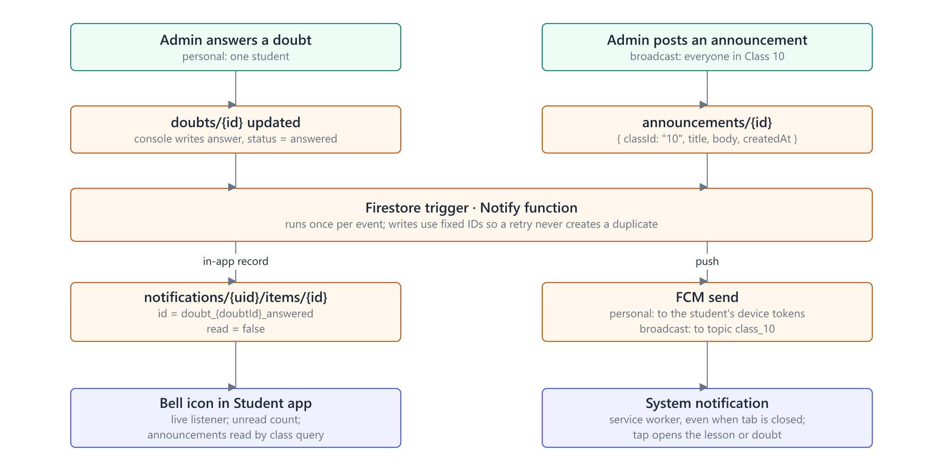
Figure 4. From an admin action to the student's screen
If a student blocks notifications, the bell still works. Push is a bonus; the in-app record is the source of truth.
Channel | Used for | Notes
In-app bell | Everything | The source of truth. Works even if push is blocked.
Push (FCM) | Everything, if the student allowed it | Web push. On iPhone only after "Add to Home Screen" (iOS 16.4+).
Email (Resend) | Reminders and parental consent | Already in place. Not used for every event.

Rules
- A personal notification's ID is built from the event, for example doubt_{doubtId}_answered. If the function retries, it overwrites the same document instead of creating a second one.
- A broadcast is stored once in announcements, not copied to every student. Each student reads announcements for their class and keeps a lastSeenAnnouncementsAt time for the unread count. This replaces the single announcement field in settings today.
- Device tokens live in users/{uid}/devices. When a device registers, or the student's class changes, a function subscribes the token to the topic class_{n}. A token that FCM reports as unregistered is deleted on the spot. Tokens not seen for 60 days are removed by the daily job.
- Quiet hours: between 22:00 and 07:00 IST, broadcasts wait for the 07:00 run and personal notifications go to the bell without a push. Most students are minors.

7. Data model
Existing collections are unchanged except where noted. New ones are marked.
Collection or document | Written by | Read by | Holds
admin_config/contentSource (new) | connectSheet | Admins | Sheet ID, tab, column map, status, last run
settings/catalog (new) | syncSheet | Everyone | Catalogue version and time
videos/{youtubeId} | syncSheet; admins for hidden and premium | Everyone (visible only) | Lessons
sync_runs/{runId} (new) | syncSheet | Admins | Added, updated, hidden, errors by row
locks/sheetSync (new) | syncSheet | Functions only | Lease so two syncs never overlap
classes, subjects, chapters | Admins | Everyone | Curriculum structure
notes/{noteId} | Admins | Everyone (published) | Chapter notes and files
users/{uid} | Student (profile); functions (role, consent) | Owner, admins | Profile, class, streak
users/{uid}/devices/{id} (new) | registerDevice | Owner, functions | FCM token, last seen
users/{uid}/user_progress/{videoId} | Student | Owner, admins | Watch progress
doubts/{doubtId} | askDoubt; admins answer | Owner, admins | Question and answer
notifications/{uid}/items/{id} (new) | Functions | Owner (may mark read) | Bell entries
announcements/{id} (new) | Admins | Students of that class | Broadcasts
audit_log/{id} (new) | Functions | Admins | Who did what, when

8. Security
- Students can write only their own documents, and rules limit which fields they may change. This is already how role and consent are protected.
- Shared data changes through admin writes checked by rules, or through callable functions that check App Check and the admin claim.
- The sync account has Viewer access to one sheet and nothing else. The function reads only the spreadsheet ID saved in admin_config. settings is public, so the sheet link must never be stored there.
- The sheetPing secret is kept in Secret Manager. The ping can only mark a sync as due, and it is limited to one call per minute.
- Sheet content is treated as untrusted text. It is rendered as text, never HTML. Video IDs must match the 11-character pattern and PDF links must be https.
- Every admin action (connect sheet, hide lesson, answer doubt, post announcement, change a student's class) writes an audit_log entry.

9. Edge cases

9.1 Sheet
Situation | What happens
Sheet unshared or deleted | Sync fails with "no access". Live content stays as it was. The console shows a red status, and admins get an email after three failed runs in a row.
A required column renamed or removed | The run stops before writing anything. The report names the missing column.
Same video ID on two rows | Both rows are rejected and listed; every other row syncs.
Blank or half-filled row | Skipped and listed in the report. The run still succeeds.
Row deleted | Lesson hidden, not deleted. Progress and doubts are kept.
Thousands of rows | One API call per tab. Only rows whose content hash changed are written, in batches of 500.
Schedule and button fire together | The second run sees the lock and exits. If a run crashes, the lock expires after 5 minutes.
Admin edits during a sync | The edit sends another ping, and the next run reads the full sheet again. Nothing is lost.
A different sheet is connected | The console first shows how many lessons would be hidden and asks for confirmation.
Sheets API error or quota | Retried with backoff. We use a handful of calls per sync, far under the limit.

9.2 Student
Situation | What happens
No network | Cached content opens. Own writes are queued. Listeners catch up on reconnect.
Several tabs or devices | Tabs share one local cache. Progress keeps the furthest position reached, not the last write.
Lesson hidden while being watched | The video plays to the end. Next navigation shows "no longer available". askDoubt already refuses hidden lessons.
Video removed from YouTube | The player error is reported and the lesson is flagged in the admin queue.
Student moves to another class | The server moves the push topic, and the announcements listener switches class.
Notifications blocked | The bell still works.
App reinstalled or token expired | A new token registers on next open; the old one is deleted on its first failed send.
Account deleted | The existing deleteAccount function also removes devices and notifications.

9.3 Admin
Situation | What happens
Admin removed | Claim removed and refresh tokens revoked. Access ends when the current token expires, within an hour.
Two admins answer one doubt | The answer is written in a transaction that refuses if the doubt is already answered, and shows who answered it.
Announcement posted by mistake | Deleting it removes it from every bell at once, because there is only one copy. A push already sent cannot be recalled.

10. Rollout
Phase | Scope | Done when
1. Sync on the server | connectSheet, syncSheet, sync reports, Content source page; Apps Script reduced to the ping | Two weeks of clean runs; old script and key removed
2. Live content | settings/catalog version, fetch of changed lessons, persistent cache | A sheet edit shows up in open apps within two minutes
3. In-app notifications | Bell, notifications collection, doubt-answered trigger, announcements | An answer appears in the bell without a refresh
4. Push | Service worker, device registration, class topics, token cleanup, quiet hours | Push arrives with the tab closed on Android Chrome and desktop
5. Hardening | Audit log, alerts on failed syncs, admin claim cleanup | Rules no longer read users/{uid}.role

11. Decisions
Decision | Reason | Revisit if
The app reads Firestore, never the sheet | The sheet is slow, rate-limited and can be mid-edit | –
Service account instead of admin login | Survives staff changes; Viewer only | Admins need the app to write back to the sheet
No custom server, websockets or queue | Firestore listeners and FCM already deliver realtime | Something must run outside Firebase
One version document instead of a collection listener | Cost follows the number of changes, not students times lessons | –
Announcements stored once per class | No fan-out writes | Per-student targeting is needed

