VYUH-MCS
Features and User Journey
How a new user is onboarded, what gets configured, and what each person can do in the console.
Version 1.0 · 21 September 2026 · Satellite mission control console and its ground-segment services

1. What this document covers
This is a working guide to the product as it stands: the steps to bring a new team onto it, the screens each role uses, and the flows that matter most in daily operations. It deliberately leaves out system architecture.
Status labels. Built = works in the console today. Demo data = the screen works, but the numbers behind it are simulated because the service that would supply them does not exist yet. Planned = designed, not built.

2. Onboarding at a glance
Onboarding has two halves. Administrators set the workspace up once: who the tenant is, which stations and satellites exist, what the telemetry means, who may do what. After that, each new person goes through a short first-use path of sign-in, role, shift confirmation and personalisation.
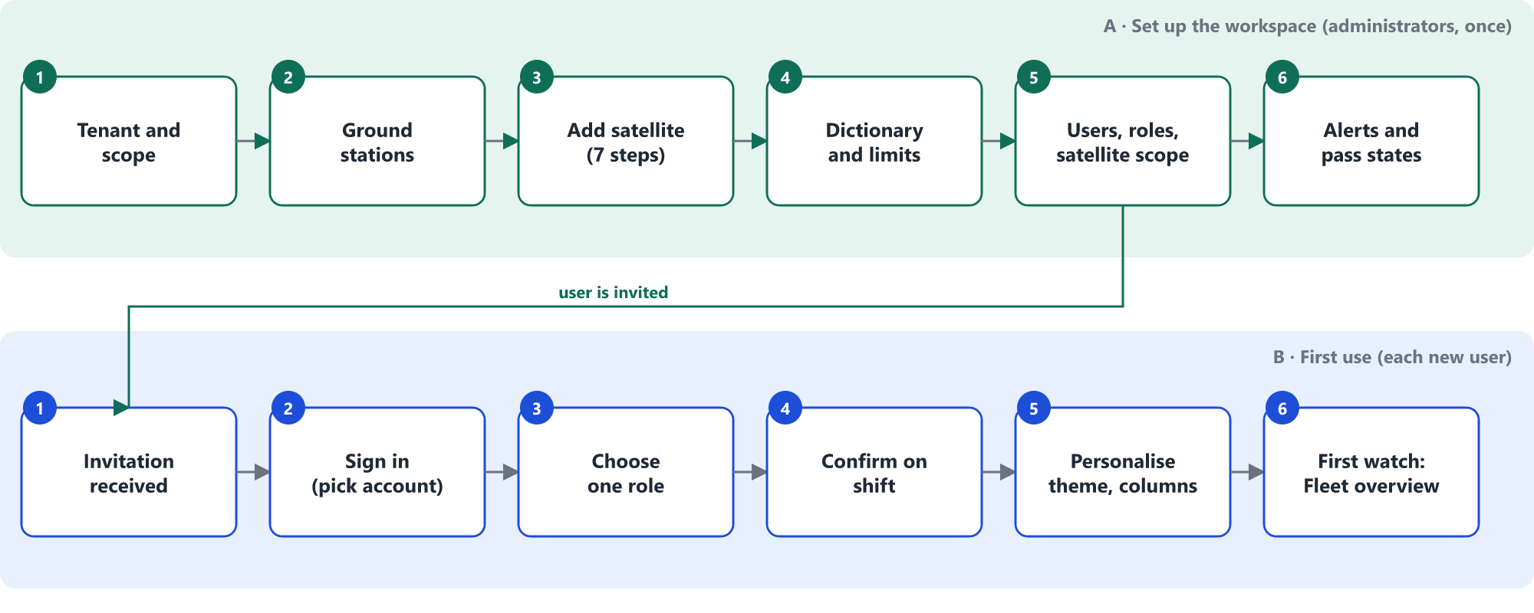
Figure 1. Onboarding: workspace set-up (top) and first use by each new user (bottom)

Set-up steps and where each is configured
# | Step | Who does it | Where in the console | What is set | Status
1 | Tenant and scope | Platform Administrator | Users & access; role step at sign-in | Which tenant (Akashaveda, Nabhas Agritech, Terra Analytics) a person belongs to. One tenant never sees another's data. | Built
2 | Ground stations | Ground Station Engineer | Ground stations | Provider, protocol (SLE, AWS Data/IP, own), bands, station health. Credentials live in the secrets store and are never displayed. | Built · Demo data
3 | Add a satellite | Mission Planner or Flight Engineer | Fleet overview → Add satellite | Seven guided steps: register the spacecraft, declare virtual channels, load the telemetry dictionary, set alarm limits, correlate the on-board clock, book ground contacts, verify and enable. | Built · Demo data
4 | Dictionary and limits | Mission Database Engineer | Mission database | Upload and version the telemetry and command dictionary; each parameter carries warning and critical limits (low and high). Released versions are what the live decoder uses. | Built (JSON in backend; XTCE XML upload is Planned)
5 | Users, roles, scope | Security Officer or Platform Administrator | Users & access → Invite operator | Person, one or more roles, satellite scope (for example AKV-* or NBH-01), passkey / MFA enforcement. | Built · Demo data
6 | Alerting | Flight Director or Platform Administrator | Notifications & on-call | Routing rules, escalation policy and the on-call rota that Escalate hands an alarm to. | Built · Demo data
7 | Pass states | Ground Station Engineer | Live pass monitor → Configure states | Name, description and the actions each pass state offers (section 5.3). | Built
8 | Alarm thresholds | Flight Dynamics / Flight Director | Configuration file for now | Conjunction alarm distance (10 km, critical under 5 km) and screening window (4 h). Editing these from the console is Planned. | Planned

3. First sign-in and roles
A new user arrives at the landing page, either through Sign in or through the "Or jump in as" shortcuts. The role step offers only roles that person actually holds, and commanding roles need an on-shift confirmation before the console opens. A Customer User goes straight to the Customer portal and only ever sees their own tenant.
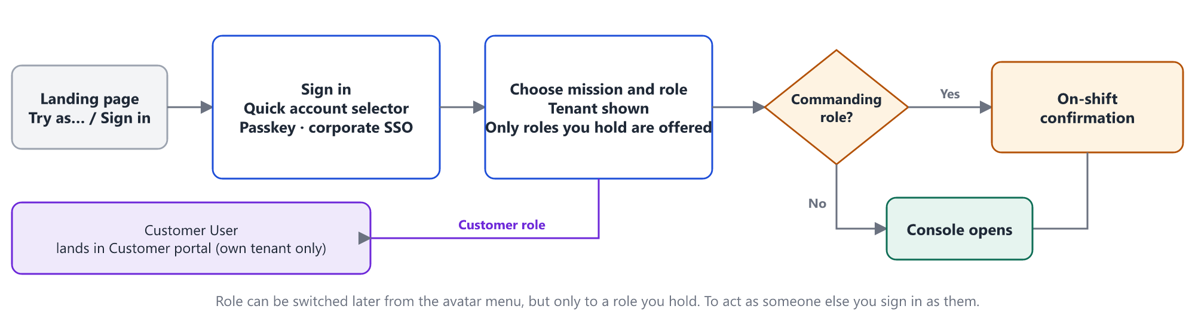
Figure 2. Sign-in, role choice and shift confirmation
In the demo, signing in means picking an account from the quick selector (grouped by role category). Passkey and corporate SSO buttons are present, but real identity is Planned.

Roles and what each sees
Category | Role | Screens | What the role is for
Operations | Spacecraft Operator | 12 | Monitor, acknowledge alarms, send routine commands, request critical ones.
 | Flight Director | 10 | Approve critical commands, run recovery, escalation point.
Engineering | Flight Engineer | 11 | Analyse telemetry, author procedures, review advisories.
 | Mission Database Engineer | 2 | Author, review and release dictionaries.
 | ML Engineer | 2 | Anomaly models and advisory quality.
Planning & ground | Mission Planner | 6 | Build plans, book passes, manage deliveries.
 | Ground Station Engineer | 6 | Operate stations and adapters, pass quality.
Governance & platform | Security Officer | 3 | Manage access, verify the audit ledger, break-glass.
 | Platform Administrator | 4 | Platform health, deployments, on-call.
 | System Administrator | all | Support and administration; no spacecraft authority.
Customers | Customer User | 3 | Own satellites, passes and deliveries. No commanding.

4. A working day in the console
Whatever the role, the day follows the same six stages. The table shows what the person does at each stage and where.
Stage | What the user does | Where | What they get
Orient | Check fleet health, who is in contact, what needs attention. | Fleet overview | Health counts, contact table, alarm bell.
Watch | Follow one satellite live; open several in their own windows. | Satellite health → Live | Cells, table or graphs; last and next contact; contact timeline.
Triage | Open an alarm, read its analysis, acknowledge, shelve or escalate. | Alarm console | Six alarm types, each with its own analysis view.
Act | Send a command or run a procedure; approve someone else's. | Command console, Approvals, Procedure runner | Safety checks, second-person approval, uplink status.
Plan | Book passes, set imaging, prepare the next contact. | Contact schedule, Mission plan, Live pass monitor | Planned procedures per contact; pass states.
Review | Look back: history, playback of a past pass, audit trail. | Satellite health → History / Playback; Audit ledger | Reconstructed history, replay, hash-chained record.

4.1 Fleet overview
- Table of every satellite with columns you choose. A Columns button lists 15 default columns (health, ground contact, last critical parameter, payload, last imaging, data downloaded and processed, procedure uplink %, conjunction, last and planned manoeuvre, last contingency) plus all 43 telemetry parameters. The choice is remembered; headers sort.
- Globe and map with layers you can switch on and off: satellites, orbit paths, labels, ground stations (each its own colour), coverage, place references, space debris, conjunction alerts. Satellites can be coloured by health, plane or individually, and the globe has seven map styles plus day/night, atmosphere and grid.
- Observe one satellite: hides all others and follows it with the camera, while zoom, tilt and layers keep working.
- Conjunctions: every 10 minutes each satellite is screened against a demo catalogue of debris and rocket bodies for the next 4 hours; close approaches are listed and critical ones raise a toast.

4.2 Satellite health
- Live, History and Playback are tabs on one page. History compares up to six parameters (overlay, stacked or side by side, zoom, pause and play, table and CSV export). Playback replays by time range, last duration, last pass or pass number, with play, speed and a scrubber.
- Three views of the live values: cells, a paged table, and a grid of small graphs. In each view an Edit button chooses which parameters appear; every view remembers its own choice.
- Header shows only last and next contact. A collapsible timeline below shows every contact 2 hours back and 10 hours ahead; hovering a segment shows AOS, LOS and the procedures and commands planned on it, with the percentage completed.
- Side panel: open alarms, payload and data status, procedure uplink progress, last events (imaging, dump, manoeuvre), what is planned on board, flight-dynamics summary and conjunction status.
- New window opens the satellite alone in its own browser window, so several can be watched side by side.

5. Key flows

5.1 Alarm handling
Alarms come in six types: health (limit violations, grouped by subsystem), conjunction, payload, commands and procedures, ground contact, and data processing. Clicking any alarm opens an analysis that fits its type: limits and a recent chart for health, encounter geometry and recommended steps for a conjunction, station status and affected contacts for a ground alarm, and so on.
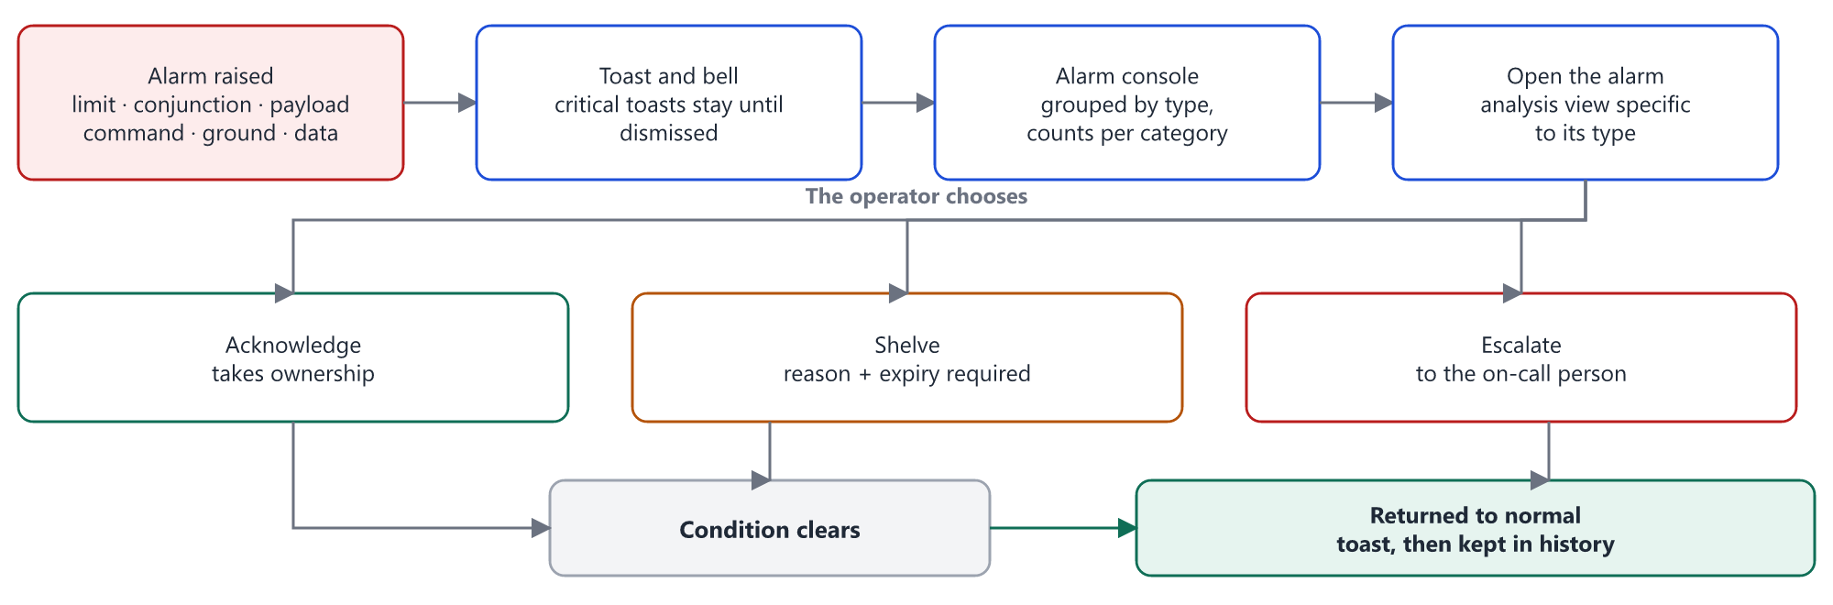
Figure 3. Alarm lifecycle from raised to returned-to-normal

5.2 Sending a critical command
Routine commands go straight through the safety checks. A critical command adds a second person: the requester cannot approve their own request, and the approver confirms with a fresh passkey touch after seeing the interlock telemetry captured at request time. A command is only marked completed when telemetry shows its effect, not merely because the spacecraft acknowledged it.
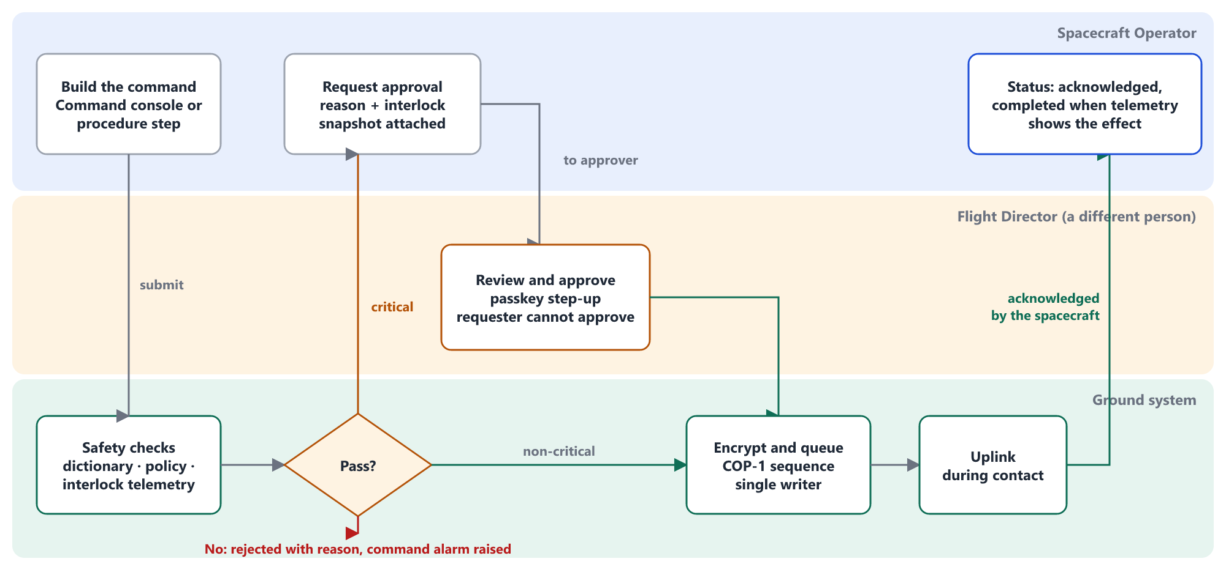
Figure 4. Critical command: request, approval, uplink and confirmation

5.3 A contact from plan to sign-off
Each pass moves through six states. The default names below are suggestions and can be renamed; the description and the actions each state offers are also configurable from the Live pass monitor. The monitor shows the current state's actions as buttons.
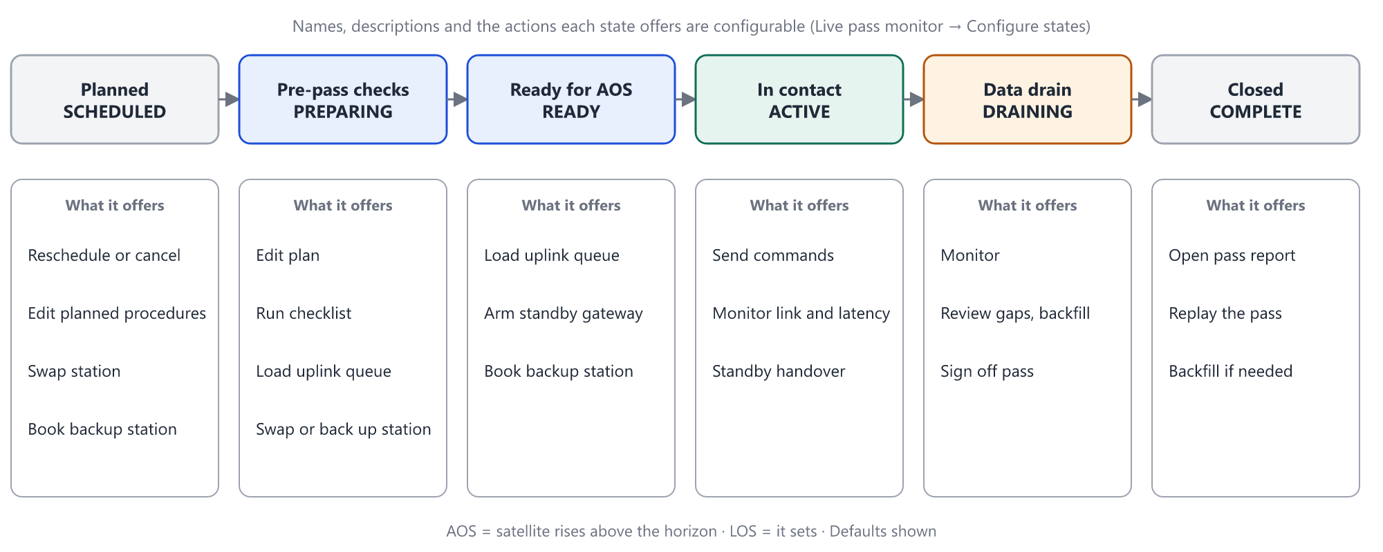
Figure 5. Pass states and what each offers (defaults)

6. Configuration and personal settings
Some settings belong to the whole workspace, others to the person. Personal settings are stored in the browser today, so they follow the browser, not the account; moving them to the account is Planned.
Setting | Where to change it | Applies to | Default
Theme (light / dark) | Sun / moon button in the top bar and on sign-in | Person (browser) | Dark
Fleet table columns | Fleet overview → Columns | Person (browser) | 15 columns
Satellite health view and which parameters show | Satellite health → view switch and Edit | Person (browser) | Cells, all parameters
Globe layers, colour mode, map style | Globe → Layers button | Person (browser) | Satellites, orbits, stations, places, conjunctions
Active role | Avatar menu (only roles you hold) | Session | First role held
Pass state names, descriptions, actions | Live pass monitor → Configure states | Browser today; workspace Planned | Planned, Pre-pass checks, Ready for AOS, In contact, Data drain, Closed
Dictionary, limits, satellites, stations | Mission database, Add satellite, Ground stations | Workspace | Per satellite
Users, roles, satellite scope, MFA | Users & access | Workspace | None until invited
Alarm routing and escalation | Notifications & on-call | Workspace | Rota and rules as defined

7. One journey per persona
Persona | From invitation to first useful day
Spacecraft Operator | Invited by the Security Officer with role and satellite scope. Signs in, picks the Operator role, confirms on shift.  Fleet overview shows who is in contact. Opens AKV-03 in its own window and watches the graphs view.  A heater alarm arrives: the toast opens the Alarm console, the analysis shows the limit and trend, the operator acknowledges and starts the recovery procedure.  The critical step needs approval, so the operator requests it and waits for the Flight Director; status follows the command to completed.
Flight Director | Signs in with the Flight Director role and confirms on shift. The bell and Approvals show pending requests.  Reviews who asked, why, and the interlock snapshot, approves with a passkey touch.  Handles escalations from the alarm console and owns conjunction decisions: reads the encounter analysis and requests a manoeuvre plan.
Mission Planner | Signs in, opens Contact schedule and the Live pass monitor. Books passes and edits planned procedures per contact.  Onboards a new satellite through the seven-step wizard, then checks it appears in the Fleet overview table.  Watches pass states move from Planned to Closed and opens the pass report.
Customer User | Invited with a tenant scope only. Signs in and lands in the Customer portal.  Sees own satellites, upcoming passes, deliveries and tasking requests, and manages API keys and webhooks. No commanding, no other tenant's data.

8. What is real today
- Real: the telemetry path from simulator through decoding to the console, limit alarms, the command chain with safety checks and COP-1 acknowledgement, contact windows and satellite positions from an orbit model, and conjunction screening geometry.
- Demo data: payload, data-processing, procedure and flight-dynamics figures, the debris catalogue, history for parameters (reconstructed around the live value), and most administration screens.
- Planned: real sign-in (SSO, passkeys), personal settings stored on the account, XTCE upload, editable alarm thresholds, live tracking data for conjunctions, and separate windows sharing one live session.

