

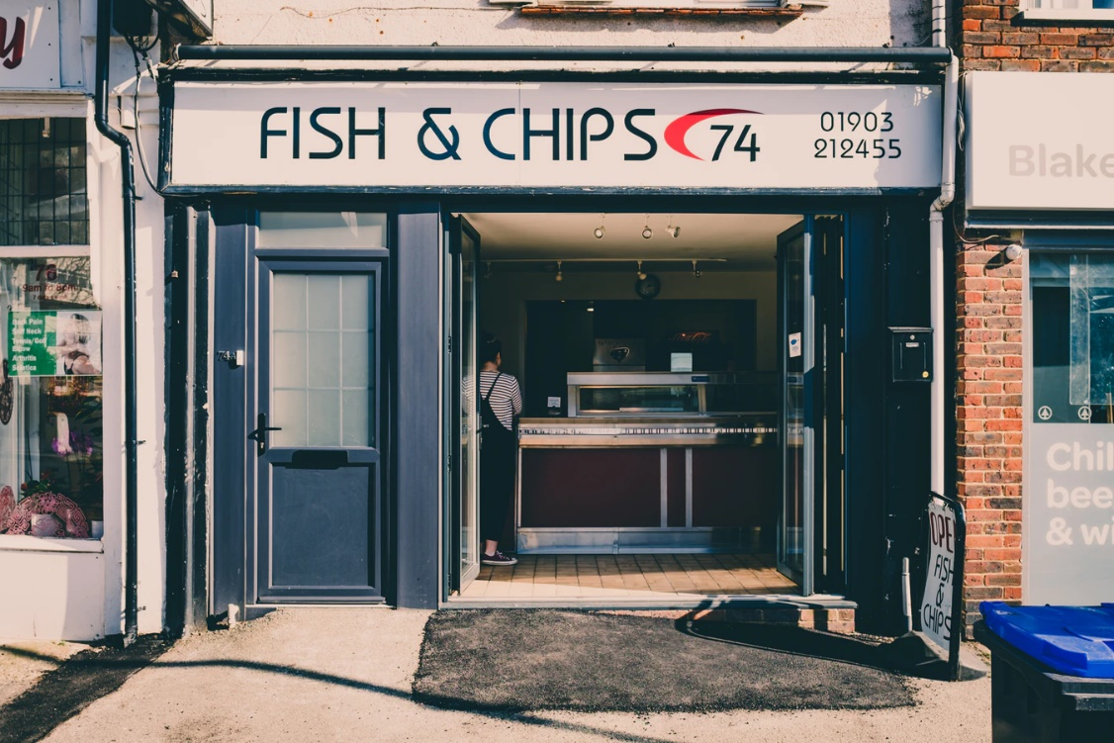

**A report outlining the design and implementation of a food ordering application for a Fish & Chips shop.**

The project

**Making a food ordering application (app) for the customers of Moana Fish & Chips in Aranui.**

Richard Lovell the proprietor of this shop wanted to improve customer engagement and sales by enabling his customers to place orders via digital devices.

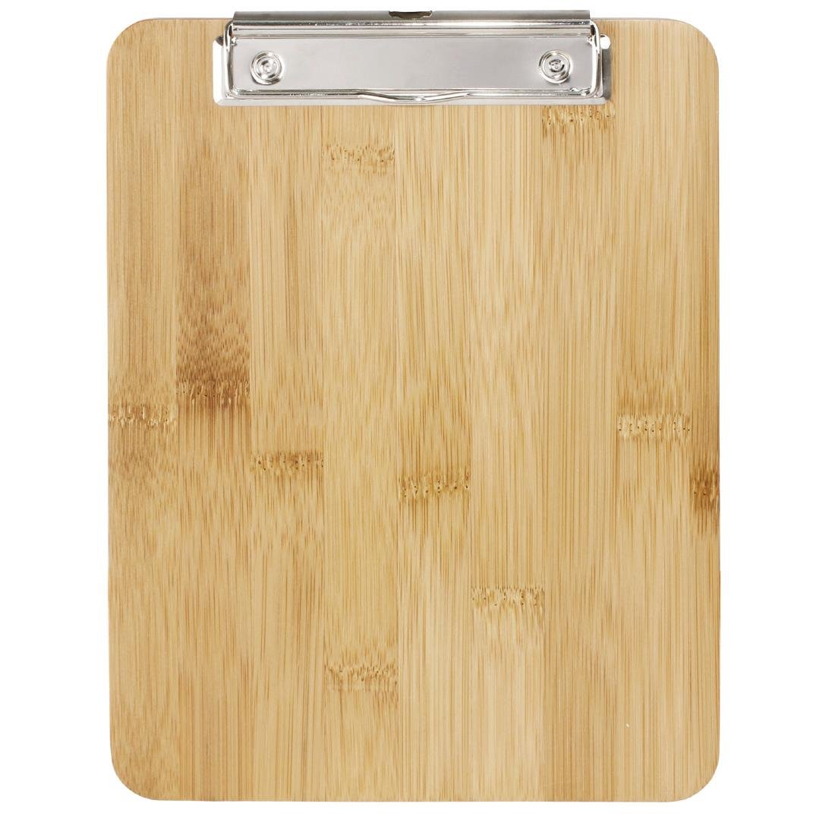

Information gathered at a kick-off meeting with Richard

Client’s values

* The client has a strong sense of belonging in the community, and wants to promote the health and wellbeing of his customers
* The client wants to help Maori and the community at large fight obesity
* The client wants to provide information about the nutritional value of the food on sale
* The client wants to help Maori make informed nutritional and lifestyle decisions

**Discover**

**Requirements Gathering**

**Kick-off meeting summary**

Look and feel the client wants

* For the product to look like a mobile app
* For the app to have a clean and modern look
* For the app to have subtle hints of the shop’s brand

Application features the client wants

* The ability to order items on the menu
* The ability to see items on special
* The ability to see nutritional information about the food
* A way for customers to see how far their order is, after they have paid for it
* A way for customers to leave feedback about their food and their experience

**Discover**

**Stakeholder interviews**

Stakeholder needs gathered from interviews

The proprietor

* Making good nutrition & lifestyle advise available to his mostly Maori clientele
* Making nutrition and allergen information available for all food items on the menu

The cook

* The ability to mark items as “Out of stock”

The cashier

* The ability to add orders, which have been paid for to a “To cook list”

List of stakeholders in the project

The shop’s

* Proprietor
* Cook
* Cashier
* Patrons

**Discover**

**Stakeholder interviews**



Customer needs gathered from interviews

The interviews have been attached in Appendix A

* The ability to see the menu categorised into burgers, fish, chicken, sides & sauces, desserts and drinks
* A desire to be rewarded for their loyalty with a discounts system
* The ability to see these discounted specials featured before any of the other items on the app’s menu
* The ability to post feedback about their experience at the shop
* All interviewees believed that customers would be more inclined to make purchases at the shop, if the shop advertised their eco-friendly business practices through their app

**Discover**

A competing fast food vendor’s app was analysed to see how they provided the features which the stakeholders of Moana Fish & Chips wanted.

* McDonald’s’ food ordering app was chosen for this comparison
* A report detailing how McDonald’s lets their customers do the following tasks has been attached in Appendix B
  + Ordering items on the menu
  + Viewing what is on special
  + Viewing nutritional information about food items
  + Viewing the progress of orders
  + Leaving feedback about their experience

Two of the stakeholders, the cook and the cashier, asked for the ability to mark items on the menu as “Out of stock” and for a way to add orders to a “To cook list”.

* The way McDonald’s solved these problems was not visible in their customer facing app.
* So, in-house expertise was used to find a suitable way to implement these app features.

**Competitor analysis**

**Discover**

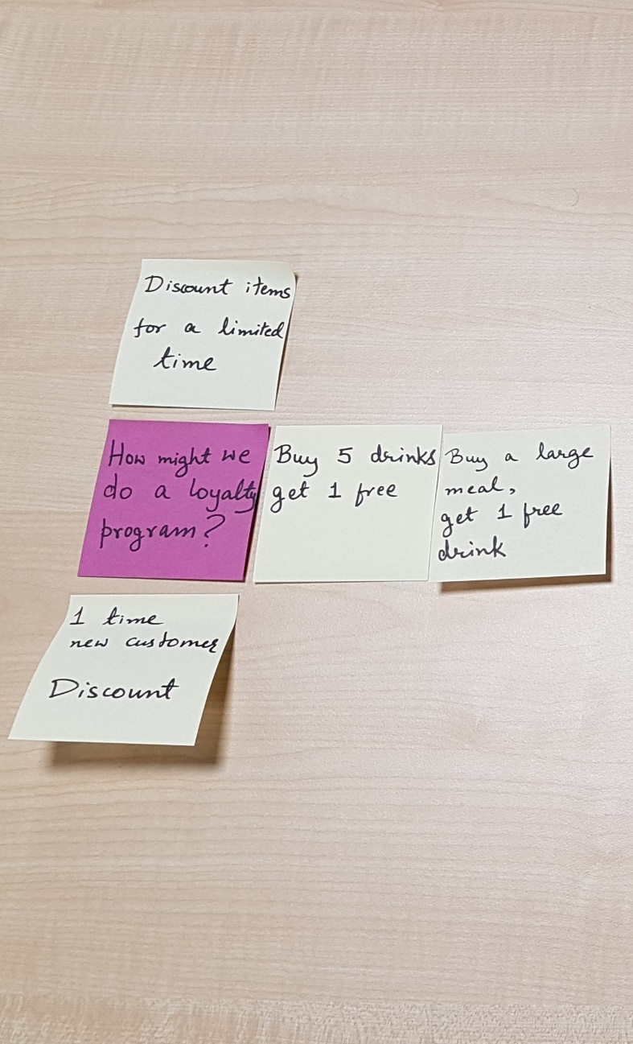

To gain better insight into the best ways to provide the features requested by stakeholders, post-it notes were used for sense-making.

For every feature requested, “How might we – *best implement this feature*?” questions were posed to explore all possible solutions.

For example, to find out the best way to reward customers for their loyalty to the shop, the following question was posed.

“*How might we do a loyalty program?”*

**Define**

**Ideation**

To find out the best way to categorise the food items for sale, the following question was posed.

“*How might we categorise food groups?”*

To find out the best way to enable customers to leave feedback about their experience, the following question was posed.

“*How might we let users leave feedback*?”

**Ideation**

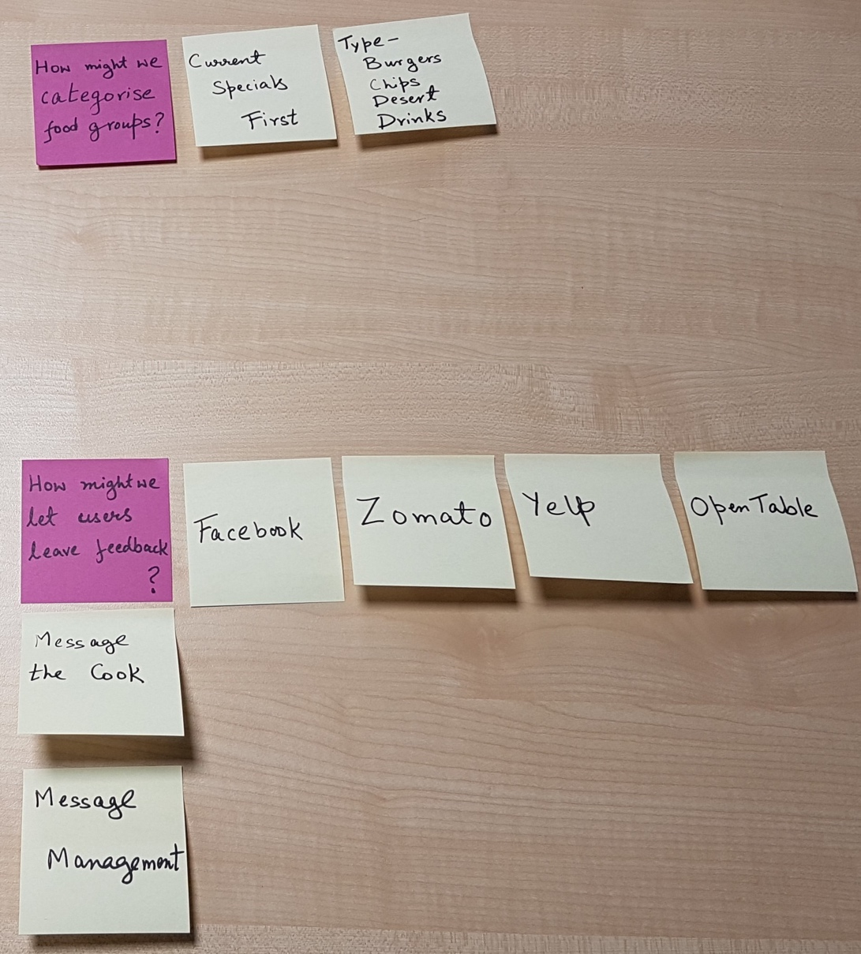

**Define**

**User profiling**



To better understand the shop’s customers, fictional user profiles were created.

For example, Nina shown on the left –

*“… is a busy careerwoman with two kids who does not have time to cook.*

*She often purchases dinners for her family from Moana Fish & Chips.*

*She does not like spending her time queuing for her meals, and often wishes that she could spend that time browsing the shop’s menu.”*

**Define**

**User experience definition**

To define the ideal user experience “user journeys” were outlined. One such journey is shown below.

*“A customer walks into Moana Fish & Chips.*

*She sees a lot of people queuing for their meals.*

*She opens the shop's app on her phone to see what food is available.*

*She finds that the menu is categorised into burgers, fish, chicken, sides & sauces, deserts and drinks.*

*She orders a chicken burger from the burger category.*

*The app directs her to pay at the counter.*

*After paying for her burger she can track the progress of her order on the app's screen.*

*She receives her burger and leaves the shop satisfied.”*

**Define**

**Content strategy**

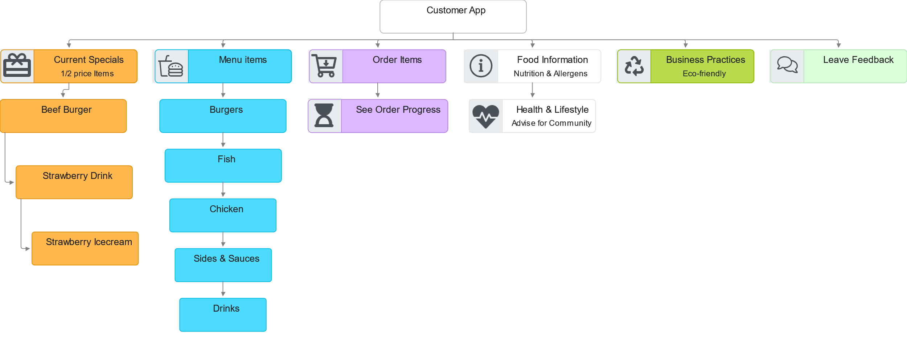

**Define**

The information which would appear in the customer-facing app was organised into a hierarchy as shown below.

**Content strategy**

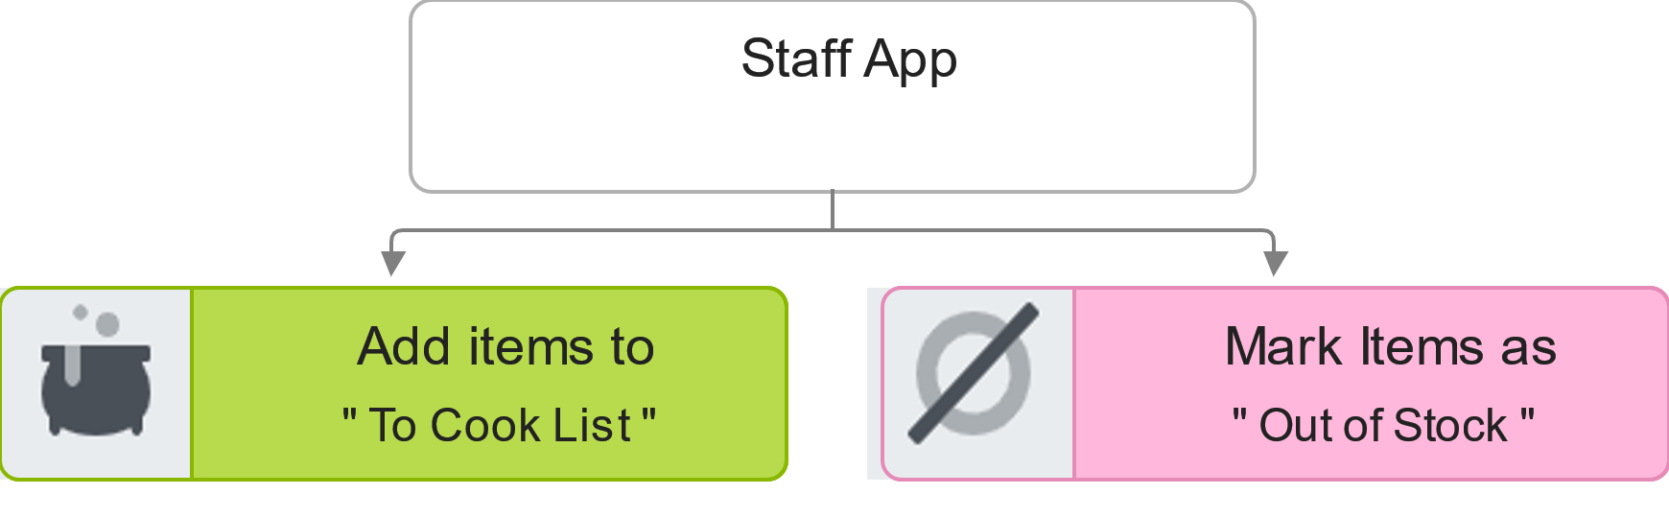

After consulting the shop’s proprietor, a second time -   
it was decided that some features, namely

1. the ability to add orders for which payment had been received and
2. the ability to mark items as “Out of Stock”  
   should only be available via a staff-facing app.

The information which would appear in this staff-facing app was organised into the hierarchy shown below.

**Define**

Other information gathered from this second meeting with the proprietor, which helped “define” this project.

1) the ability to add orders for which payment had been received and  
2) the ability to mark items as “Out of Stock”  
should only be available via a staff-facing app.  
  
The information which would appear in this staff-facing app was organised into the hierarchy shown below.

**Content strategy**

**Define**

**Content strategy & Information hierarchy**

Our strategy was to keep all the content from the existing website as this is what Richard wanted.

Our ideation process did lead us to make changes to the information architecture of the existing website.

These changes are visually represented in the sitemap on the next page.

**Design**

**Sitemap**

**Design**

To validate the new navigation system and labelling system we did some open card sorting with users.

The results confirmed that users think and sort the information on Waipara Wine’s website exactly like we represented it on our sitemap.

**Sitemap**

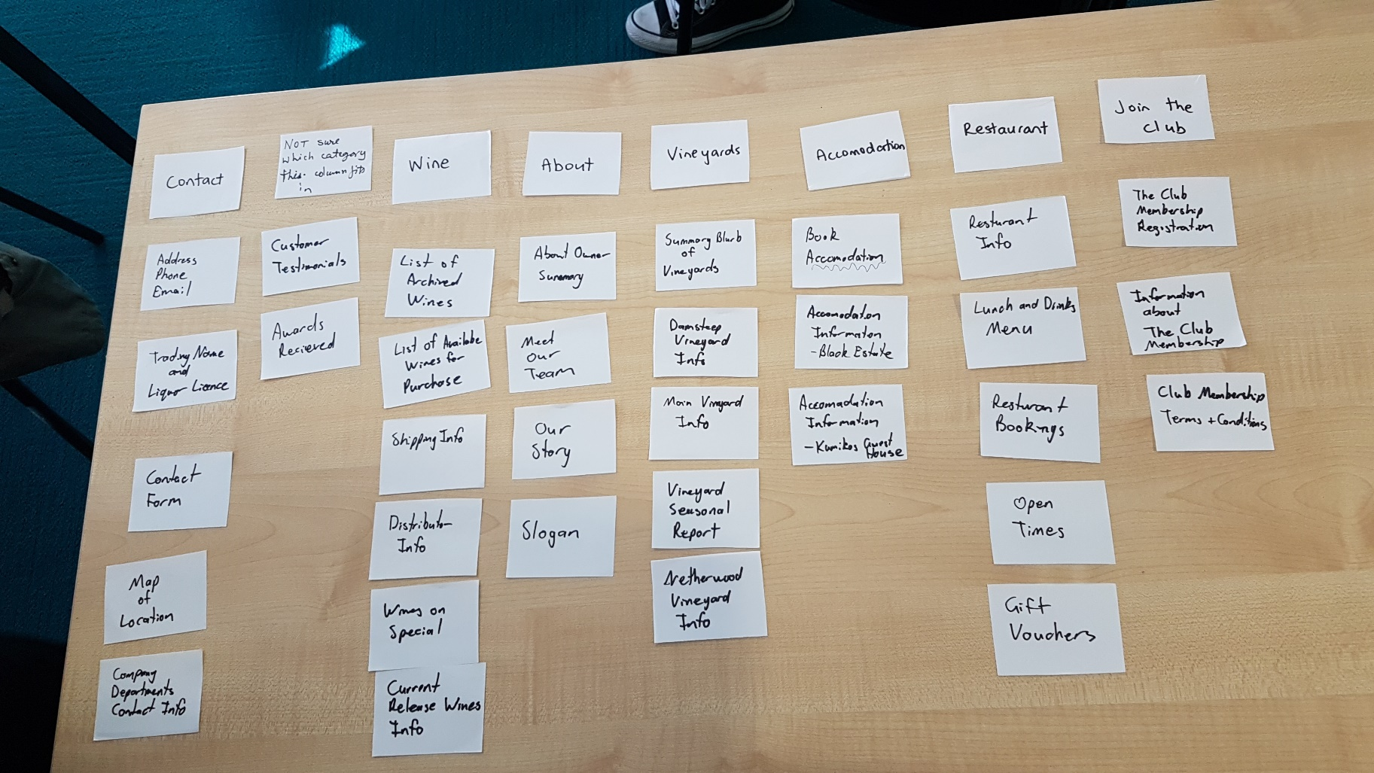

**Design**

**Low fidelity prototyping**

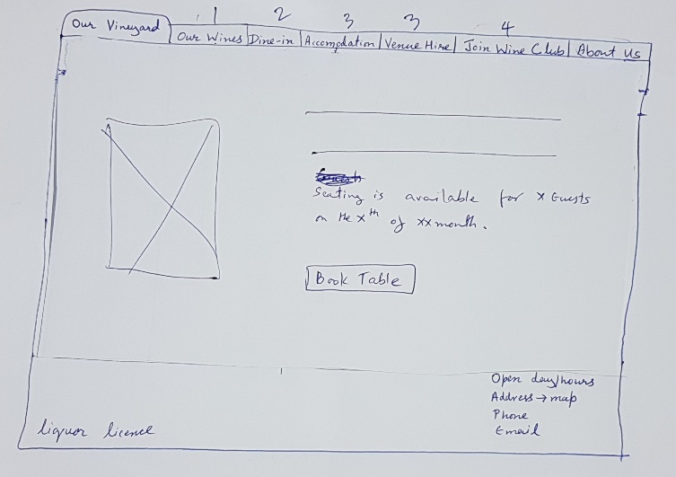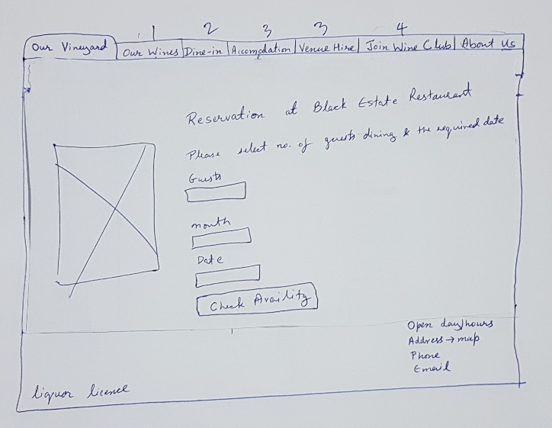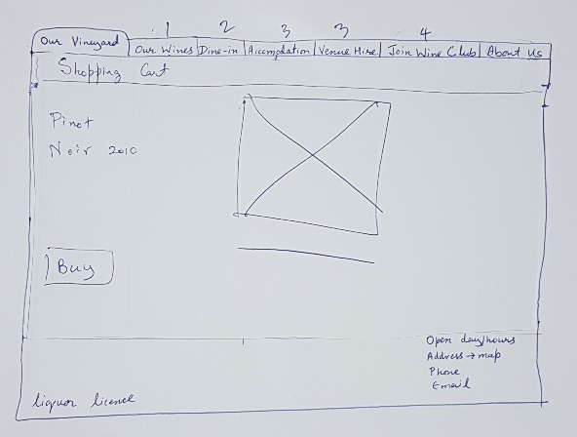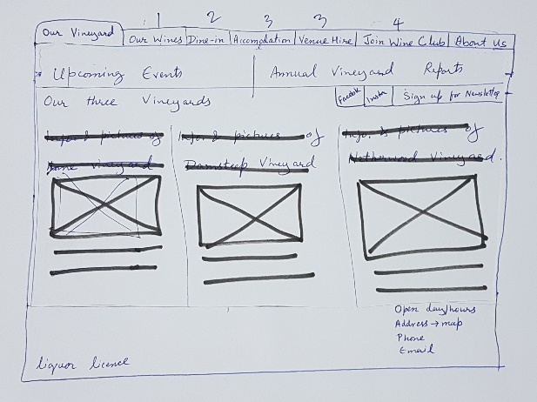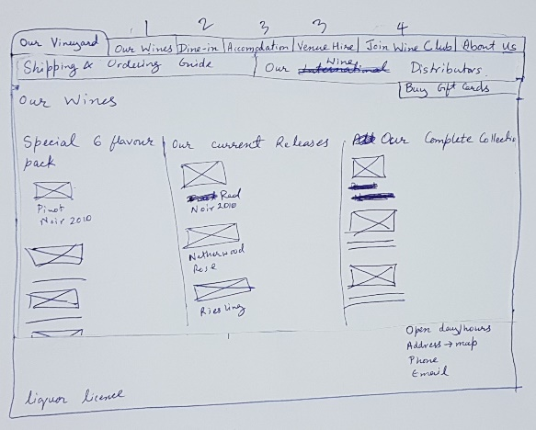

**Design**

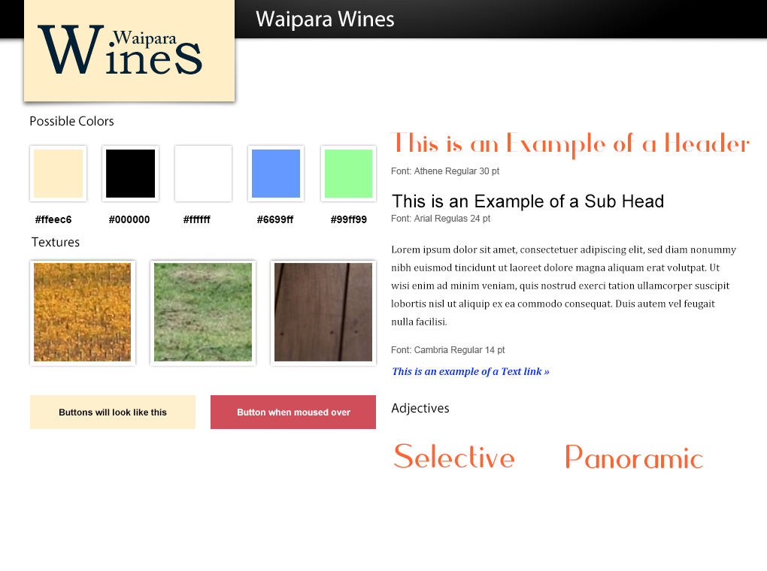

**Style tile**

**Design**

**Hi fidelity prototype**

**Design**