# Concept(s) to remember

1. Hypervisor is a kind of software by which we can run several virtual machines. Some of the hypervisor are
   * Virtual Box
   * VM Ware
   * Hyper-V (windows only)
2. Virtual machine vs Containers (all containers share same underlying kernel of OS, doesn’t need specific CPU, memory, very fast to start)
3. Docker architecture
   * Docker client
   * Docker Server (docker engine)

# Docker Workflow

## Create image

* + 1. Write docker file in location say "C:\repository\git\Docker"
    2. Build docker image from file

*C:\Users\echypal> docker build -t <hub-user>/<repo-name>[:<tag>] <docker file   
 location>*

If tag is not specified it is taken as latest

*C:\Users\echypal> docker build -t akash007ganga/hello-docker C:\repository\git\Docker*

* + 1. check image is available

*C:\Users\echypal>docker images*

*REPOSITORY TAG IMAGE ID CREATED SIZE*

*hello-docker latest c3bd764e3654 24 seconds ago 113MB*

*nginx 1.14-alpine 8a2fb25a19f5 2 years ago 16MB*

*docker/whalesay latest 6b362a9f73eb 6 years ago 247MB*

* + 1. Create and start Containers from image.(it is a process with own file system provided by image)

*C:\Users\echypal>docker run akash007ganga/hello-docker*

*Hello Docker !*

## Push the image into docker registry(like docker hub)

1. Create the repository in docker hub (hello-docker)

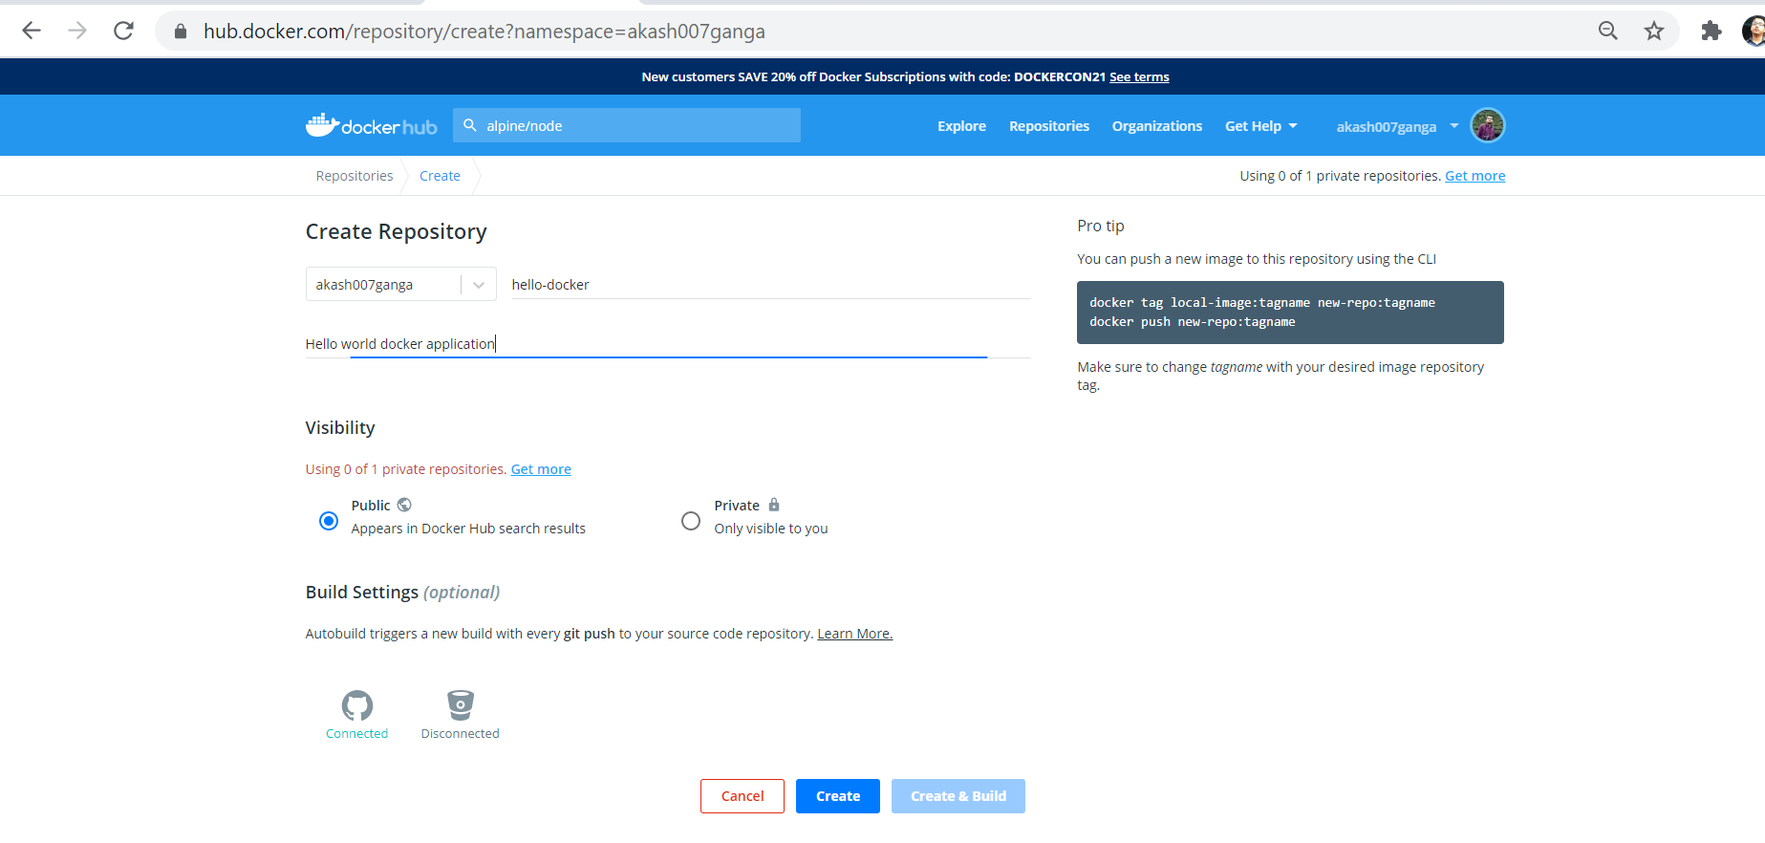

1. Push the image

*C:\Users\echypal>docker push akash007ganga/hello-docker:latest*

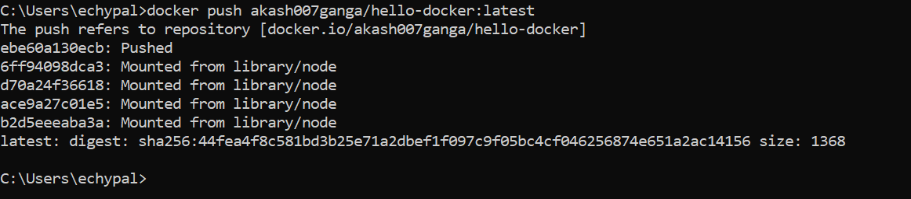

1. Check from docker hub

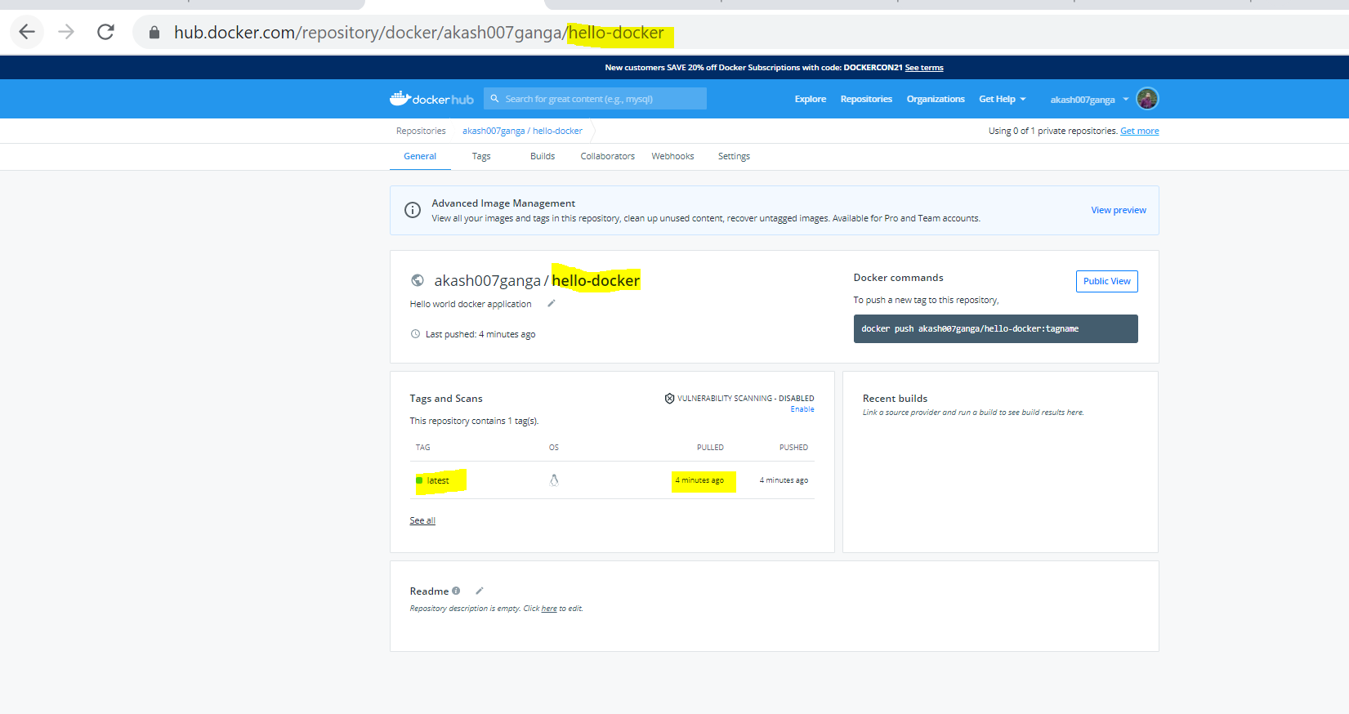

## Run the image into another machine

1. Go to a sandbox environment <https://labs.play-with-docker.com/>
2. Login with docker ID (if docker hub is logged in then it will automatically login)
3. Click on start
4. Click on add new instance to start a new VM
5. Maximize the console with alt + enter
6. Check docker version

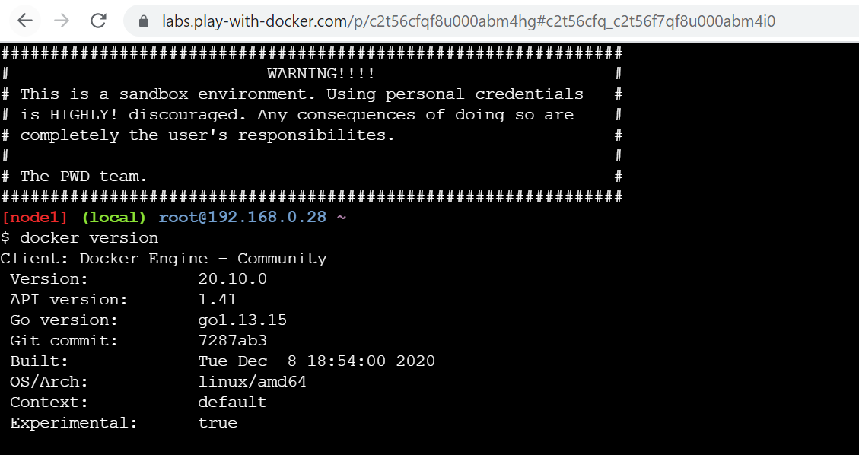

1. Run our image

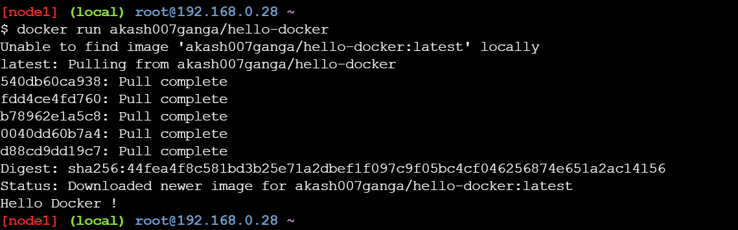

1. Check images

