📌 Project Overview
This project focuses on analyzing Walmart retail sales and inventory data to identify revenue patterns, inventory inefficiencies, and business optimization opportunities.
The analysis helps uncover:
- Revenue concentration risks
- Inventory mismanagement issues
- Stockouts and overstock problems
- Demand vs inventory mismatches
The goal is to provide data-driven insights to improve inventory planning, reduce losses, and increase profitability.

🎯 Objectives
- Analyze revenue by product, category, and store
- Identify top-performing and low-performing products
- Detect stockout and overstock risks
- Analyze monthly revenue trends
- Measure correlation between demand and inventory
- Identify slow-moving products
- Provide business recommendations

🛠️ Technologies Used
- Python
- Pandas
- NumPy
- Matplotlib
- Seaborn
- Jupyter Notebook

📊 Project Workflow
- Data Loading
- Data Cleaning
- Exploratory Data Analysis (EDA)
- Revenue Analysis
- Inventory Risk Analysis
- Correlation Analysis
- Visualization
- Business Insights & Recommendations

📈 Key Insights
- Top 10 products contribute ~42% of total revenue
- High dependency on limited products and stores
- 30–40% products at risk of stockouts
- 25–35% stores have overstock
- Poor correlation between demand and inventory
- Estimated $750,000+ revenue loss due to stockouts
- Large capital tied in slow-moving products

📉 Sample Visualizations
Images:-
├── revenue_by_category.png
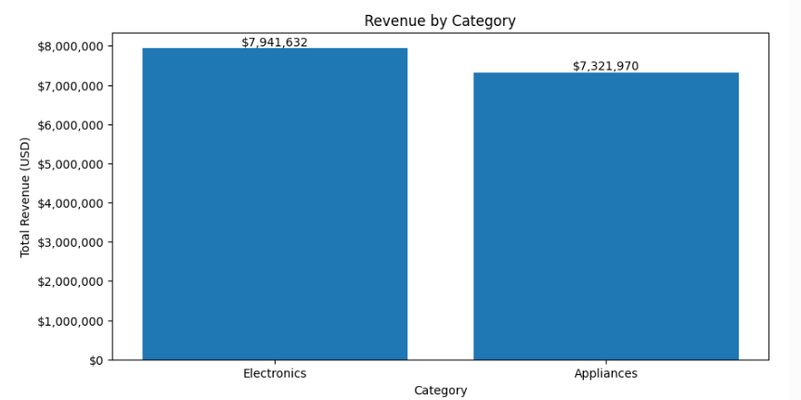

├── monthly_revenue_trend.png
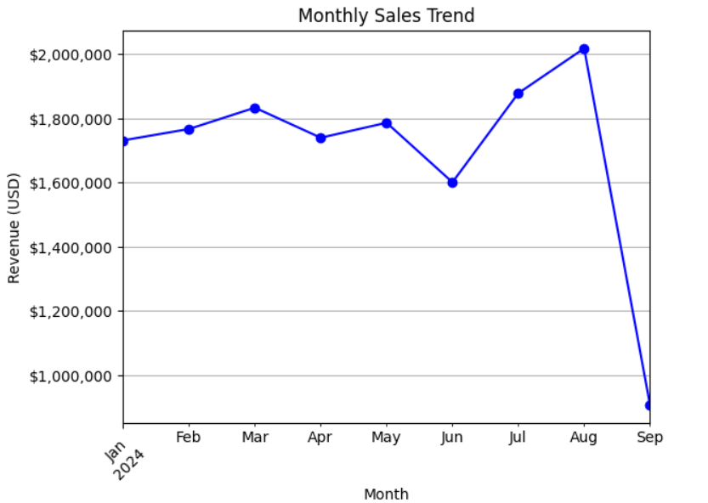

├── Top Selling Products with Lower Revenue.png
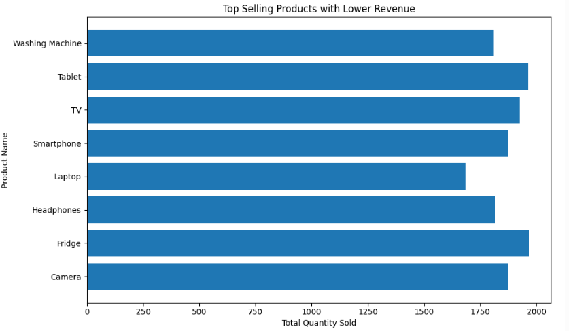

├── overstock_analysis.png
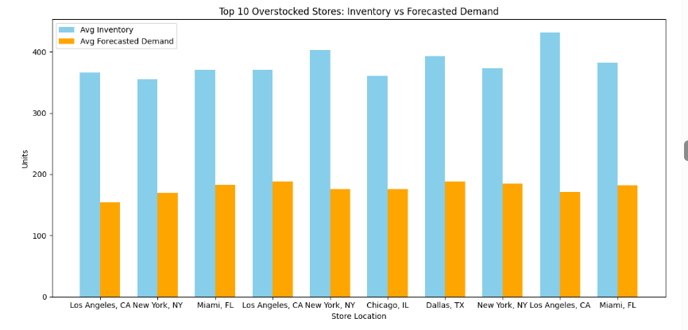

├── Store-wise Revenue, Quantity Sold, and AOV
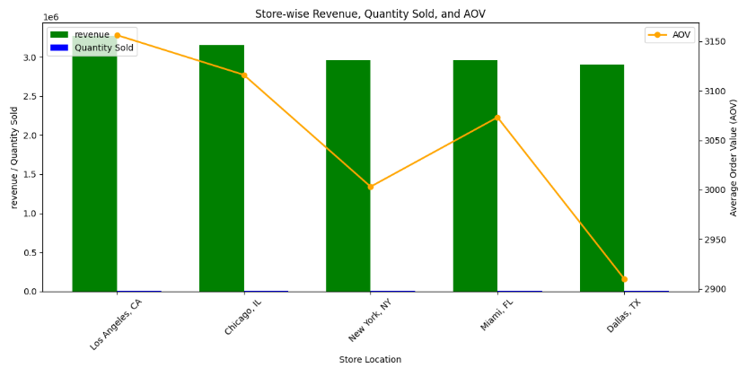

💼 Business Impact
This project helps businesses:
- Reduce stockouts
- Reduce overstock costs
- Improve revenue planning
- Optimize inventory management
- Improve demand forecasting

👨‍💻 Author
Akash More
- GitHub: https://github.com/yourusername
- LinkedIn: https://www.linkedin.com/in/akash-more-linkdin/

