Set 2 – Bank Loan Portfolio
Name : AKASH S
Date : 13/11/2026

1. Problem Overview
A bank's credit team studies its loans, customers, branches, repayments and guarantors to find risk early: loans that have fallen behind, customers whose exposure is unusually high for their branch, borrowers who have stopped paying, and people who guarantee other loans while carrying loans of their own. These questions need more than simple SELECT statements, so they are answered with inner and outer joins, a self join, correlated and uncorrelated subqueries, EXISTS / NOT EXISTS and a nested subquery.
This document solves the ten required questions, shows every query in the MySQL Workbench SQL editor with the exact result grid it returned on MySQL 8.0, and closes with a justification note that explains why each join and subquery was chosen.
Deliverables: advanced_reports.sql (schema, sample data and all ten queries in one runnable script) and this justification note.

2. Database and Sample Data
The database bank_loans uses five InnoDB tables linked by foreign keys. A guarantor can be an outside person or an existing bank customer, so guarantors.customer_id is nullable; when it is filled in, it points back to the customers table, which is what makes the self join in Q3 possible.
Table | Key columns | Rows
branches | branch_id (PK), branch_name, city, ifsc_code (UNIQUE), opened_on | 7
customers | customer_id (PK), full_name, city, phone, customer_since, home_branch_id (FK) | 14
loans | loan_id (PK), customer_id (FK), branch_id (FK), loan_type, principal, interest_rate, tenure_months, emi_amount, first_emi_date, status | 19
repayments | repayment_id (PK), loan_id (FK), instalment_no, paid_on, amount; UNIQUE (loan_id, instalment_no) | 206
guarantors | guarantor_id (PK), loan_id (FK), guarantor_name, relationship, customer_id (FK, nullable) | 10
Table 1: Tables of the bank_loans database
The sample data was planned so that every question has a meaningful answer:
- Overdue loans: loans 5003, 5009, 5012 and 5014 have stopped paying and are 4 to 6 EMIs behind; loans 5006 and 5018 are only 2 and 1 EMI behind, so they test the "more than three" boundary.
- Multi-branch customers: Arjun Rao, Priya Nair, Rahul Sharma and Imran Khan each hold loans at two branches.
- Customer guarantors: five guarantors are themselves bank customers with loans; the other five are outside persons (customer_id NULL).
- Branches without loans: Gokulam (Mysuru) and RS Puram (Coimbatore) opened in 2026 and have not disbursed any loan yet.
- Closed loan: gold loan 5008 is CLOSED and is excluded from overdue and exposure figures.
All date logic uses a fixed report date of 14-Nov-2026 set with SET @report_date, so the overdue counts and the 60-day window are reproducible. After loading the data, a UNION ALL row-count query confirms the load:
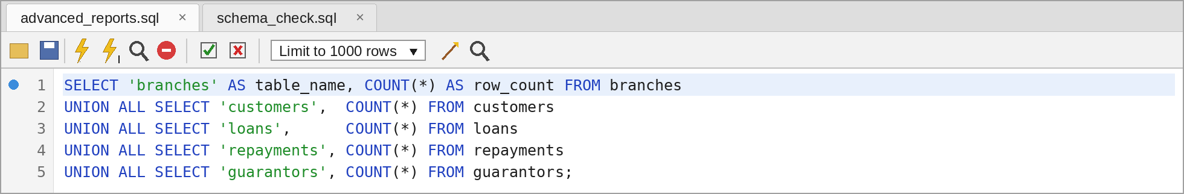
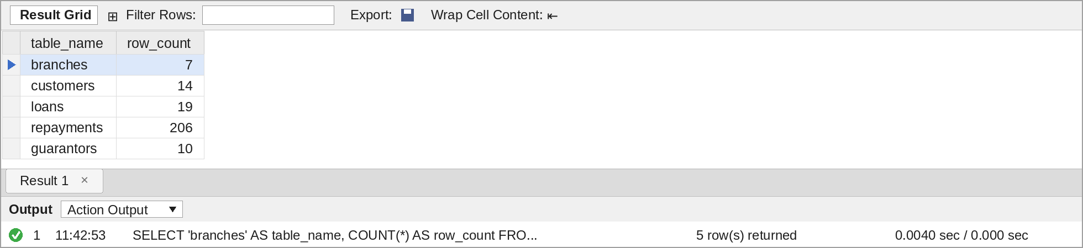
Figure 1: Row count check after loading the sample data – query and output in MySQL Workbench

3. Task 1 – The Ten Questions
Questions Q1 to Q7 are answered in this section. Q8 (exposure above branch average), Q9 (EXISTS / NOT EXISTS) and Q10 (nested subquery) belong to Tasks 2, 3 and 4 and are covered in Sections 4, 5 and 6.

3.1 Q1 – Loans Overdue by More Than Three Instalments
The number of EMIs due is the number of months from the first EMI date to the report date plus one, capped at the tenure with LEAST. The number paid is the count of repayment rows. A LEFT JOIN to repayments is used so that a loan with no repayment at all still appears with a count of 0. HAVING keeps only loans where due minus paid is more than 3.
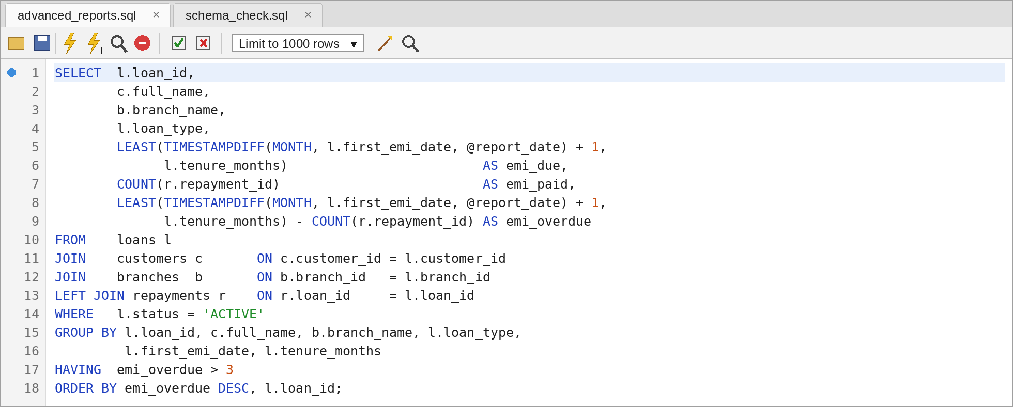
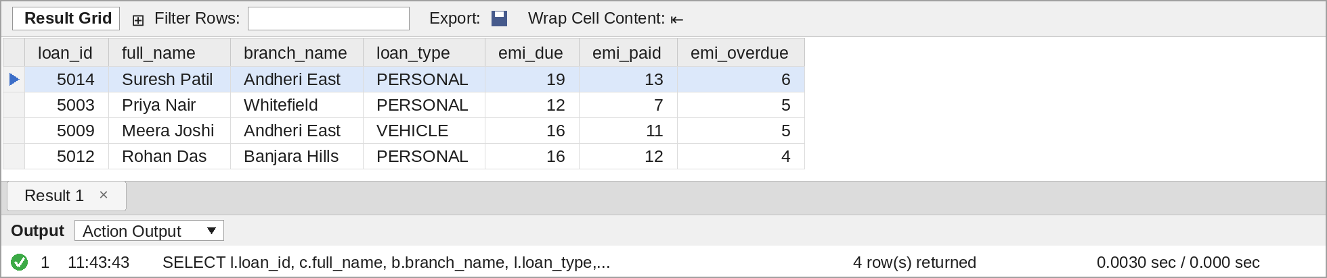
Figure 2: Q1 – Loans overdue by more than three instalments – query and output in MySQL Workbench
Four loans qualify. Suresh Patil's personal loan is the worst case with 6 EMIs unpaid, followed by Priya Nair and Meera Joshi with 5 each and Rohan Das with 4. Sneha Iyer (2 behind) and Pooja Verma (1 behind) are not listed because they do not cross the limit of three.

3.2 Q2 – Customers with Loans in More Than One Branch
Loans are joined to customers and branches and grouped per customer. COUNT(DISTINCT branch_id) counts different branches, not loans, so two loans at the same branch count as one. GROUP_CONCAT lists the branch names in a single column.
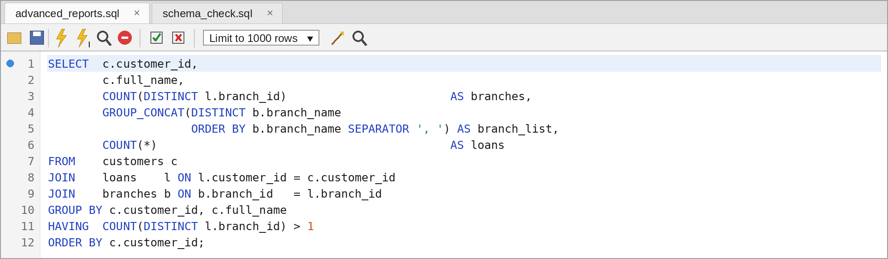
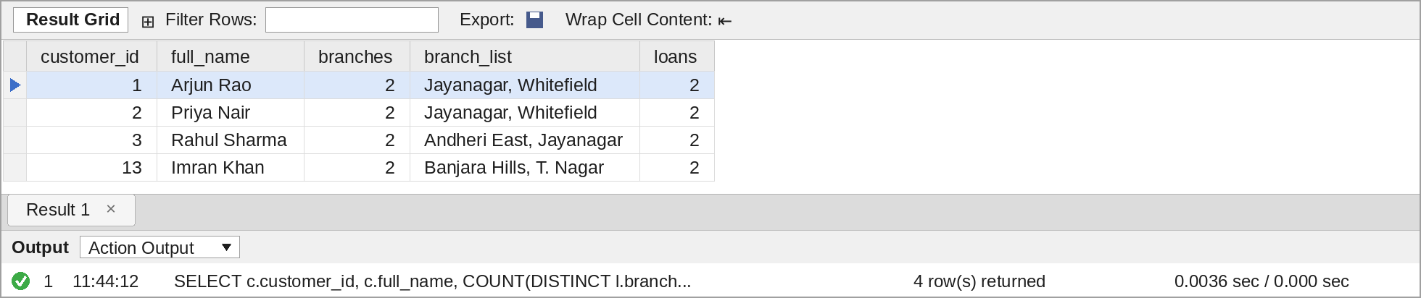
Figure 3: Q2 – Customers with loans in more than one branch – query and output in MySQL Workbench
Four customers borrow from two branches each. Arjun Rao and Priya Nair use both Bengaluru branches, while Rahul Sharma (Mumbai and Jayanagar) and Imran Khan (Hyderabad and Chennai) borrow in different cities, which the credit team should consider when checking total exposure.

3.3 Q3 – Guarantors Who Are Also Borrowers (Self Join)
The customers table appears twice: alias g is the customer acting as guarantor and alias b is the borrower whose loan is guaranteed. guarantors links g to the guaranteed loan, and the loan links to b. EXISTS confirms that the guarantor has loans of their own, and a small correlated subquery counts them.
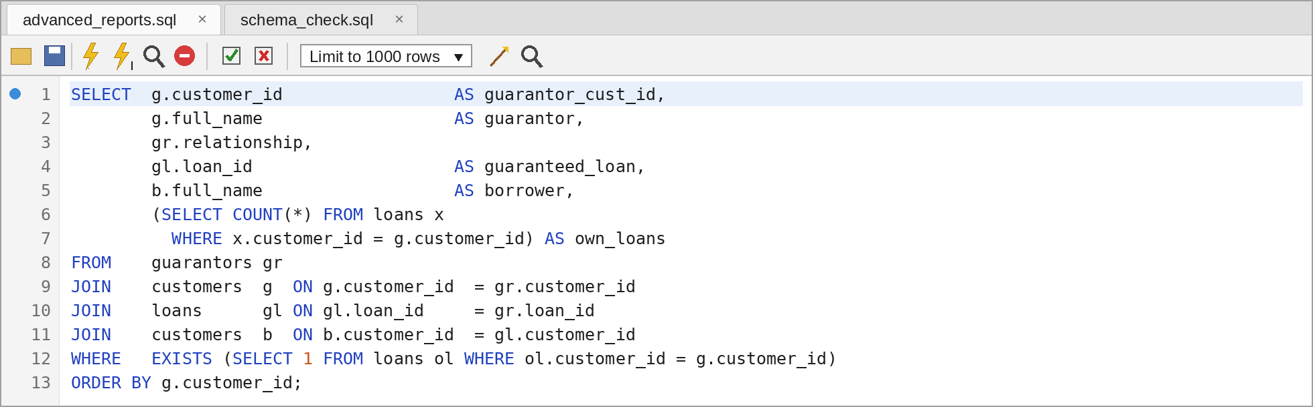
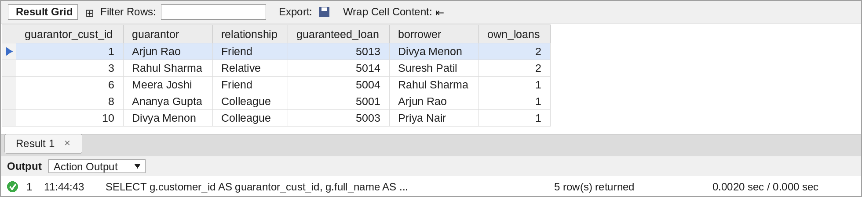
Figure 4: Q3 – Guarantors who are also borrowers (self join) – query and output in MySQL Workbench
Five guarantors also hold loans. Arjun Rao and Rahul Sharma stand guarantee while carrying two loans of their own, so a default by the borrowers they back would add to their own liability. The five outside guarantors (customer_id NULL) are correctly left out by the inner join.

3.4 Q4 – Branches with No Loans
A LEFT JOIN from branches to loans keeps every branch. Branches that have no matching loan get NULL in every loan column, and WHERE l.loan_id IS NULL keeps only those branches. DATEDIFF shows how long each branch has been open.
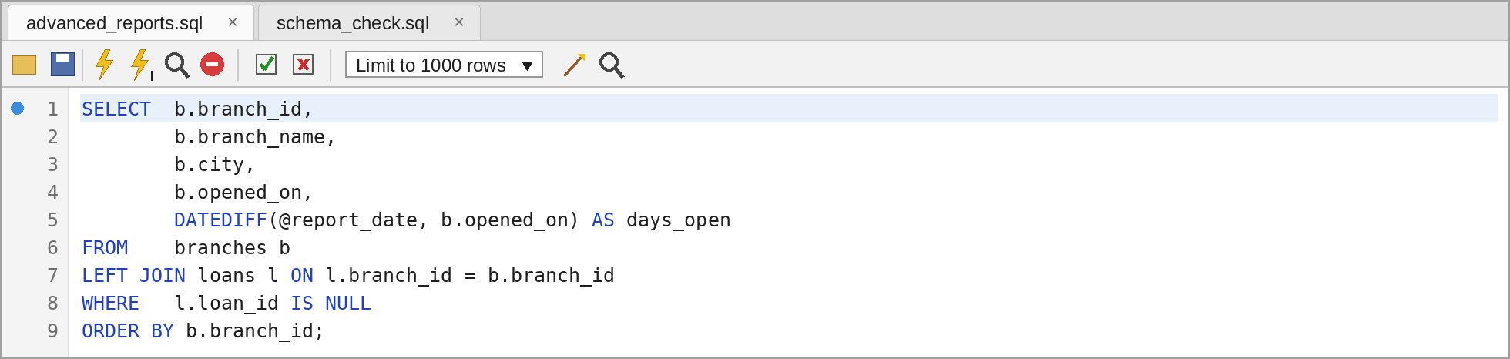
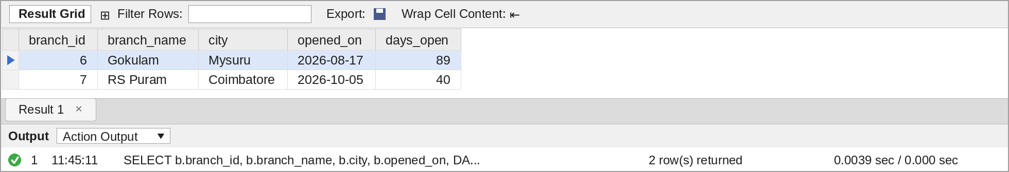
Figure 5: Q4 – Branches with no loans – query and output in MySQL Workbench
Gokulam (open 89 days) and RS Puram (open 40 days) have not disbursed a single loan yet; both are new branches, so the result is expected rather than a data problem.

3.5 Q5 – Branch-wise Portfolio Summary
This report again uses a LEFT JOIN from branches so that the empty branches appear with zeros. SUM(l.status = 'ACTIVE') counts active loans because MySQL treats a true comparison as 1, and IFNULL turns the NULL sums of the empty branches into 0.
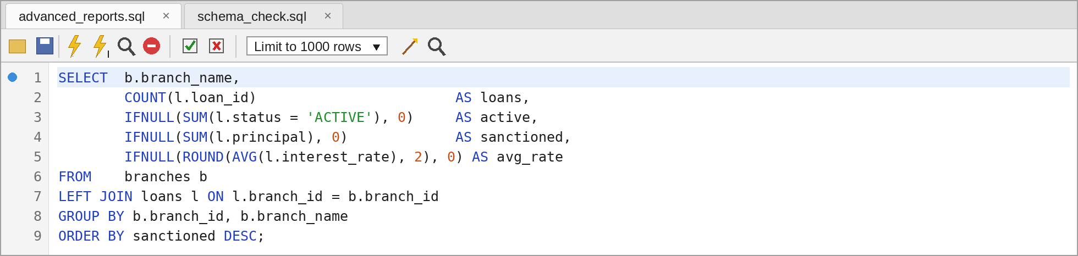
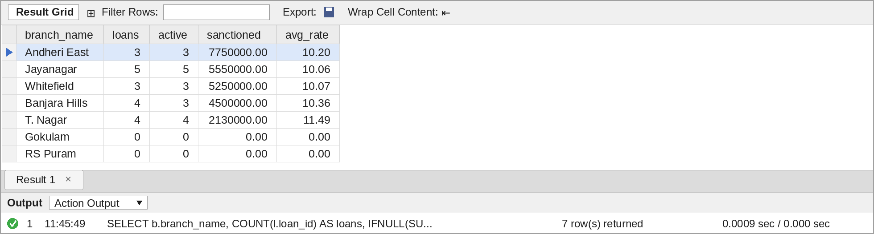
Figure 6: Q5 – Branch-wise portfolio summary – query and output in MySQL Workbench
Andheri East has the largest book at Rs. 77.5 lakh, driven by Rahul Sharma's Rs. 62 lakh home loan. T. Nagar has the smallest book but the highest average rate (11.49 %) because most of its loans are personal and gold loans.

3.6 Q6 – Loan Types with an Average Ticket Above Rs. 5 Lakh
Loans are grouped by type and HAVING filters the groups on AVG(principal). This filter cannot go in WHERE, because the average only exists after grouping.
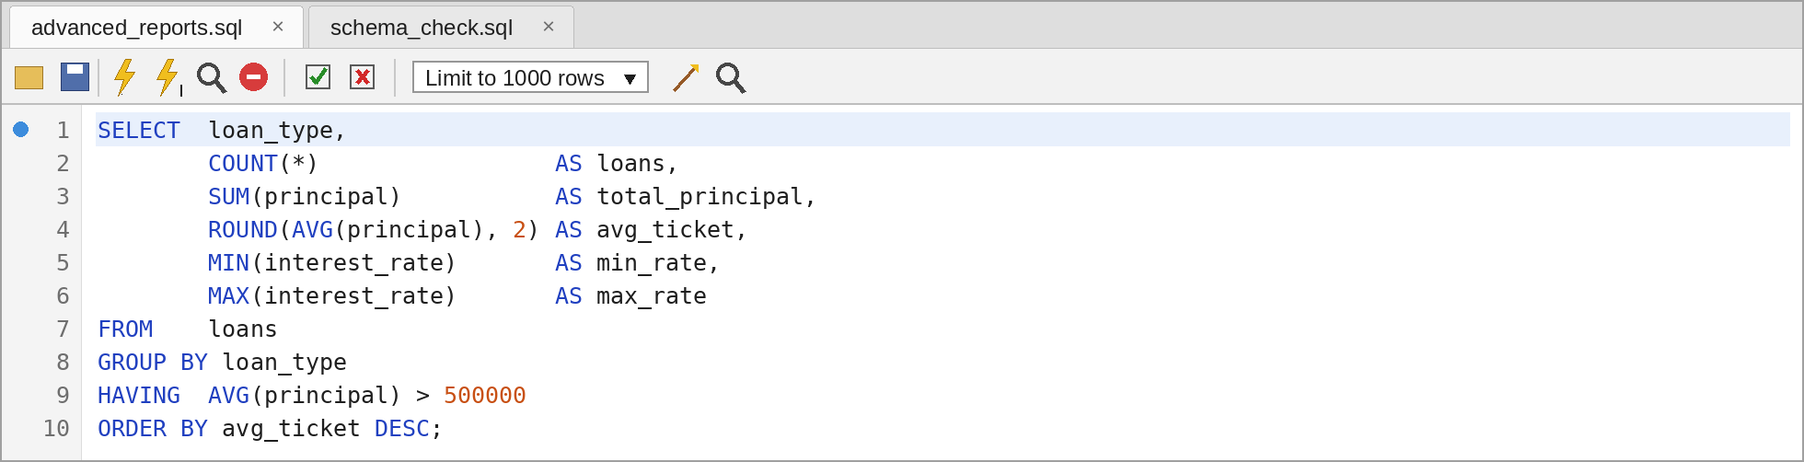
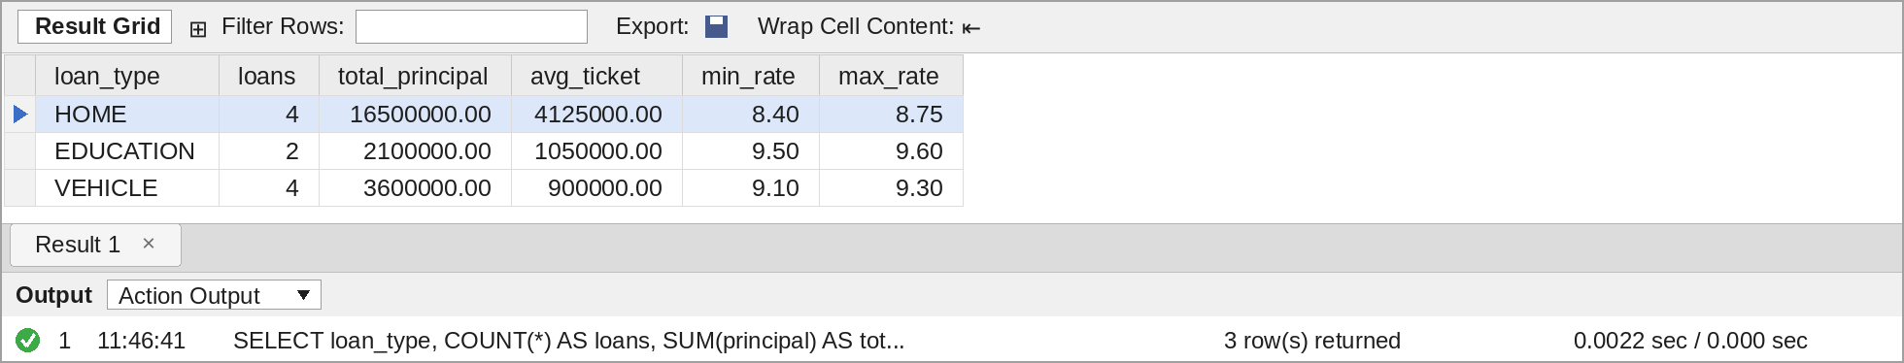
Figure 7: Q6 – Loan types with an average ticket above Rs. 5 lakh – query and output in MySQL Workbench
Home loans average Rs. 41.25 lakh, far above every other type. Personal loans (average Rs. 4 lakh) and gold loans (about Rs. 1.93 lakh) are removed by HAVING.

3.7 Q7 – High-Value Loans without a Guarantor
A LEFT JOIN to guarantors with WHERE g.guarantor_id IS NULL finds loans that have no guarantor row, and the principal filter keeps only loans of Rs. 8 lakh and above.
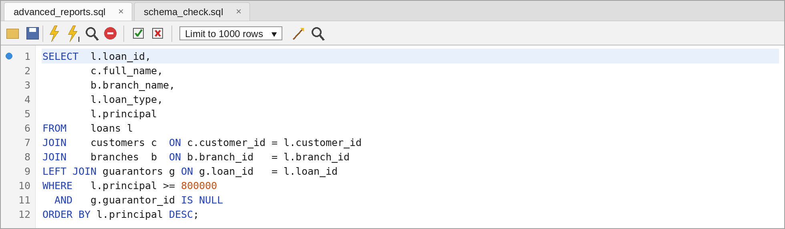
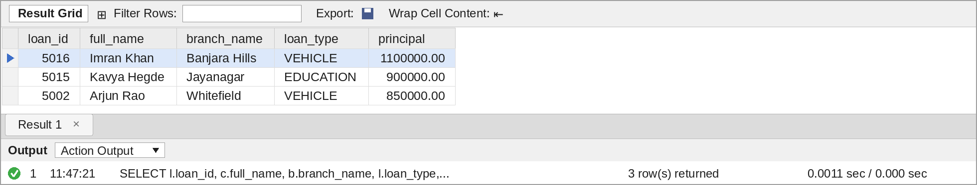
Figure 8: Q7 – High-value loans without a guarantor – query and output in MySQL Workbench
Three loans worth Rs. 28.5 lakh together have no guarantor on record. They are the first ones the credit team should review for additional security.

4. Task 2 – Exposure Above the Branch Average (Q8)
A customer's exposure is the total principal of their ACTIVE loans. The branch average is the average exposure of all customers who share the same home branch. The same question is solved twice, once with a correlated subquery and once with uncorrelated subqueries, to compare the two approaches.

4.1 Q8(a) – Correlated Subquery
The subqueries in the WHERE clause refer to c.customer_id and c.home_branch_id from the outer query, so MySQL evaluates them again for every customer row: one computes that customer's exposure and the other the average for that customer's home branch.
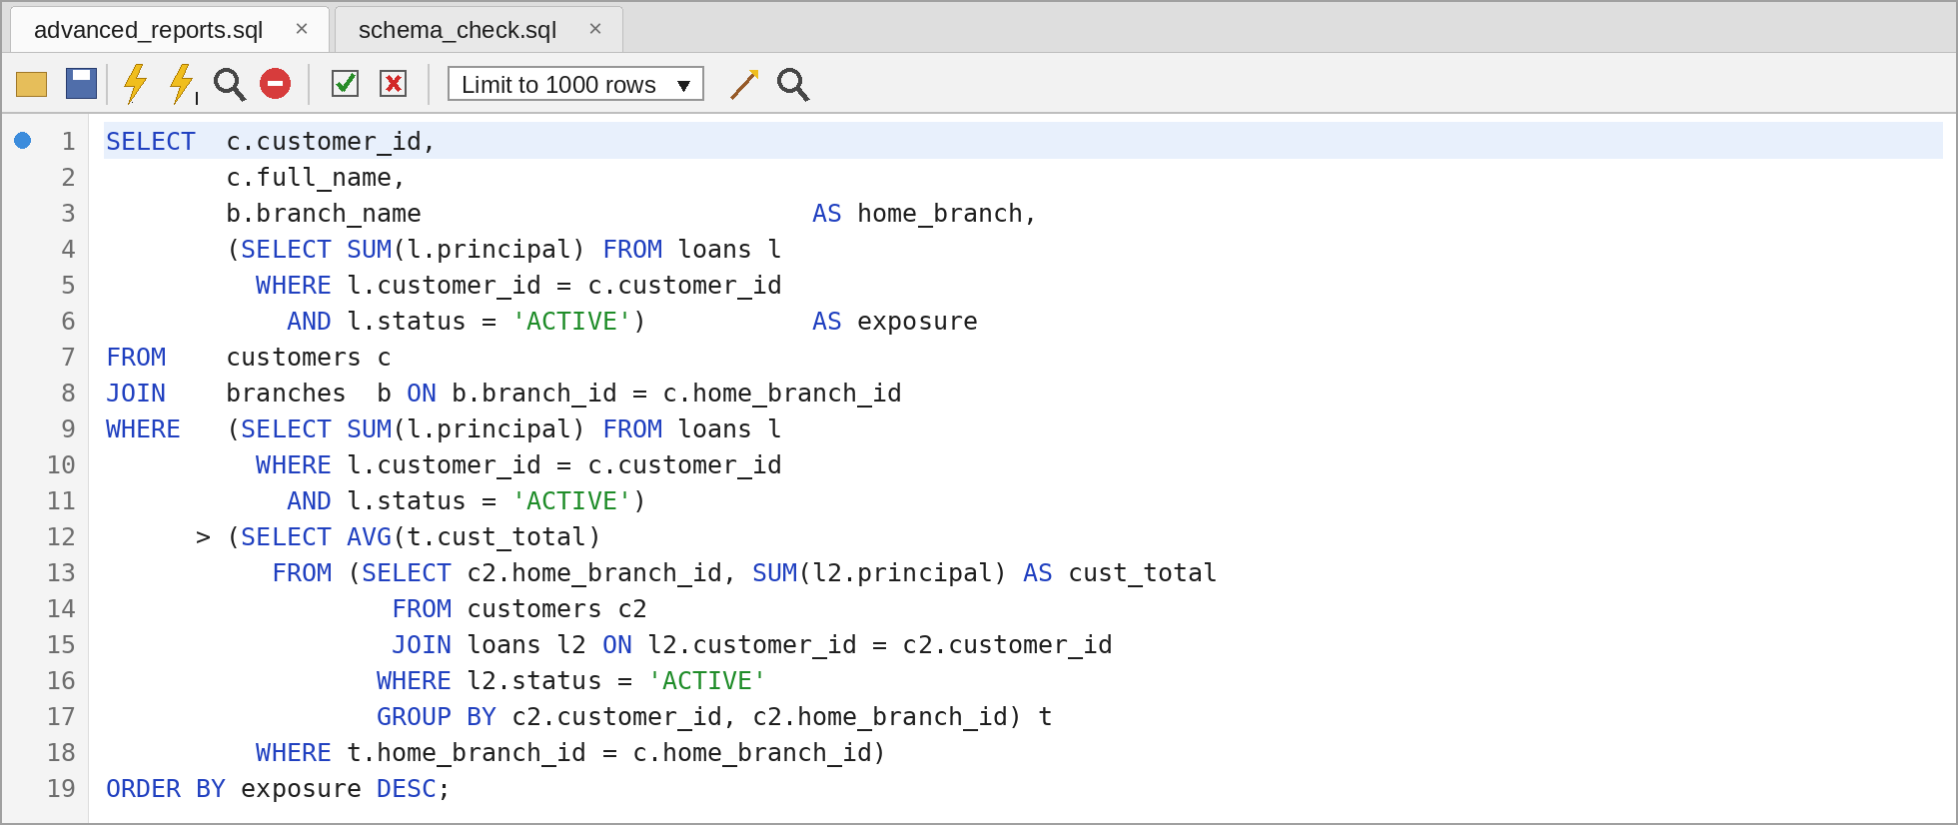
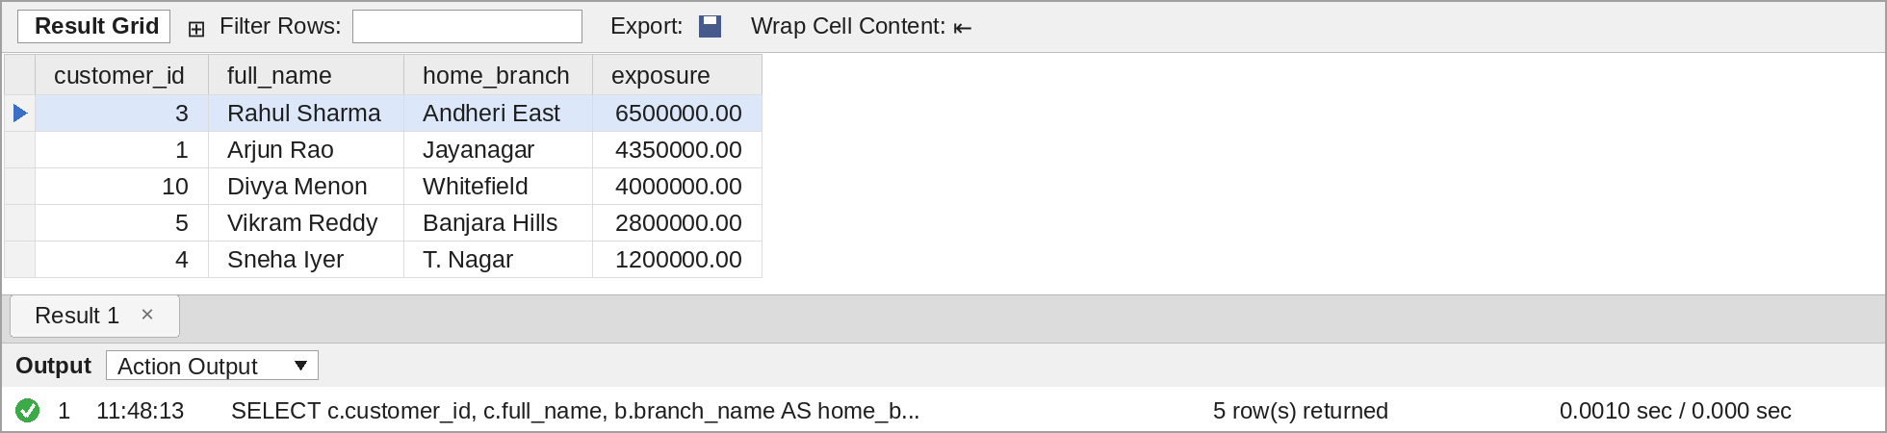
Figure 9: Q8(a) – Exposure above branch average, correlated subquery – query and output in MySQL Workbench

4.2 Q8(b) – Uncorrelated Subqueries (Derived Tables)
Here derived table e calculates every customer's exposure once and derived table ba calculates every branch average once. Neither refers to the outer query, so each runs a single time and the results are then joined on home_branch_id. The branch average is also shown as a column for checking.
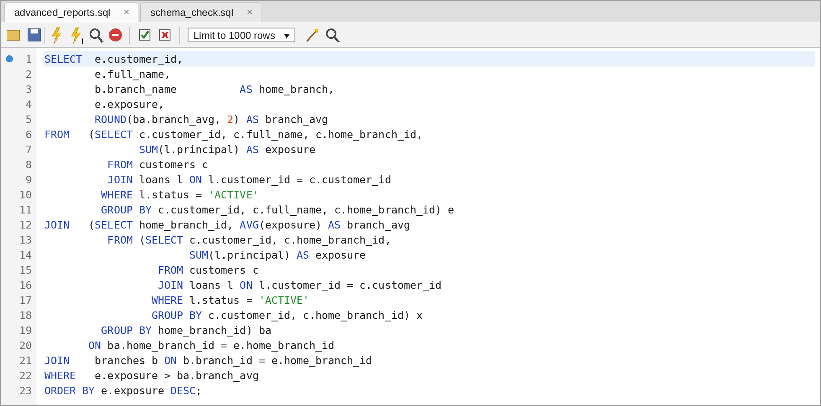
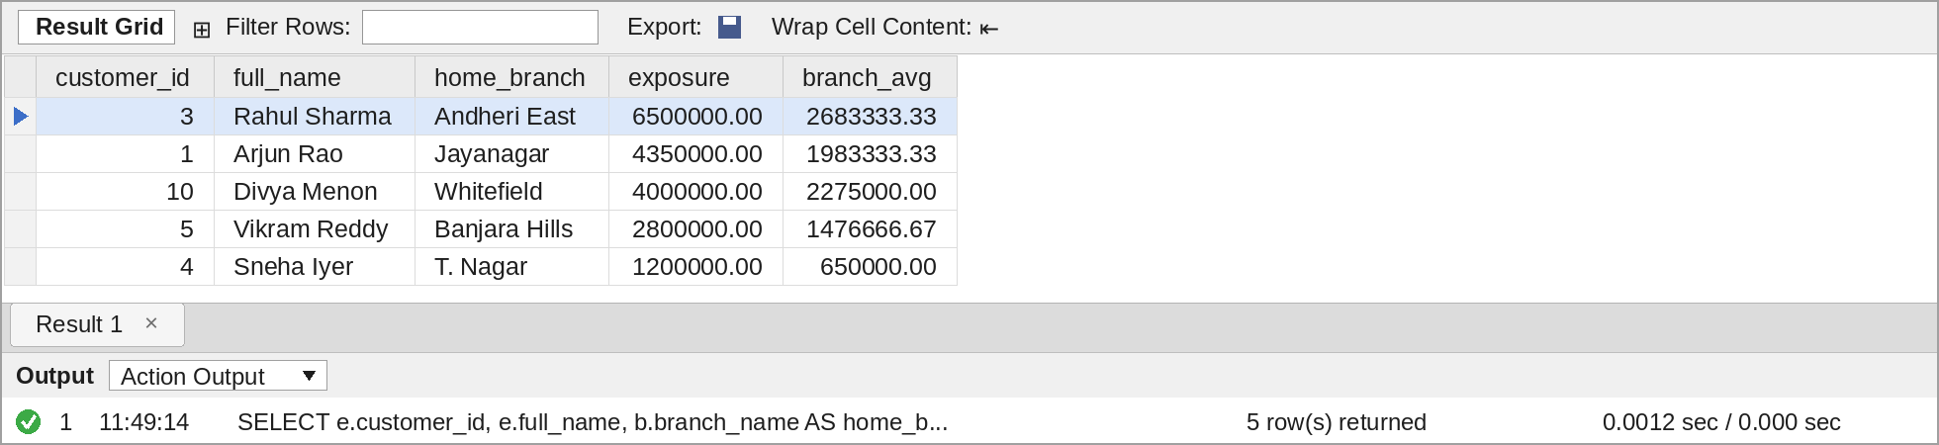
Figure 10: Q8(b) – Exposure above branch average, uncorrelated subqueries – query and output in MySQL Workbench
Both versions return the same five customers, one per branch. Rahul Sharma's Rs. 65 lakh is more than twice the Andheri East average of Rs. 26.83 lakh. Sneha Iyer appears with only Rs. 12 lakh because T. Nagar customers borrow small amounts (average Rs. 6.5 lakh).
Point | Correlated – Q8(a) | Uncorrelated – Q8(b)
Link to outer query | Uses c.customer_id and c.home_branch_id | None; runs on its own
Times executed | Once per customer row | Once per derived table
Readability | Reads like the question: "exposure > average of my branch" | Longer, but shows the average as a column
Best for | Small tables, row-by-row checks | Larger tables, reusable aggregates
Table 2: Correlated and uncorrelated subqueries compared

5. Task 3 – EXISTS and NOT EXISTS (Q9)
EXISTS checks that the customer has at least one ACTIVE loan, and NOT EXISTS checks that none of the customer's loans has a repayment on or after 15-Sep-2026 (60 days before the report date). Both subqueries stop at the first matching row, and NOT EXISTS is safe with NULLs, unlike NOT IN.
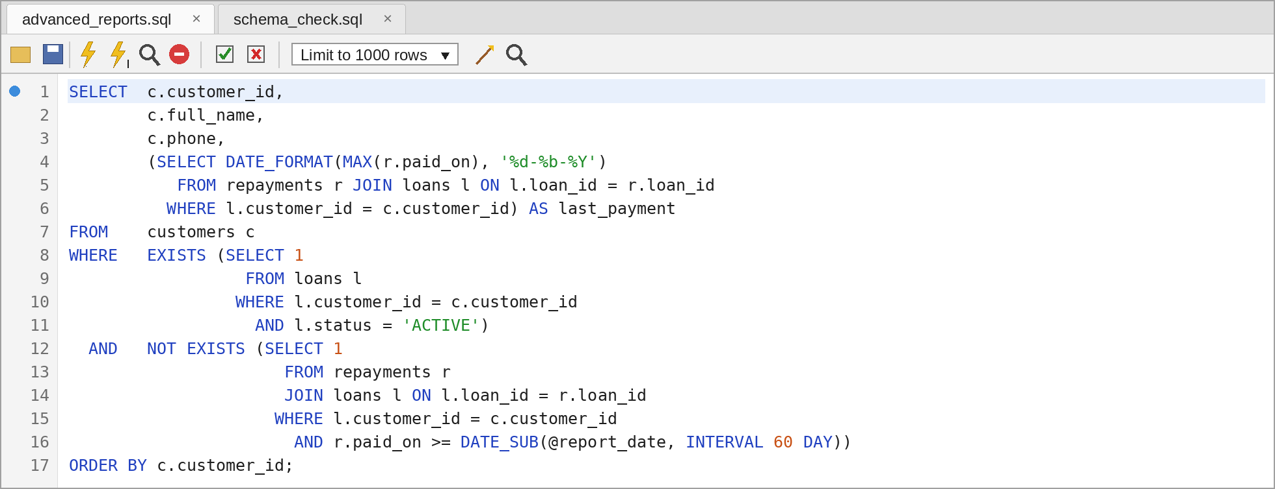
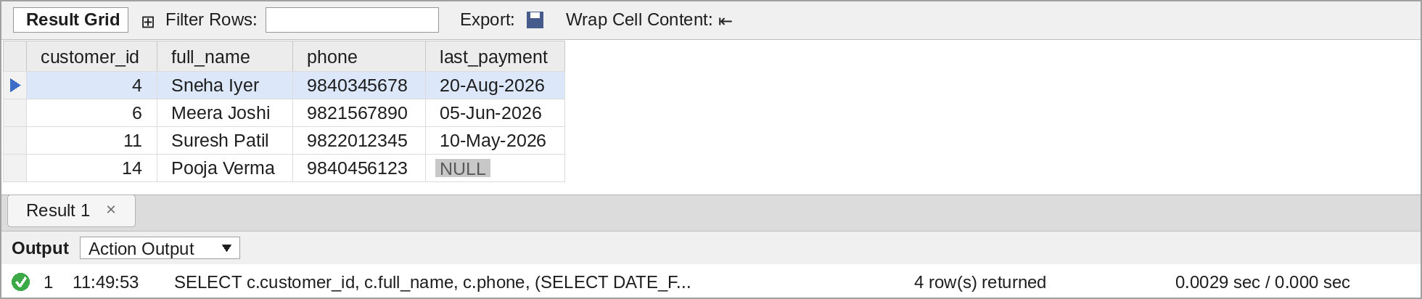
Figure 11: Q9 – Customers with a loan but no repayment in the last 60 days – query and output in MySQL Workbench
Four customers have not paid in 60 days. Pooja Verma has never paid (last_payment is NULL) because her first EMI fell due on 30-Oct-2026. Priya Nair is behind on her personal loan but is not listed, because she paid her gold loan EMI in November; Rohan Das is also excluded because of his payment on 25-Sep-2026.

6. Task 4 – Nested Subquery (Q10)
The innermost query finds the largest loan of each branch. The middle query takes the average of those maximums, and the outer query keeps branches whose own maximum is above that value using HAVING.
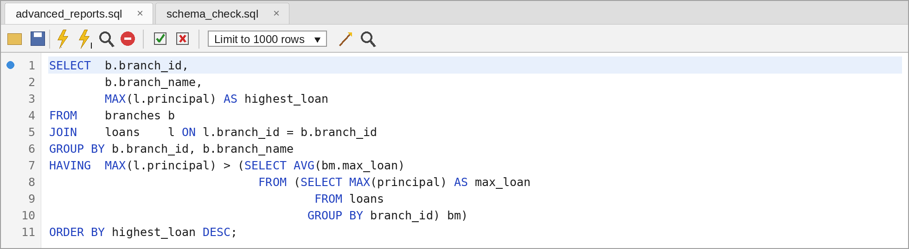
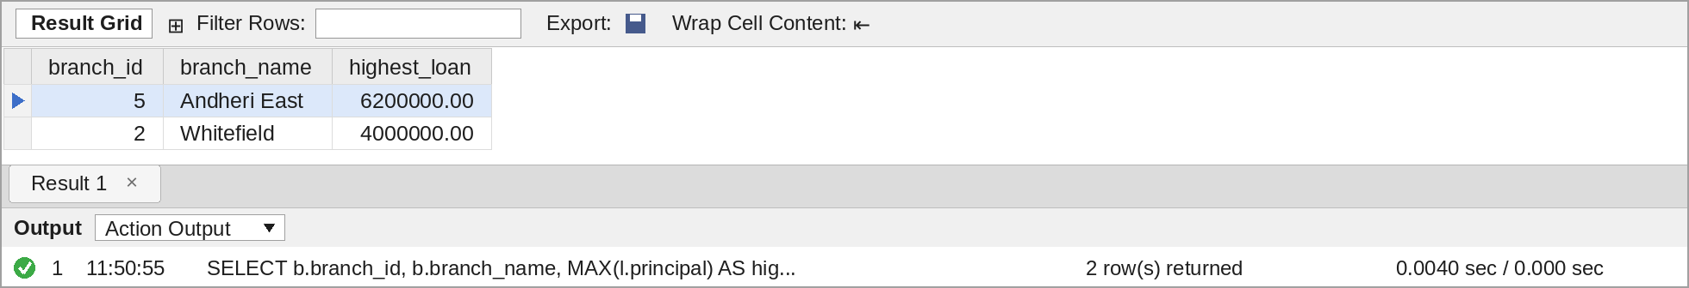
Figure 12: Q10 – Branches whose highest loan exceeds the average of branch maximums – query and output in MySQL Workbench
Running the inner part on its own shows the value used for the comparison:
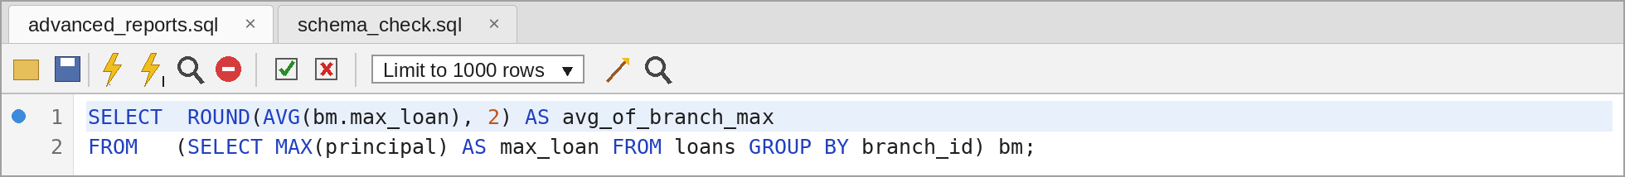
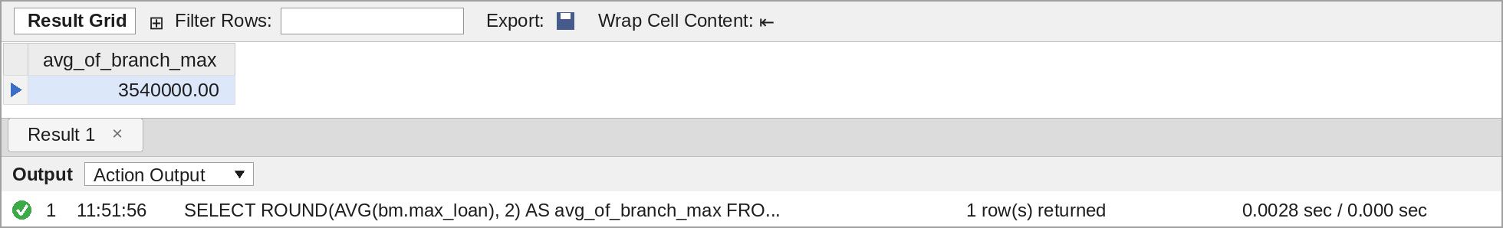
Figure 13: Average of the branch maximums used in Q10 – query and output in MySQL Workbench
The average of the five branch maximums is Rs. 35.4 lakh. Andheri East (Rs. 62 lakh) and Whitefield (Rs. 40 lakh) are above it; Jayanagar's Rs. 35 lakh home loan falls just short. Gokulam and RS Puram have no loans, so they have no maximum and do not affect the average.

7. Task 5 – Justification Note
The table below records why each join or subquery type was chosen.
Query | Join / subquery used | Reason for the choice
Q1 | INNER JOIN customers, branches; LEFT JOIN repayments; HAVING | LEFT JOIN keeps loans with no repayment (count 0); the overdue filter uses an aggregate, so it must be in HAVING.
Q2 | INNER JOIN; GROUP BY with COUNT(DISTINCT) | Only customers with loans are relevant; DISTINCT counts branches rather than loans.
Q3 | SELF JOIN of customers (g and b) through guarantors and loans; EXISTS | Guarantor and borrower are both rows of customers, so the table is joined to itself; EXISTS confirms the guarantor has own loans.
Q4 | LEFT JOIN + IS NULL (anti-join) | Keeps every branch and picks the ones with no matching loan.
Q5 | LEFT JOIN branches to loans | Empty branches must still show in a branch report with zeros.
Q6 | GROUP BY with HAVING | The condition is on AVG(principal), which is available only after grouping.
Q7 | LEFT JOIN guarantors + IS NULL | Finds loans that have no guarantor row at all.
Q8(a) | Correlated scalar subqueries | The comparison depends on each customer's own home branch.
Q8(b) | Uncorrelated derived tables joined | Exposure and branch averages are computed once and reused; scales better on large data.
Q9 | EXISTS and NOT EXISTS | Checks only for presence or absence of rows, stops at the first match and is NULL-safe.
Q10 | Nested subquery (subquery inside a subquery) in HAVING | An average of maximums needs two levels of aggregation; the result is compared with each branch's MAX.
Table 3: Reason for each join and subquery

8. Conclusion
All ten questions run without errors on MySQL 8.0 and return the results shown. The reports point the credit team to four loans more than three EMIs behind, four customers silent for 60 days, three unsecured high-value loans and five customers who carry both their own loans and guarantees for others. The full script, including schema and sample data, is in advanced_reports.sql.

