Set 3 – Hospital Appointment Booking Application
Name : AKASH S
Date : 02/11/2026

1. Problem Overview
A hospital group wants a mobile application through which patients can book, reschedule and cancel doctor appointments, and which reminds them before every visit. Today most bookings come in by phone or at the front desk, so patients wait in queues, the same slot is sometimes promised to two people, and a noticeable share of patients simply forget their appointment.
This document plans the product the Agile way. It starts with a vision and the people involved, breaks the product into epics and user stories, checks those stories against INVEST, writes Given / When / Then acceptance criteria for booking and cancellation, prioritises the backlog using business value against effort, estimates with Planning Poker, and finally publishes the backlog in JIRA with an agreed Definition of Ready and Definition of Done. Each idea is shown as a diagram rather than a table so that the relationships are easy to follow.
Deliverables: prioritised backlog (Section 6), JIRA board (Section 7) and DoR / DoD checklist (Section 8).

2. Task 1 – Vision Statement and Stakeholders

2.1 Vision Statement
For patients of the hospital group who need to see a doctor without long phone queues or missed visits, the Hospital Appointment Booking App is a mobile application that lets them find a doctor and book, reschedule or cancel an appointment in under a minute, and reminds them before every visit. Unlike phone and walk-in booking, our product shows real-time doctor availability, prevents double-booking and reduces no-shows, giving doctors a fuller and better-planned day.
In one line: the right doctor, at the right time, in three taps – and never a missed appointment.

2.2 Stakeholders and Their Scrum Roles
Every person or group with an interest in the app was listed and then placed under one of the four roles the task asks for. Only one person can be the Product Owner, so the hospital's Digital Services Manager takes that role, since they own the product vision and decide the order of the backlog. The people who actually build and test the app – mobile developers, backend developers, the QA engineer and the UI/UX designer – are all Developers in Scrum. Everyone who uses the app or pays for it is a Customer.
- Product Owner – Hospital Digital Services Manager: owns the vision, orders the backlog, accepts finished stories.
- Scrum Master – Agile Coach / Delivery Lead: runs the ceremonies, removes blockers and protects the team.
- Developers – Android/iOS developers, backend/API developers, QA engineer, UI/UX designer: design, build and test each increment.
- Customers – patients, doctors, front-desk staff, hospital management (sponsor) and the compliance officer: use the app, fund it, or set rules such as patient-data privacy that it must follow.
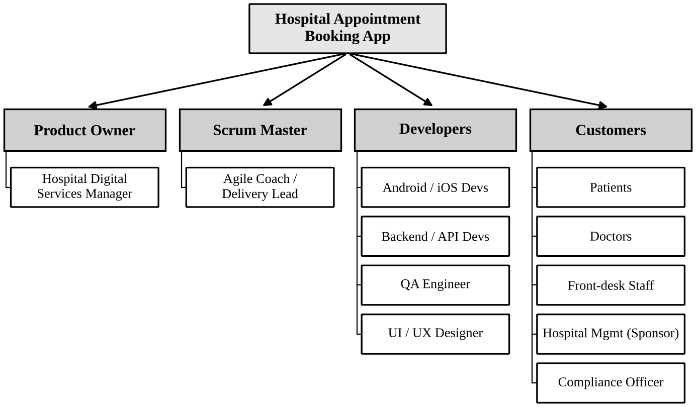
Figure 1: Stakeholders mapped to Product Owner, Scrum Master, Developer and Customer

3. Task 2 – Epics and User Stories

3.1 Approach
The four areas named in the task became four epics. Each epic was then broken into user stories written in the standard form "As a <user>, I want <goal>, so that <benefit>". Fourteen stories were written, which is more than the twelve required, so that every epic has enough detail to be planned on its own.
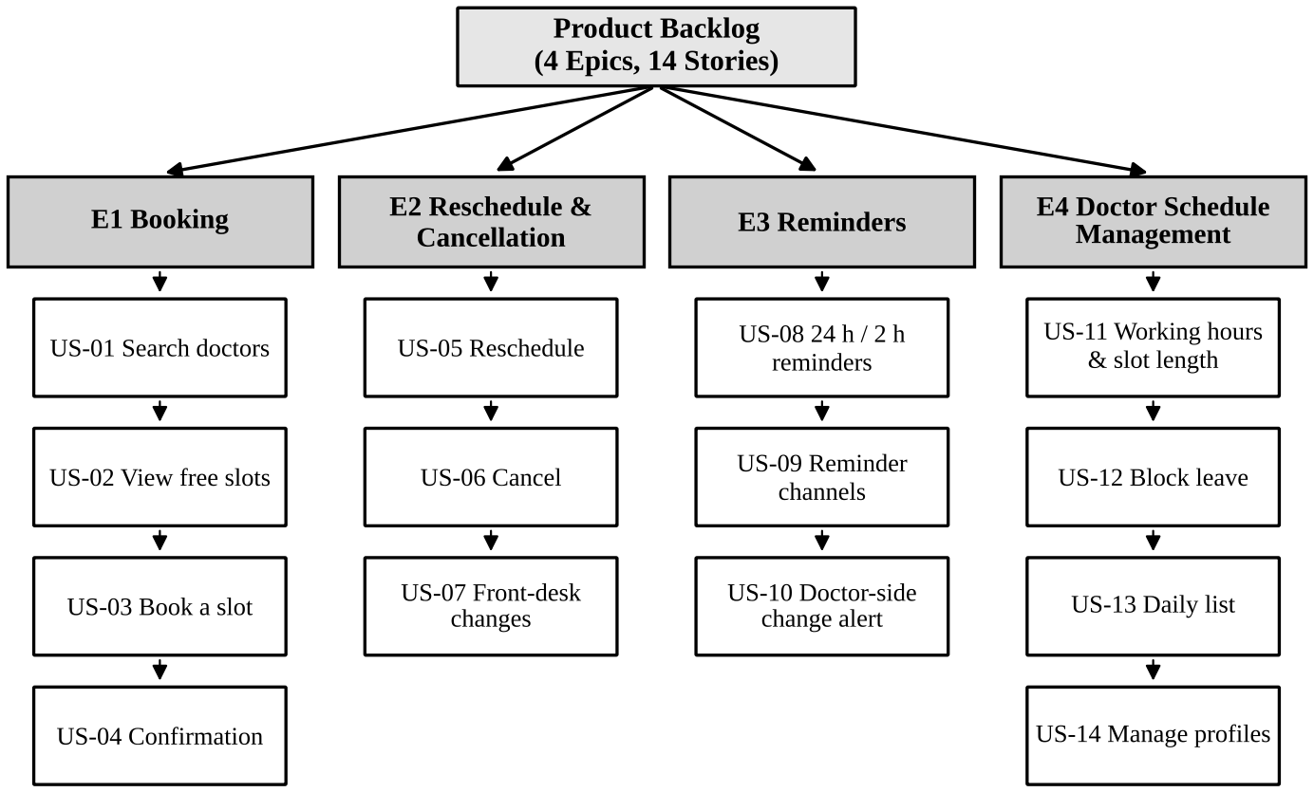
Figure 2: Epic breakdown of the product backlog

3.2 User Stories
E1 – Booking
US-01: As a patient, I want to search for doctors by specialty, hospital branch and date, so that I can find a suitable doctor quickly.
US-02: As a patient, I want to see a doctor's available time slots for a chosen date, so that I can pick a time that suits me.
US-03: As a patient, I want to book an available slot with a doctor, so that my appointment is reserved.
US-04: As a patient, I want an in-app and SMS confirmation with a booking ID after booking, so that I have proof of my appointment.
E2 – Rescheduling and Cancellation
US-05: As a patient, I want to move my appointment to another available slot of the same doctor, so that I can still attend when my plans change.
US-06: As a patient, I want to cancel an upcoming appointment, so that the slot is freed when I cannot attend.
US-07: As a front-desk staff member, I want to cancel or reschedule an appointment for a patient who calls in, so that patients without the app are also served.
E3 – Reminders
US-08: As a patient, I want a reminder 24 hours and 2 hours before my appointment, so that I do not miss it.
US-09: As a patient, I want to choose my reminder channels (push, SMS, e-mail), so that I get reminders the way I prefer.
US-10: As a patient, I want to be told immediately if the doctor cancels or changes my appointment, so that I can rebook in time.
E4 – Doctor Schedule Management
US-11: As a doctor, I want to set my weekly working hours and slot length, so that patients can only book times when I am available.
US-12: As a doctor, I want to block dates or hours for leave, so that no new bookings are taken while I am away.
US-13: As a doctor, I want to view my appointment list for the day, so that I can prepare for my consultations.
US-14: As a hospital administrator, I want to add, edit and deactivate doctor profiles, so that the app always shows the correct doctors.

4. Task 3 – INVEST Review

4.1 Approach
Each story was checked against the six INVEST qualities. A good story should be Independent (can be built and released without waiting for another), Negotiable (describes a need, not a fixed design), Valuable (gives something useful to a user), Estimable (the team can size it), Small (fits comfortably inside one sprint) and Testable (has a clear pass or fail).
In the first draft, ten stories passed and four did not. Two of them bundled several features together, so they were neither independent nor small and were split. The other two used vague words such as "fast and easy" or "in good time", which cannot be tested, so they were rewritten with measurable conditions. The final wording of all fourteen stories is the one given in Section 3.2.
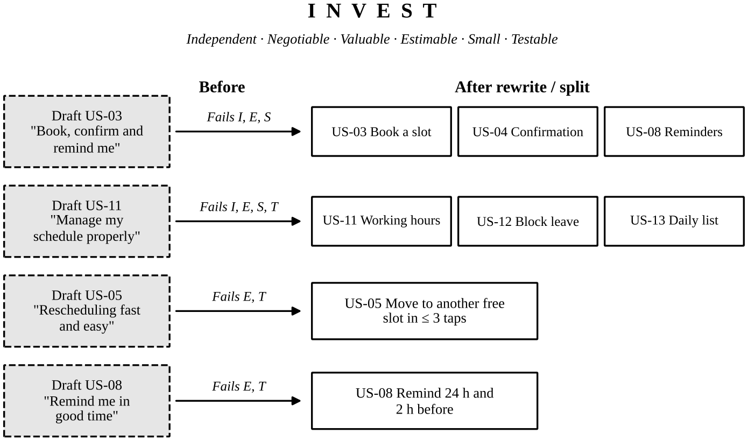
Figure 3: Stories that failed INVEST and how they were split or rewritten

4.2 Rewritten Stories
- US-03 (draft): "As a patient, I want to book an appointment and get a confirmation and reminders." – Problem: three features in one; not independent, hard to estimate, too large. – Fix: split into US-03 (book a slot), US-04 (confirmation) and US-08 (reminders).
- US-11 (draft): "As a doctor, I want to manage my schedule properly." – Problem: covers working hours, leave and the daily list, and "properly" cannot be tested. – Fix: split into US-11, US-12 and US-13.
- US-05 (draft): "As a patient, I want rescheduling to be fast and easy." – Problem: no measurable outcome and no stated benefit. – Fix: move to another free slot of the same doctor in at most three taps, with the old slot released.
- US-08 (draft): "As a patient, I want the app to remind me in good time." – Problem: "in good time" is undefined. – Fix: remind 24 hours and 2 hours before the appointment.

5. Task 4 – Acceptance Criteria (Given / When / Then)

5.1 Booking – US-03 Book an Appointment Slot
Figure 4 shows every path a booking can take. The most important branch is the "slot already taken" case: when two patients press Confirm on the same slot at almost the same moment, only the first one may succeed. The second must get a clear message and a fresh list of free slots, and no duplicate appointment may ever be stored.
1. Successful booking: Given a logged-in patient is viewing Dr. Rao's free 10:00 slot on 10 Dec; When the patient taps Book and confirms; Then the appointment is saved as "Booked", a unique booking ID is created and the 10:00 slot disappears for every other user.
2. Slot already taken: Given two patients are viewing the same free 10:00 slot and Patient A confirms first; When Patient B taps Confirm for the same slot; Then Patient B sees "Sorry, this slot has just been taken. Please choose another time", no duplicate appointment is created and the refreshed list of free slots is shown.
3. Slot in the past: Given the time is now 10:05 on 10 Dec; When the patient looks for the 10:00 slot on 10 Dec; Then that slot is not offered and cannot be booked.
4. Duplicate booking with the same doctor: Given the patient already has an appointment with Dr. Rao on 10 Dec; When the patient tries to book a second slot with Dr. Rao that day; Then the app warns "You already have an appointment with this doctor today" and suggests rescheduling instead.
5. Not logged in: Given the user is not logged in; When the user taps Book on any slot; Then the user is sent to the login screen and returned to the same slot afterwards.
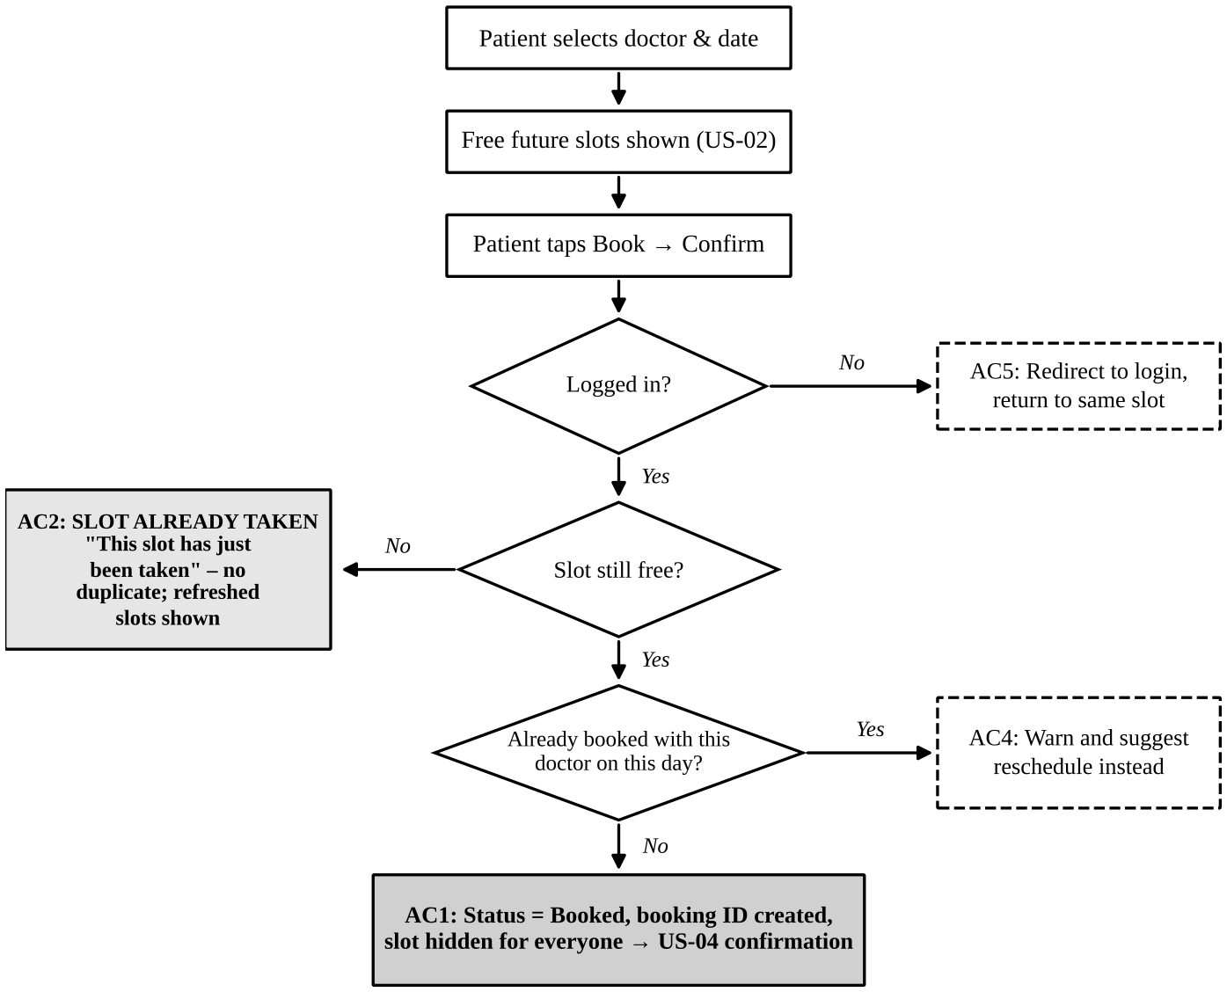
Figure 4: Booking decision flow with each acceptance criterion

5.2 Viewing Slots – US-02
1. Free slots listed: Given Dr. Rao works 09:00–13:00 with 15-minute slots on 10 Dec and 09:30 is already booked; When the patient selects Dr. Rao and 10 Dec; Then every slot from 09:00 to 12:45 is shown except 09:30, which cannot be selected.
2. Doctor on leave: Given Dr. Rao has blocked 11 Dec as leave; When the patient selects 11 Dec; Then the message "No slots available on this date" is shown with the next available date.

5.3 Cancellation – US-06 Cancel Appointment
Cancellation is allowed online up to two hours before the appointment. After that, the patient is asked to call the front desk so that the hospital has a chance to fill the slot. A successful cancellation must release the slot straight away so that another patient can take it.
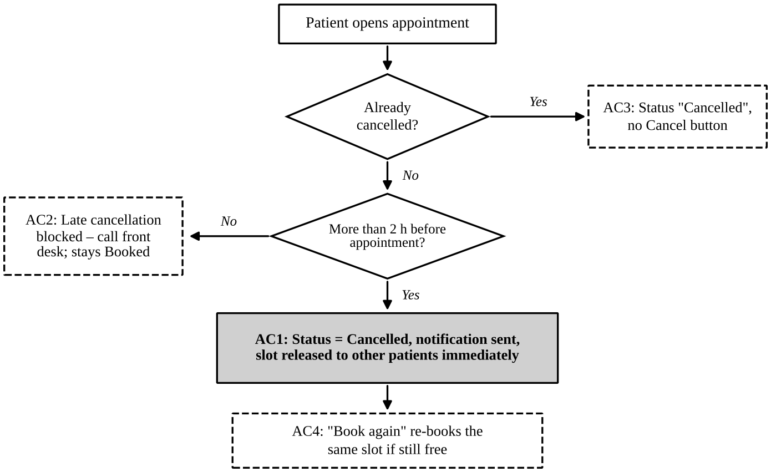
Figure 5: Cancellation decision flow with each acceptance criterion
1. Successful cancellation: Given the patient has a booked appointment more than 2 hours away; When the patient taps Cancel and confirms; Then the status changes to "Cancelled", a cancellation notice is sent and the slot becomes available to other patients immediately.
2. Too late to cancel online: Given the appointment starts in less than 2 hours; When the patient tries to cancel; Then the app shows "Appointments can be cancelled online up to 2 hours before. Please call the front desk" and the appointment stays booked.
3. Already cancelled: Given the appointment has already been cancelled; When the patient opens it; Then the Cancel button is hidden and the status "Cancelled" is shown.
4. Cancelled by mistake: Given the patient has just cancelled and the slot is still free; When the patient taps Book again; Then the same slot is booked again as a new appointment.

6. Task 5 – Prioritisation, Planning Poker and Story Points

6.1 Business Value versus Effort
The Product Owner gave each story a business-value score from 1 to 10, based on how much it helps patients and the hospital. Effort is the story-point estimate agreed by the team in Planning Poker. Plotting the two against each other places every story in one of four quadrants, which shows at a glance what to do first (Figure 6).
- Quick wins (high value, low effort): US-02, US-04, US-06, US-08, US-10 – done first.
- Major projects (high value, high effort): US-01, US-03, US-05, US-11 – planned early because the product depends on them.
- Fill-ins (low value, low effort): US-07, US-09, US-12, US-13 – taken when capacity allows.
- Thankless (low value, high effort): US-14 – deferred to the last sprint.
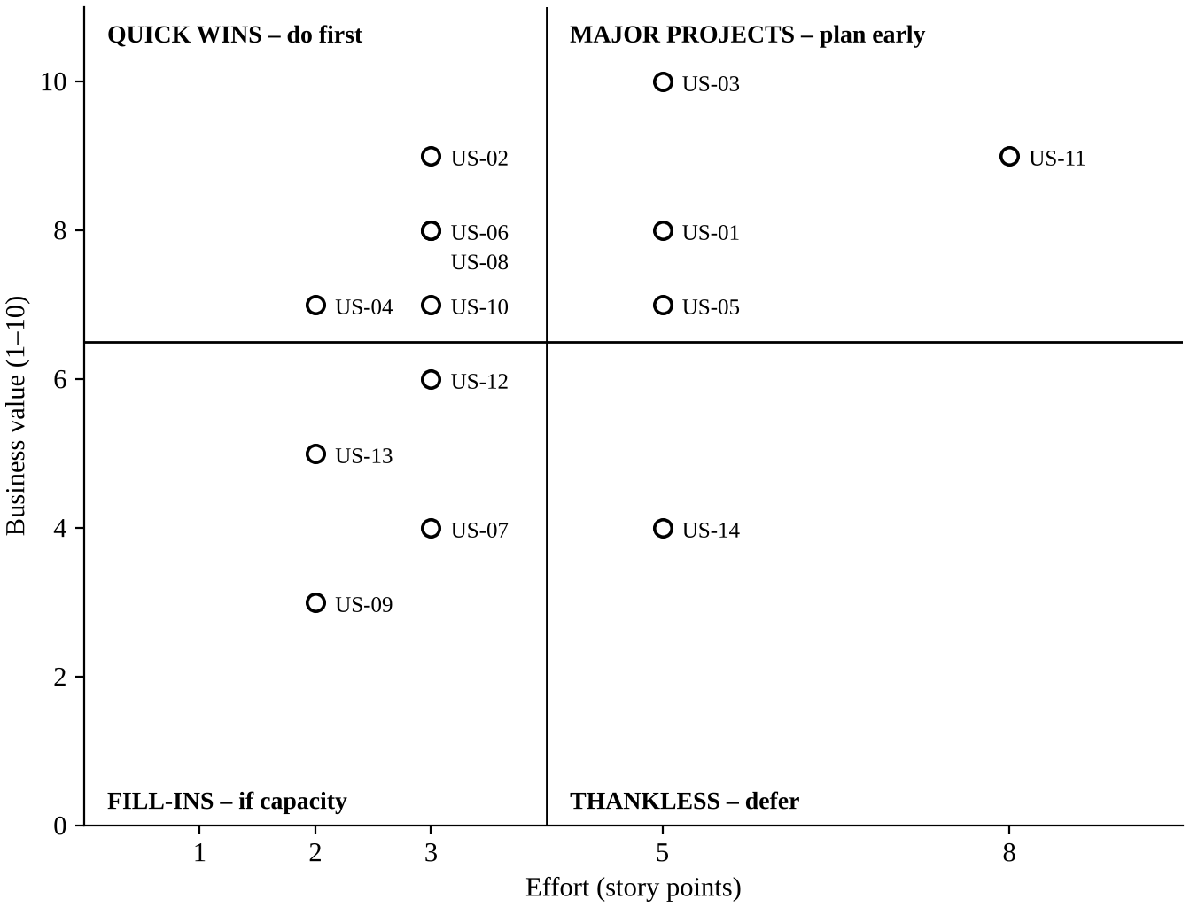
Figure 6: Business value against effort for all fourteen stories
To turn the quadrants into a strict order, each story was given a priority score of value ÷ effort, so a higher score means more value for each point of work. One adjustment was made for dependencies: US-11 (doctor working hours) has a low score but goes first, because no slot can be shown or booked until doctors have set their schedules.

6.2 Prioritised Product Backlog
With a team velocity of about 20 story points per two-week sprint, the 52-point backlog fits into three sprints. Sprint 1 (18 SP) delivers the smallest product a patient can actually use: doctor schedules, free slots, booking and confirmation. Sprint 2 (19 SP) adds cancellation, reminders and the doctor's tools. Sprint 3 (15 SP) completes rescheduling, reminder preferences and admin functions. With a team velocity of about 20 story points per two-week sprint, the 52-point backlog fits into three sprints. Sprint 1 (18 SP) delivers the smallest product a patient can actually use: doctor schedules, free slots, booking and confirmation. Sprint 2 (19 SP) adds cancellation, reminders and the doctor's tools. Sprint 3 (15 SP) completes rescheduling, reminder preferences and admin functions. Stories are taken strictly in rank order, so the highest-value work is always finished first even if a sprint runs short. Each sprint ends with a working increment that is demonstrated to the Product Owner in the Sprint Review. Feedback from that review is used to re-order the remaining backlog before the next Sprint Planning. If the measured velocity after Sprint 1 differs from the estimate, the Sprint 2 and Sprint 3 commitments are adjusted accordingly. This keeps the plan realistic and gives the hospital a usable booking app as early as possible.

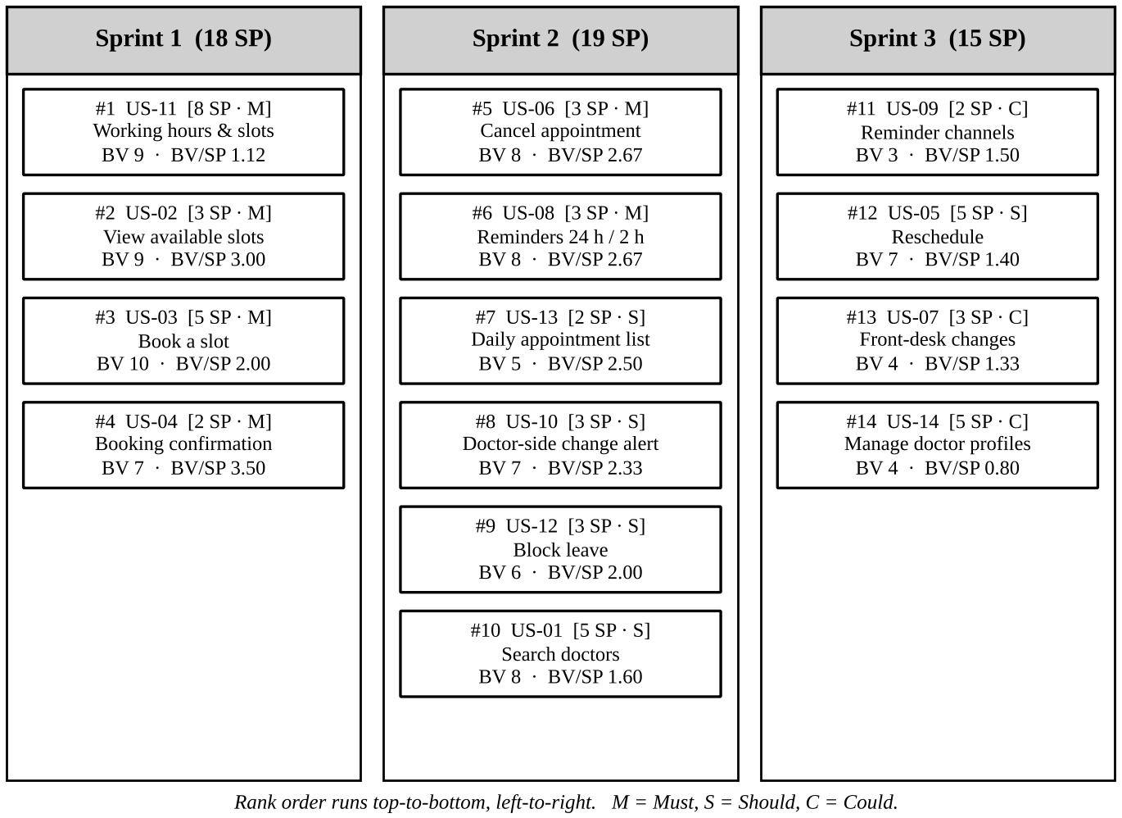
Figure 7: Prioritised product backlog arranged by sprint (rank #1 to #14)

6.3 Planning Poker Round
Four developers voted – Dev A (Android), Dev B (iOS), Dev C (backend) and Dev D (QA) – using Fibonacci cards 1, 2, 3, 5, 8 and 13. The Product Owner explained the story and answered questions but did not vote; the Scrum Master ran the session. US-04 (booking confirmation) was agreed beforehand as the 2-point reference story.
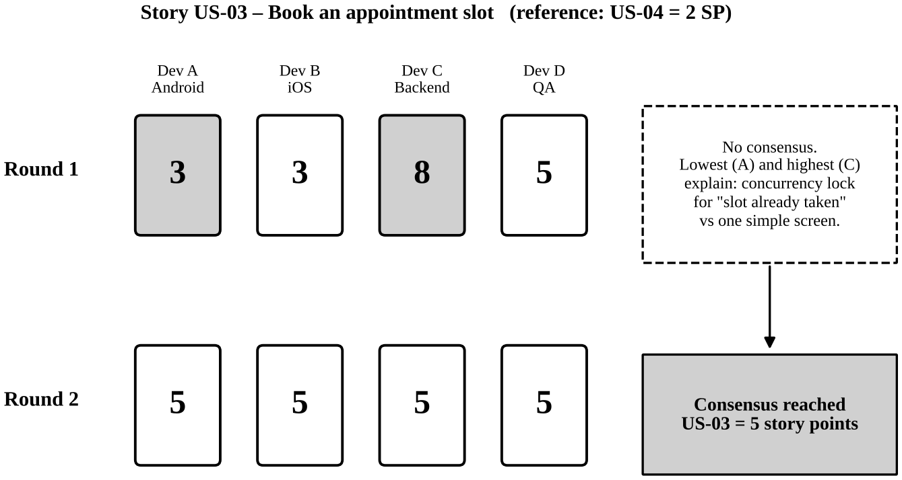
Figure 8: Planning Poker round for US-03 – Book an appointment slot
In round 1 the votes spread from 3 to 8, so the lowest and highest voters explained their thinking. Dev A saw only a single confirm screen. Dev C pointed out that two patients could confirm the same slot at the same moment, which needs a database lock or unique constraint, retry handling and the "slot already taken" message. Dev D added that this needs concurrency tests. The team agreed the locking is real work, while the SMS confirmation belongs to US-04, not to this story. In round 2 everyone showed 5, so US-03 = 5 story points.
The same method gave US-11 = 8 points (round 1: 5, 8, 13, 8), US-08 = 3 points (round 1: 2, 3, 5, 3) and US-06 = 3 points, which reached agreement in the first round.

6.4 How a Story Point Differs from an Hour
A story point measures the relative size of a story – the effort, complexity and uncertainty combined – by comparing it with a reference story. An hour measures absolute time. The difference matters because the same story takes different amounts of time for different people, while its size stays the same for the whole team.
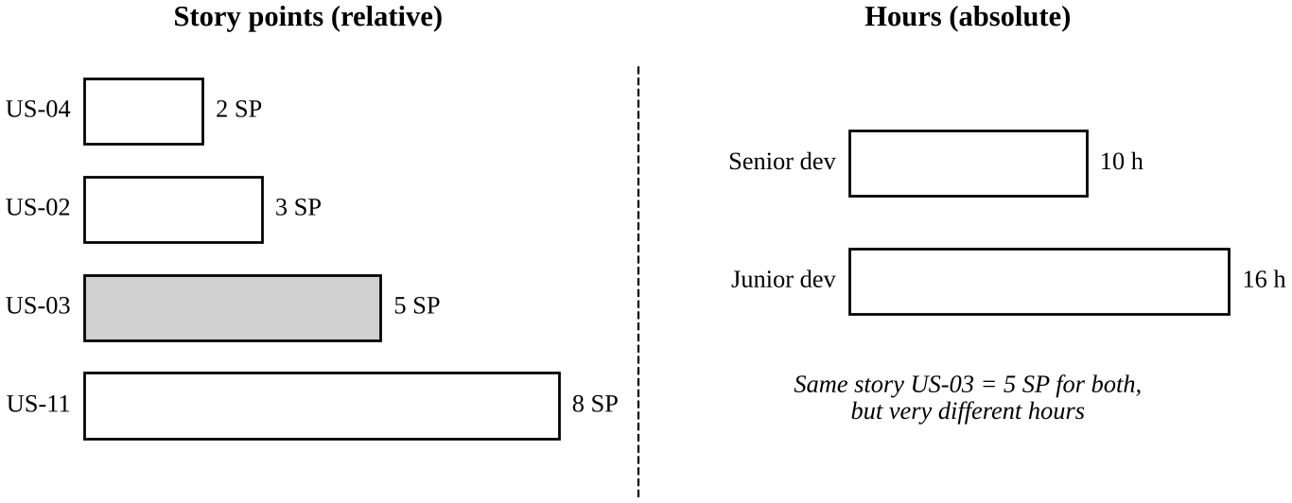
Figure 9: Story points compare stories; hours depend on who does the work
- Relative, not absolute: US-03 is 5 points because it is roughly two and a half times the 2-point confirmation story, plus the concurrency risk.
- Same for the whole team: a senior developer may finish US-03 in 10 hours and a junior developer in 16, but it is 5 points for both.
- Uncertainty built in: the widening gaps in the Fibonacci scale stop the team from pretending to know that a large story will take exactly 13.5 hours.
- Linked to time only through velocity: points become a forecast only when divided by the team's velocity, for example 52 points ÷ 20 per sprint ≈ 3 sprints.

7. Task 6 – Publishing the Backlog in JIRA

7.1 JIRA Set-up
- Project: Hospital Appointment Booking, key HAB, created from the Scrum software template.
- Epics: HAB-1 Booking, HAB-2 Rescheduling & Cancellation, HAB-3 Reminders, HAB-4 Doctor Schedule Management.
- Stories: US-01 to US-14 created as HAB-5 to HAB-18, each linked to its epic, with the user story, acceptance criteria, story points and priority filled in (Must = Highest, Should = High, Could = Medium).
- Backlog order: stories dragged into the rank order shown in Figure 7 and assigned to HAB Sprint 1, 2 and 3.
- Board columns: To Do → In Progress → In Review / QA → Done.

7.2 JIRA Board
The board below shows HAB Sprint 1 after it was started, with the four committed stories (18 SP) moving across the columns. Each card shows the issue key, story points, priority and epic, and the team updates it daily in the stand-up. When every Sprint 1 story reaches the Done column, the sprint is closed and Sprint 2 begins.
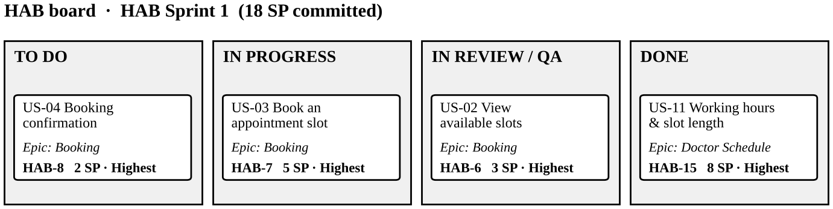
Figure 10: JIRA Scrum board for HAB Sprint 1

8. Definition of Ready and Definition of Done
The Definition of Ready is the gate a story must pass before the team accepts it into a sprint; the Definition of Done is the gate it must pass before it can be called finished. Together they stop half-understood work from entering a sprint and half-finished work from leaving it. Figure 11 shows where each gate sits.

8.1 Definition of Ready (DoR)
- The story is written as "As a … I want … so that …" with a clear user and benefit.
- It meets all six INVEST qualities.
- Acceptance criteria are written in Given / When / Then form, including negative and edge cases such as "slot already taken".
- The team has estimated it in Planning Poker and it is 8 story points or less.
- Dependencies (APIs, other stories, SMS gateway, test data) are known and either resolved or scheduled.
- UI/UX mock-ups are attached and approved for any story with a screen.
- The Product Owner has set its business value and priority, and it is linked to its epic in JIRA.
- Non-functional needs such as response time and patient-data privacy are noted.

8.2 Definition of Done (DoD)
- Code is complete and merged into the main branch after a peer code review.
- Unit tests are written and pass, covering at least 80% of the new code.
- Every acceptance criterion passes in the QA environment and is verified by the tester.
- Integration and regression tests pass with no open Critical or High defects.
- The feature works on the supported Android and iOS versions and passes basic accessibility checks.
- Patient data is encrypted and no personal data appears in logs.
- API documentation and release notes are updated.
- The Product Owner has reviewed and accepted the story in the Sprint Review.
- The JIRA issue is moved to Done with its story points recorded for velocity.
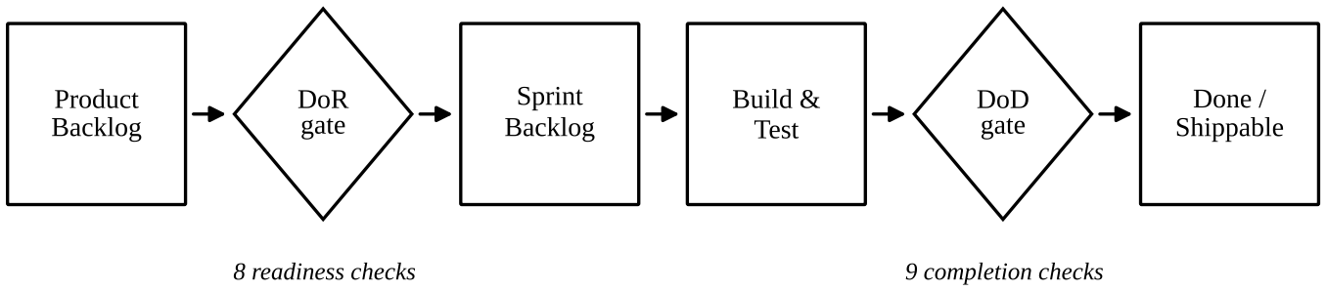
Figure 11: Where DoR and DoD sit in the flow of a story

9. Assumptions and Risks
A few assumptions were made while planning, and each carries a risk that the team will watch during the sprints.
- Team velocity of about 20 SP per sprint: this is an estimate for a new team; if the real velocity after Sprint 1 is lower, Sprint 3 stories such as US-14 move to a fourth sprint.
- SMS gateway availability: confirmations and reminders (US-04, US-08) depend on a third-party SMS provider; push notifications act as the fallback if SMS fails.
- Concurrent bookings: the "slot already taken" rule relies on a database lock or unique constraint; load testing in Sprint 1 confirms that no slot can be double-booked.
- Doctor adoption: booking only works if doctors keep their schedules up to date, which is why US-11 is ranked first and front-desk staff can still update slots for them.
- Patient-data privacy: all appointment data is health-related, so the compliance officer reviews each release against the hospital's data-protection rules.

10. Conclusion
The Hospital Appointment Booking backlog holds four epics and fourteen INVEST-compliant user stories worth 52 story points in total. The stories were ordered by value for effort, adjusted so that doctor schedules come first, and spread across three two-week sprints. Clear Given / When / Then criteria – above all the "slot already taken" case – together with an agreed Definition of Ready and Definition of Done, make sure each sprint delivers something that can be tested and released.

