Set 1 – Retail Sales Reporting
Name : AKASH S
Date : 12/11/2026

1. Problem Overview
The retail sales team needs daily and monthly reports built from the orders, order_items, customers and products tables. Instead of exporting the raw rows and working them out in a spreadsheet, the reports are written as SQL queries that return customer-friendly columns: names in capitals, readable dates, rounded rupee amounts and percentages.
This document writes the eight required report queries, uses string, date and mathematical functions to format their output, demonstrates how NULL values affect COUNT, SUM and AVG, explains the difference between WHERE and HAVING with one of the queries, and documents the expected result set of every query. All queries were run against the sample data described in Section 2, and each figure shows the query in the SQL editor with its exact result grid.
Deliverables: reports.sql (the eight queries plus the NULL and WHERE/HAVING demonstrations) and this output document with the expected results.

2. Database and Sample Data
The database retail_sales uses five InnoDB tables. A small payments table is added beside the four tables named in the scenario, because the "orders without payment" report needs a table to LEFT JOIN against.
Table | Key columns | Rows
customers | customer_id (PK), first_name, last_name, email, city, signup_date | 12
products | product_id (PK), product_name, category, unit_price | 10
orders | order_id (PK), customer_id (FK), order_date, status, discount_amount (nullable) | 22
order_items | (order_id, product_id) (PK), quantity, unit_price at time of sale | 35
payments | payment_id (PK), order_id (FK, UNIQUE), payment_date, method, amount | 19
Table 1: Tables of the retail_sales database
The sample data covers August to November 2026 and was planned so that every report has something meaningful to show:
- Cancelled order: order 1008 is CANCELLED and is excluded from every sales figure, which is what makes the WHERE filter in Q3 change the result.
- Unpaid orders: orders 1008, 1021 and 1022 have no payment row, for the LEFT JOIN in Q5.
- Inactive customers: customers 11 and 12 have signed up but never ordered, for Q6.
- NULL discounts: discount_amount is NULL when no coupon was used (14 orders) and 0.00 for order 1012, where a coupon gave no saving, for Task 3.
- Festive sale: three large orders on 20 October 2026 give a clear best sales day for Q8.
Revenue in every query is SUM(quantity × unit_price) from order_items, and all queries use a fixed report date of 12-Nov-2026 set with SET @report_date so that the DATEDIFF columns are reproducible.

3. Task 1 – The Eight Report Queries (reports.sql)

3.1 Q1 – Top-5 Products by Revenue
Revenue for each product is the sum of quantity × unit price over all order lines. The cancelled order is filtered out with WHERE, the products are grouped, sorted by revenue from highest to lowest and LIMIT 5 keeps the top five. UPPER prints the product name in capitals and CONCAT with FORMAT turns the figure into a readable rupee amount.
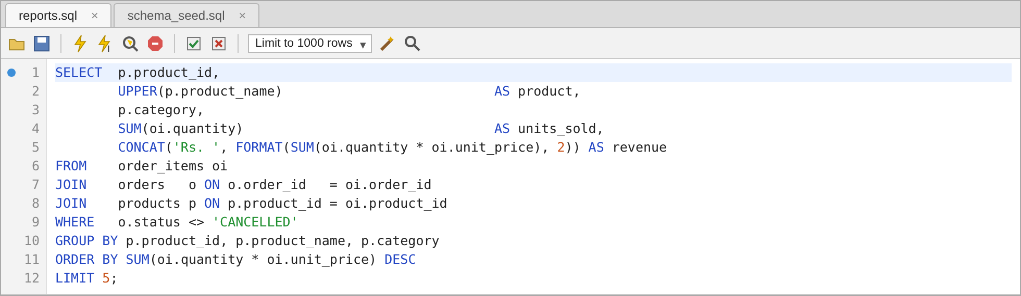
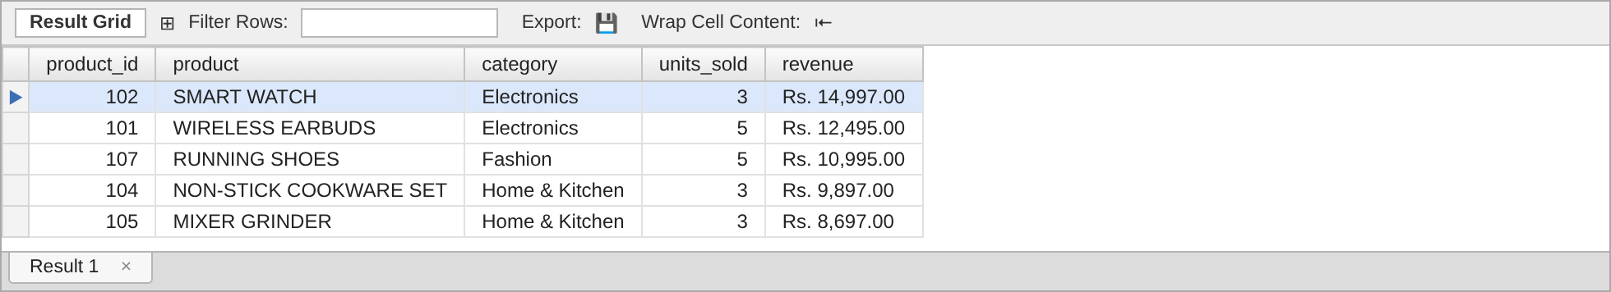
Figure 1: Q1 – Top-5 Products by Revenue – query and expected result
The Smart Watch leads with Rs. 14,997 from only three units, ahead of the Wireless Earbuds, which sold five units at a lower price. Electronics takes the first two places, which matches the category share in Q7.

3.2 Q2 – Month-wise Sales
DATE_FORMAT(order_date, '%Y-%m') gives a sortable month key and DATE_FORMAT(order_date, '%M %Y') gives the label shown to the sales team. COUNT(DISTINCT order_id) counts orders rather than order lines, and ROUND keeps the revenue to two decimals.
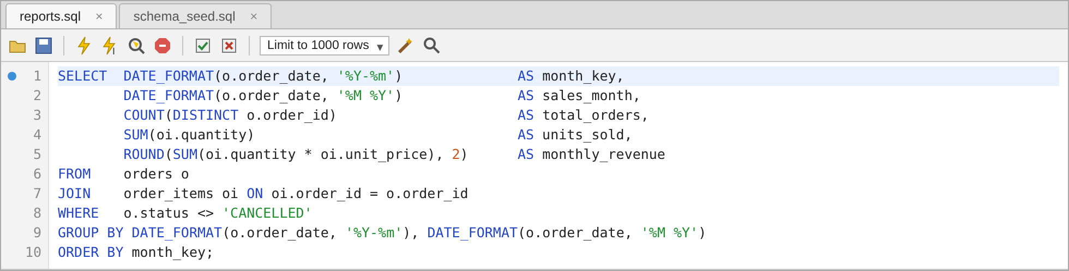
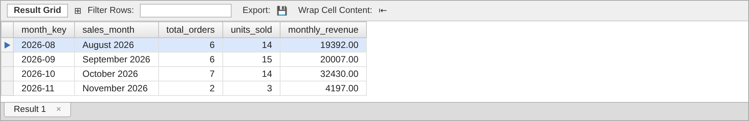
Figure 2: Q2 – Month-wise Sales – query and expected result
October 2026 is the strongest month at Rs. 32,430 because of the three festive-sale orders on 20 October. November holds only the first two orders of the month. The four months add up to Rs. 76,026, the same total used for the category shares in Q7.

3.3 Q3 – Customers with More Than Three Orders (HAVING)
Orders are joined to customers, cancelled orders are removed with WHERE, and the rows are grouped per customer. HAVING COUNT(order_id) > 3 then keeps only the groups with four or more orders. CONCAT joins the first and last names, UPPER prints the city in capitals and DATE_FORMAT shows the last order date as 02-Nov-2026.
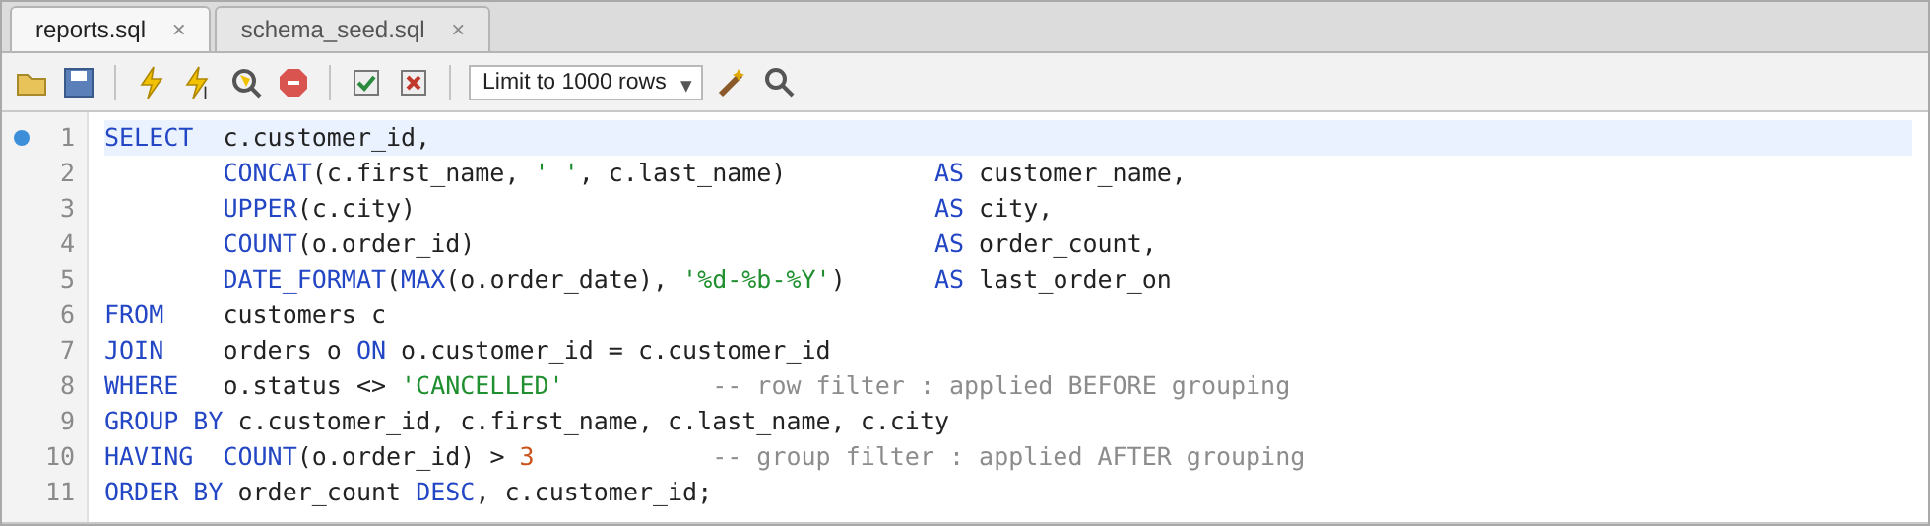
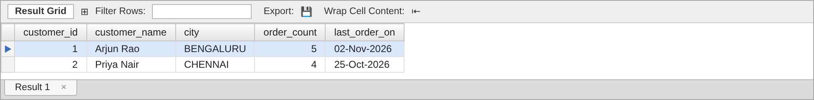
Figure 3: Q3 – Customers with More Than Three Orders (HAVING) – query and expected result
Only Arjun Rao (5 orders) and Priya Nair (4 orders) qualify. Rahul Sharma also placed four orders, but one of them was cancelled, so after the WHERE filter he has three and is left out. Section 6 uses this query to explain WHERE and HAVING.

3.4 Q4 – Average Basket Value per City
A basket is the total value of one order, so the inner query first adds up the lines of every order. The outer query joins each basket to its customer, removes the cancelled order and takes AVG of the baskets per city. ROUND keeps two decimals and UPPER standardises the city name.
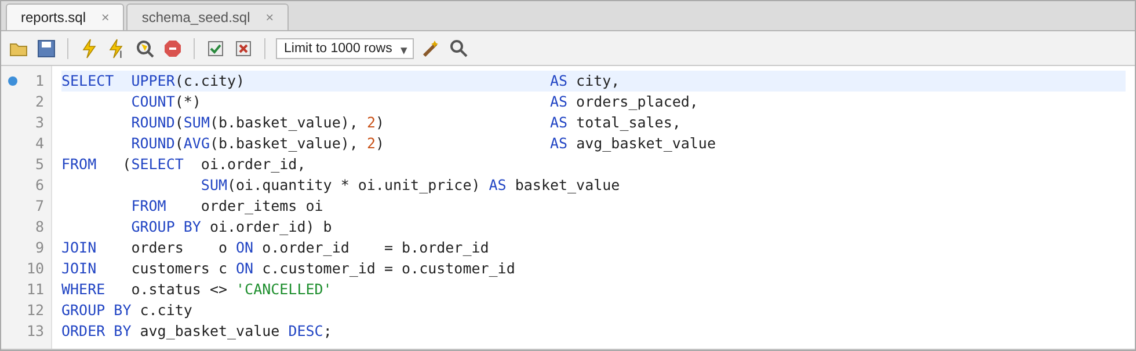
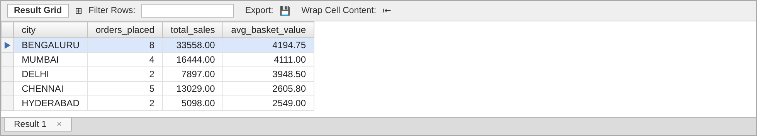
Figure 4: Q4 – Average Basket Value per City – query and expected result
Bengaluru customers place the most orders and also the largest baskets, about Rs. 4,195 on average. Chennai and Hyderabad shoppers buy more groceries and books, so their average basket is close to Rs. 2,600.

3.5 Q5 – Orders without Payment (LEFT JOIN)
A LEFT JOIN from orders to payments keeps every order. Where no payment row matches, the payment columns come back as NULL, so WHERE payment_id IS NULL leaves only the unpaid orders. DATEDIFF counts the days between the order date and the report date of 12-Nov-2026, which is fixed in a session variable so the result does not change from day to day.
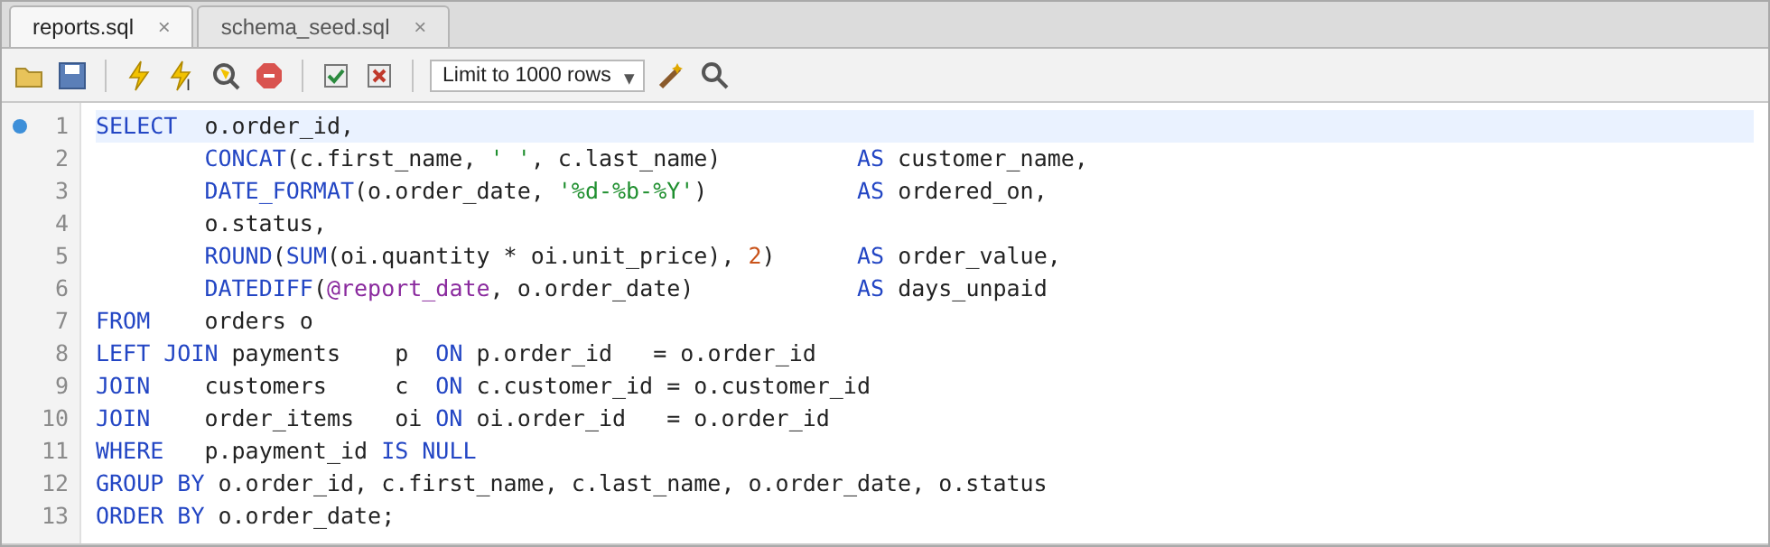
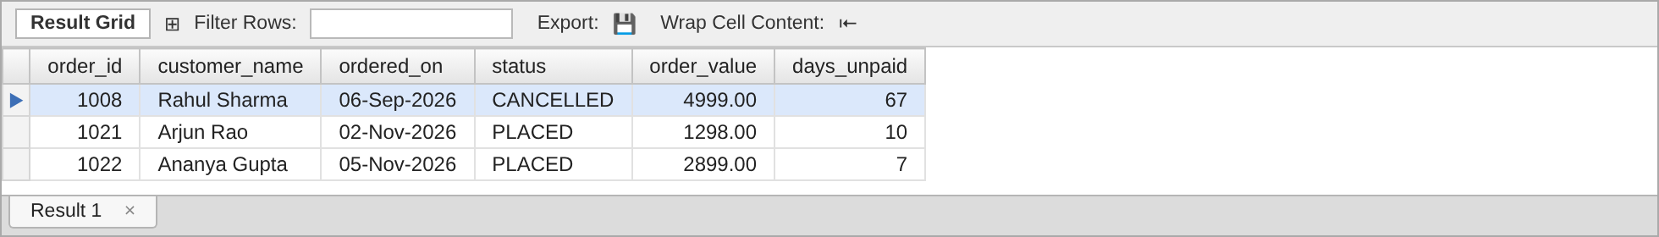
Figure 5: Q5 – Orders without Payment (LEFT JOIN) – query and expected result
Three orders have no payment. Order 1008 was cancelled, so no payment is expected. Orders 1021 and 1022 were placed in November and are still waiting for payment, 10 and 7 days after they were placed, so they are the ones the team should follow up.

3.6 Q6 – Customers with No Orders
This is the same LEFT JOIN pattern, this time from customers to orders. A customer with no orders gets NULL for every order column, and WHERE order_id IS NULL picks out exactly those customers. DATEDIFF shows how long each one has been registered without buying.
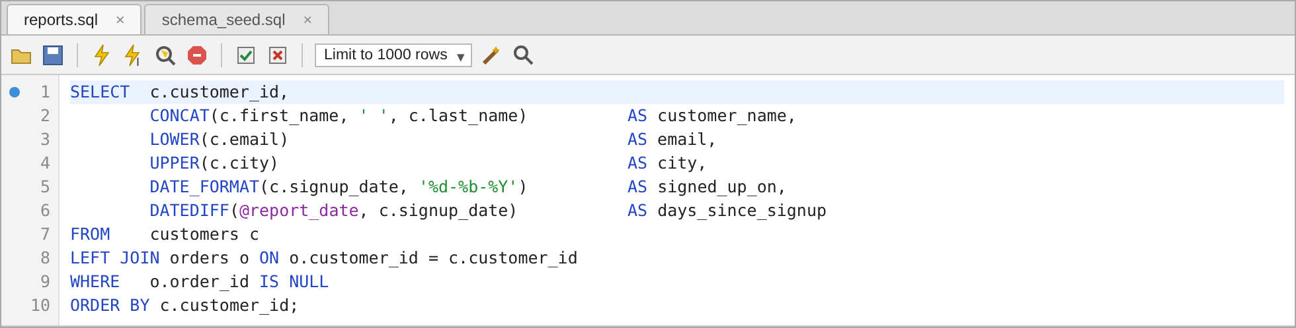
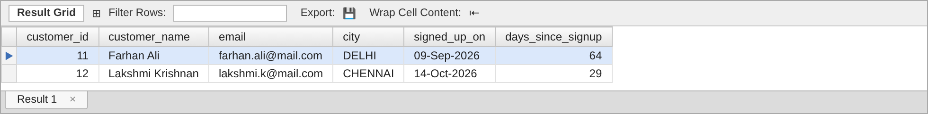
Figure 6: Q6 – Customers with No Orders – query and expected result
Farhan Ali and Lakshmi Krishnan have signed up but never ordered. Farhan has been inactive for 64 days and is a good target for a welcome coupon.

3.7 Q7 – Product-Category Revenue Share
The outer query adds up revenue per category. A scalar subquery in the SELECT list returns the revenue of the whole store, and the category revenue is divided by it and multiplied by 100. ROUND keeps two decimals and CONCAT adds the percent sign.
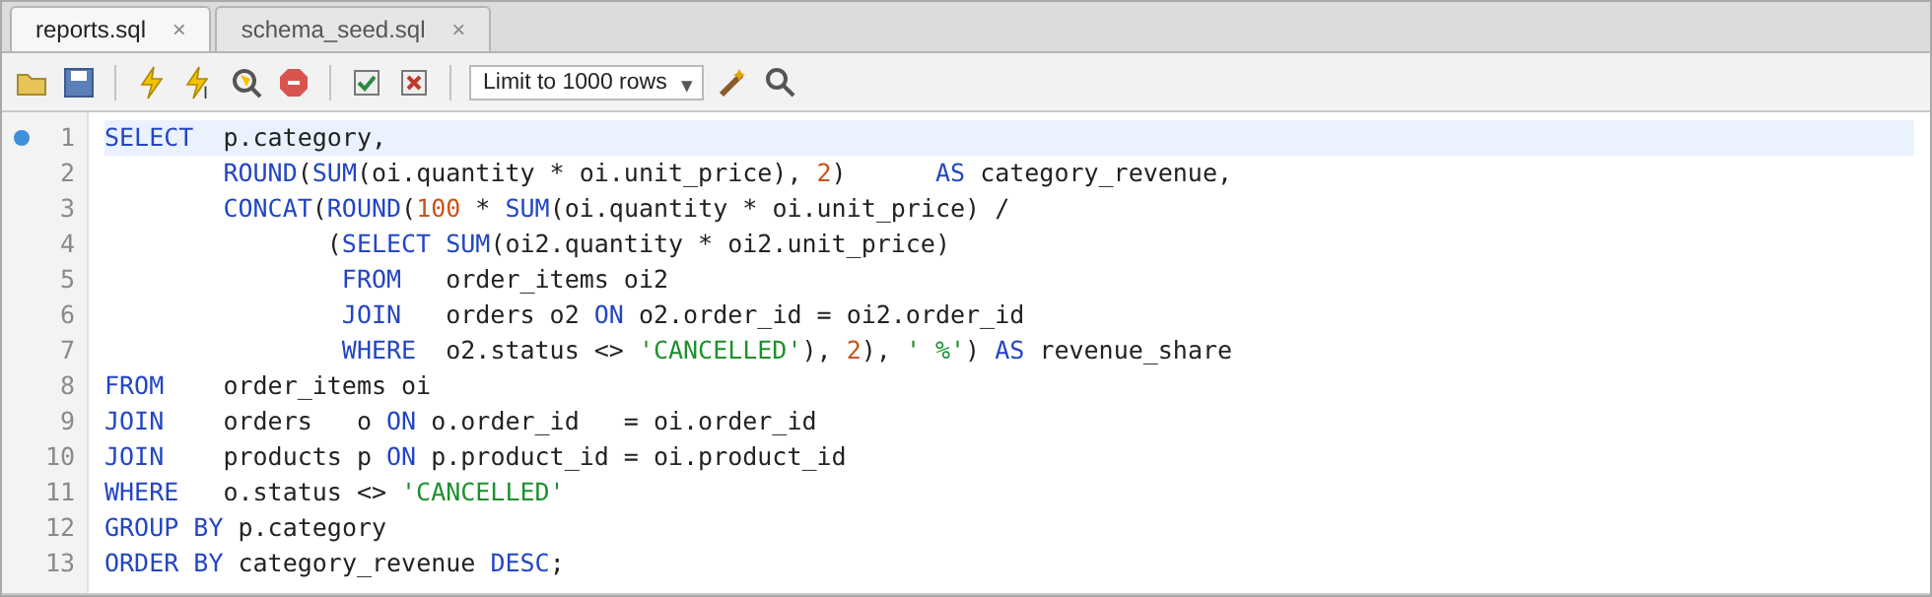
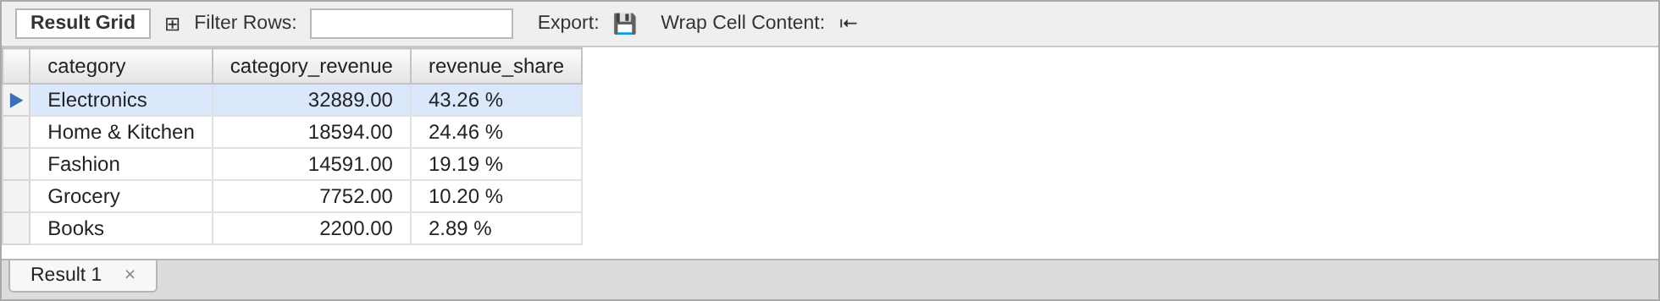
Figure 7: Q7 – Product-Category Revenue Share – query and expected result
Electronics brings in 43.26 % of all revenue, and Electronics plus Home & Kitchen together make up more than two thirds. The five shares add up to 100 %.

3.8 Q8 – Day with the Highest Sales
Order lines are grouped by order date, revenue is added up for each day, and the days are sorted from highest to lowest so that LIMIT 1 returns the best day. DATE_FORMAT with '%W, %d %M %Y' prints the weekday and the full date.
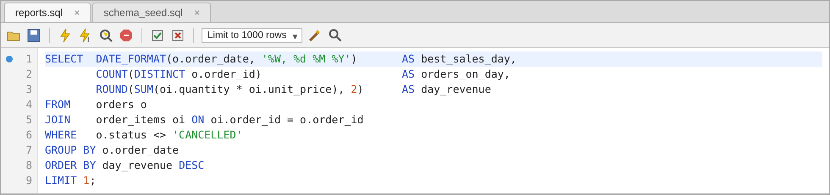
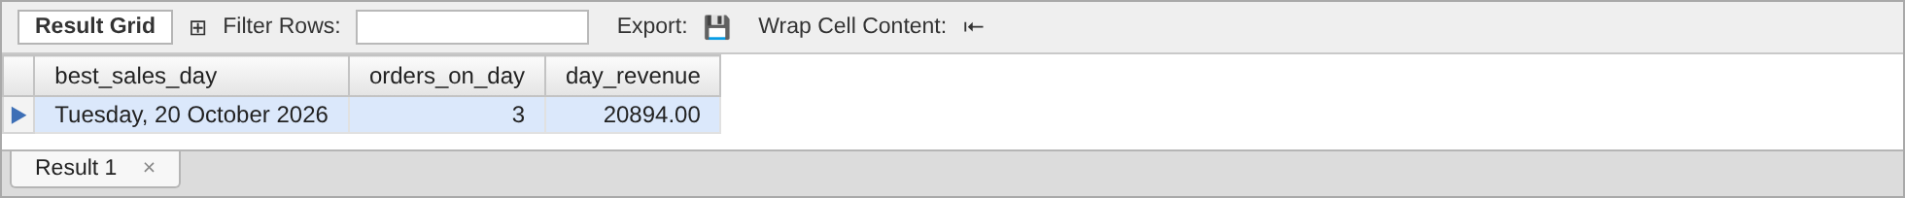
Figure 8: Q8 – Day with the Highest Sales – query and expected result
Tuesday, 20 October 2026, the festive-sale day, had three orders worth Rs. 20,894, which is more than any whole month except October.

4. Task 2 – String, Date and Mathematical Functions
The queries use functions so that the output can go to the sales team without any cleaning in Excel. The table below lists each function, where it is used and what it produces.
Function | Type | Used in | Example output
UPPER(text) | String | Q1, Q3, Q4, Q6 | SMART WATCH, BENGALURU
CONCAT(a, b, …) | String | Q1, Q3, Q5, Q6, Q7 | Arjun Rao, Rs. 14,997.00, 43.26 %
LOWER(text) | String | Q6 | farhan.ali@mail.com
DATE_FORMAT(date, fmt) | Date | Q2, Q3, Q5, Q6, Q8 | October 2026, 02-Nov-2026, Tuesday, 20 October 2026
DATEDIFF(d1, d2) | Date | Q5, Q6 | 10 days unpaid, 64 days since signup
ROUND(x, 2) | Math | Q2, Q4, Q5, Q7, Q8 | 4194.75, 43.26
FORMAT(x, 2) | Math / String | Q1 | 14,997.00 (thousands separator)
Table 2: Functions used to build customer-friendly columns
The DATE_FORMAT codes used are %Y (four-digit year), %m (month number), %M (month name), %d (day of month), %b (short month name) and %W (weekday name). DATEDIFF returns the number of days from the second date to the first, so DATEDIFF(@report_date, order_date) is positive for past orders.

5. Task 3 – NULL Behaviour in COUNT(*), COUNT(column), SUM and AVG
The orders table has 22 rows. discount_amount holds a value for 8 of them (seven real discounts and one 0.00) and is NULL for the other 14. Running all four aggregates on this one column shows how each treats NULL:
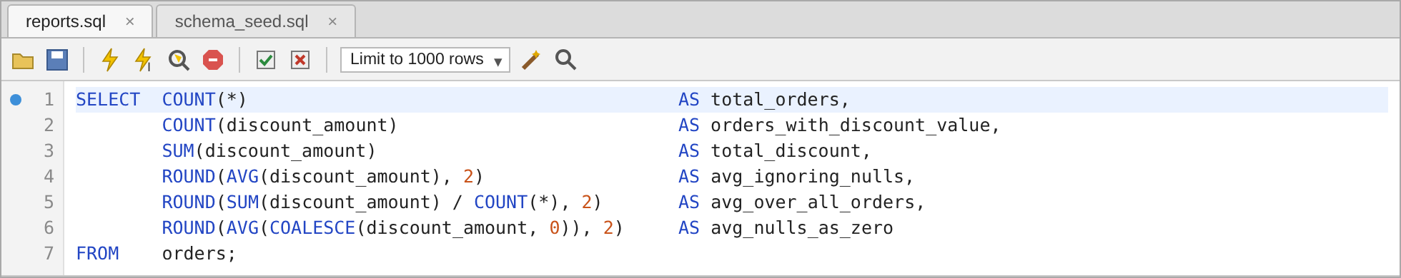
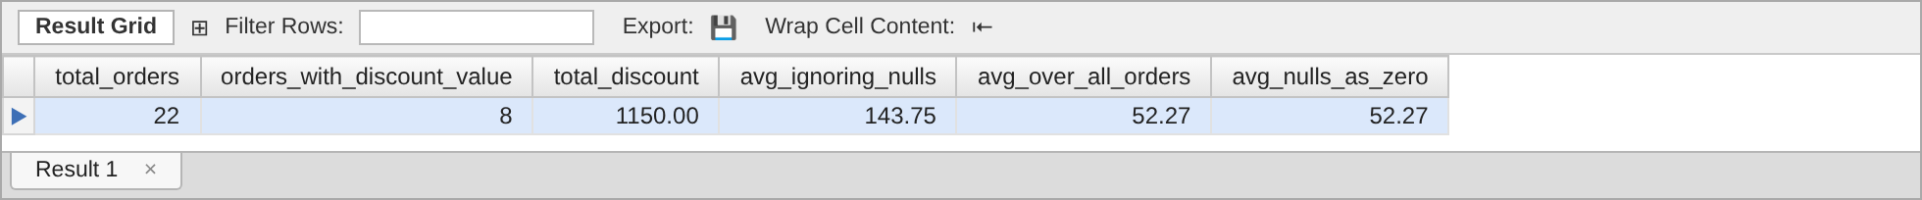
Figure 9: NULL behaviour of the aggregate functions on orders.discount_amount
- COUNT(*) counts rows, whatever they contain, so it returns all 22 orders.
- COUNT(discount_amount) counts only non-NULL values and returns 8. The 0.00 of order 1012 is counted, because zero is a value while NULL means "no value".
- SUM(discount_amount) skips the NULLs and adds the 8 values to Rs. 1,150.
- AVG(discount_amount) also skips the NULLs, so it divides by 8 and not by 22: 1150 / 8 = 143.75. This is the average discount of orders that used a coupon. Dividing by all orders gives 1150 / 22 = 52.27, which is what AVG(COALESCE(discount_amount, 0)) returns once the NULLs are turned into zeros.
When every value in the set is NULL, the difference is even clearer. COUNT still counts the rows, but SUM and AVG return NULL rather than 0:
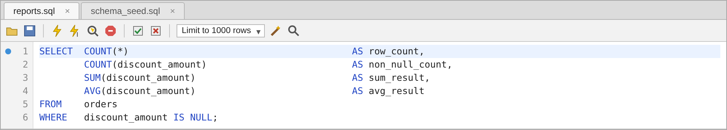
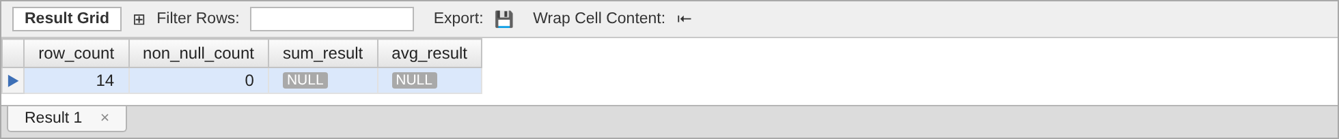
Figure 10: Aggregates over the 14 orders whose discount is NULL
The lesson for the reports is to choose deliberately: use AVG(column) for "the average among orders that have the value" and AVG(COALESCE(column, 0)) for "the average over all orders", and wrap SUM in COALESCE when a report must show 0 instead of NULL.

6. Task 4 – WHERE versus HAVING (using Q3)
WHERE and HAVING both filter, but at different stages of the query. MySQL processes Q3 in this order: FROM and JOIN build the rows, WHERE removes individual rows, GROUP BY collects the rest into groups, HAVING removes whole groups, and finally SELECT and ORDER BY produce the output.
- WHERE works on single rows before grouping. In Q3, WHERE o.status <> 'CANCELLED' throws away the cancelled order row before anything is counted. It cannot use aggregate functions because the groups do not exist yet.
- HAVING works on groups after grouping. In Q3, HAVING COUNT(o.order_id) > 3 keeps only the customers whose group has more than three rows. It is the only place an aggregate condition can be written.
Removing the WHERE clause shows that the stage matters. Without it, the cancelled order 1008 is counted and Rahul Sharma reaches four orders:
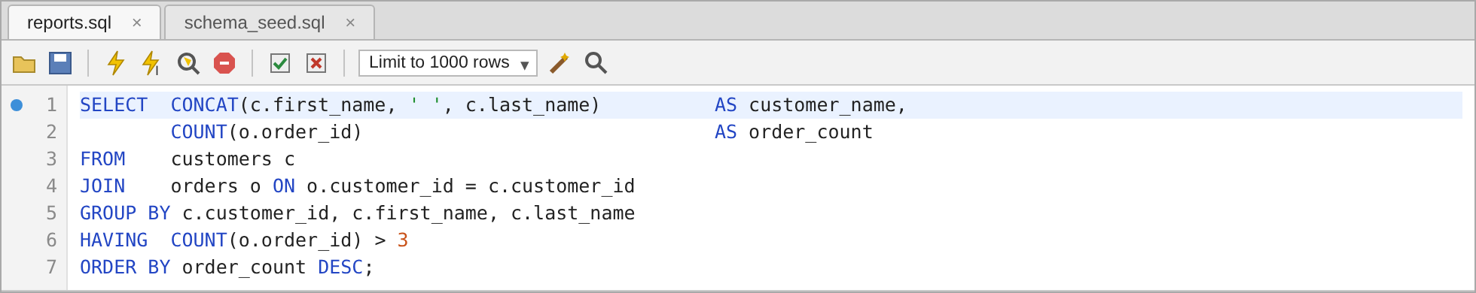
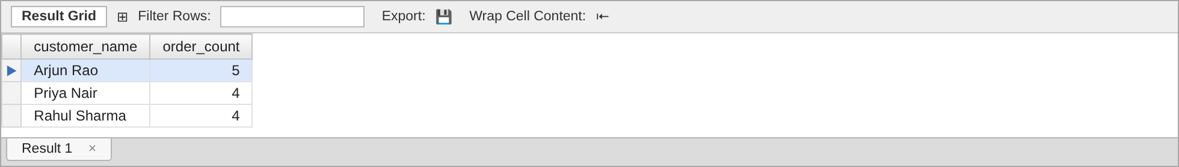
Figure 11: Q3 without the WHERE filter – the cancelled order lets Rahul Sharma qualify
With the WHERE filter (Figure 3) Rahul has only three valid orders and is correctly excluded. Trying to move the aggregate condition into WHERE fails:
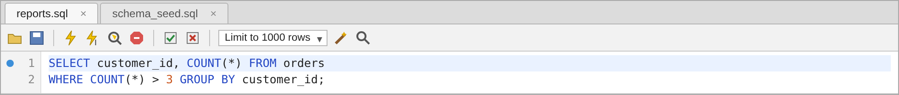
Figure 12: An aggregate in WHERE is rejected with Error Code 1111
In short, conditions on individual columns go in WHERE, which also makes the query faster because fewer rows are grouped, and conditions on aggregates such as COUNT, SUM or AVG go in HAVING.

7. Task 5 – Summary of Expected Result Sets
The full result grid of every query is shown in its figure in Section 3. The table below summarises the expected outcome so the results can be checked quickly after running reports.sql.
Query | Rows | Expected result
Q1 Top-5 products | 5 | Smart Watch first at Rs. 14,997, then Wireless Earbuds, Running Shoes, Cookware Set, Mixer Grinder
Q2 Month-wise sales | 4 | Aug 19,392 · Sep 20,007 · Oct 32,430 · Nov 4,197 (total 76,026)
Q3 Customers > 3 orders | 2 | Arjun Rao (5), Priya Nair (4)
Q4 Avg basket per city | 5 | Bengaluru highest at 4,194.75; Hyderabad lowest at 2,549.00
Q5 Orders without payment | 3 | Orders 1008 (cancelled), 1021 and 1022
Q6 Customers with no orders | 2 | Farhan Ali, Lakshmi Krishnan
Q7 Category revenue share | 5 | Electronics 43.26 %, Home & Kitchen 24.46 %, Fashion 19.19 %, Grocery 10.20 %, Books 2.89 %
Q8 Highest sales day | 1 | Tuesday, 20 October 2026 – 3 orders, Rs. 20,894
NULL demo | 1 | COUNT(*) 22, COUNT(col) 8, SUM 1,150, AVG 143.75
Table 3: Expected result set of every query

8. Conclusion
The eight queries answer the sales team's daily and monthly questions straight from the database. GROUP BY with SUM gives revenue by product, month, city, category and day, LEFT JOIN with IS NULL finds the missing payments and the inactive customers, and HAVING filters on counts that only exist after grouping. String, date and mathematical functions make the output readable without further editing. The NULL demonstration shows that COUNT(column), SUM and AVG ignore NULLs, so the choice between AVG(column) and AVG(COALESCE(column, 0)) has to be made on purpose.
Repository: the deliverables are sql/reports.sql (all queries), sql/schema_seed.sql (tables and sample data) and this document. Running schema_seed.sql and then reports.sql reproduces every result shown here.

