Set 1 – Retail Inventory Management
Name : AKASH S
Date : 11/11/2026

1. Problem Overview
A retailer keeps all of its stock in a single spreadsheet with the columns SKU, product name, category, supplier name, supplier phone, warehouse, quantity and reorder level. Because every row repeats the product and supplier details for each warehouse, the sheet grows quickly, the same phone number is typed again and again, and a single careless edit can leave the data contradicting itself.
This document redesigns the register as a relational database in MySQL. It identifies the anomalies in the original sheet, normalises it to Third Normal Form and draws the ER diagram, builds the schema with InnoDB tables and every required constraint, loads sample data and proves that bad data is rejected, corrects and removes records with UPDATE and DELETE, and finally inspects the MySQL system databases. Every query was run in MySQL Workbench and its output is shown as a screenshot.
Deliverables: schema.sql (Section 3), seed_data.sql with the failing inserts (Section 4), the ER diagram (Section 2.4) and the failing-insert evidence (Figure 3).

2. Task 1 – Normalisation, Anomalies and ER Diagram

2.1 Anomalies in the Original Sheet
In the spreadsheet a row is identified only by the pair (SKU, warehouse). SKU-1001, Filter Coffee Powder, appears once for the Peenya warehouse and again for Shivamogga, and both rows carry the category Beverages and the supplier Sri Lakshmi Traders with phone +91 98450 11223. This repetition causes three kinds of anomaly:
- Insert anomaly: a new supplier, category or warehouse cannot be recorded until at least one SKU is stocked with it, because a row without an SKU has no key. A supplier who has signed a contract but not yet delivered simply cannot be stored.
- Update anomaly: Prakash FMCG Agencies supplies several SKUs, so its phone number sits on many rows. If the number changes and only one row is edited, the sheet holds two different numbers for the same supplier and nobody knows which is right.
- Delete anomaly: when the last row of a discontinued SKU such as Herbal Shampoo is deleted, the only record of its supplier, that supplier's phone and possibly the whole category disappears with it.

2.2 Functional Dependencies
Studying the columns gives the following dependencies. SKU determines product name, category and supplier name. Supplier name determines supplier phone, so the phone depends on SKU only indirectly through the supplier. The combination of SKU and warehouse determines quantity and reorder level, because the same product can hold different stock in different warehouses.

2.3 Normalisation Steps
- First Normal Form: every cell already holds a single value and there are no repeating groups, so the sheet is in 1NF as INVENTORY(SKU, warehouse, product_name, category, supplier_name, supplier_phone, quantity, reorder_level) with the composite key (SKU, warehouse).
- Second Normal Form: product name, category and supplier depend on SKU alone, which is only part of the key. These partial dependencies are removed by splitting the sheet into PRODUCT(SKU, product_name, category, supplier_name, supplier_phone) and STOCK(SKU, warehouse, quantity, reorder_level).
- Third Normal Form: inside PRODUCT the phone depends on the supplier, not on the SKU, and the category is a separate fact. These transitive dependencies are removed by creating SUPPLIER and CATEGORY tables, and WAREHOUSE becomes its own table so its name and city are stored once.
The final five relations are CATEGORY(category_id, category_name, description), SUPPLIER(supplier_id, supplier_name, phone, email, city), WAREHOUSE(warehouse_id, warehouse_code, warehouse_name, city, capacity_units), PRODUCT(sku, product_name, category_id, supplier_id, unit_price, status) and STOCK(warehouse_id, sku, quantity, reorder_level). Every non-key column now depends on the key, the whole key and nothing but the key, and each of the three anomalies above is removed.

2.4 ER Diagram
The diagram uses crow's-foot notation. A category and a supplier each have zero or many products, while each product belongs to exactly one category and one supplier. STOCK resolves the many-to-many relationship between PRODUCT and WAREHOUSE, so a product can be held in many warehouses and a warehouse can hold many products.
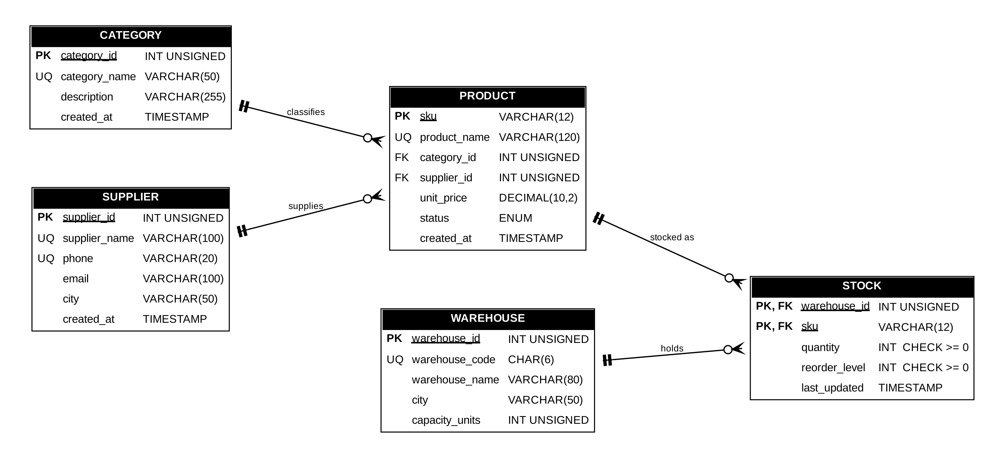
Figure 1: ER diagram of the 3NF retail inventory schema

3. Task 2 – MySQL Schema (schema.sql)
The script creates the database retail_inventory and the five tables, all with ENGINE = InnoDB because only InnoDB enforces foreign keys. The constraints were chosen as follows:
- Primary keys: category_id, supplier_id and warehouse_id are auto-increment surrogate keys, product uses the natural key sku, and stock uses the composite key (warehouse_id, sku).
- Foreign keys: product refers to category and supplier, and stock refers to warehouse and product. Every foreign key uses ON DELETE RESTRICT, so a parent row cannot be deleted while child rows still point to it, and ON UPDATE CASCADE, so a changed key flows automatically to the child rows.
- UNIQUE: category name, supplier name, supplier phone, warehouse code and product name cannot repeat.
- CHECK: quantity >= 0 and reorder_level >= 0 on stock, unit_price >= 0 on product and capacity_units > 0 on warehouse.
- DEFAULT and NOT NULL: quantity defaults to 0, reorder level to 10, status to 'ACTIVE' and timestamps to CURRENT_TIMESTAMP, while every mandatory column is declared NOT NULL.
The STOCK table brings most of these constraints together:
CREATE TABLE stock (
warehouse_id INT UNSIGNED NOT NULL,
sku VARCHAR(12) NOT NULL,
quantity INT NOT NULL DEFAULT 0,
reorder_level INT NOT NULL DEFAULT 10,
last_updated TIMESTAMP NOT NULL DEFAULT CURRENT_TIMESTAMP
ON UPDATE CURRENT_TIMESTAMP,
CONSTRAINT pk_stock PRIMARY KEY (warehouse_id, sku),
CONSTRAINT chk_stock_quantity CHECK (quantity >= 0),
CONSTRAINT chk_stock_reorder CHECK (reorder_level >= 0),
CONSTRAINT fk_stock_warehouse FOREIGN KEY (warehouse_id)
REFERENCES warehouse (warehouse_id)
ON DELETE RESTRICT ON UPDATE CASCADE,
CONSTRAINT fk_stock_product FOREIGN KEY (sku)
REFERENCES product (sku)
ON DELETE RESTRICT ON UPDATE CASCADE
) ENGINE = InnoDB;

4. Task 3 – Seed Data and Failing Inserts (seed_data.sql)

4.1 Loading Valid Data
Parent tables are filled before child tables so that every foreign key is satisfied: 10 categories, 10 suppliers, 10 warehouses, 15 products (three of them marked DISCONTINUED for Task 4) and 17 stock rows. The surrogate keys category_id, supplier_id and warehouse_id are generated by AUTO_INCREMENT, so the product and stock rows simply refer to the numbers 1 to 10. Multi-row INSERT statements are used so that each table is loaded in a single round trip:
INSERT INTO stock (warehouse_id, sku, quantity, reorder_level) VALUES
(1, 'SKU-1001', 420, 50),
(1, 'SKU-1003', 900, 150),
(2, 'SKU-1008', 12, 20),
(3, 'SKU-1013', 8, 15),
... -- 17 rows in total
(10,'SKU-1003', 260, 80);

Columns that are not listed, such as created_at, last_updated and status where omitted, take their DEFAULT values, so the DEFAULT constraints are exercised by the same statements.

4.2 Deliberately Failing Inserts
Four inserts are then written to fail on purpose, each breaking exactly one rule:
- Duplicate key: inserting SKU-1001 a second time breaks the primary key and returns Error 1062, Duplicate entry 'SKU-1001' for key 'product.PRIMARY'.
- Missing parent: a stock row for warehouse 99, which does not exist, breaks fk_stock_warehouse and returns Error 1452, Cannot add or update a child row.
- Negative quantity: a stock row with quantity -25 breaks chk_stock_quantity and returns Error 3819, Check constraint is violated.
- NULL in a mandatory column: a product with no name breaks the NOT NULL rule and returns Error 1048, Column 'product_name' cannot be null.
In the Output panel the five valid inserts show green ticks with “Duplicates: 0 Warnings: 0”, and the four deliberate inserts show red errors. Counting the rows afterwards confirms that every table holds at least ten rows and that none of the rejected inserts wrote anything.
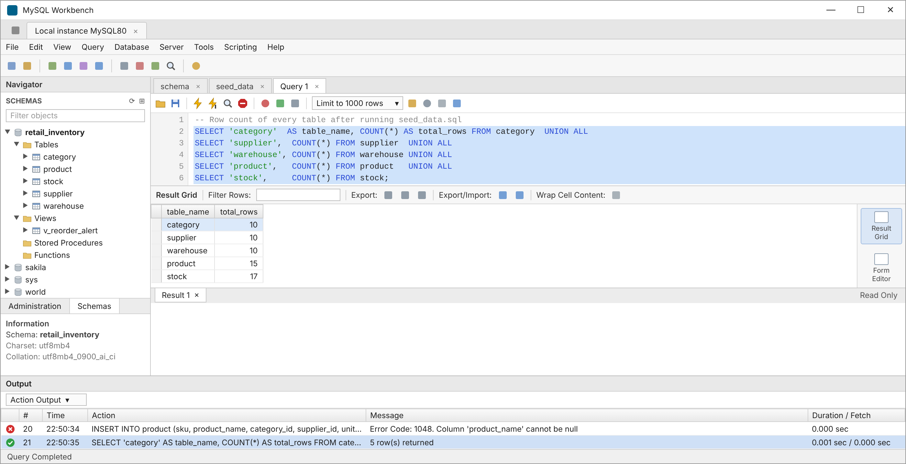
Figure 2: Row count of every table after seeding – the rejected inserts added nothing
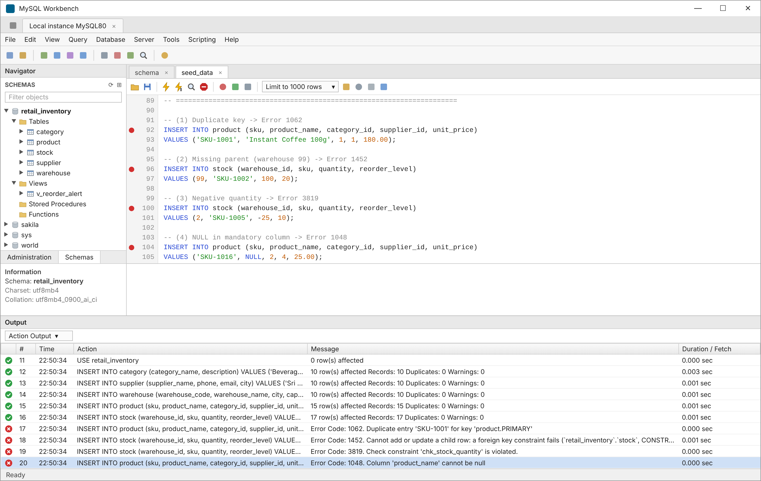
Figure 3: Seed inserts succeed and the four failing inserts return errors 1062, 1452, 3819 and 1048

5. Task 4 – UPDATE and DELETE with WHERE

5.1 Correcting a Supplier Phone Number
Prakash FMCG Agencies (supplier 4) changed its number from +91 97400 44556 to +91 97400 45678. Because the phone is now stored in exactly one row of the supplier table, a single UPDATE with WHERE supplier_id = 4 corrects it for every product the supplier provides. The SELECT before and after the update shows the change.
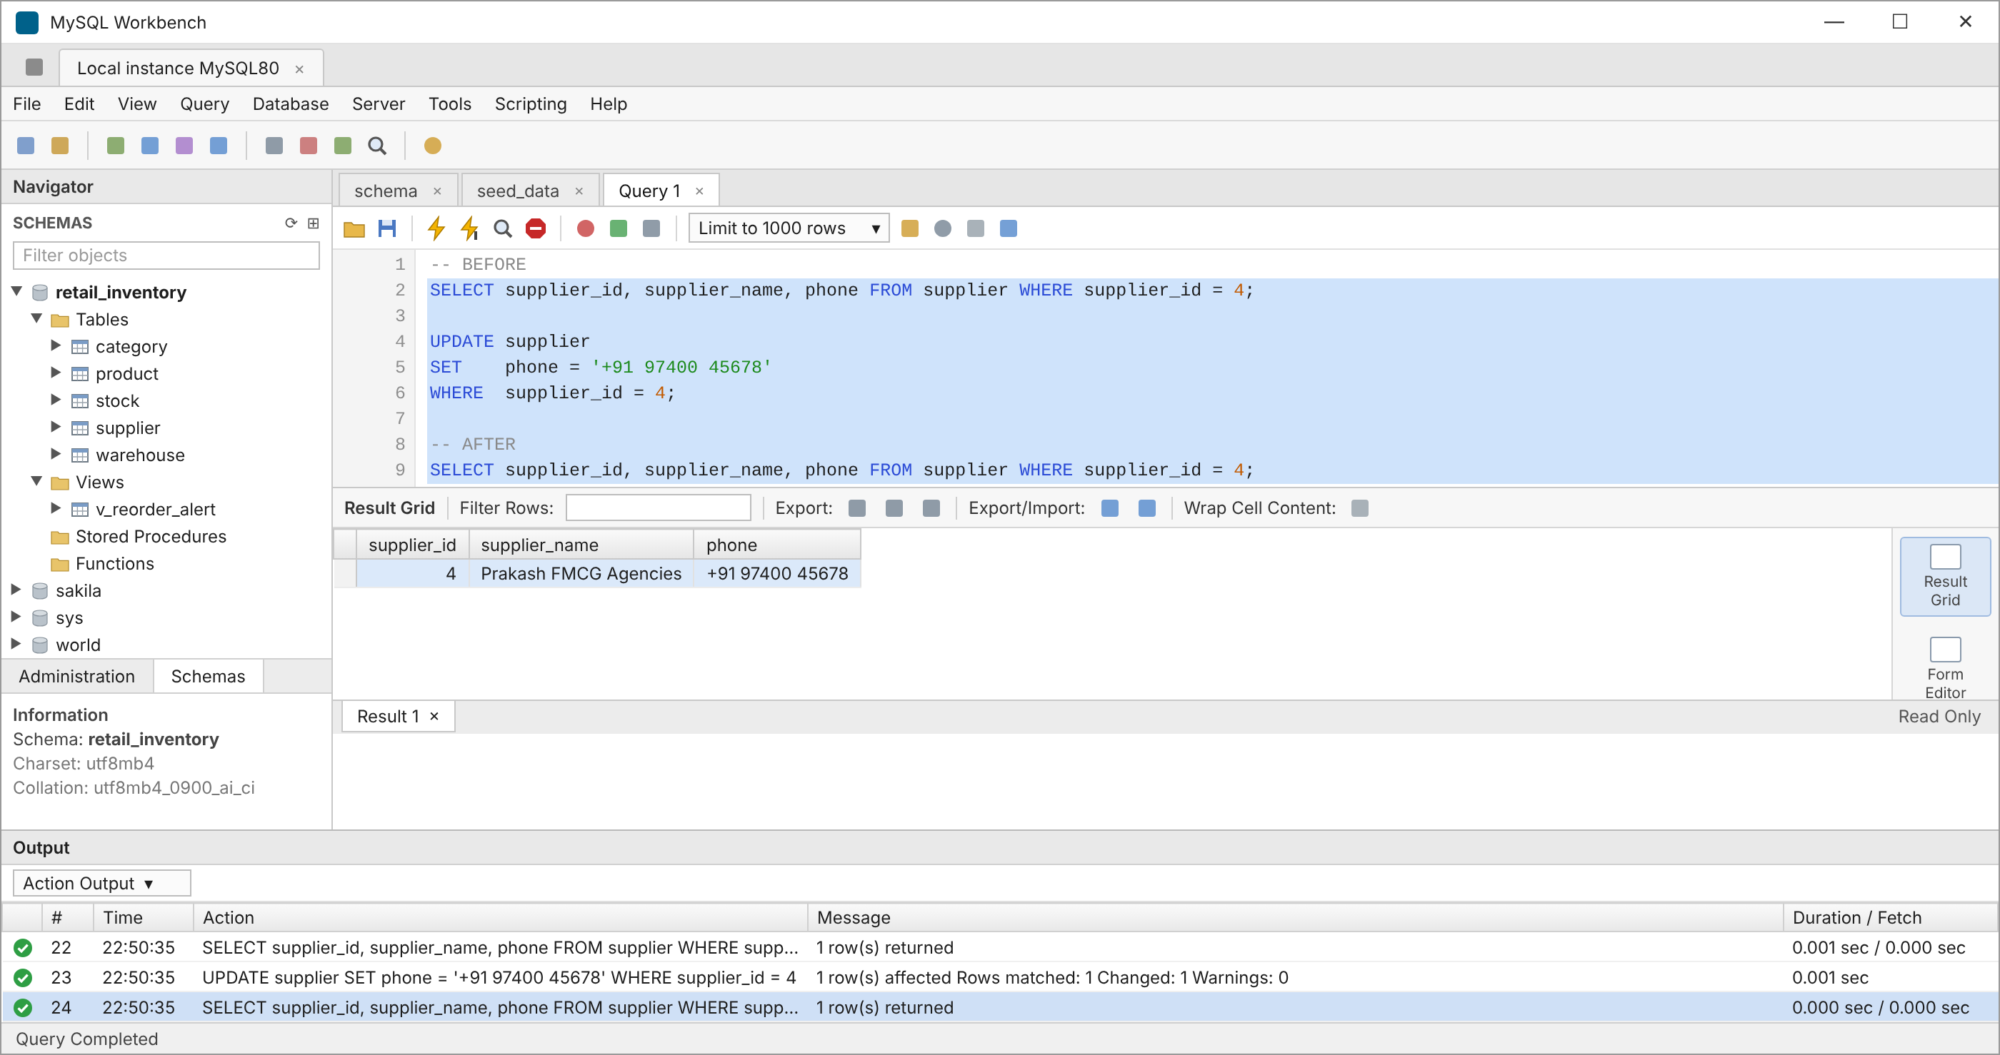
Figure 4: Supplier phone before and after the UPDATE

5.2 Removing Discontinued SKUs
Three SKUs (SKU-1008, SKU-1013 and SKU-1015) are discontinued but still have stock rows. Since every foreign key uses ON DELETE RESTRICT, MySQL will not delete a product while stock rows refer to it, so the stock rows are deleted first and the products second. Running the whole script opens one result tab per SELECT: Result 1 holds the BEFORE query, which lists the three SKUs with their warehouses and quantities, while the Output log confirms that three stock rows and three product rows were deleted and that the same SELECT run AFTER the delete returns 0 rows.
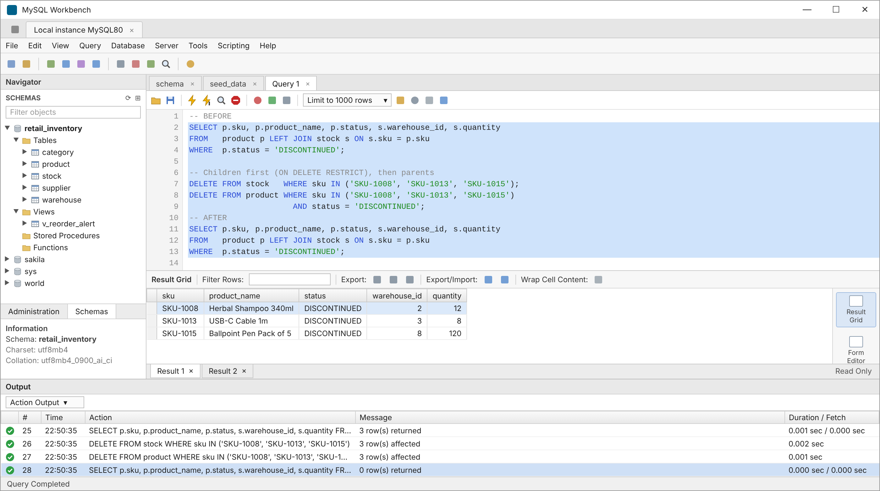
Figure 5: Result 1 lists the three discontinued SKUs before the DELETE; the Output log shows both DELETEs and the AFTER query returning 0 rows

6. Task 5 – Exploring the System Databases
Besides retail_inventory, the server holds four system databases:
- information_schema: read-only views over the data dictionary describing every schema, table, column and constraint.
- mysql: the server's own tables for user accounts, privileges, time zones and InnoDB statistics.
- performance_schema: low-level instrumentation recording statements, waits and I/O while the server runs.
- sys: easy-to-read summary views built on top of performance_schema.
SHOW DATABASES lists all five. ANALYZE TABLE refreshes the InnoDB statistics, and information_schema.TABLES then lists every table of retail_inventory with its engine and row count. All five tables use InnoDB; the view has no engine. Product and stock now show 12 and 14 rows because Task 4 removed the discontinued SKUs.
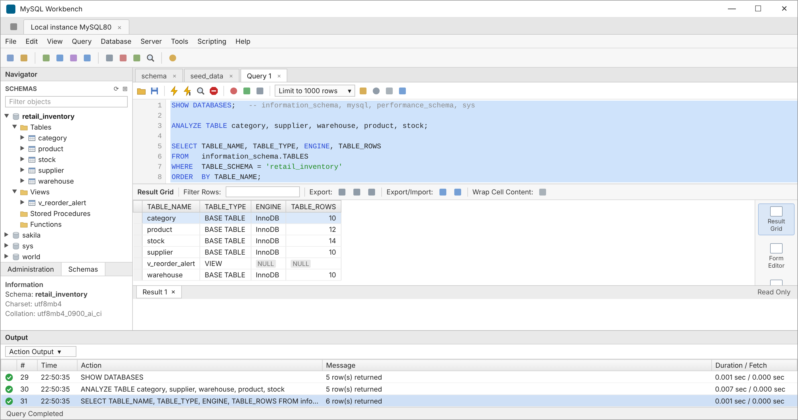
Figure 6: Tables of retail_inventory with ENGINE and TABLE_ROWS from information_schema

7. Conclusion
The single spreadsheet was split into five relations in Third Normal Form, which removes the insert, update and delete anomalies. The MySQL schema enforces data quality on its own: keys stop duplicates, foreign keys stop orphan rows and protect parents, CHECK constraints stop negative stock and NOT NULL stops missing data. The outputs show valid data being accepted, invalid data being rejected, and corrections being made in one place.
Repository: the deliverables are pushed to GitHub as sql/schema.sql (database, tables, constraints and view), sql/seed_data.sql (sample data followed by the four failing inserts), docs/er_diagram.png (ER diagram) and the screenshots folder holding the output evidence. Running schema.sql and then seed_data.sql, with Continue on SQL Script Error enabled in Workbench, rebuilds the database exactly as shown in this report.

