PROJECT 10

# P 10.0: Logisim

## Intro

In this mini-project I will try to make a simple representation of digit numbers 0-9, by a given binary input.

The binary input number, hence, will be between 0000-1001. Thus, 4 variables, named, $w,x,y,z$ can be used to make the Boolean functions for the combinational circuit.

## 7 bars

Before proceeding in making the combinational circuit, it is first important to know how many outputs there will be given $w,x,y,z$.

Thus, the main thinking is how can we represents the digits 0-9 with minimum possible bars but still comprehensible to read them.

Just like the analogy of LCD digital clocks/watches, digits can be shaped more “rectangularly” as follows:

|  |  |  |  |  |  |  |  |  |  |
| --- | --- | --- | --- | --- | --- | --- | --- | --- | --- |
| 0 | 1 | 2 | 3 | 4 | 5 | 6 | 7 | 8 | 9 |
|  |  |  |  |  |  |  |  |  |  |

**Table 1**: screenshots taken from Microsoft Whiteboard

It can be noticed that 7 bars are indeed a good solution.

Therefore:

* there will be 4 inputs $w,x,y,z∈\left\{0,1\right\}$, that represent a binary number $wxyz$,
* 7 outputs, named, $a,b,c,d,e,f,g$ in the following format:
  + Diagram

    Description automatically generated with medium confidence

## Boolean functions

Now for each output we can create a Boolean function. Since the there are 4 inputs a 4D Karnaugh map can be used for assisting in simplification and optimization of Boolean functions.

The source of the 4D K-map is mentioned here: <https://www.tutorialspoint.com/digital_circuits/images/4_variable_k_map.jpg>

Note that for numbers between 10 and 15, inclusively, are IRRELEVANT for the design of Boolean functions, since those will be assumed to be INVALID inputs.

We assume the input is always between 0-9, inclusively, 0000-1001.

However, these IRRELEVANT numbers may be used in making groups in K-maps larger, which aid in smaller Boolean functions, thus more optimized.

### Output a

Looking at Table 1, the bar $a$ would be on (so $a=1)$ if the inputs are $0,4,5,6,8 or 9$.

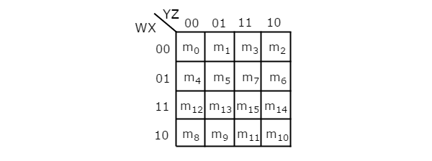



Therefore, the Boolean function is:

$$a=w+y^{'}z^{'}+xy^{'}+xz'$$

Further optimized:

$$a=w+y^{'}z^{'}+x(y^{'}+z^{'})$$

### Output b

Bar $b$ is set when inputs are .



So, . Further optimized it is:

$$b=\left(x^{'}+y\right)z'$$

### Output c

Bar $c$ is set when inputs are



So,

### Output d

Bar $d$ is set when inputs are



So,

### Output e

Bar $e$ is set when inputs are



So,

### Output f

Bar $f$ is set when inputs are .



So,

### Output g

Bar $g$ is set when inputs are .



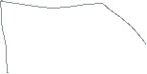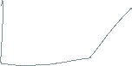

So,

Further optimized:

$$g=wx^{'}+x'y+x^{'}z^{'}+yz^{'}+xy^{'}z$$

$$g=x^{'}\left(w+y\right)+\left(x^{'}+y\right)z'+xy'z$$

Further optimized via substitution:

$$g=x^{'}\left(w+y\right)+b+xy'z$$

## Overall optimization

Note that some Boolean functions, such as $y^{'}+z'$, which are part of Boolean functions of $a$ and $f$, are repeated. This implies that we do not need to make duplicate/redundant use of logic gates.

This allows to further reduce the count of overall logic gates.

However, note that through the use of K-Maps the solution has been optimized at a significant level. Although it may not be the best optimal solution with the fewest logic gates. The optimization procedures have been applied to the extent of intuitive capabilities as much as possible.

## Logisim design

The design is planned as follows:

* Make a combinational circuit with 4 inputs and 7 outputs, with logic gates representing Boolean functions as represented above
* Use the combinational circuit to show digits using LED lights
* Use the combinational circuit to show digits using the 7-segment display
  + I noticed I could use the 7-segment display as well

You may see the file with “.circ” extension, using Logisim application (“.exe” file included) in the ‘section Logisim’ folder.

## Demos

You may access files with prefix name “1” and “2” in the ‘demos’ folder.