**Business Analysis Report: Sales Performance Insights (January 2022 – September 2023)**

**Objective**

The goal of this analysis is to examine the sales performance of a particular brand from January 2022 to September 2023. The analysis focuses on product-level insights, store performance, and supply chain considerations to identify areas of improvement and recommend actionable steps to enhance future sales.

**Dataset Overview**

* **Period Covered:** January 2022 – September 2023
* **Data Fields:**
  + **item:** Product category (A, B, C, D, E, F, G, H)
  + **store_id:** Unique identifier for each store
  + **sales:** Monthly sales figures for each product at each store

**1. Data Preparation and Cleaning**

* **Handling Missing Values:**
  + Replaced missing values (NaN) with 0 to account for months where no sales were recorded, assuming no sales occurred rather than missing data.
* **Data Reshaping:**
  + Transformed the dataset from wide format to long format using the **melt()** function. This restructuring facilitated time-series analysis by consolidating all monthly sales columns into a single date column with corresponding sales values.

**2. Product-Level Insights**

**2.1. Sales Comparison between 2022 and 2023**

Calculated the accumulated sales for each product in 2022 and 2023.

| **Product** | **Accumulated Sales 2022** | **Accumulated Sales 2023** | **Growth Rate (%)** |
| --- | --- | --- | --- |
| A | 89,259 | 76,261 | -14.56 |
| B | 84,832 | 75,129 | -11.44 |
| C | 66,626 | 57,549 | -13.62 |
| D | 42,797 | 36,190 | -15.44 |
| E | 4,810 | 4,699 | -2.31 |
| F | 2,632 | 7,621 | **189.55** |
| G | 6,011 | 18,336 | **205.04** |
| H | 1,784 | 3,242 | **81.73** |

**Observation:**

* Products **A**, **B**, **C**, and **D** experienced a decline in sales in 2023 compared to 2022.
* Products **F**, **G**, and **H** showed significant growth in 2023.

**2.2. BCG Matrix Analysis**

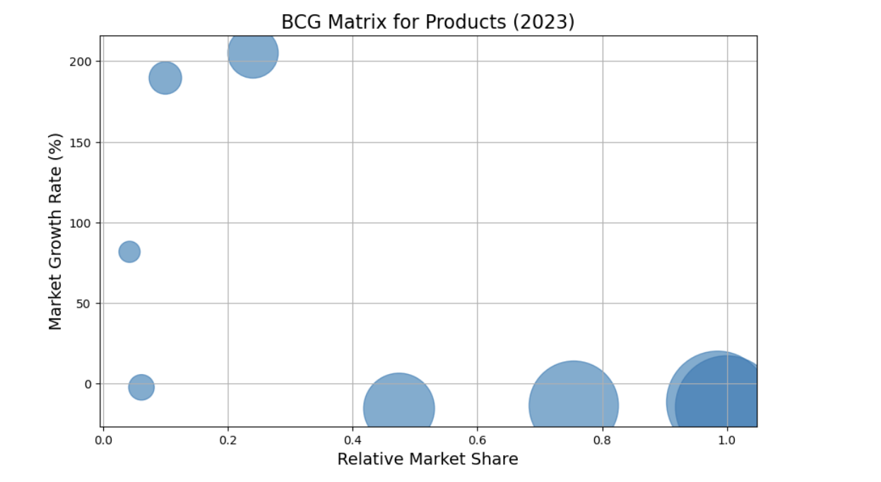

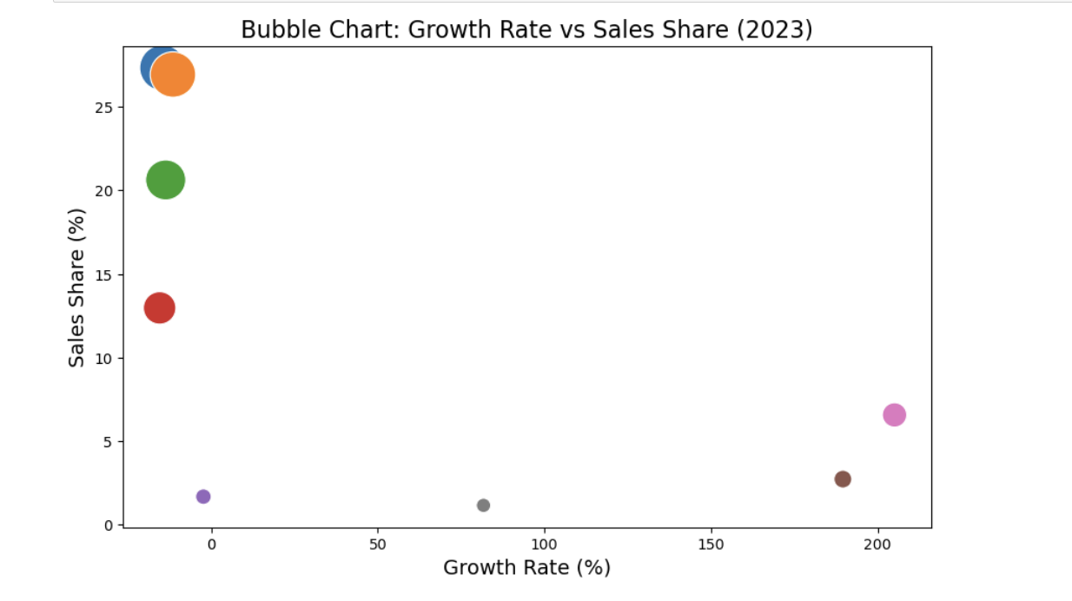

The BCG Matrix positions products based on **Market Growth Rate** and **Relative Market Share**.

**Calculated Metrics:**

* **Market Growth Rate:** Percentage change in accumulated sales from 2022 to 2023.
* **Relative Market Share:** Product's accumulated sales in 2023 divided by the highest accumulated sales among all products in 2023.

**BCG Matrix Positioning:**

1. **Stars (High Market Share, High Growth):**
   * **No products** fell into this category, as top-selling products showed negative growth rates.
2. **Question Marks (Low Market Share, High Growth):**
   * **Products F and G**:
     + High growth rates (189.55% and 205.04%).
     + Low market shares (2.73% and 6.57%).
3. **Cash Cows (High Market Share, Low Growth):**
   * **Products A, B, and C**:
     + High market shares (27.33%, 26.93%, and 20.62%).
     + Negative growth rates.
4. **Dogs (Low Market Share, Low Growth):**
   * **Products E and H**:
     + Low market shares (1.68% and 1.16%).
     + Negative or minimal growth rates.

**3. Sales Trend Analysis**

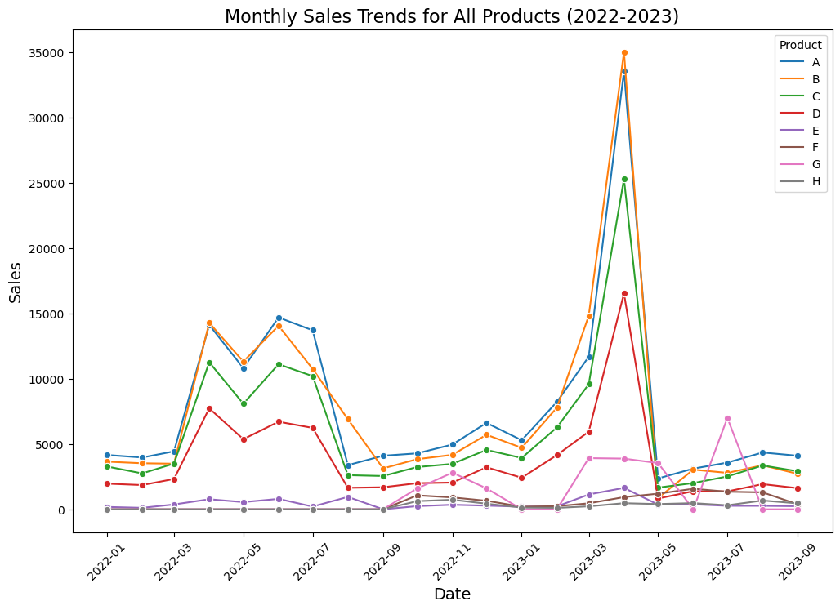**3.1. Monthly Sales Trends**

**Key Observations:**

* **Seasonality:** Notable sales spikes in March and mid-year periods for products **A**, **B**, and **C**.
* **Product G Volatility:** Significant fluctuations in sales, indicating potential but unstable performance.
* **Underperforming Products:** Products **E** and **H** consistently recorded low sales.

**3.2. Monthly Sales Growth Rate**

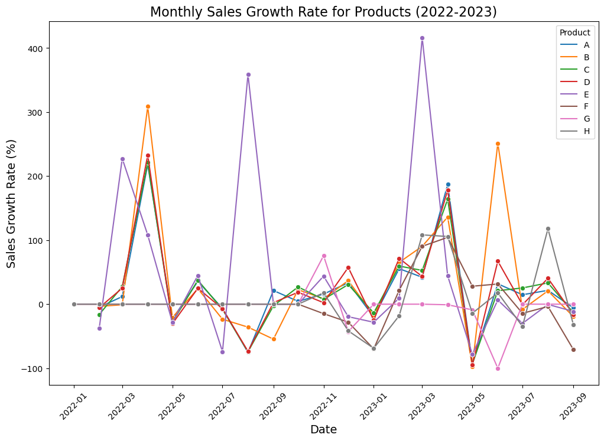

Calculated the month-over-month sales growth rate for each product.

**Key Observations:**

* **Growth Spikes:** Products **B** and **G** showed significant growth spikes during specific periods.
* **Stable Products:** Products **E** and **H** showed minimal fluctuations.
* **Negative Growth Periods:** Several products experienced negative growth in mid-2022 and early 2023.

**4. Store-Level Insights**

**4.1. Store Segmentation**

Used K-Means clustering to segment stores into **High**, **Medium**, and **Low** performers based on total sales.

**4.2. Product Performance across Store Segments**

Analyzed how each product performed in different store segments.

| **Product** | **High Segment Sales** | **Medium Segment Sales** | **Low Segment Sales** |
| --- | --- | --- | --- |
| A | 49,849 | 28,804 | **86,867** |
| B | 48,318 | 28,956 | **82,687** |
| C | 36,661 | 23,104 | **64,410** |
| D | 23,985 | 14,975 | **40,027** |
| E | 2,747 | 1,901 | **4,861** |
| F | 2,005 | 813 | **7,435** |
| G | 4,698 | 1,664 | **17,985** |
| H | 710 | 660 | **3,656** |

**Key Observations:**

* **Low Segment Stores** generated the highest sales across all products, contrary to expectations.
* **Medium Segment Stores** consistently underperformed.
* **High Segment Stores** did not fully capitalize on the sales potential of key products.

1. **Supply Chain Insights**

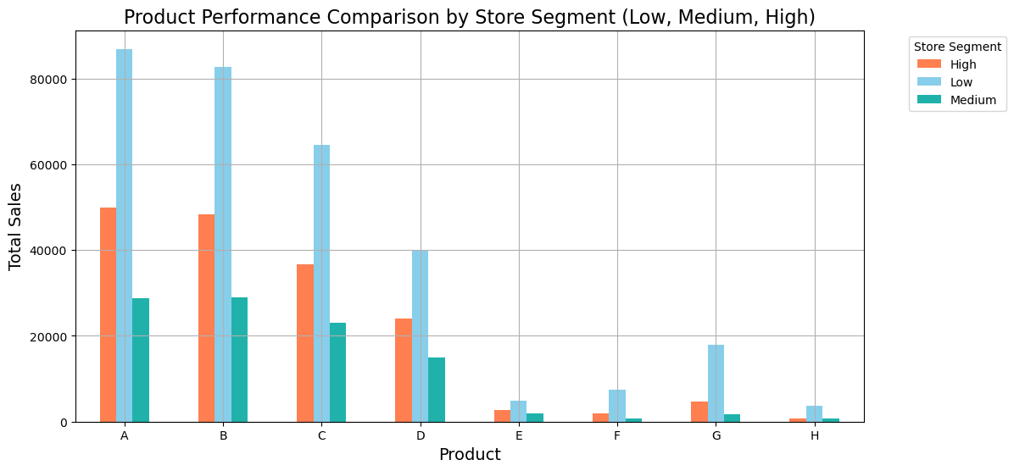

**5.1. Stock Imbalances**

* **Overstocking in Low Segment Stores:** Higher sales in low-performing stores suggest possible overstocking.
* **Understocking in High Segment Stores:** Lower sales in high-performing stores may indicate supply shortages or inventory management issues.

**5.2. Stocking Strategy in Medium Segment Stores**

* Frequent stockouts may be causing underperformance.
* Potential issues with demand forecasting and inventory replenishment.

**5.3. Niche Product Availability**

* Products **E**, **F**, **G**, and **H** have low sales across all segments.
* May not be adequately stocked or promoted.

**6. Recommendations**

**6.1. Product Strategy**

* **Invest in High-Growth Products:** Allocate resources to products **F** and **G** to increase market share.
* **Maintain Cash Cows:** Continue supporting products **A**, **B**, and **C** while monitoring declining trends.
* **Reassess Underperforming Products:** Consider discontinuing or repositioning products **E** and **H**.

**6.2. Store Strategy**

* **Optimize Inventory Distribution:**
  + Rebalance stock levels to prevent overstocking in low-performing stores and understocking in high-performing stores.
* **Improve Medium Segment Stores:**
  + Investigate operational challenges and supply chain inefficiencies.
  + Enhance demand forecasting and inventory management.

**6.3. Supply Chain Optimization**

* **Demand Forecasting:** Implement advanced forecasting methods to align inventory with actual demand.
* **Inventory Management:** Utilize just-in-time inventory practices to reduce stockouts and overstock situations.
* **Distribution Efficiency:** Review logistics to ensure timely and adequate stock replenishment across all store segments.

**7. Conclusion**

The analysis highlights discrepancies between store segmentation and actual sales performance, especially for key products. By addressing supply chain inefficiencies and optimizing product and store strategies, the company can improve overall sales performance and better meet market demand.