
PROJECT REPORT
SESSION 2025-2026
(2nd YEAR – III SEMESTER)

LASER THEIF DETECTION SYSTEM

A MINOR PROJECT REPORT SUMITTED IN THE PARTIAL FULFILLMENT OF REQUIREMENT FOR THE AWARD OF DEGREE OF BACHELOR OF ENGINEERING IN
ELECTRONICS AND COMMUNICATION

UNDER THE GUIDANCE OF:
- Mr. MANISH PUROHIT
(Lecturer)

THE TEAM COLLABORATION BY-
- AKASH RATHORE
- KULDEEP PATEL

TABLE OF CONTENTS

- INTRODUCTION

- HARDWARE REQUIREMENTS

- WORKING OF PROJECT

- CIRCUIT DIAGRAM

- PURPOSE, FUTURE SCOPE AND APPLICABILITY

- EXPENDITURE OF THE PROJECT

INTRODUCTION

- In today’s world, security is one of the most important needs for homes, offices, and industries. To make security smarter and more efficient, we have designed a Laser Theft Detection System using ESP32.

- This system uses a laser light and an LDR (Light Dependent Resistor) to detect any unauthorized movement. When the laser beam is blocked by an intruder, the ESP32 detects the change in light and immediately activates an alarm or buzzer to alert the user.

- The ESP32 microcontroller is used as the main controller. It processes signals from the LDR and can also send alerts through Wi-Fi, making the system modern and efficient.

- The main advantage of this project is that it is low-cost, reliable, and easy to implement, which makes it suitable for home security, banks, offices, and restricted areas.

HARDWARE REQUIREMENTS

Hardware of this project includes an ESP32 microcontroller, a laser module, an LDR sensor, a buzzer, and a few resistors, jumper wires, and a breadboard.
These components work together to detect interruptions in the laser beam and trigger an alert when someone crosses the line.
The ESP32 receives input from the LDR sensor and activates the buzzer to warn about any unauthorized entry.
1. ESP32 Microcontroller:
- Acts as the main controller of the system. It continuously reads the light intensity value from the LDR sensor and checks for any sudden changes.
When the laser beam is interrupted, the ESP32 detects this and immediately sends a signal to the buzzer to turn ON.
It can also send alerts over Wi-Fi if IoT functionality is added.
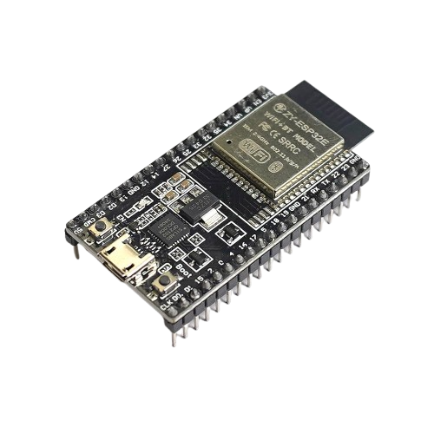
2. Laser Module:
• Emits a continuous laser beam toward the LDR sensor.
• Acts as an invisible light barrier; when someone crosses it, the beam is blocked.
• It serves as the main detection source for the system.
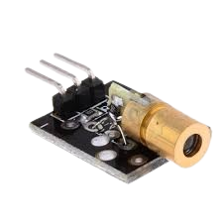
3. LDR (Light Dependent Resistor) Sensor:
• Detects the presence or absence of the laser beam.
• When light from the laser falls on it, the LDR has low resistance.
• If the beam is interrupted, its resistance increases sharply, signaling the ESP32 that someone has crossed the line.
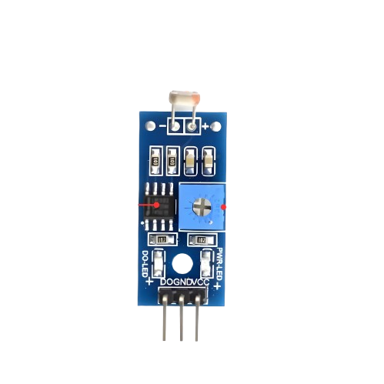

4. Buzzer:
• Works as an alert device that produces sound when the ESP32detects an interruption.
• It helps to immediately notify the user about the intrusion.
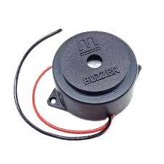

5. Resistors (10kΩ):
• Used in combination with the LDR to form a voltage divider circuit.
• Helps the ESP32 read accurate voltage changes based on light intensity.
• Also protects components by limiting current flow.
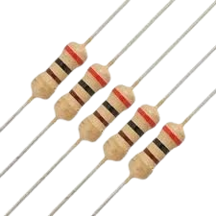
WORKING OF PROJECT
This project is designed to detect unauthorized movement or intrusion using a laser beam and an LDR sensor.
The system uses an ESP32 microcontroller connected to a Laser Module, LDR Sensor, and a Buzzer to sense beam interruption and alert the user immediately.

- Step-by-Step Working:
- Laser Beam Setup:
The Laser Module continuously emits a straight beam of light that falls directly on the LDR sensor.
As long as the light remains uninterrupted, the system stays in a normal or “safe” state.

- LDR Sensing:
The LDR (Light Dependent Resistor) constantly senses the laser light intensity.
When the light is present, the LDR has low resistance, and the ESP32 reads a stable voltage value.

- Intrusion Detection:
If any object or person crosses the path of the laser beam, the light falling on the LDR is blocked.
This causes the resistance of the LDR to increase sharply, leading to a sudden voltage change.
The ESP32 detects this change and identifies it as a possible intrusion.

- ESP32 Processing:
After detecting the interruption, the ESP32 processes the signal and triggers a connected buzzer to produce an alert sound.
In an advanced version, the ESP32 can also send a Wi-Fi notification to the user’s smartphone or IoT dashboard.

- Alert Activation:
The Buzzer starts beeping to indicate that the laser beam has been disturbed, warning the user about the intrusion or movement in the protected area.

- System Reset and Stability: After the alert, the system automatically returns to its normal state once the laser beam is restored.
The ESP32 resumes monitoring the LDR signal continuously for any further interruptions.
This makes the system self-resetting, stable, and ready for the next detection without manual intervention.

CIRCUIT DIAGRAM, TEAM WORK
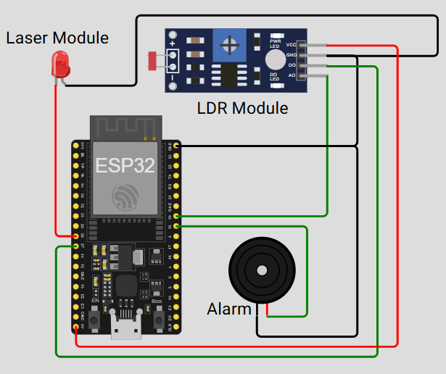

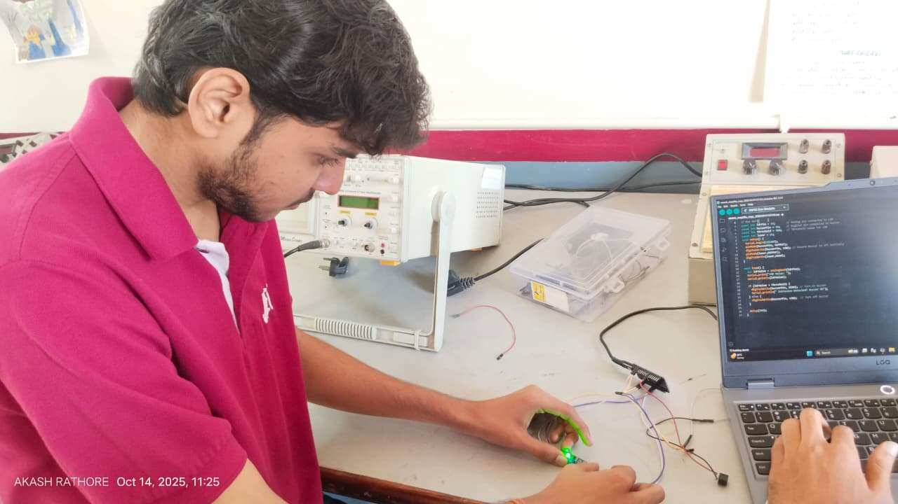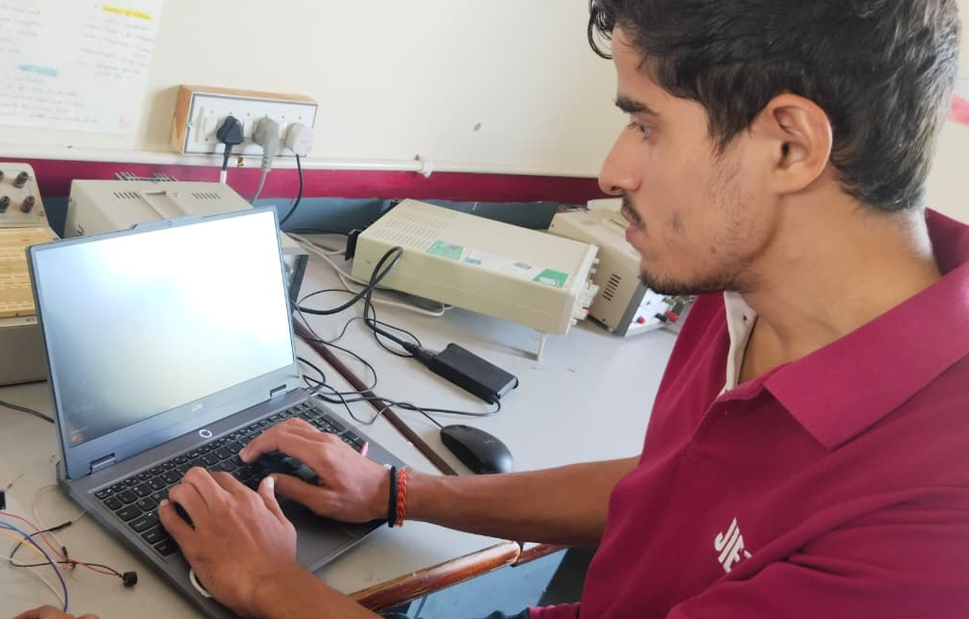
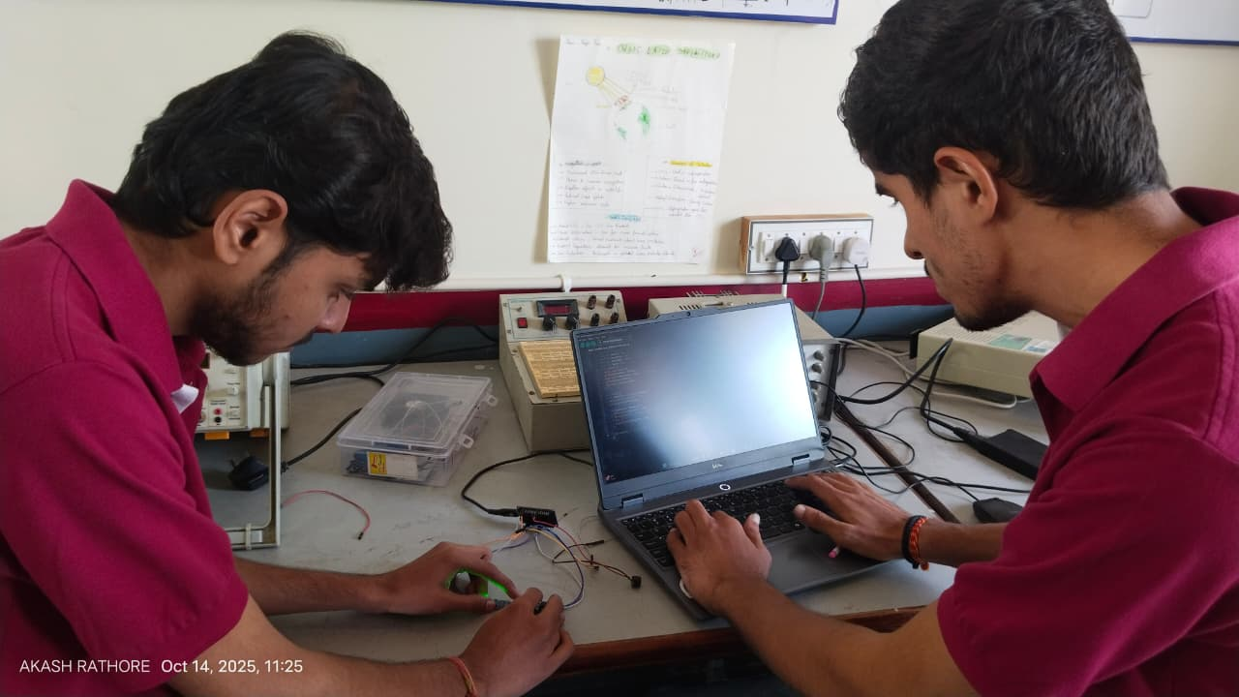
PURPOSE, FUTURE SCOPE AND APPLICABILITY
SCOPE:

The scope of the Laser Theft Detection System using ESP32 extends across the fields of security, electronics, and automation.
This project not only provides hands-on learning about sensors and microcontrollers but also demonstrates how simple components can be combined to create an effective security solution.
It includes the following aspects:

Learning and Implementation:
• Understanding the working of laser modules, LDR sensors, and ESP32 microcontrollers.
• Implementing a functional prototype that detects intrusions using light interruption and triggers an alert through a buzzer.

Applications in Real-World Devices:
• Integration into homes, offices, and banks for real-time theft detection and perimeter security.
• Can be used in restricted zones, storage areas, or parking lots where monitoring movement is essential.

Innovation and Research:
• Exploring how laser-based sensing and IoT can enhance smart security systems.
• Improving detection reliability using multiple sensors, wireless connectivity, and machine learning in future upgrades.

Future Expansion:
• Adding Wi-Fi or GSM modules for remote alert notifications via mobile or email.
• Developing a complete IoT-based monitoring system with cloud storage, camera integration, and real-time alerts.

PURPOSE:

The main purpose of this project is to design and implement a low-cost and efficient security system that can detect unauthorized access through laser interruption and immediately trigger an alert using a buzzer or alarm.

It aims to:

1.Help students understand the integration of sensors with microcontrollers.
– This project offers practical experience in interfacing LDRs, lasers, buzzers, and ESP32 using coding and circuit design.

2.Provide a smart and reliable method for theft detection.
– When someone crosses the laser beam, the system instantly identifies it and activates a buzzer or siren.

3.Enhance safety in homes and institutions.
– It ensures continuous monitoring and instant alert, preventing unauthorized access to secured areas.

4.Demonstrate how simple components can create efficient automated systems.
– It shows that effective security solutions can be made using minimal hardware and cost.

5.Encourage future innovation in security automation.
– This project serves as a base for developing advanced security models with AI, IoT, and real-time surveillance.

6.Promote awareness about smart and preventive security systems.
– By implementing this project, users understand how modern technology can help reduce theft and improve protection in everyday environments.

APPLICABILITY:

Home and Office Security
Used to secure doors, windows, and hallways by detecting any intrusion or movement when the laser beam is interrupted.

Banks and ATMs
Installed near safes or ATMs to detect unauthorized entry or tampering attempts and immediately alert security personnel.

Museums and Art Galleries
Protects valuable exhibits and artwork by triggering alarms when someone crosses restricted zones.

Warehouses and Storage Areas
Monitors valuable goods and prevents theft or unauthorized access during off-hours.

Military and Defense Zones
Provides a cost-effective way to secure boundaries and detect any unauthorized movement in sensitive areas.

Educational Institutions and Labs
Used for monitoring restricted labs or inventory rooms to prevent unauthorized access and equipment theft.

EXPENDITURE OF THE PROJECT

Component | Quantity | Approx. Cost (INR)
ESP32 Microcontroller | 1 | Rs.330
Laser Module | 1 | Rs.70
LDR Sensor | 1 | Rs.20
Buzzer | 1 | Rs.40
Resistor (10kΩ) | 1 | Rs.10
Power Supply  (5V or Battery) | 1 | Rs.100
TOTAL AMOUNT |  | Rs. 670

