
EXPLORATORY
PROJECT REPORT
SESSION 2024-2025
(I YEAR – I SEMESTER)

TOUCH SENSOR WITH LED

A MINOR PROJECT REPORT SUMITTED IN THE PARTIAL FULFILLMENT OF REQUIREMENT FOR THE AWARD OF DEGREE OF BACHELOR OF ENGINEERING IN
ELECTRONICS AND COMMUNICATION
THE TEAM COLLABORATION BY-
- AKASH RATHORE
- DARSHAN SHARMA
UNDER THE GUIDANCE OF –
- Mr. PREMA RAM
(Assistant Lecturer)
- Mr. AJAY KUMAR KUSHWAHA
(Assistant Lecturer)

TABLE OF CONTENTS

- INTRODUCTION

- HARDWARE REQUIREMENTS

- WORKING OF PROJECT

- CIRCUIT DIAGRAM

- PURPOSE, FUTURE SCOPE AND APPLICABILITY

- EXPENDITURE OF THE PROJECT

INTRODUCTION
Touch sensor technology has revolutionized the way we interact with electronic devices. From smartphones to modern home appliances, touch sensors provide intuitive and user-friendly interfaces.

Our project explores the working principle, design, and applications of touch sensors, focusing on their significance in creating innovative solutions. By simulating real-world scenarios, we aim to understand the efficiency and adaptability of this cutting-edge technology.

Incorporating touch sensors into everyday devices not only enhances user experience but also paves the way for smarter and more responsive systems. This technology represents a key step forward in bridging the gap between humans and machines."

The project aims to provide hands-on experience with sensor-based circuits, giving students a deeper understanding of how touch technology works and its integration into real-world systems. It also explores the potential for further innovation, such as incorporating touch sensors into multi-touch or gesture recognition systems. By working on this project, students not only develop technical skills in circuit design and troubleshooting but also gain insights into the vast scope of touch sensor applications, making it a valuable learning experience in the field of electronics and communication engineering.

This presentation will take you through the fundamentals of touch sensors, our project implementation, and the potential future advancements in this field."
HARDWARE REQUIREMENTS

Hardware of this project consists of a transistor, two resistors, an LED, Pushbutton switch.
The touch sensor circuit with a transistor works by utilizing the transistor as a switch that activates when a small voltage is applied through the touch input. When a conductive object, such as a human finger, touches the sensor plate (a metallic pad or wire), it allows a small current to flow into the base of the transistor. This current is enough to switch the transistor from its OFF state to the ON state.

Hardware Used:
1. TRANSISTOR: Touching the sensor plate sends a small current to the transistor's base, turning it ON and activating an output like an LED or buzzer. Removing the touch turns the transistor OFF.
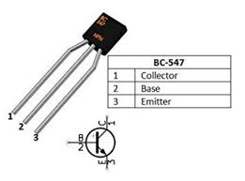
2. Resistors: A resistor is an electrical component that limits or regulates the flow of current in a circuit. It is used to protect components, divide voltage, and control current, ensuring the circuit operates safely and efficiently.

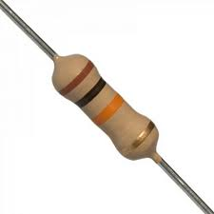

3. LED: An LED (Light Emitting Diode) is a semiconductor device that emits light when current flows through it. It is energy-efficient, long-lasting, and commonly used for indicators, displays, and lighting.

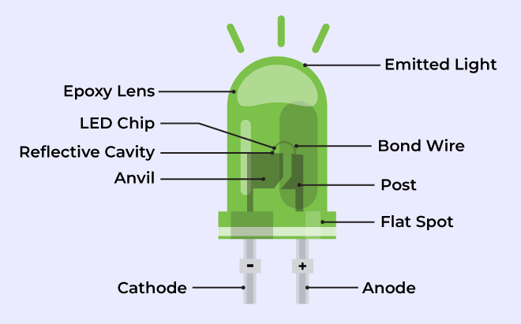
4. PUSHBUTTON: A pushbutton is a simple mechanical switch that opens or closes a circuit when pressed. It is commonly used for user input in devices, such as turning on/off systems or triggering actions.

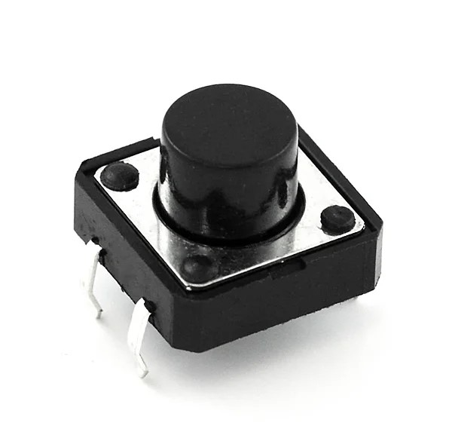

5. BATTERY: A battery is a portable energy source that stores electrical energy in chemical form and releases it as electrical power when needed. It consists of one or more electrochemical cells and is used to power electronic devices, from small gadgets to larger systems.

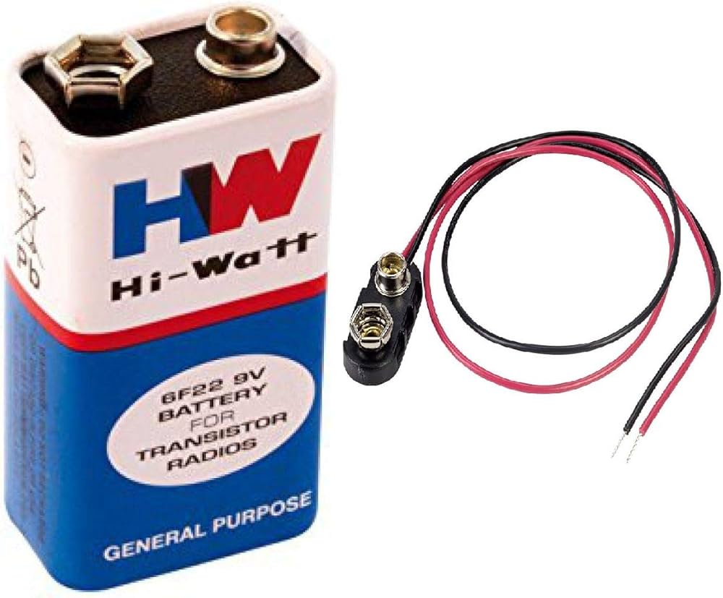
Hand tools:
1. Soldering Iron: A soldering iron is a tool used to melt solder, a metal alloy, to join electronic components together. It heats up to a high temperature, allowing the solder to flow and create strong electrical connections on circuit boards.

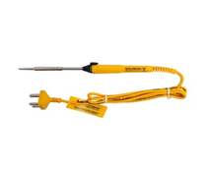
2. Wire Cutter: A wire cutter is a tool used to cut wires and cables. It has sharp blades that allow for clean, precise cuts, making it essential for electrical work, electronics, and general wire management.

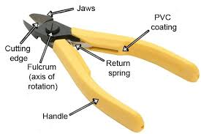
3. Drilling machine: A drill machine is commonly used for making precise holes in printed circuit boards (PCBs) to mount components. It ensures accurate placements and connections for soldering in electronic circuits.

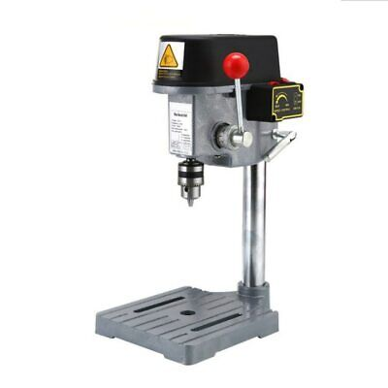

4. Variable Power Supply: A variable power supply is a device that provides adjustable voltage and current to power electronic circuits and devices. It is commonly used in precise control over the input power to match the requirements of various components or circuits.

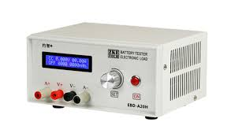
WORKING OF PROJECT
The touch sensor project operates by utilizing a simple circuit that detects physical touch and triggers an output, such as lighting up an LED. Here’s a step-by-step explanation of the working:
- Touch Detection:
  - The circuit includes a touch plate, which acts as the sensor. When a user touches the plate, their body provides a small current due to its natural capacitance and conductivity.
- Transistor Activation:
  - This small current is fed into the base of a transistor. The transistor acts as a switch, allowing a larger current to flow from the collector to the emitter when the base current is present.
- LED Illumination:
  - As the transistor switches ON, it completes the circuit, allowing current to flow through the LED. The LED lights up, indicating that touch has been detected.
- Role of Resistors:
  - Resistors are used in the circuit to limit the current flowing through the transistor and LED, ensuring their protection and preventing damage.
- Resetting or Deactivating:
  - If a pushbutton is incorporated, pressing it can reset the circuit, turning off the LED and preparing the system for the next touch.
- Power Supply:
  - The circuit is powered by a battery or a DC power source, which provides the necessary voltage for operation.
This working principle demonstrates how a touch sensor can convert a simple human touch into an electrical signal, triggering an action. The setup is scalable and can be adapted for more complex applications like controlling devices, activating alarms, or enhancing user interfaces.
TINKERCAD CIRCUIT AND DESIGN

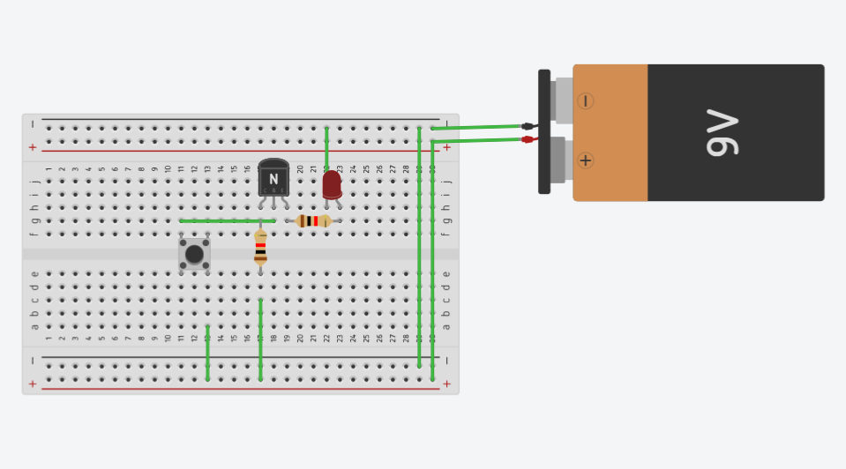

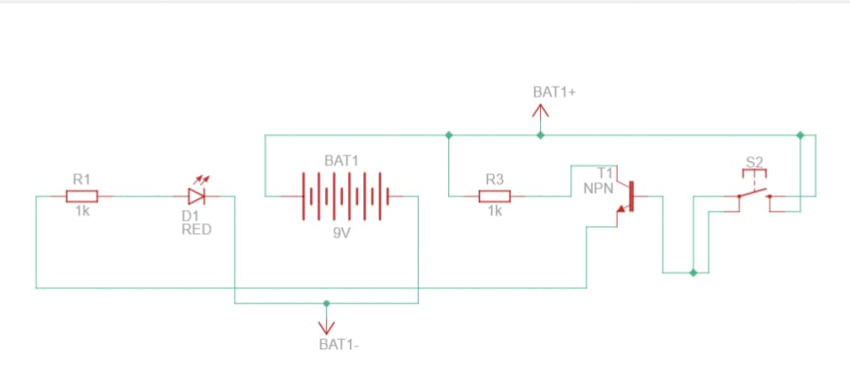
ESAYEDA CIRCUIT AND DESIGN
CIRCUIT DIAGRAM:
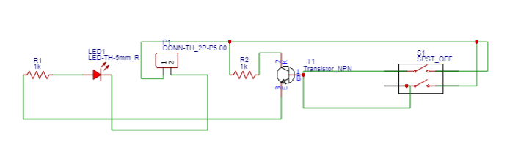

PCB ARTWORK WITH COMPONENTS:
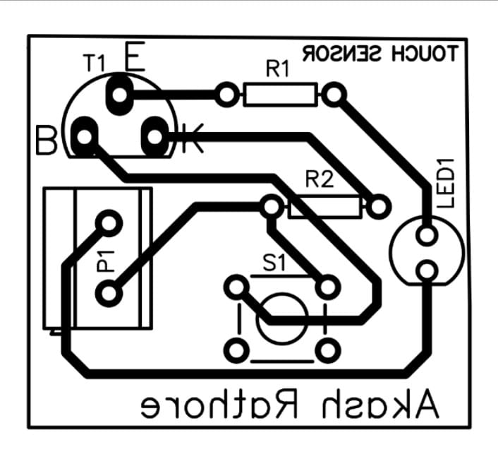
PCB ARTWORK WITHOUT COMPONENTS:
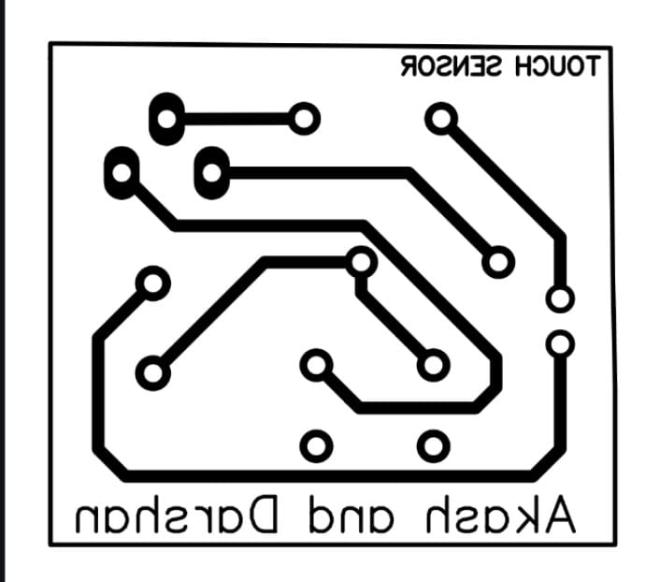
3D MODEL:

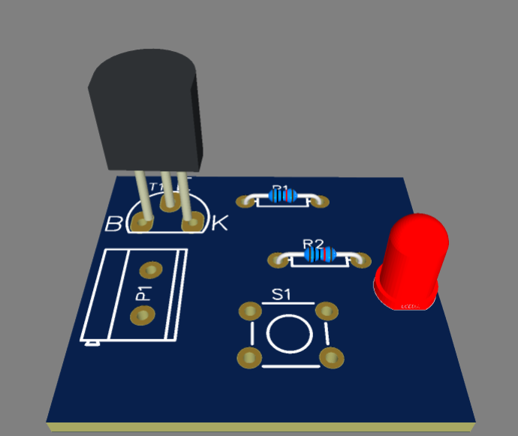
PCB MAKING
BREADBOARD CIRCUIT:
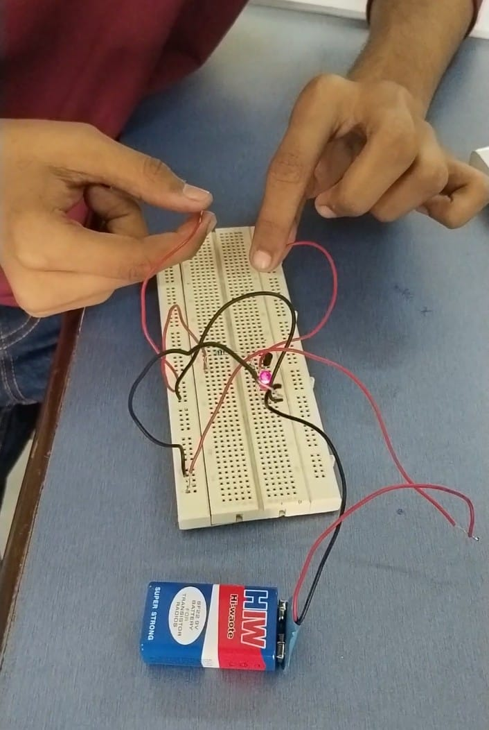
PCB:
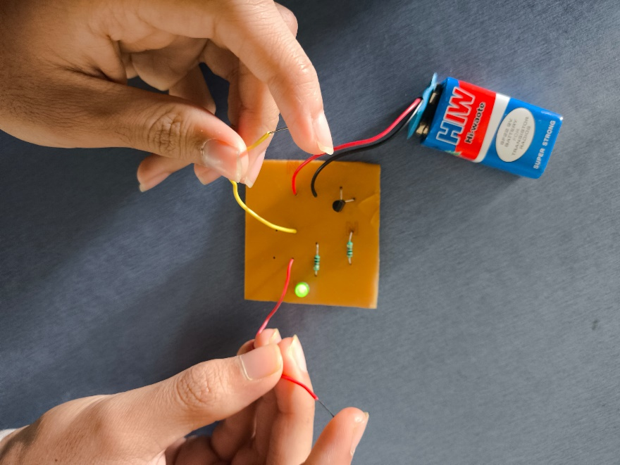

PCB SUBMITON:
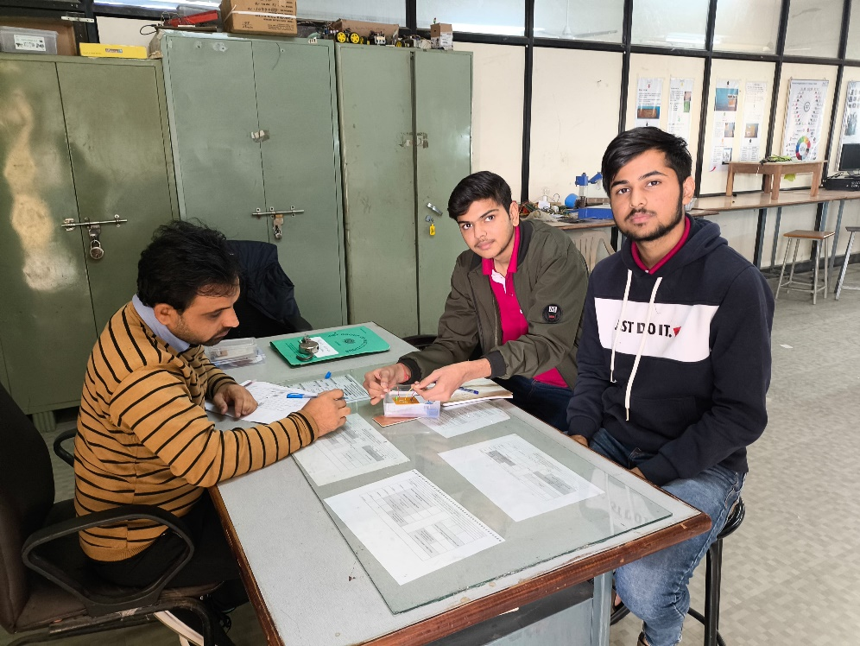
PURPOSE, FUTURE SCOPE AND APPLICABILITY

SCOPE: The scope of the touch sensor project is vast and extends across various fields of technology and innovation. It includes the following aspects:
- Learning and Implementation:
  - Understanding the principles of touch-based sensing technology.
  - Implementing a functional prototype to demonstrate its working.
- Applications in Real-World Devices:
  - Integration into home automation systems, such as touch-controlled lights or appliances.
  - Use in consumer electronics like smartphones, laptops, and wearable devices.
- Innovation and Research:
  - Exploring new ways to use touch sensors in robotics, medical devices, and industrial control systems.
  - Advancing user interfaces for enhanced interactivity and efficiency.
- Skill Development:
  - Developing practical skills in circuit design, microcontroller programming, and troubleshooting.
  - Gaining experience with components like transistors, resistors, and capacitive touch sensors.
- Future Expansion:
  - Adapting the project for advanced applications, such as multi-touch interfaces or gesture recognition.
  - Incorporating wireless communication for IoT (Internet of Things) integration.

Purpose:
The primary purpose of the touch sensor project is to design a system that replaces traditional mechanical buttons with a touch-based interface, offering a modern, efficient, and durable solution. This project demonstrates the practical application of touch sensor technology by detecting physical touch and converting it into an electrical signal to trigger an output, such as lighting up an LED.
It aims to:
- Provide hands-on learning about touch-sensitive circuits and their components.
- Showcase the functionality and advantages of touch technology, such as seamless operation and reduced wear and tear.
- Highlight real-world applications in home automation, electronics, and industrial systems.
- Encourage innovation in developing advanced touch-based systems for user-friendly and intuitive interfaces.
The project serves as a stepping stone for exploring cutting-edge technologies like gesture recognition and multi-touch interfaces, paving the way for integration into modern devices and systems.

APPLICABILITY:
1.Home Automation
  - Touch-controlled lights, fans, and appliances for intuitive operation.
- Consumer Electronics
  - Integration in smartphones, laptops, smartwatches, and other gadgets.
- Industrial Automation
  - Replacing mechanical buttons in control panels for enhanced durability.
- Healthcare
  - Non-invasive and responsive control in medical devices.
- Robotics
  - Enhancing human-machine interaction for advanced robotics applications.
- Education
  - Teaching sensor-based technologies and circuit design principles.
- Research and Development
  - Exploring IoT, gesture recognition, and innovative user interfaces.
- Public Utility Systems
  - Use in ATMs, kiosks, and other touch-based public devices for improved usability.

EXPENDITURE OF THE PROJECT

Component | Quantity | Approx. Cost (INR)
Transistor ( BC547) | 1 | Rs.5-10
Resistors | 2-3 | Rs.2-5 each
LED | 1 | Rs.5-10
Pushbutton (Optional) | 1 | Rs.10-15
Battery (9V) | 1 | Rs.50-100
Battery Clip/Connector | 1 | Rs.10-20
Breadboard/PCB | 1 | Rs.50-100
Connecting Wires | 1 | Rs.10-20
TOTAL AMOUNT |  | Rs.300

