
EXPLORATORY
PROJECT REPORT
SESSION 2024-2025
(I YEAR – II SEMESTER)

VOICE CONTROL HOME AUTOMATION SYSTEM

A MINOR PROJECT REPORT SUMITTED IN THE PARTIAL FULFILLMENT OF REQUIREMENT FOR THE AWARD OF DEGREE OF BACHELOR OF ENGINEERING IN
ELECTRONICS AND COMMUNICATION

THE TEAM COLLABORATION BY-
- AKASH RATHORE
- DARSHAN SHARMA
UNDER THE GUIDANCE OF
- Mr. PREMA RAM
(Assistant Lecturer)
- Mr. AJAY KUMAR KUSHWAHA
(Assistant Lecturer)

TABLE OF CONTENTS

- INTRODUCTION

- HARDWARE REQUIREMENTS

- WORKING OF PROJECT

- CIRCUIT DIAGRAM

- PURPOSE, FUTURE SCOPE AND APPLICABILITY

- EXPENDITURE OF THE PROJECT

INTRODUCTION
- Today, technology is helping us make our homes smarter and more comfortable. One of the easiest and modern ways to control home appliances is by using our voice. In this project, we have made a Voice Controlled Home Automation System that works completely offline, meaning it does not need the internet to work.

- We are using an Arduino Uno as the main controller. With the help of a voice recognition module and a relay module, this system can control devices like lights and fans just by using voice commands. The best part is that everything works without Wi-Fi or mobile data.

- We are using an Arduino Uno as the main controller. With the help of a voice recognition module and a relay module, this system can control devices like lights and fans just by using voice commands. The best part is that everything works without Wi-Fi or mobile data.

- We are using an Arduino Uno as the main controller. With the help of a voice recognition module and a relay module, this system can control devices like lights and fans just by using voice commands. The best part is that everything works without Wi-Fi or mobile data.
HARDWARE REQUIREMENTS

Hardware of this project includes an Arduino Uno, a voice recognition module, a relay module, an LED, and a few resistors and connecting wires. These components work together to control electrical devices using voice commands. The Arduino receives input from the voice module and activates the relay to turn devices ON or OFF.

1. Arduino Uno: Acts as the brain of the system, processing voice commands. It controls the relay module based on the input received from the voice module.
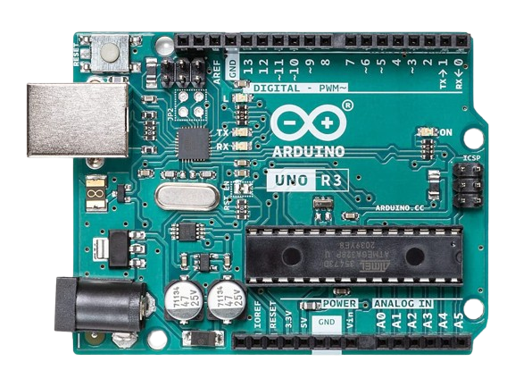

2. Voice Recognition Module:
- Listens and stores specific voice commands offline.
- Sends recognized command signals to the Arduino for further action.
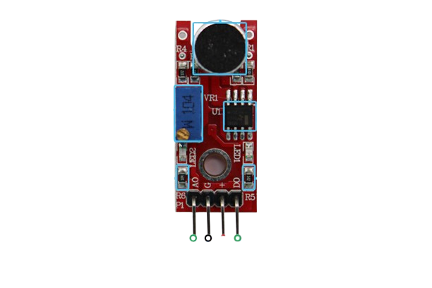
Digital Output
VCC
GND
Analog Output

3. Relay Module: Works as an electronic switch to control AC appliances. It is triggered by signals from the Arduino to turn devices ON or OFF.
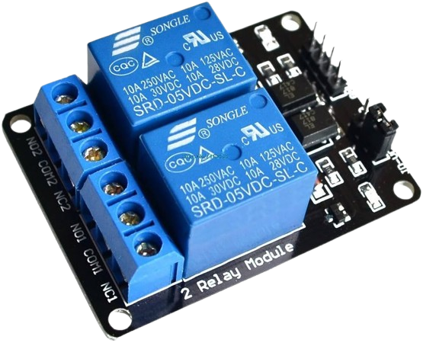
4. Mini DF Player: Mini DF Player is a small and low-cost MP3 module that can play audio files from a micro SD card. It is often used to give voice feedback or audio alerts in embedded systems and automation projects.
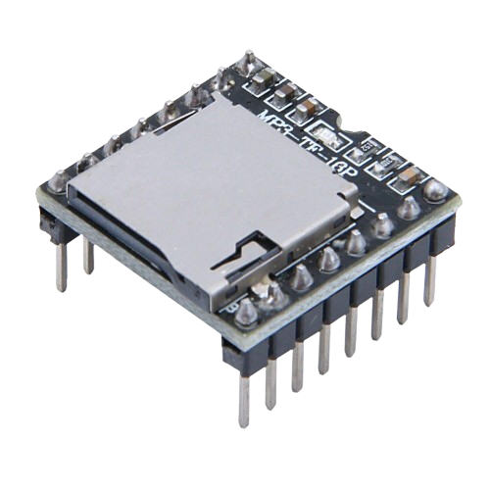
5.SD CARD: The SD card stores audio files (like MP3) that the Mini DF Player reads and plays. It acts as the memory source for storing commands, alerts, or instructions in audio form.

6.DC Fan: The DC fan is one of the output devices controlled by the voice commands. It turns ON or OFF through the relay module based on the user's spoken instructions.
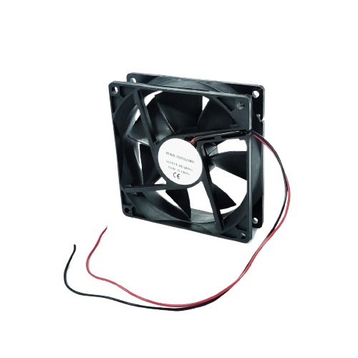
7. LED/Bulb: The LED or bulb is used as an output device to indicate the result of a voice command. It is controlled through the relay module and switches ON or OFF based on user input.

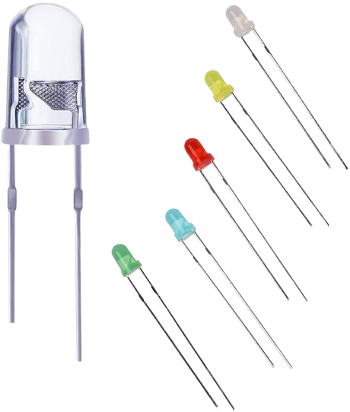
WORKING OF PROJECT
This project is designed to control home appliances like lights or fans using voice commands without any internet connection. The system uses a Voice Recognition Module connected to an Arduino Uno and a Relay Module to operate electrical devices.
👉 Step-by-Step Working:
1. Voice Command Input: The user speaks a predefined command (like “Light On” or “Fan Off”). The Voice Recognition Module listens and compares the spoken word to its stored voice commands.
2. Voice Recognition Module Processing: If the command matches a trained phrase, the module sends a specific signal or code to the Arduino Uno.
3. Arduino Uno Decision Making: The Arduino receives the command and checks what action is required (e.g., turn ON or OFF a particular device). Based on the command, it sends a HIGH or LOW signal to the Relay Module.
4. Relay Activation: The relay module acts like a switch. When it receives the signal from the Arduino, it either connects or disconnects the AC power supply to the appliance.
CIRCUIT DIAGRAM AND DESIGN

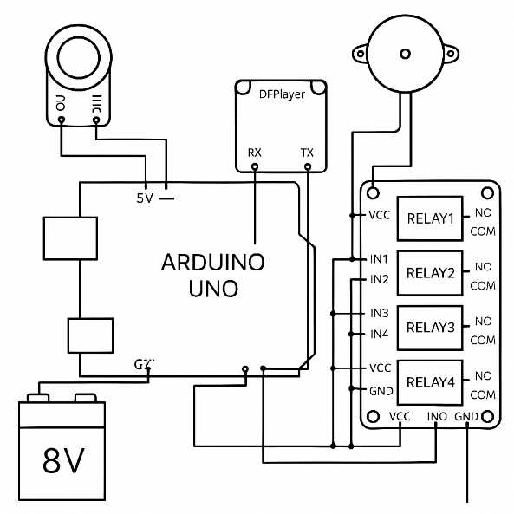
VOICE CONTROL HOME
AUTOMATION CIRCUIT Diagram

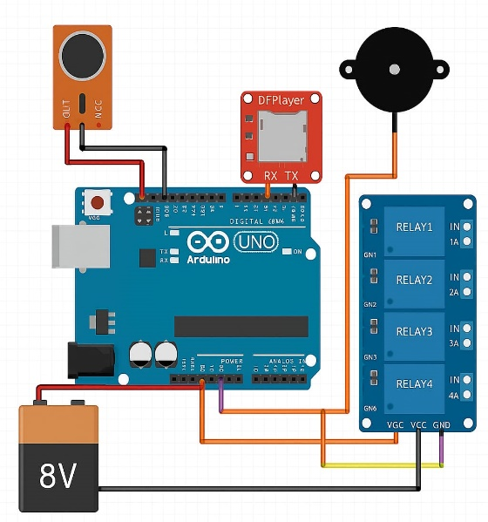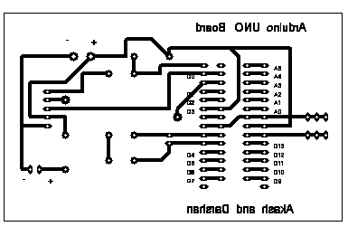
PCB Circuit Diagram
VOICE CONTROL HOME
AUTOMATION 2D MODEL

2. SOLDERING PROCESS:
1. DRILLING PROCESS:

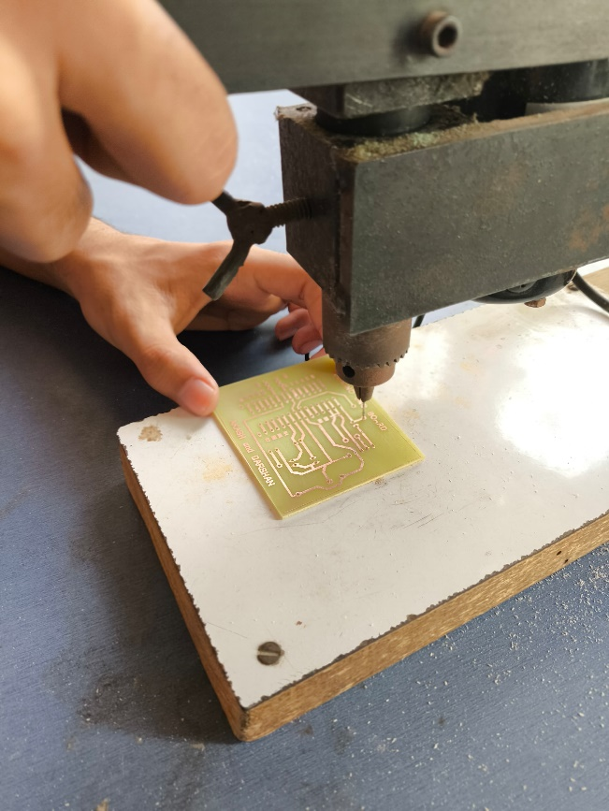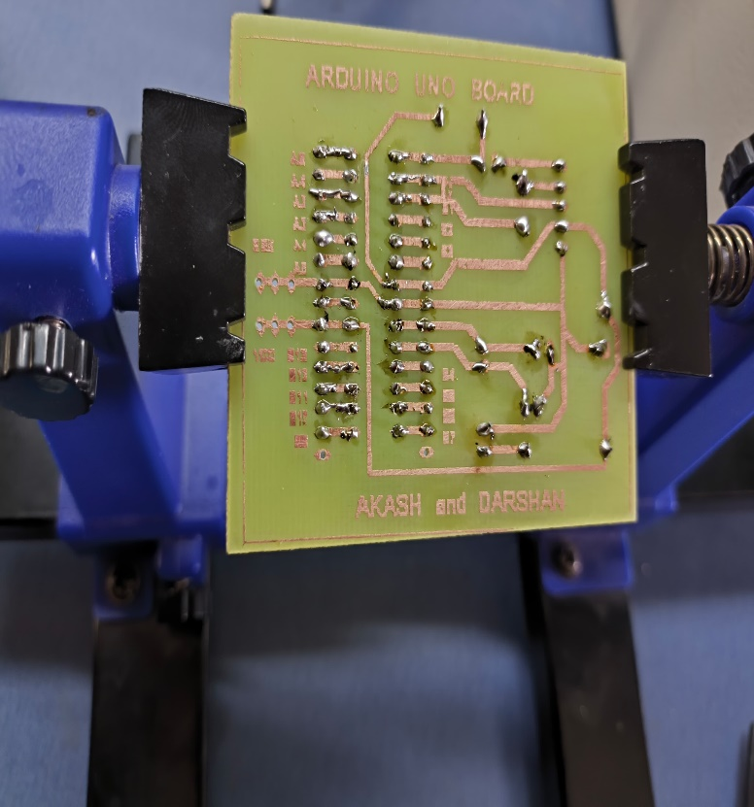
3. PCB TESTING:
4. PCB CMPLETED:

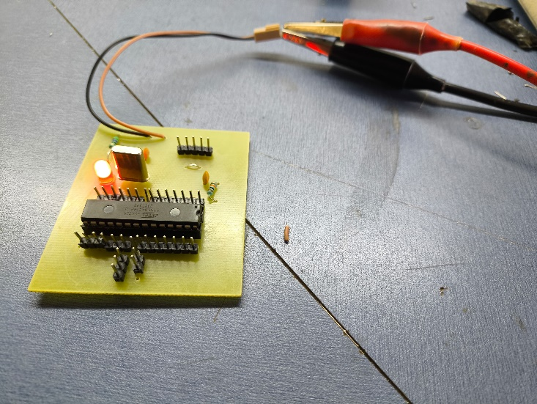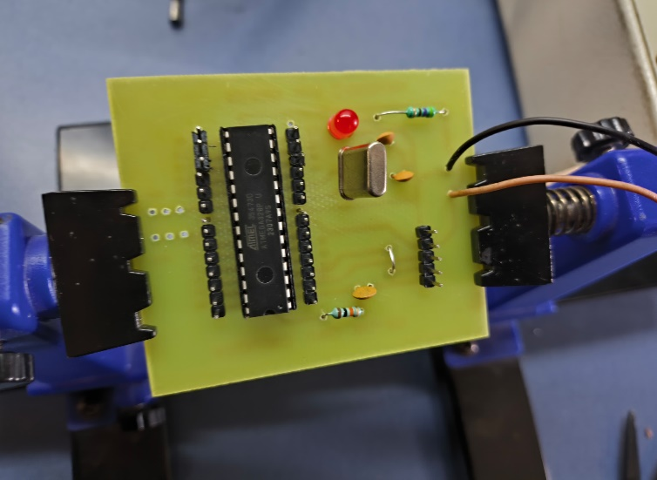

Team Work
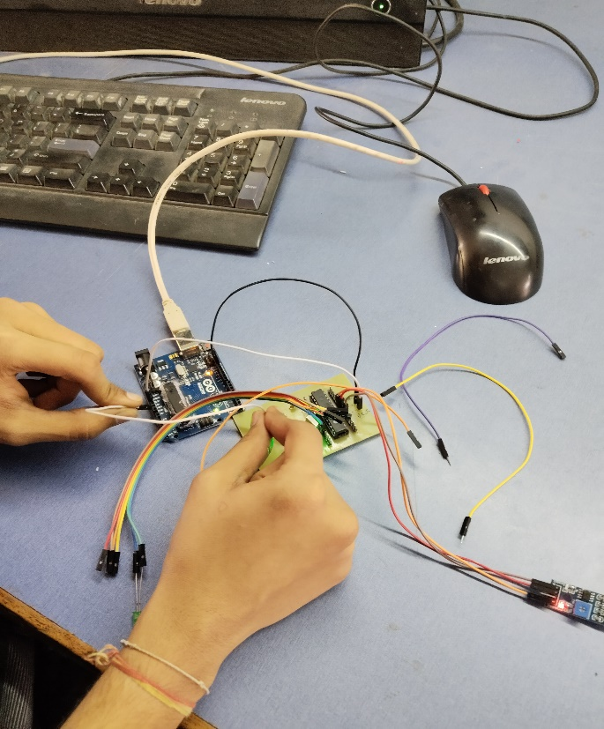
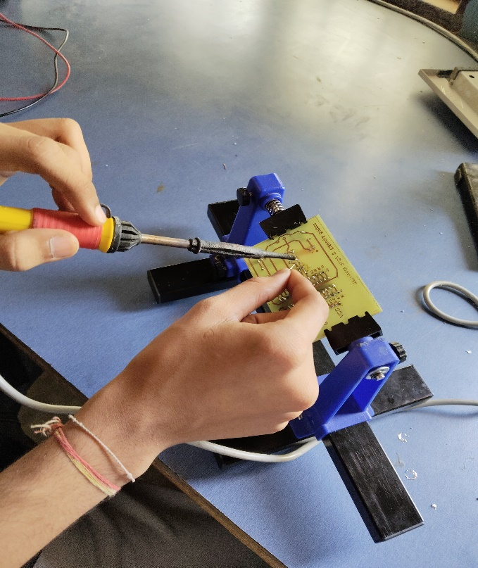

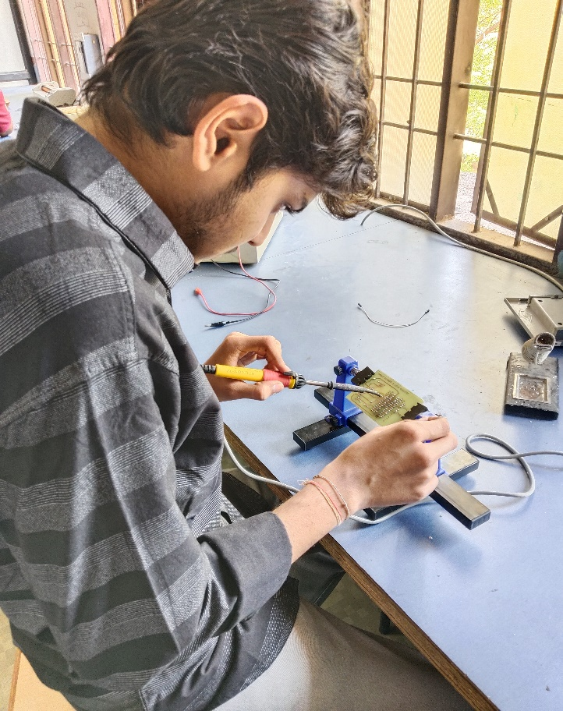
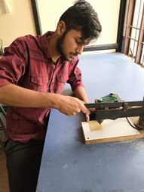

PURPOSE, FUTURE SCOPE AND APPLICABILITY

SCOPE: The scope of the voice control home automaton project is vast and extends across various fields of technology and innovation. It includes the following aspects:
1.Learning and Implementation: Understanding the working of voice recognition modules and microcontrollers.
- Implementing a functional offline prototype using Arduino and relays.
2. Applications in Real-World Devices: Integration into smart homes for controlling lights, fans, and appliances via voice.
- Use in environments where hands-free operation is beneficial, like hospitals and homes for elderly
3. Innovation and Research: Exploring the use of voice commands for automation in industrial and security systems.
- Enhancing offline voice interaction to increase reliability and privacy.
4. Future Expansion: Adding Bluetooth, Wi-Fi, or mobile app support for hybrid voice + app control. Enabling personalized commands, multi-language support, and IoT integration.

Purpose: The main purpose of the voice-controlled home automation project is to control home appliances using voice commands without needing the internet. It uses a voice module and microcontroller to turn voice into actions like switching on a light or fan.

It aims to:

1. Help students understand how voice recognition and electronics work together in real-life projects.
– This project gives practical experience in working with sensors, modules, and coding.

2. Make daily life easier by letting people control devices without touching switches.
– Just say “Light On” or “Fan Off” and the system will do it for you.

3. Show how useful voice control can be in smart homes, hospitals, and for people with limited mobility.
– It brings comfort and independence to those who need it the most.

4. Promote smart systems that are simple, low-cost, and work offline (without Wi-Fi).
– No need for the internet, making it useful even in rural or low-network areas.

5. Encourage future development in automation using artificial intelligence and smart home technologies.
– This project is just the beginning; it can lead to more advanced systems using gestures or mobile apps.
APPLICABILITY:
1. Home Automation
Control lights, fans, and appliances using voice commands, making daily life easier and hands-free.
2. Assisted Living for Elderly and Disabled
Helps people with limited mobility operate household devices just by speaking, increasing independence and safety.
3. Smart Offices
Use voice control to manage lighting, projectors, air conditioning, and other devices for better efficiency and convenience.
4. Hotels and Hospitality
Enhance guest experience by allowing them to control room features like lights, TV, and AC using voice assistants.
5. Healthcare Facilities
Voice control reduces the need for touch in sensitive environments, helping maintain hygiene and comfort for patients.
6. Educational Institutions
Automate classroom environments—control smart boards, lights, and fans with simple voice commands to improve teaching setups.

EXPENDITURE OF THE PROJECT

Component | Quantity | Approx. Cost (INR)
ATmega328P-PU | 1 | Rs.250
Relay Module (4-Channel) | 1 | Rs.180
DF Player | 1 | Rs.150
Microphone Module | 1 | Rs.80
DC Fan | 1 | Rs.80
Battery | 1 | Rs.80
LED | 1 | Rs.10
TOTAL AMOUNT |  | Rs. 830

