**Appendix**

Figure 1: BASIC CHAID MODEL_Summary 1

Figure 2: BASIC CHAID MODEL_Tree_Viewer 2

Figure 3: BOOSTING_Summary 2

Figure 4: Boosting Summary_1 3

Figure 5: Boosting Summary_Component Models 3

Figure 6: Bagging_Summary 4

Figure 7: Bagging_Summary_1 4

Figure 8: Predictor Importance 5

Figure 9: Neural Network 5

Figure 10: Predictor Importance 6

Figure 11: Neural Network 6

Figure 12: Predictor Importance 7

Figure 13: Predictor Importance 7

Figure 14: Predictor Importance 8

Figure 15: Neural Network 8

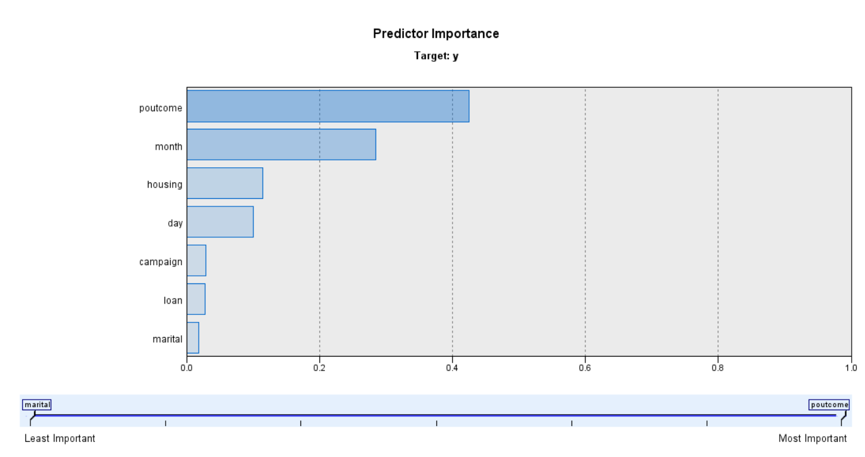

Figure 1: BASIC CHAID MODEL_Summary

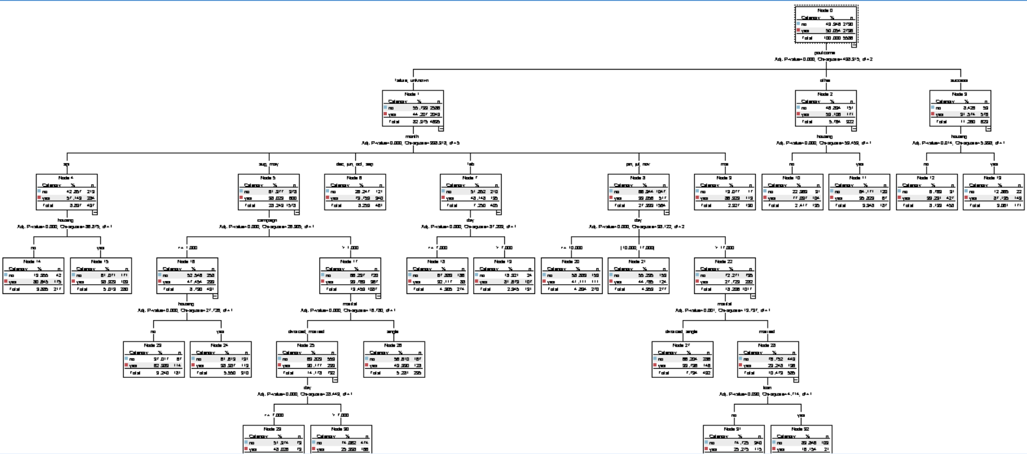

Figure 2: BASIC CHAID MODEL_Tree_Viewer

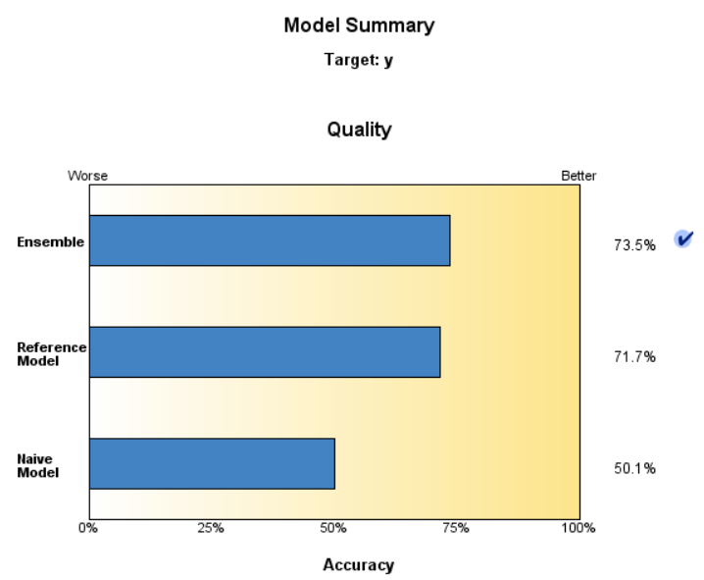

Figure 3: BOOSTING_Summary

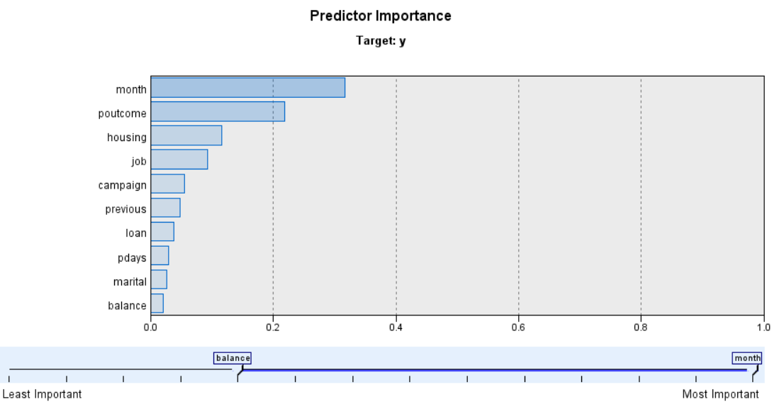

Figure 4: Boosting Summary_1

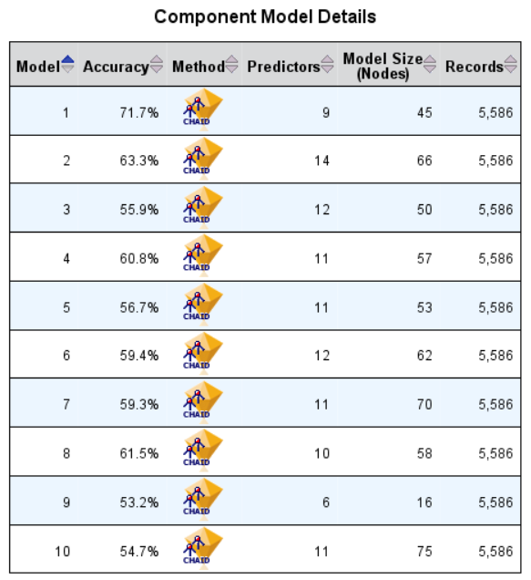

Figure 5: Boosting Summary_Component Models

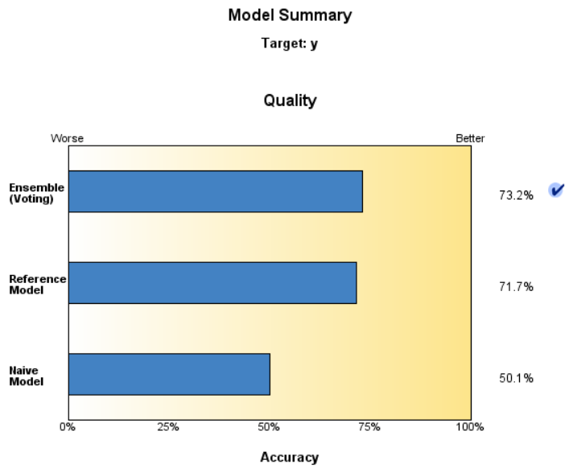

Figure 6: Bagging_Summary

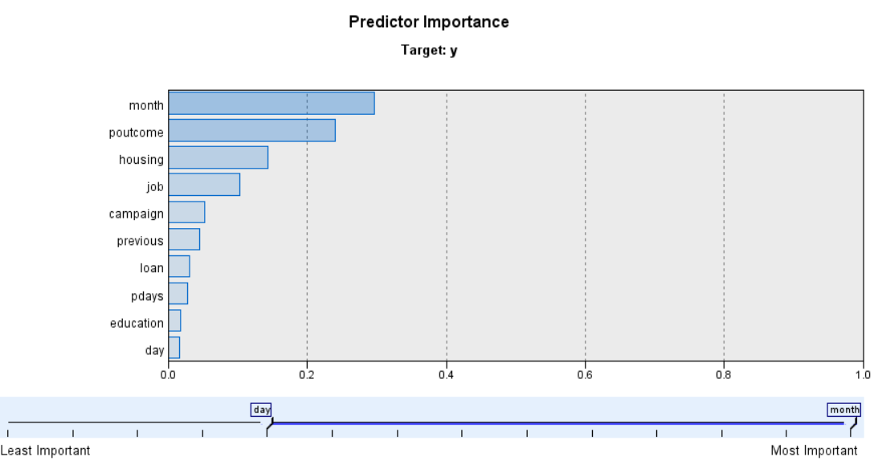

Figure 7: Bagging_Summary_1

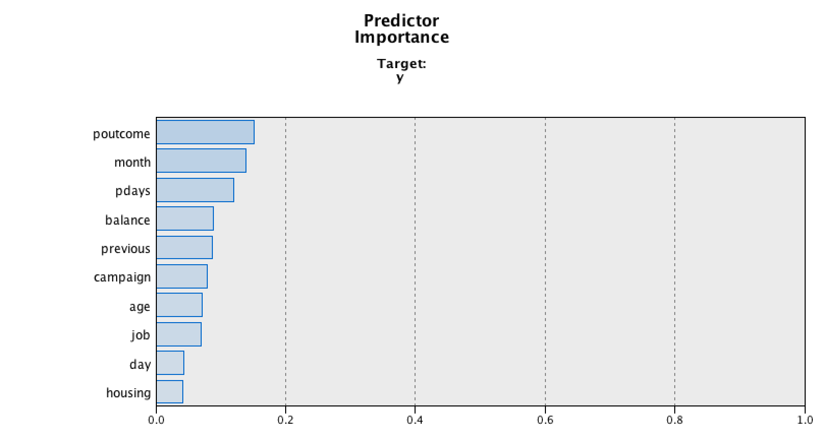

Figure 8: Predictor Importance

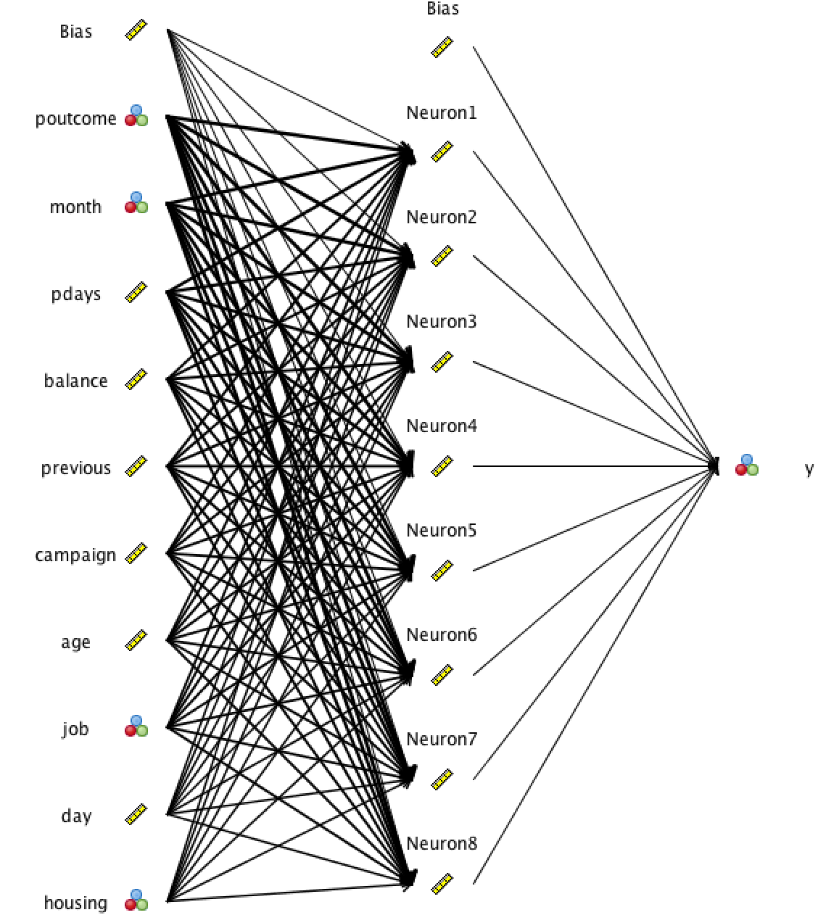

Figure 9: Neural Network

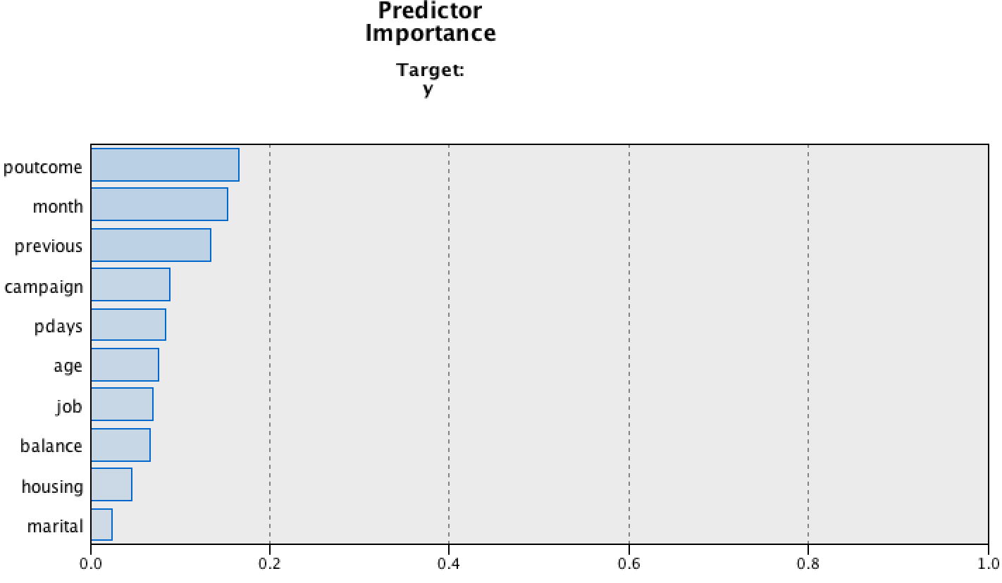

Figure 10: Predictor Importance

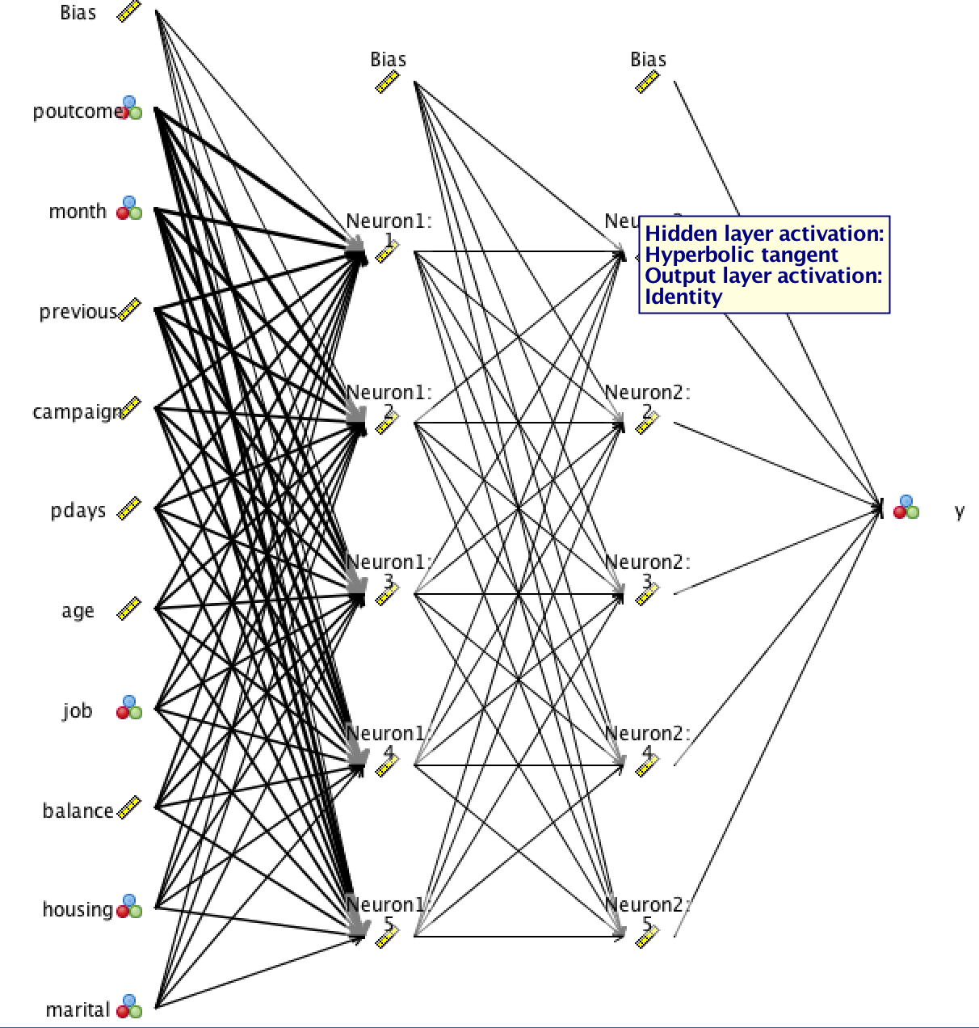

Figure 11: Neural Network

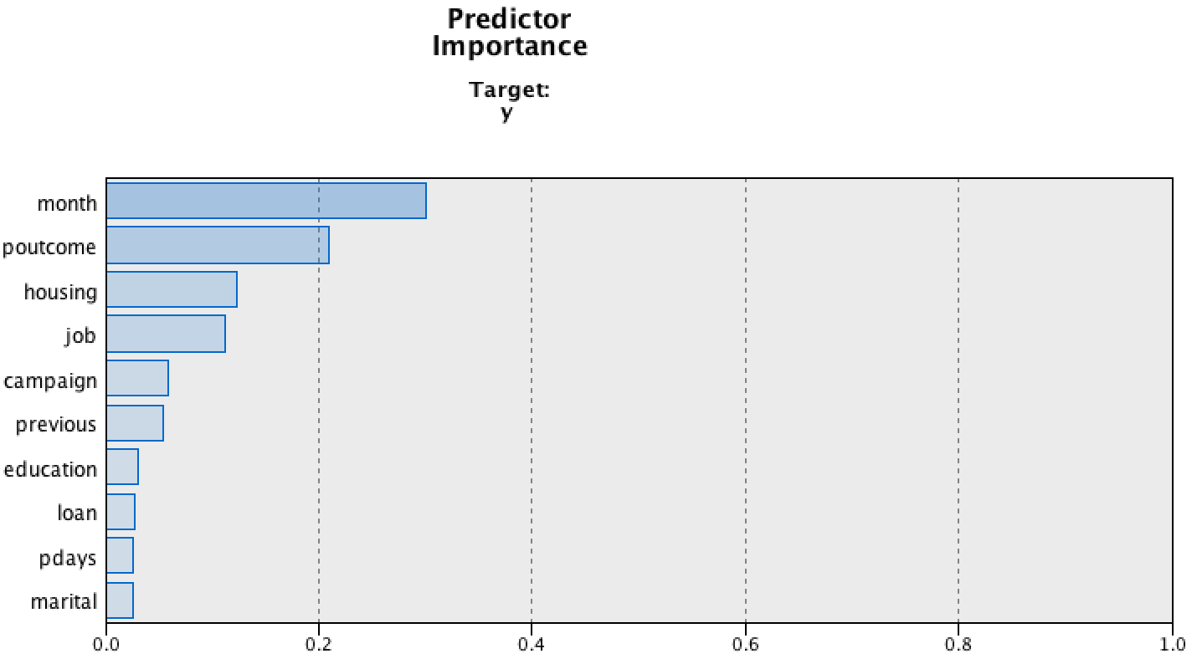

Figure 12: Predictor Importance

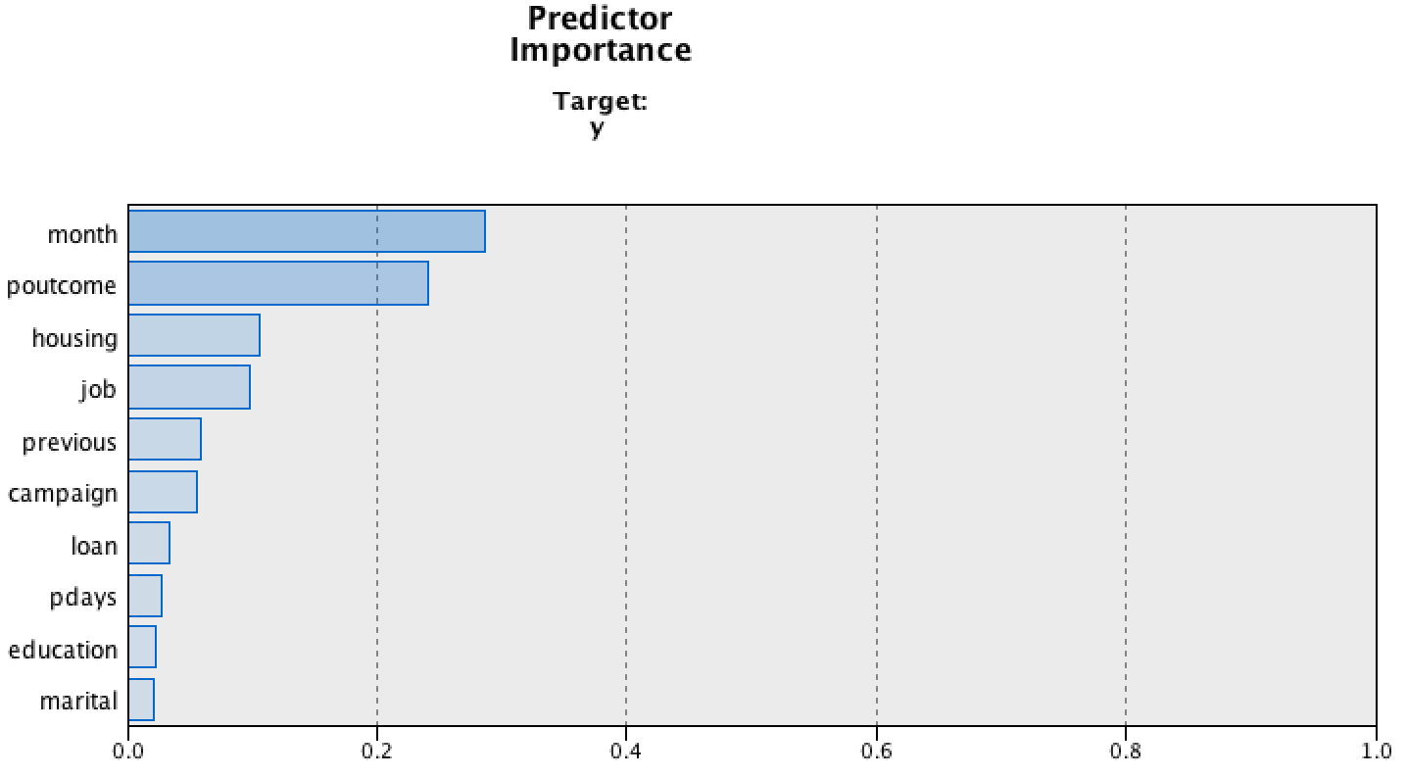

Figure 13: Predictor Importance

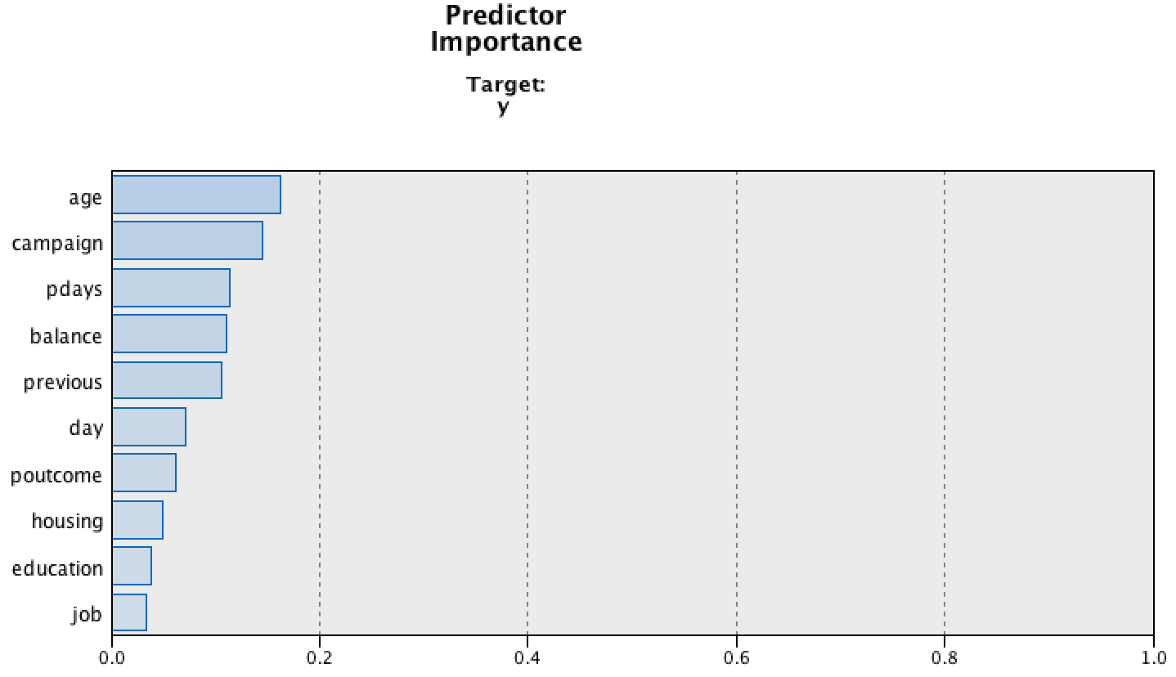

Figure 14: Predictor Importance

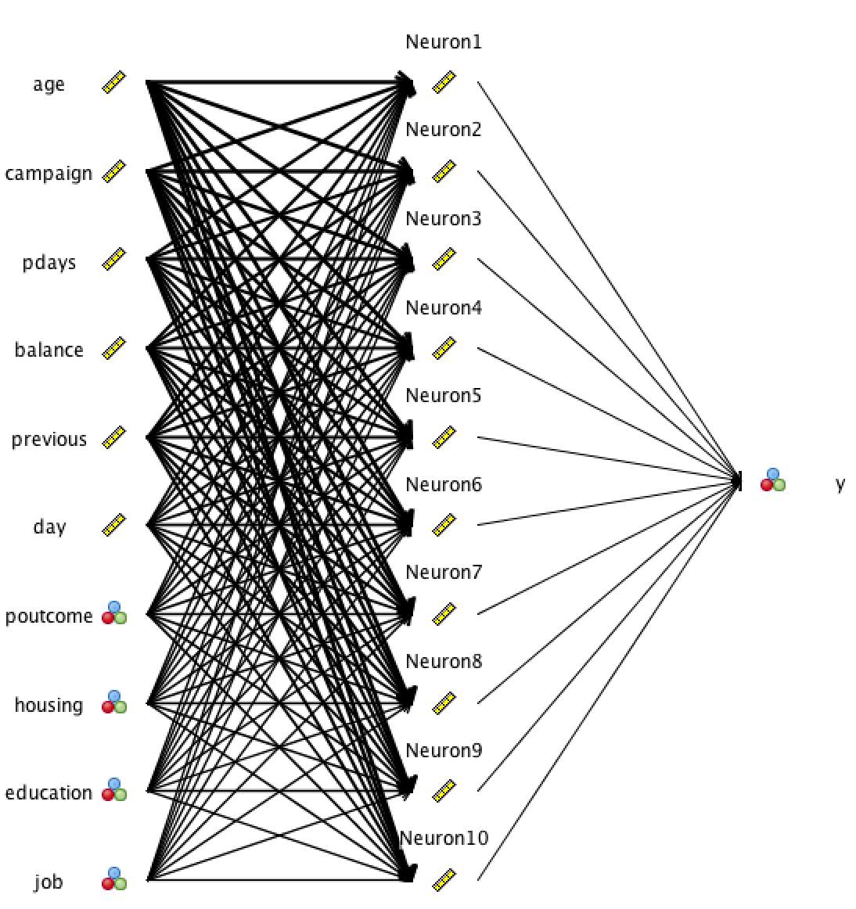

Figure 15: Neural Network

## 