Angular
Download & Install Node
Open Command line
Command Description
---------------------------------------------------------------------------------
Node –v check node version

Npm –v check npm version

npm install -g @angular/cli Install Cli

ng version check current version of Angular

D: User move in D drive

Mkdir abc Make folder with name abc

Cd abc move in abc directory

Ng new blog create project with name blog

Code . open project in VS Code
Ng s Run project

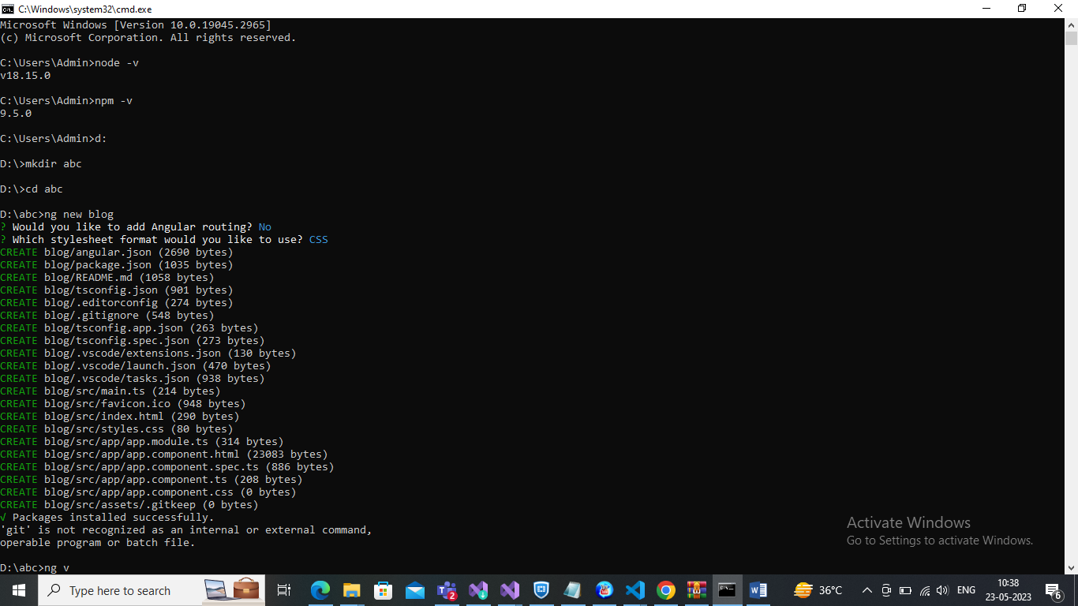

Component Generate
Cmd:
Ng generate component Component_Name
Ng g c Componet_Name

Module Generate
Cmd:
Ng g m Module-Name

Now create Component inside Module
Cmd:
Ng g c Module-Name/component_name

Now Generate class
Cmd:
Ng g class class_Name

Build
Cmd:
Ng build

Generate Component with Item Style
Cmd
Ng g c component_Name –inline-Style

Generate Component with Item Style
Cmd
Ng g c component_Name –inline-Template

Bootstrap Install
Cmd: npm i bootstrap
Now open angular.json file and add bootstarp inside style
"styles": [
"node_modules/bootstrap/dist/css/bootstrap.min.css",
"src/styles.css"
],

For loop
In html file
<p *ngFor="let items of userDetail">

{{items.name}} {{items.email}} {{items.age}}

</p>

In .ts file
userDetail=[
{name:'xyz',email:'xyz@gmail.com',age:'12'},
{name:'abc',email:'abc@gmail.com',age:'16'},];

IF Else Condition
We have work with html and .ts page,below show code in html
<h1>if else condition </h1>

<p *ngIf="show>11; then ifblock else elseblock">

</p>

<ng-template #ifblock>
{{show}} is bigger
</ng-template>

<ng-template #elseblock>
{{show}} is smaller
</ng-template>

Nested If Else Condition

<ng-template [ngIf]="color==='Red'" [ngIfElse]="elseb">
<p style="color: red;"> Color is {{color}} </p>

</ng-template>

<ng-template [ngIf]="color==='Green'">
<p style="color: green;"> Color is {{color}} </p>

</ng-template>

<ng-template #elseb>
<p style="color:brown"> No color </p>

</ng-template>

In .ts file
show=10;
color='Blue'

Switch Case

<h1>Switch case</h1>

<div [ngSwitch]="color">

<h1 *ngSwitchCase="'Red'" style="color: red;"> Color is Red</h1>

<h1 *ngSwitchCase="'Green'" style="color: green;"> Color is Green</h1>

<h1 *ngSwitchCase="'Blue'" style="color: blue;"> Color is Blue </h1>

<h1 *ngSwitchDefault="" style="color: black;"> Unknown Color </h1>

</div>

Work With Function
In .ts file
users=["Anil","Dhiraj","Shobit","Surya","Subham","Gaurav","Akash"];

getdata(users:any)
{
return this.users ;
}

In html file
<h1>Function call</h1>

{{getdata(data)}}

Call function on button click
In Html
<button (click) ="getname()"> call fun</button>
In .ts
getname()
{
alert("call");
}

Dynamic Style
Change Color & background Color on button click
In .ts page
coloor="black";
bgcolor="red"

updateColor(parm1:any,param2:any)
{
alert("ok");
this.coloor=param2
this.bgcolor=parm1
}

In html page
<div [style.color]="coloor" [style.backgroundColor]="bgcolor">
<h1>Hello</h1>

</div>

<button (click)="updateColor('black','white')">Color change </button>

Routing
Routing set in app-routing.module.ts file
Routing is set in
const routes:Routes = [ ];
Before routing

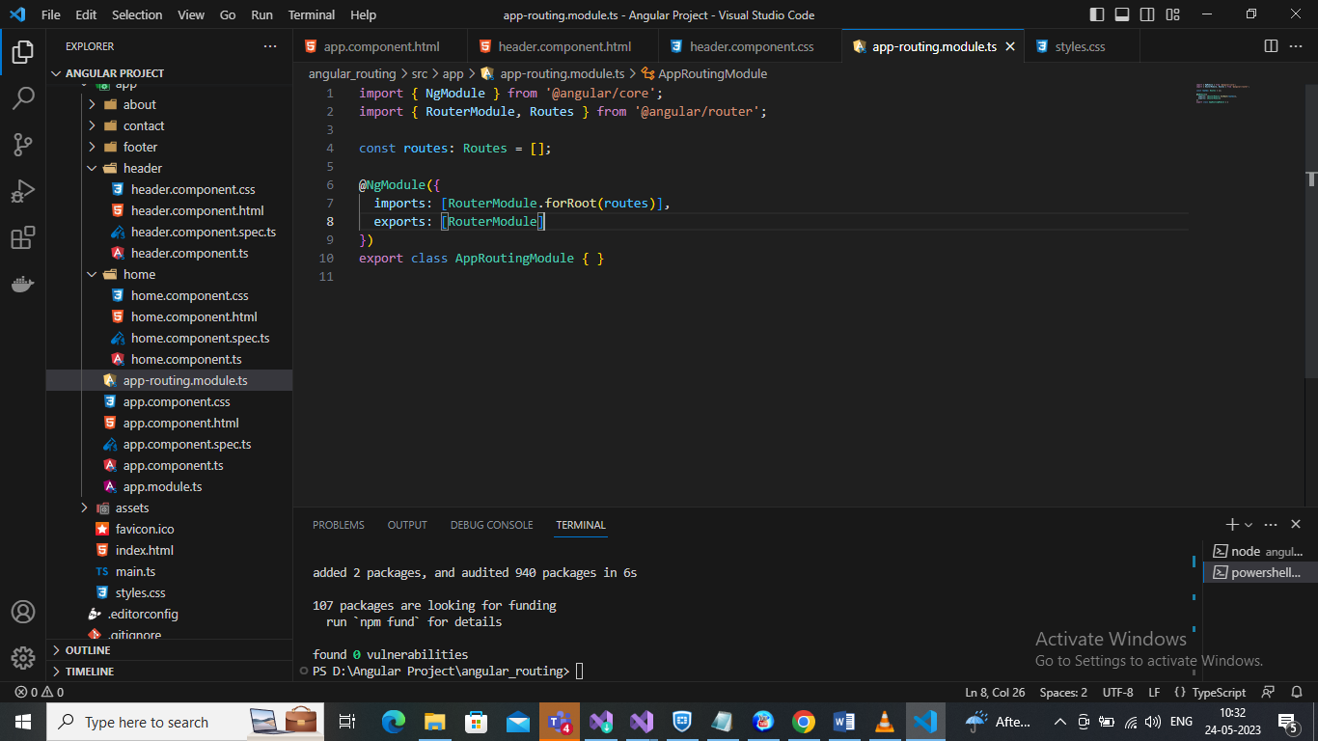

After Add Routing
const routes:Routes = [
{
path:’home’
component:HomeComponent
},
{
path:’about’
component:AboutComponent
}, ];
Two Way Data Binding
Property binding : Data transfer from Component to View
Event Binding: Data transfer from view to Component
When data is transfer from component to view or view to component is called Two way data binding , which is [ngModle].

Template Form
We can create normal form like html
But we need to be add something for template form which is
- Go inside >> app.module.ts and import
import { FormsModule } from '@angular/forms';

- In same page import FormsModule like
- imports: [
- BrowserModule,
- AppRoutingModule,
- FormsModule

- ],

Now Move on Component.html page and add

<form #login=”ngForm” (onSubmit)=”GetData(login.value)”>

<input type=”text” name=”name” ngModel />
<input type=”text” name=”age” ngModel />
<input type=”text” name=”contact” ngModel />
<button> SignUp </button>
</form>

Now Move on .ts page and Add

GetAllData(data:any)
{
Console.log(data)
}
Reactive Forms

In app.module.ts file import ReactiveFormsModule
import { ReactiveFormsModule } from '@angular/forms';

And add it on same page in Import section
imports: [
BrowserModule,
AppRoutingModule,
FormsModule,
ReactiveFormsModule //this add

],

Now move on component.html file and create a form

<form [formGroup]=”signUpform” (ngSubmit)=submitData()>
<input type=”text” formControlName=”pass”/>
<input type=”text” formControlName=”name”/>

</form>

Now Move in .ts file and add
import {FormGroup,FormControl} from '@angular/forms'

export class SignupComponent {
title = 'Sign Up';
signUpform = new FormGroup({
user:new FormControl(''),
pass:new FormControl(''),
})
submitData()
{
console.log(this.signUpform.value)

}

}

Note : Remove Red Line From Your Document
Press: Alt +T + O Choose Proofing Option
Then Go to “When correcting spelling and grammar in Word.
Uncheck “check spelling as you type'
Uncheck “Mark grammar errors as you type.

How to change Angular Project Version
We have a project with version 12 . Show Below Image.
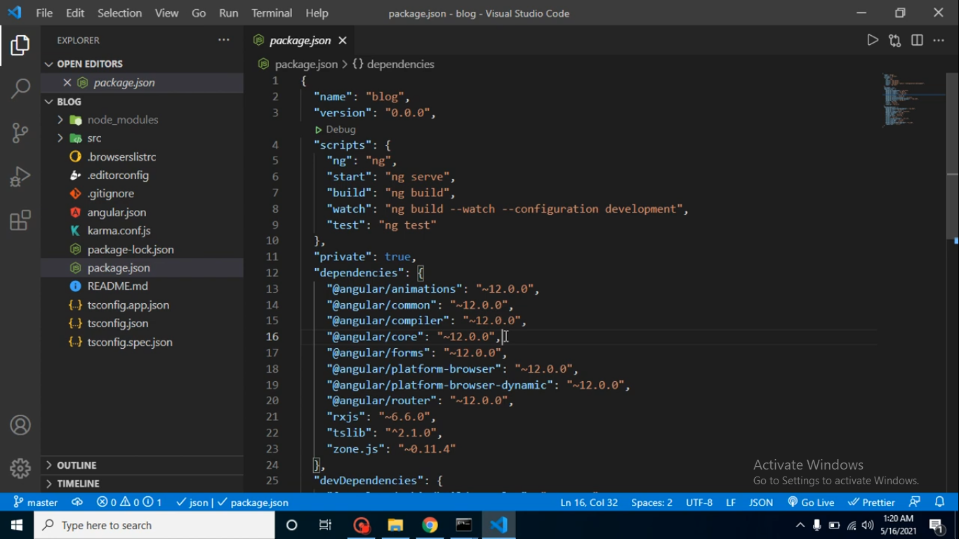
Now I want to change it’s version from 12 to 10
Start command and
First Uninstall Current Version of npm.
Then run command :: npm install –g@angular/cli@10.0.0
After install 10.0.0 version
Run command :: ng new

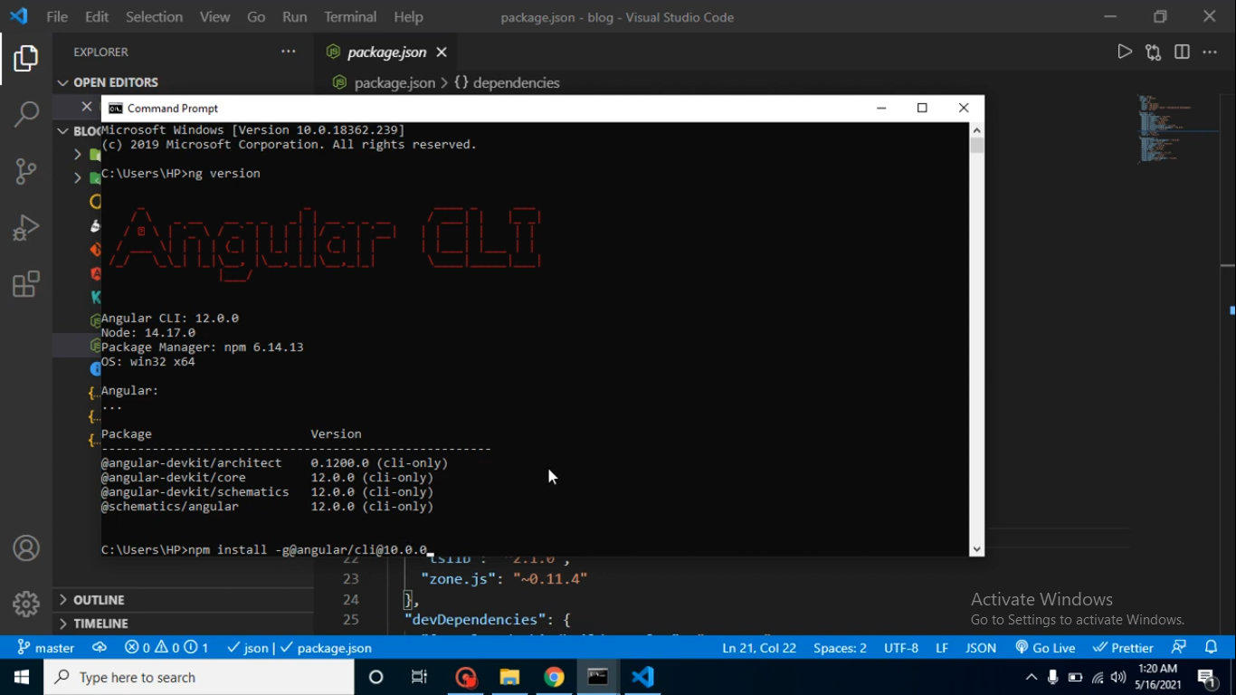
We can see the version is updated.

