IEnumerable VS IQueryable
IEnumerable and IQueryable are used for data manipulation in LINQ from the database and collections.
IEnumerable is inherited by IQueryable, Hence IQueryable has all the features of IEnumerable and except this, it has it’S own features
Both works with Select statement
IEnumerable is present in System.collection
IQueryable is present in System.Linq

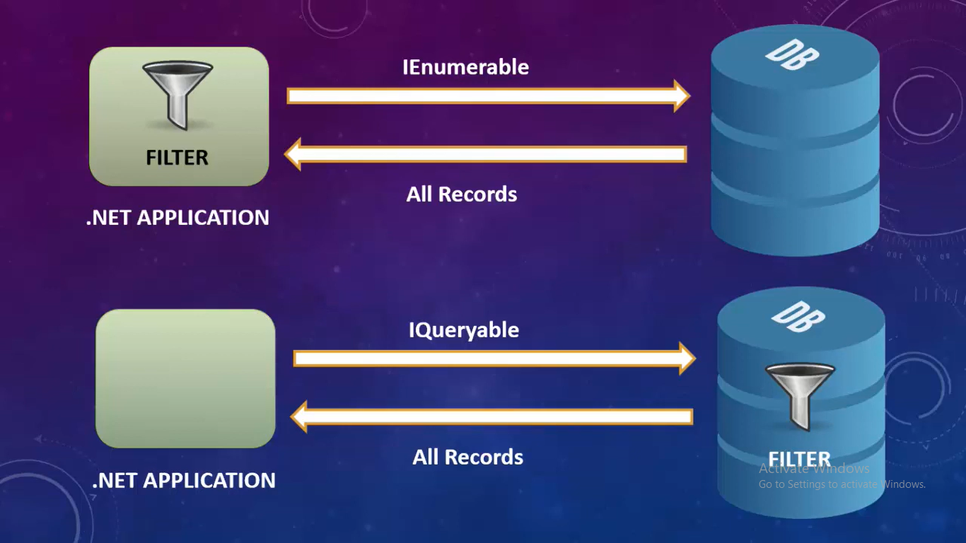
Example
Table: Student
ID | Name | Age | Marks
1 | A | 18 | 78
2 | B | 19 | 69
3 | C | 17 | 84
4 | D | 18 | 72
5 | E | 20 | 65

Now we want those student who’s marks greater than 75 marks

