
MEPCO SCHLENK ENGINEERING COLLEGE (Autonomous), SIVAKASI
Department of Computer Science and Engineering
ASSIGNMENT – 1
Class: 3rd Year B.E. CSE

Sub. Code & Name: 19CS694 –Web User Interface Design | Total Marks: 100
Date of Announcement: 01-02-2024 | Date of Submission: 15-02-2024

CL, CO,  PI | # | Question(s) | Mark
- A, CO1,  - 4.1.3 | 1. | Use HTML5 to create a document that contains the following text:  Internet and World Wide Web How to Program: Fifth Edition  Welcome to the world of Internet programming. We have provided  Coverage for many Internet-related topics.  Use h1 for the title (the first line of text), p for text (the second and third lines of text). Insert a horizontal rule between the h1 element and the p element. Open your new document in a web browser to view the marked-up document | (2)
- A, CO1,  - 4.3.2 | 2. | An image named deitel.png is 200 pixels wide and 150 pixels high. Write an HTML5 statement using the width and height attributes of the img element to perform each of the following transformations:  a) Increase the size of the image by 100 percent.  b) Increase the size of the image by 50 percent.  c) Change the width-to-height ratio to 2:1, keeping the width attained in part (a) | (2)
- A, CO1,  - 4.1.3 | 3. | Create an HTML5 document containing an ordered list of three items—ice cream, soft serve and frozen yogurt. Each ordered list should contain a nested, unordered list of your favourite flavors. Provide three flavors in each unordered list. | (2)
- A, CO1,  - 3.3.1 | 4. | Create an HTML5 document that uses an image as an e-mail link. Use attribute alt to provide a description of the image and link. | (2)
- A, CO1,  - 3.3.2 | 5. | Create an HTML5 document that contains links to your five favorite daily deals websites (possibly Groupon, Living Social, etc.). Your page should contain the heading “My Favorite Daily Deals Web Sites.” Click on each of these links to test your page. | (2)
- A,  - CO1,  - 5.1.2 | 6. | Create the HTML5 markup that produces the table shown in Fig below. Use <em> and <strong> tags as necessary.  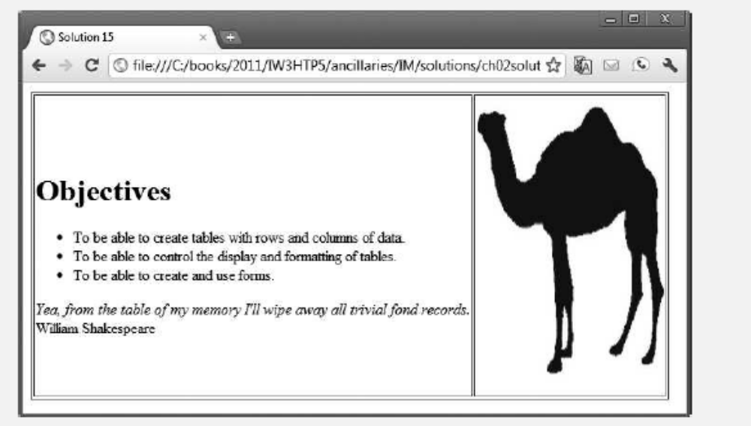 | (8)
A, CO1,  3.3.2 | 7. | Write an HTML5 document that produces the table shown  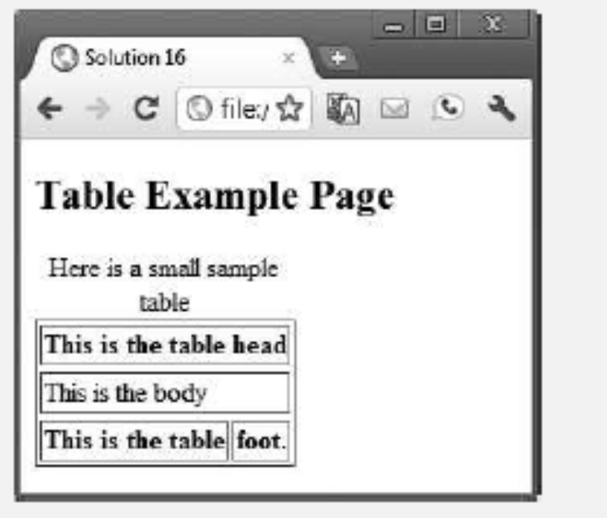 | (8)
A,  CO1, 5.1.1 | 8. | A local university has asked you to create an HTML5 document that allows prospective college students to provide feedback about their campus visit. Your HTML5 document should contain a form with text fields for a name and e-mail. Provide checkboxes that allow prospective students to indicate what they liked most about the campus. The checkboxes should include: campus, students, location, atmosphere, dorm rooms and sports. Also, provide radio buttons that ask the prospective students how they became interested in the college. Options should include: friends, television, Internet and other. In addition, provide a text area for additional comments, a submit button and a reset button. Use post to sent the information in the form to http://www.deitel.com. | (8)
A,  CO1, 3.3.2 | 9. | Write an HTML5 element (or elements) to accomplish each of the following tasks:  a) Students were asked to rate the food in the cafeteria on a scale of 1 to 10. Use a meter element with text to its left and right to indicate that the average rating was 7 out of 10.  b) Create a details element that displays the summary text "Survey Results" for Part (a). When the user clicks the arrow next to the summary text, an explanatory paragraph about the survey should be displayed.  c) Create a text input element for a first name. The element should automatically receive the focus when the form is rendered in a browser. d) Modify Part (c) to eliminate the label element and use placeholder text in the input element  e) Use a datalist to provide an autocomplete list for five states.  f) Create a range input element that allows the user to select a number from 1 to 100.  g) Specify that autocomplete should not be allowed for a form. Show only the form’s opening tag.  h) Use a mark element to highlight the second sentence in the following paragraph. <p>Students were asked to rate the food in the cafeteria  on a scale of 1 to 10. The average result was 7.</p>. | (8)
A,  CO1,  5.1.1 | 10. | Create a website registration form to obtain a user’s first name, last name and e-mail address. In addition, include an optional survey question that asks the user’s year in college (e.g., Freshman). Place the optional survey question in a details element that the user can expand to see the question. | (8)
A,  CO1,  5.2.1 | 11. | Create a simple search form using a search input element in which the user can enter a search query. Using the Firefox web browser, test the form by entering January and submitting the form. Then enter a J in the input element to see previous entries that started with J—January should be displayed below the input element. Enter June and submit the form again. Now enter a J in the input element to see previous entries that started with J— January and June should be displayed below the input element. Try this with your own search queries as well. | (8)
R,  CO1,  5.3.1 | 12 | Create an autocomplete input element with an associated datalist that contains the days of the week. | (2)
A,  CO1,  5.3.1 | 13 | Design the HTML page with the below table display  13. b Create Simple website with 5 pages (Home, About, Gallery, Course, Contact). Gallery and contact page with contact us form is must.  13.c Create the online shopping webpage | (10)
  left | center | right
  left | center | right
  left | center | right
  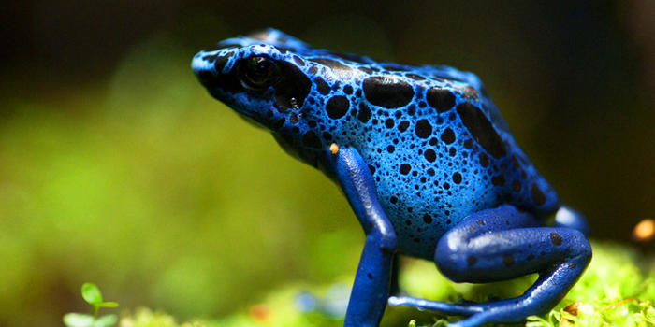
 |  | 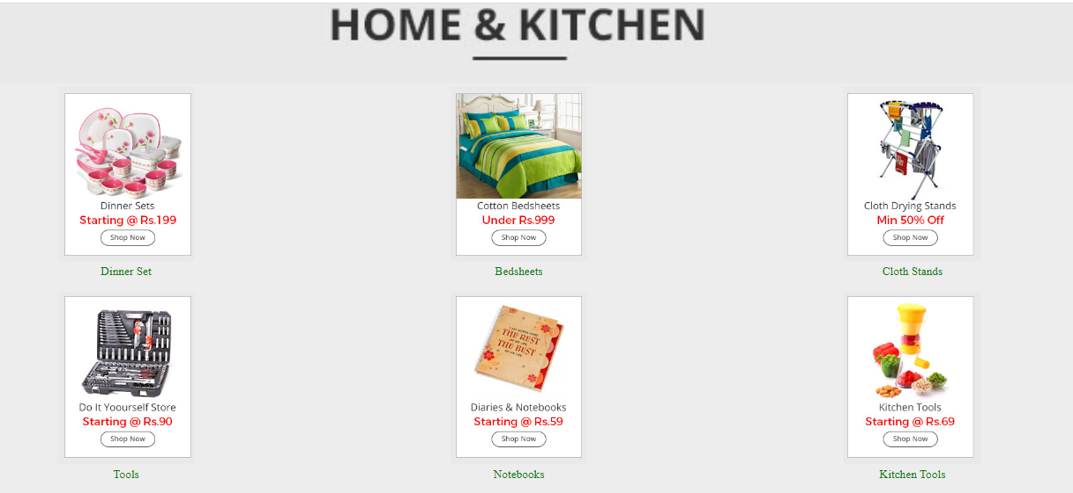

Faculty Signature

