**Smart Vehicle ditector Using Arduino Uno and UltraSonic Sensor.**

**Abstract:**

A winter morning is a cold morning of the winter season. The environment is dull and dismal. It is covered with mist and fog. One can hardly see and identify things at a distance. So the drivers of vehicles can’t also see objects at a distance. So in a winter morning road accidents frequently happen. In this paper we have developed a Smart Vehicle detector which can detect objects or vehicle at a distance in the cold and winter morning using Arduino and some other sensors. This system is highly efficient with high accuracy and low cost. It consumes low power which makes it a resource efficient technology.

**Introduction:**

In recent years there are a lots of road accidents in winter mornings because of the dense of the fog. In this project we use Ultrasonic sensor to measure distance of objects and vehicles at a distance in winter morning when things can hardly be seen at a distance .We take input in Arduino from heat sensor and Ultrasonic sensor and give a warning to the driver when some object or vehicles comes in the range of the ultrasonic sensor. When the driver got the warning he will be aware of the danger. From this process we can reduce the percentage of accidents.

**2. COMPONENTS USED :**

**2.1 Arduino uno:**

Arduino is an open-source physical platform based on microcontroller board having the ATmega32 series controllers and Integrated Development Environment for writing and uploading codes to the microcontroller. It has input and output pins for interaction with the outside world such as with sensors, switches, motors and so on. To be precise it has 14 digital input/output pins (of which 6 can be used as PWM outputs), 6 analog inputs, a 16 MHz quartz crystal, a USB connection, a power jack, an ICSP header and a reset button. It contains everything needed to support the microcontroller .It can take supply through USB or we can power it with an AC-to-DC adapter or a battery Arduino acts as the processing module of the system.

It takes data from LM-35 heat sensor and HC-SR04 ultrasonic sensor and gives output in LCD display, Pizeo Buzzer and in LED.

Arduino is open-source computer hardware and software company, project and user community that designs and manufactures microcontroller-based kits for building digital devices and interactive objects that can sense and control objects in the physical world. The project is based on microcontroller board designs, manufactured by several vendors, using various microcontrollers. These systems provide sets of digital and analog I/O pins that can be interfaced to various expansion boards ("shields") and other circuits. The boards feature serial communications interfaces, USB on some models, for loading programs from personal computers. The microcontrollers are primarily programmed using a dialect of features from the C and C++ programming languages. In addition to using traditional compiler tool chains, the Arduino project provides an integrated development environment (IDE) based on the Processing project. The Arduino project started in 2005 as a program for students at the Interaction Design Institute Ivrea in Ivrea, Italy, aiming to provide an inexpensive and easy way for novices and professionals to create devices that interact with their environment using sensors and actuators. Common examples of such devices intended for beginner hobbyists include simple robots, thermostats, and motion detectors. Arduino boards are available commercially in preassembled form, or as do-it-yourself kits.

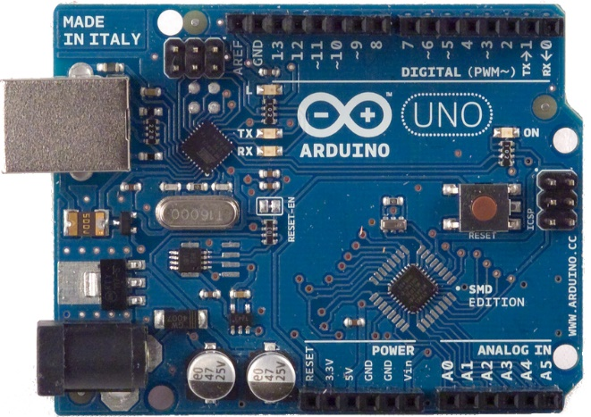

**Figure1: Arduino UNO board**

**2.2 LED:**

Light Emitting Diode (LED) A light-emitting diode (LED) is a p-n junction diode, which emits light when activated. When we apply voltage across its leads, electrons are able to recombine with holes within the LED, releasing energy in the form of photons which gives the light.

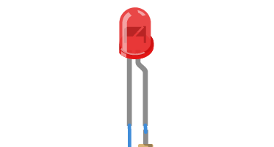

**Figure2: LED**

**2.3 Ultrasonic Sensor:**

Ultrasonic Sensor: Ultrasonic sensors (also known as transceivers when they both send and receive, but more generally called transducers) work on a principle similar to radar or sonar which evaluate attributes of a target by interpreting the echoes from radio or sound waves respectively. Ultrasonic sensors generate high frequency sound waves and evaluate the echo which is received back by the sensor. Sensors calculate the time interval between sending the signal and receiving the echo to determine the distance to an object. This technology can be used for measuring wind speed and direction (anemometer), tank or channel level, and speed through air or water. For measuring speed or direction a device uses multiple detectors and calculates the speed from the relative distances to particulates in the air or water. To measure tank or channel level, the sensor measures the distance to the surface of the fluid. Further applications include: humidifiers, sonar, medical ultra sonography, burglar alarms and non-destructive testing. Systems typically use a transducer which generates sound waves in the ultrasonic range, above 18,000 hertz, by turning electrical energy into sound, then upon receiving the echo turn the sound waves into electrical energy which can be measured and displayed. 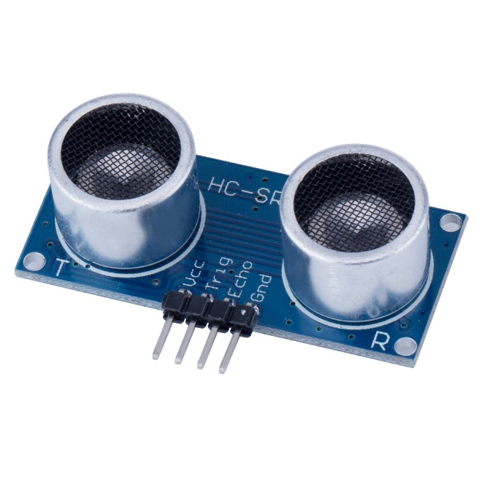

**Figure2: HC-SR04 Ultrasonic Sensor.**

**2.4 LM-35 Heat Sensor:**

The LM35 series are precision integrated-circuit temperature devices with an output voltage linearlyproportional to the Centigrade temperature. The LM35 device has an advantage over linear temperature sensors calibrated in Kelvin, as the user is not required to subtract a large constant voltage from the output to obtain convenient Centigrade scaling. The LM35 device does not require any external calibration or trimming to provide typical accuracies of ±¼°C at room temperature and ±¾°C over a full −55°C to 150°C temperature range.

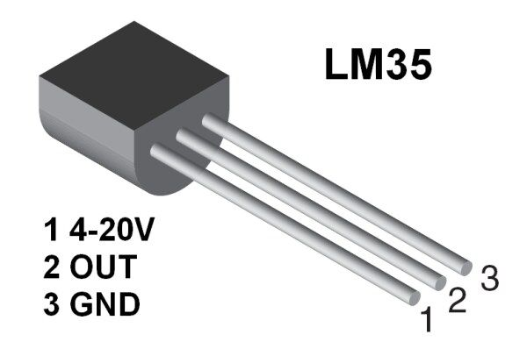

**Figure4: LM-35 Heat Sensor.**

**2.5 Piezo Buzzer:**

Piezo buzzers are used for making beeps, tones and alert.We Use a Piezo buzzer in this project to make a warning for the drivers.

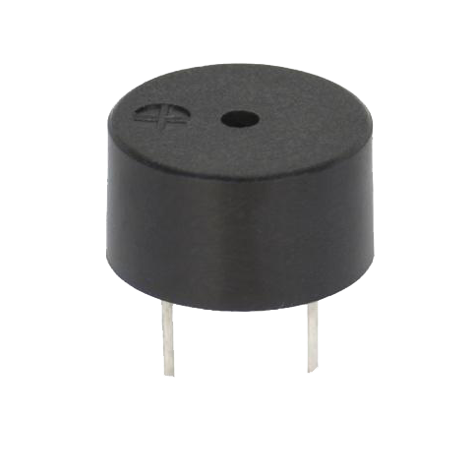

**Figure5:Piezo Buzzer.**

**2.6 LCD:**

LCD (Liquid Crystal Display) screen is an electronic display module and find a wide range of applications. A 16x2 LCD display is very basic module and is very commonly used in various devices and circuits. These modules are preferred over seven segments and other multi segment LEDs. The reasons being: LCDs are economical; easily programmable; have no limitation of displaying special & even custom characters (unlike in seven segments), animations and so on.

A 16x2 LCD means it can display 16 characters per line and there are 2 such lines. In this LCD each character is displayed in 5x7 pixel matrix. This LCD has two registers, namely, Command and Data.

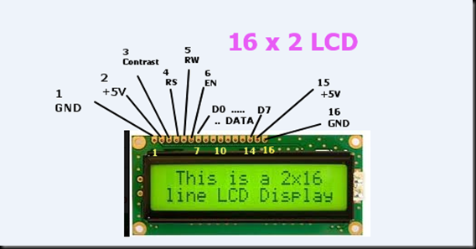

**3.Working Process:**

The working process of our system is very simple. The supply is given through the power jack.From the Arduino We take a 5V power supply and connects with the Ultrasonic sensor’s Vcc and we connect the ground pin with Arduino’s ground. Next we Connect the trigger pin ang echo pin with the digital pins of arduino.

The trigger pin is in Output mode and Echo pin is the Input mode of the arduino. The trigger pin generate sound wave after some time let ‘t’ the echo pin receives the sound wave. So this time ‘t’ is a input of the arduino.

We have to divide this ‘t’ by 1000000 to convert it into seconds.

t=t/1000000;

Next we use LM-35 heat sensor to measure the temperature of the environment.It has 3 pins. We Connect the Vcc pin with the 5v power supply of the arduino and ground with ground and it’s Output pin is connected to one of the analog pins of arduino. The LM-35 sensor will give us the temperature. Let we save it in ‘temp’ variable .We have to multiply the output with(500/1024) to convert it in degree.

So temp=(temp*500/1024);

So we can calculate the velocity of sound.

By the given formula,

v=(332+0.61*temp);

Now we can calculate the object distance by

Using the formula,

S=(v*t)/2;

So this is how we can have the object or vehicle distance.

So when a object is within the range of the Ultrasonic sensor it will give a output of the LCD display and it will warned the driver by making sounds in a buzzer and it will gives power to the RED LED.

The maximum range of this project is 4 meter. However here we have make a prototype of the model.It can have more Distance access if we can use powerfull Ultrasonic sensor or if we use Ladger sensor. This distance can increase upto 100 meter if we use Powerfull Ultrasonic sensors or ladger sensors.