CUSTOMER RETENTION
& CHURN ANALYSIS
Understanding Why Customers Leave — and How to Keep Them

Prepared for: Product / Growth / Retention Team
Dataset: Telco Customer Churn (7,043 customers)
Prepared by: Data Analytics Intern Project

Executive Summary
This report analyzes customer-level data from a subscription telecom business to understand why customers churn and which segments carry the highest risk. The dataset covers 7,043 customers, including contract type, tenure, monthly charges, and payment method.
Overall churn stands at 26.5% — roughly 1 in 4 customers leave. However, this headline number hides a much sharper pattern: churn is heavily concentrated among customers who are new, on flexible month-to-month contracts, paying higher monthly charges, and paying by electronic check rather than autopay. These four factors compound, and together they point to a clear, actionable retention strategy.

Bottom Line
The highest-risk customer profile is a new, month-to-month customer paying by electronic check. Targeting this exact segment — through contract incentives and autopay enrollment — is the fastest, most concentrated way to reduce overall churn.

Key Metrics at a Glance
Metric | Value
Total Customers Analyzed | 7,043
Overall Churn Rate | 26.5%
Highest-Risk Contract Type | Month-to-month (42.7% churn)
Lowest-Risk Contract Type | Two year (2.8% churn)
Highest-Risk Tenure Group | 0–12 months (47.4% churn)
Highest-Risk Payment Method | Electronic check (45.3% churn)

1. Overall Churn Rate
Across the full customer base, 26.5% of customers have churned. For a subscription business, this is a high rate — well above the single-digit to low-teens churn typically considered healthy — and signals a real retention problem worth addressing systematically rather than case-by-case.
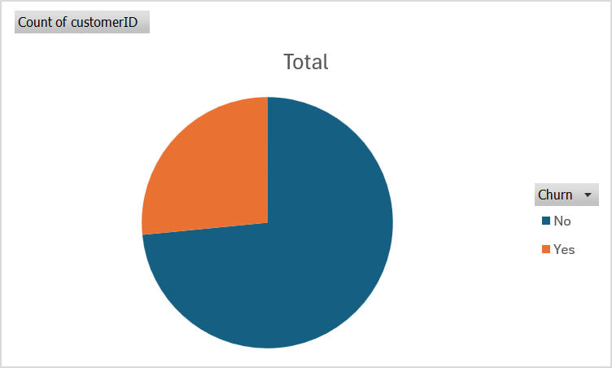
Figure 1: Overall customer churn — Yes vs. No
Recommendation
Treat churn reduction as a company-wide priority, not an isolated support issue. The following sections identify exactly which segments are driving this rate, so retention efforts can be targeted rather than spread thin.

2. Churn by Contract Type
Contract type is the single strongest predictor of churn in this dataset. Customers on flexible, no-commitment contracts leave at dramatically higher rates than those on longer-term agreements.
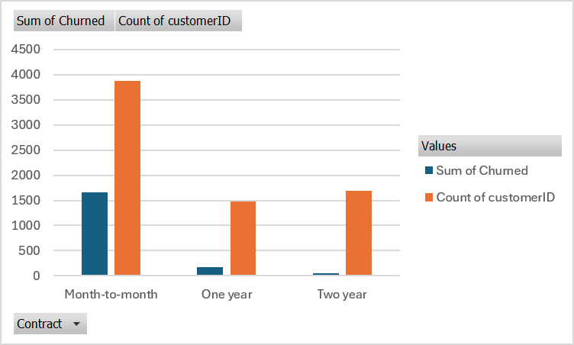
Figure 2: Churned customers vs. total customers by Contract Type
Contract Type | Customers | Churned | Churn Rate
Month-to-month | 3,875 | 1,655 | 42.7%
One year | 1,473 | 166 | 11.3%
Two year | 1,695 | 48 | 2.8%
Overall | 7,043 | 1,869 | 26.5%

Findings
- Contract length dominates churn risk: Month-to-month customers churn at 42.7% — nearly 15x the rate of two-year contract customers (2.8%).
- Largest segment, largest risk: Month-to-month is also the largest customer segment (3,875 of 7,043), meaning it accounts for the vast majority of total churned customers.

Recommendation
Introduce stronger incentives — discounts, loyalty perks, or bundled features — to convert month-to-month customers into 1-year contracts, especially once they pass their first 6–12 months and are proven likely to stay.

3. Churn by Customer Tenure
Breaking churn down by how long a customer has been active reveals a classic early-churn pattern: risk is highest in year one and falls steadily the longer a customer stays.
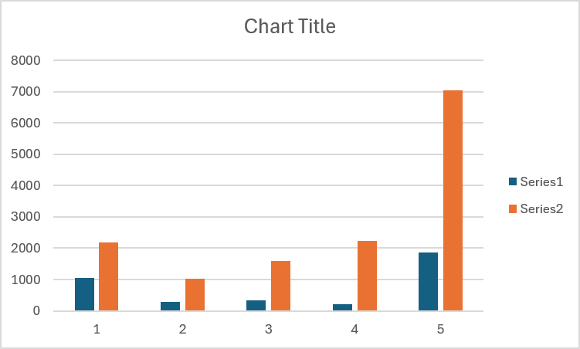
Figure 3: Churned customers vs. total customers by Tenure Group
Tenure Group | Customers | Churned | Churn Rate
0–12 months | 2,186 | 1,037 | 47.4%
13–24 months | 1,024 | 294 | 28.7%
25–48 months | 1,594 | 325 | 20.4%
49+ months | 2,239 | 213 | 9.5%
Overall | 7,043 | 1,869 | 26.5%

Findings
- The first year is the danger zone: 47.4% of customers in their first year churn, compared to just 9.5% of customers with 49+ months of tenure — a 5x drop in risk over the customer lifetime.
- Compounds with contract risk: Combined with the contract-type finding, this suggests new, month-to-month customers face the highest compounded risk of leaving.

Recommendation
Invest in a structured onboarding and engagement program for the first 90–180 days, and proactively offer contract-upgrade incentives once a customer passes the 6–12 month mark.

4. Churn by Monthly Charges
Higher-paying customers churn more than lower-paying ones — a pattern that likely reflects the type of service being purchased (e.g., premium or bundled plans) rather than price sensitivity alone.
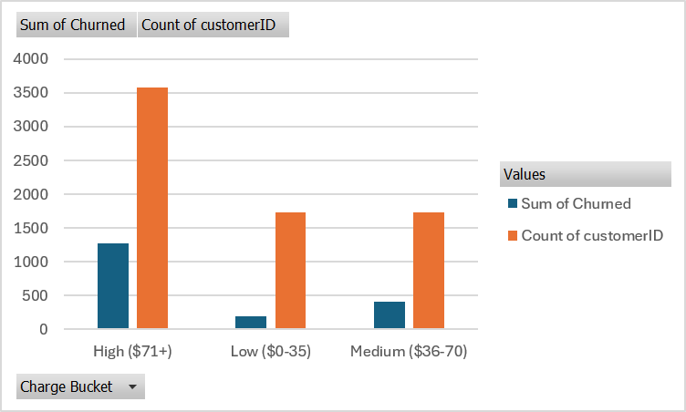
Figure 4: Churned customers vs. total customers by Charge Bucket
Charge Bucket | Customers | Churned | Churn Rate
Low ($0–35) | 1,735 | 189 | 10.9%
Medium ($36–70) | 1,725 | 413 | 23.9%
High ($71+) | 3,583 | 1,267 | 35.4%
Overall | 7,043 | 1,869 | 26.5%

Findings
- High-charge customers are highest risk: Customers paying $71+/month churn at 35.4%, more than 3x the rate of customers paying under $35/month (10.9%).
- Correlation, not necessarily causation: This likely reflects dissatisfaction with premium services or bundle complexity rather than price alone, and should be read alongside contract type and service mix.

Recommendation
Review what high-charge customers are actually paying for (e.g., fiber internet, streaming add-ons) and whether service quality, support responsiveness, or contract flexibility in that segment needs improvement.

5. Churn by Payment Method
Payment method is one of the most actionable predictors of churn in the dataset. Manual, recurring-decision payment methods correlate strongly with higher churn than automated payments.
Payment Method | Customers | Churned | Churn Rate
Electronic check | 2,365 | 1,071 | 45.3%
Mailed check | 1,612 | 308 | 19.1%
Bank transfer (automatic) | 1,544 | 258 | 16.7%
Credit card (automatic) | 1,522 | 232 | 15.2%
Overall | 7,043 | 1,869 | 26.5%

Findings
- Manual payment is a major risk factor: Electronic check customers churn at 45.3% — nearly 3x the rate of any automatic payment method (15–19%).
- Largest at-risk segment: Electronic check is also the single largest payment segment (2,365 customers), meaning it accounts for over half of all churned customers.
- Automation reduces friction: Both automatic methods (credit card, bank transfer) sit well below the overall average, suggesting automation itself reduces the recurring 'should I cancel?' decision point.

Recommendation
Launch a targeted campaign encouraging electronic-check customers to switch to autopay, using a small discount or account credit as an enrollment incentive. This is one of the simplest, highest-leverage retention actions available.

6. Summary of Recommendations
- 1. Target contract conversion: Offer incentives (discounts, loyalty perks, bundled features) to move month-to-month customers onto 1-year or 2-year contracts, particularly after the 6–12 month mark.
- 2. Strengthen first-year onboarding: Build a structured 90–180 day onboarding and engagement program for new customers, the single highest-risk group.
- 3. Reduce payment friction: Run a targeted autopay enrollment campaign for electronic-check customers — the largest and highest-risk payment segment.
- 4. Audit the premium/high-charge segment: Investigate service quality and satisfaction specifically among high-charge customers to understand what's driving elevated churn in that group.
- 5. Build a compounded risk view: Combine contract type, tenure, and payment method into a simple churn-risk score to proactively flag and prioritize the highest-risk customers for retention outreach.

Prepared using customer-level analysis of the Telco Customer Churn dataset (7,043 customers), covering Contract, Tenure, MonthlyCharges, PaymentMethod, and Churn fields.

