MARKETING FUNNEL
& CONVERSION ANALYSIS
From Visitor to Customer — Where the Funnel Leaks, and How to Fix It

Prepared for: Marketing & Growth Team
Data Period: January – December 2024 | 6,784 Leads Analyzed
Prepared by: Akash Joseph Zachariah

Executive Summary
This report analyzes the full marketing and sales funnel of a business over a 12-month period, tracking 6,784 leads from initial signup through Marketing Qualified Lead (MQL), Sales Qualified Lead (SQL), and ultimately Customer conversion, across six acquisition channels.
Overall Lead-to-Customer conversion stands at 7.1%. The steepest drop-off occurs early, at the Lead → MQL stage, where over half of all leads never progress. Channel performance varies dramatically — Referral converts leads to customers at more than 10x the rate of Social Media — and lead volume grew steadily through the year without a matching improvement in conversion efficiency. Revenue analysis adds an important nuance: some low-converting channels still produce above-average deal sizes, meaning the right fix is often better qualification rather than simply cutting spend.

Bottom Line
The funnel's biggest leak is early qualification, not the sales close. Prioritizing lead-nurturing and qualification quality — especially for Paid Search and Social Media — will do more for revenue than simply increasing top-of-funnel spend.

Key Metrics at a Glance
Metric | Value
Total Leads (2024) | 6,784
Overall Lead → Customer Conversion | 7.1%
Total Customers | 485
Total Revenue | $1,459,166
Average Deal Size | $3,009
Steepest Drop-off Stage | Lead → MQL (48.7% loss)
Best Channel (Conversion) | Referral (13.8%)
Weakest Channel (Conversion) | Social Media (1.3%)
Top Revenue Channel | Email Marketing ($581,838 — 40% of total)

1. Overall Funnel Performance
Tracking every lead through the four-stage funnel reveals exactly where volume is lost between initial signup and paying customer.
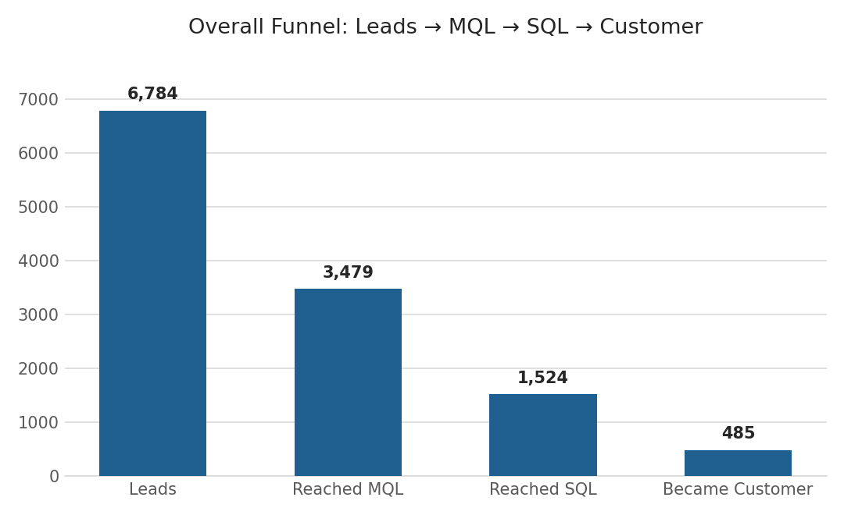
Figure 1: Overall funnel — Leads through Customer
Stage | Count | Conversion from Previous Stage
Leads | 6,784 | —
Reached MQL | 3,479 | 51.3%
Reached SQL | 1,524 | 43.8%
Became Customer | 485 | 31.8%

Findings
- The steepest drop-off is Lead → MQL: 48.7% of leads never progress to Marketing Qualified — the single largest volume loss point in the funnel.
- MQL → SQL is also weak: More than half of MQLs (56.2%) never become sales-qualified, the second-largest leak.
- SQL → Customer is comparatively strong: Once a lead is sales-qualified, nearly 1 in 3 (31.8%) closes as a customer — meaningfully healthier than the earlier stages, suggesting the sales process itself is not the primary bottleneck.

Recommendation
Focus improvement efforts on lead nurturing and qualification criteria rather than the sales close. Even a modest improvement in the Lead → MQL stage would compound through the rest of the funnel and meaningfully increase total customers without any change in top-of-funnel spend.

2. Funnel Performance by Channel
Breaking the funnel down by acquisition channel reveals dramatic differences in lead quality — some channels bring high volume with poor conversion, while others convert efficiently at lower volume.
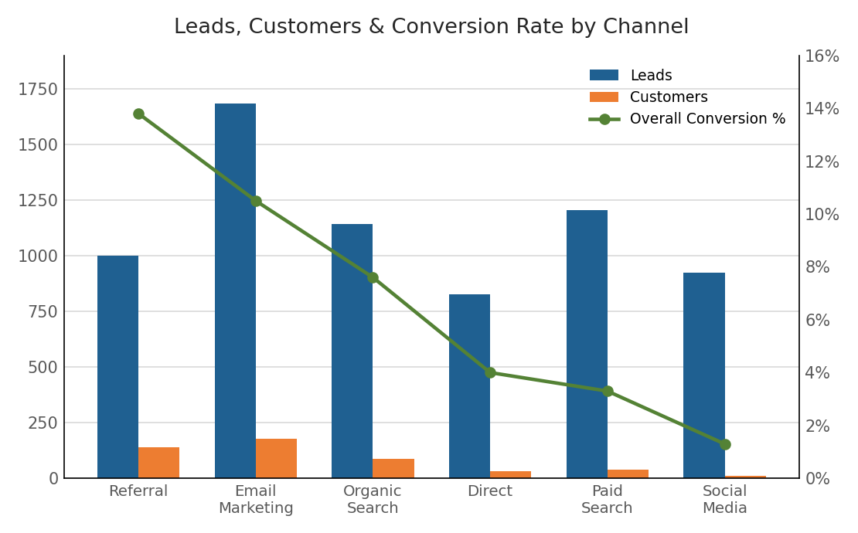
Figure 2: Leads, customers, and conversion rate by channel
Channel | Leads | Lead→MQL | MQL→SQL | SQL→Cust | Overall Conv.
Referral | 1,000 | 65.9% | 56.4% | 37.1% | 13.8%
Email Marketing | 1,684 | 61.8% | 48.4% | 35.0% | 10.5%
Organic Search | 1,144 | 52.5% | 42.8% | 33.9% | 7.6%
Direct | 827 | 43.2% | 39.2% | 23.6% | 4.0%
Paid Search | 1,205 | 39.1% | 31.0% | 26.7% | 3.3%
Social Media | 924 | 38.0% | 30.2% | 11.3% | 1.3%

Findings
- Referral is the highest-quality channel: Referral converts leads to customers at 13.8% — nearly 11x the rate of Social Media (1.3%) — despite generating fewer total leads than several other channels.
- Email Marketing is the standout volume channel: Email Marketing produces the most leads (1,684) and converts well (10.5%), making it the single most efficient high-volume channel in the funnel.
- Social Media underperforms across every stage: Social Media brings meaningful lead volume (924, 4th highest) but converts almost none of them — its SQL→Customer rate (11.3%) is roughly a third of Referral's.

Recommendation
Prioritize continued and increased investment in Email Marketing and Referral programs, which lead on both volume and conversion quality. Investigate the Social Media funnel path specifically — landing page fit, targeting, and lead qualification criteria — before continuing to scale spend there.

3. Funnel Trend Over Time
Lead volume grew steadily across 2024, but conversion efficiency did not scale proportionally — a pattern worth flagging before increasing acquisition spend further.
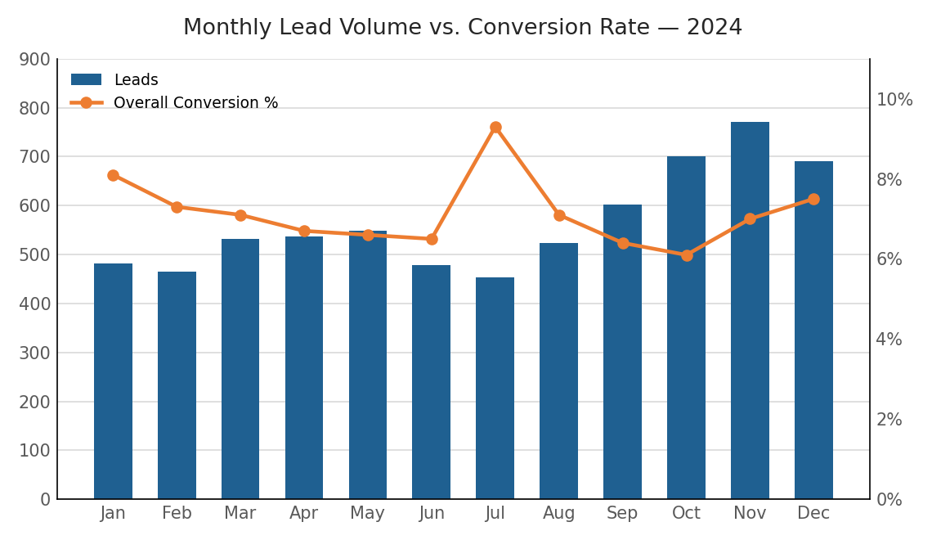
Figure 3: Monthly lead volume vs. conversion rate
Month | Leads | Overall Conversion
Jan 2024 | 481 | 8.1%
Feb 2024 | 465 | 7.3%
Mar 2024 | 532 | 7.1%
Apr 2024 | 537 | 6.7%
May 2024 | 548 | 6.6%
Jun 2024 | 479 | 6.5%
Jul 2024 | 453 | 9.3%
Aug 2024 | 524 | 7.1%
Sep 2024 | 602 | 6.4%
Oct 2024 | 701 | 6.1%
Nov 2024 | 771 | 7.0%
Dec 2024 | 691 | 7.5%

Findings
- Volume grew steadily through the year: Monthly lead volume grew roughly 60% from January (481) to November (771), reflecting the intended traffic growth trend.
- Conversion rate stayed flat or softened: Overall conversion held around 6-7% for most of the year, dipping in the high-volume months of September and October (6.4%, 6.1%) rather than improving with scale.
- One notable outlier: July's 9.3% conversion stands out as the strongest month and is worth investigating for repeatable causes (campaign timing, lead source mix, or seasonal buyer intent).

Recommendation
Before increasing top-of-funnel spend further, invest in improving conversion efficiency — lead scoring, faster follow-up, and stronger MQL qualification criteria — so that future lead growth translates into proportional customer growth rather than a larger unconverted pipeline.

4. Revenue by Channel
Conversion rate alone doesn't capture the full picture — some lower-converting channels still produce valuable customers once they do convert.
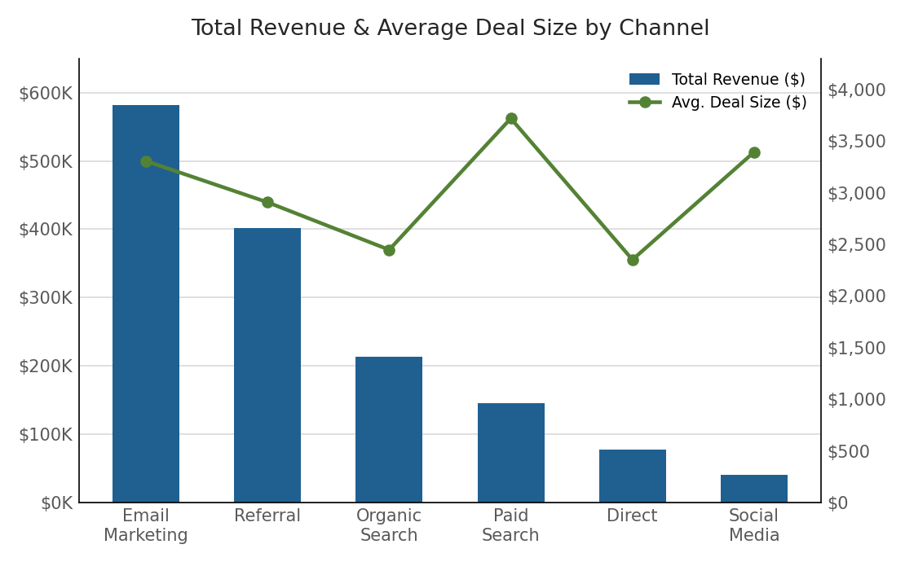
Figure 4: Total revenue and average deal size by channel
Channel | Customers | Total Revenue | Avg. Deal Size
Email Marketing | 176 | $581,838 | $3,306
Referral | 138 | $401,144 | $2,907
Organic Search | 87 | $212,863 | $2,447
Paid Search | 39 | $145,022 | $3,719
Direct | 33 | $77,581 | $2,351
Social Media | 12 | $40,719 | $3,393

Findings
- Email Marketing is the clear revenue leader: Email Marketing accounts for 40% of total revenue ($581,838 of $1,459,166), confirming it as the top channel on volume, conversion rate, and total dollars simultaneously.
- Paid Search brings the highest-value customers: Despite ranking among the weakest on conversion rate, Paid Search customers average $3,719 per deal — the highest of any channel, above even Referral ($2,907).
- Social Media customers are also above-average value: Social Media's few customers also carry an above-average deal size ($3,393), suggesting the channel's problem is qualification volume, not customer value.

Recommendation
Rather than cutting Paid Search or Social Media spend outright, fix the qualification and nurturing process for these channels — their customers are worth pursuing, but too few leads make it through. Continue prioritizing Email Marketing for scaled investment, as it is strong across every dimension measured.

5. Summary of Recommendations
- 1. Fix the top of the funnel first: Focus on improving Lead → MQL qualification criteria and nurturing (e.g., faster follow-up, lead scoring), the single largest drop-off point in the funnel.
- 2. Double down on proven channels: Increase investment in Email Marketing and Referral programs, which lead on volume, conversion rate, and revenue.
- 3. Investigate underperforming channels rather than cutting them: Audit landing pages, targeting, and lead qualification for Social Media and Paid Search — their customers are valuable, but too few leads convert.
- 4. Prioritize conversion efficiency over volume growth: Before scaling acquisition spend further, address why conversion efficiency has stayed flat as volume has grown, to avoid diminishing returns.
- 5. Study the July outlier: Look into what drove July's 9.3% conversion rate — the year's best — for repeatable tactics.

Prepared using lead-level analysis of a simulated marketing funnel dataset (6,784 leads, January–December 2024), covering Channel, Campaign, Funnel Stage, and Deal Value fields.

