Task-3:- Time setting in linux

Time settings in linux-task1

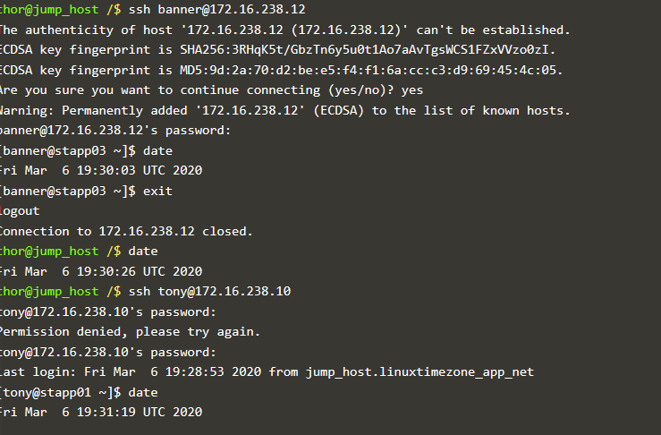

Reference link:- https://community.kodekloud.com/t/time-settings-in-linux-task1/1755.