Task-20 :- Disable Root Login

**After doing some security audits of servers, xFusionCorp Industries security team has implemented some new security policies. One of them is to disable direct root login through SSH.**

**Disable direct SSH root login on all app servers in Stratos Datacenter**.

**Terminal-1 for App-1**

ssh tony@stapp01

sudo vi /etc/ssh/sshd_config

Remove the "#" and change "yes" to "no" according to image

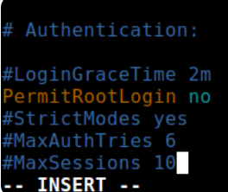

sudo systemctl restart sshd

**Terminal -2 App-2**

ssh steve@stapp02

sudo vi /etc/ssh/sshd_config

Remove the "#" and change "yes" to "no" according to image



sudo systemctl restart sshd

**Terminal-3 for App-3**

ssh banner@stapp03

sudo vi /etc/ssh/sshd_config

Remove the "#" and change "yes" to "no" according to image



sudo systemctl restart sshd

Reference link :- [Disable Root Login -KodeKloud · GitHub](https://gist.github.com/AbdullahGhani1/63d4a2c7578a86da8e2dad54b4e4bd22)

[Disable Root Login Linux KodeKloud Engineer - YouTube](https://www.youtube.com/watch?v=lVV52ri4O5g&t=160s)