WEEK-4 HANDS-ON
BONDA PRASANTH
6382932
Hands on 1
Create a Spring Web Project using Maven :
Follow steps below to create a project:
- Go to https://start.spring.io/
- Change Group as “com.cognizant”
- Change Artifact Id as “spring-learn”
- Select Spring Boot DevTools and Spring Web
- Create and download the project as zip
- Extract the zip in root folder to Eclipse Workspace
- Build the project using ‘mvn clean package -Dhttp.proxyHost=proxy.cognizant.com -Dhttp.proxyPort=6050 -Dhttps.proxyHost=proxy.cognizant.com -Dhttps.proxyPort=6050 -Dhttp.proxyUser=123456’ command in command line
- Import the project in Eclipse "File > Import > Maven > Existing Maven Projects > Click Browse and select extracted folder > Finish"
- Include logs to verify if main() method of SpringLearnApplication.
- Run the SpringLearnApplication class.
SPRING WEB PROJECT:
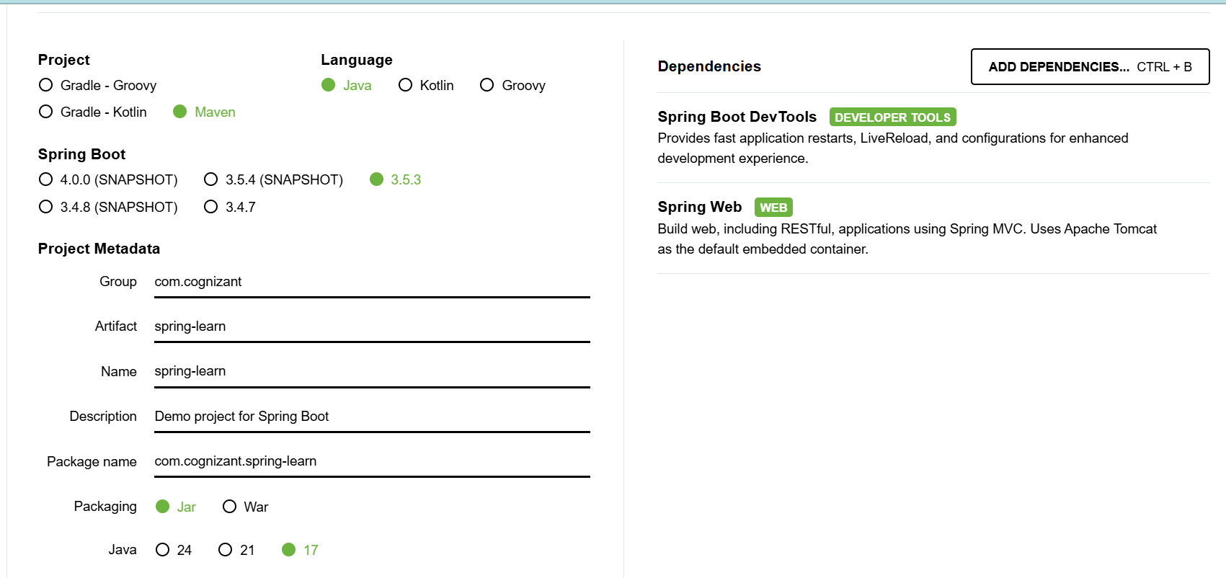
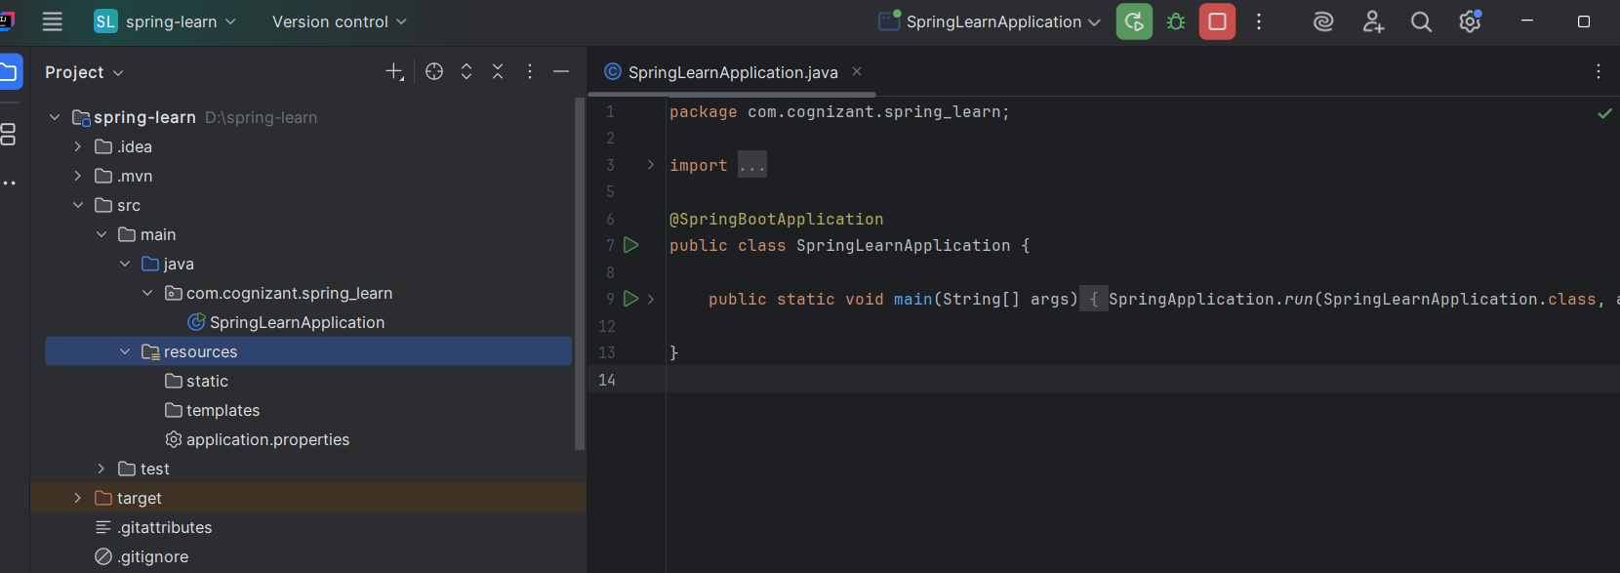
OUTPUT:
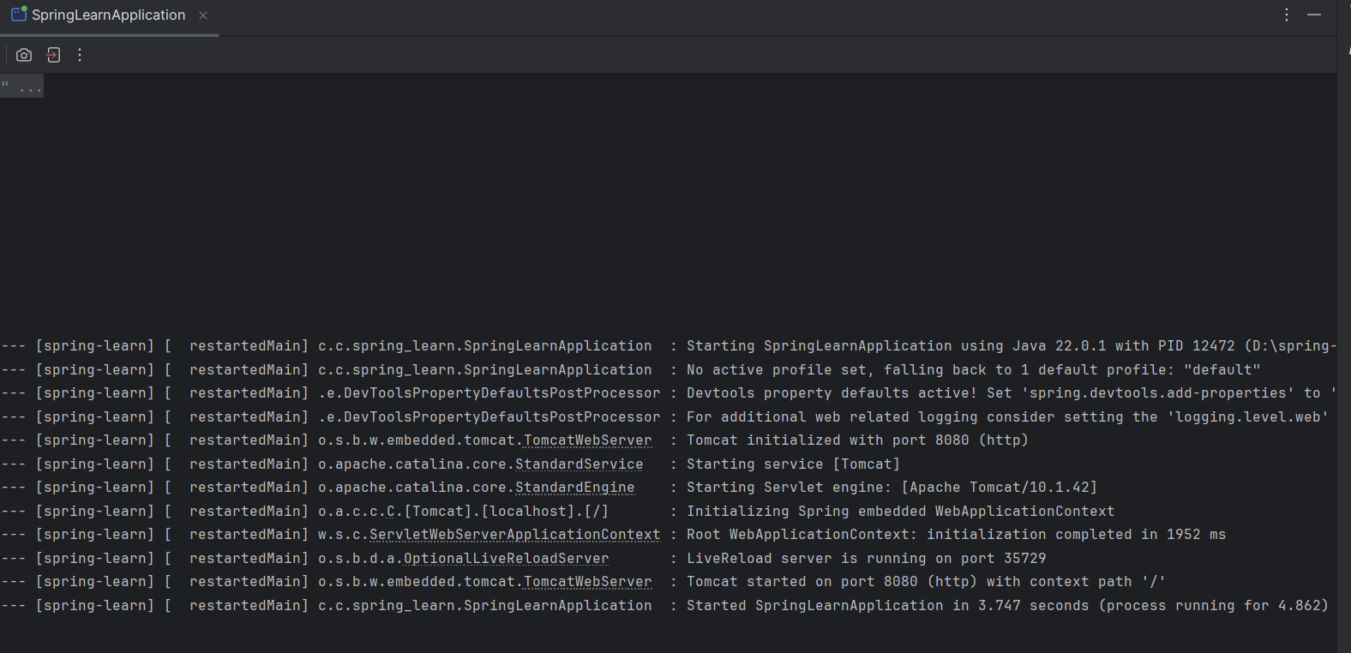
Hands on 4
Spring Core – Load Country from Spring Configuration XML
Country.java:
package com.cognizant.spring_learn;
import org.slf4j.Logger;
import org.slf4j.LoggerFactory;
public class Country {
private static final Logger LOGGER = LoggerFactory.getLogger(Country.class);
private String code;
private String name;
public Country() {
LOGGER.debug("Inside Country Constructor.");
}
public String getCode() {
LOGGER.debug("Inside getCode.");
return code;
}
public void setCode(String code) {
LOGGER.debug("Inside setCode.");
this.code = code;
}
public String getName() {
LOGGER.debug("Inside getName.");
return name;
}
public void setName(String name) {
LOGGER.debug("Inside setName.");
this.name = name;
}
@Override
public String toString() {
return "Country [code=" + code + ", name=" + name + "]";
}
}
country.xml:
<?xml version="1.0" encoding="UTF-8"?>
<beans xmlns="http://www.springframework.org/schema/beans"
xmlns:xsi="http://www.w3.org/2001/XMLSchema-instance"
xsi:schemaLocation="http://www.springframework.org/schema/beans
http://www.springframework.org/schema/beans/spring-beans.xsd">
<bean id="country" class="com.cognizant.spring_learn.Country">
<property name="code" value="IN"/>
<property name="name" value="India"/>
</bean>
</beans>
SpringLearnApplication.java:
package com.cognizant.spring_learn;
import org.slf4j.Logger;
import org.slf4j.LoggerFactory;
import org.springframework.context.ApplicationContext;
import org.springframework.context.support.ClassPathXmlApplicationContext;
public class SpringLearnApplication {
private static final Logger LOGGER = LoggerFactory.getLogger(SpringLearnApplication.class);
public static void main(String[] args) {
LOGGER.debug("START");
displayCountry();
LOGGER.debug("END");
}
public static void displayCountry() {
ApplicationContext context = new ClassPathXmlApplicationContext("country.xml");
Country country = context.getBean("country", Country.class);
LOGGER.debug("Country: {}", country.toString());
}
}
logback.xml:
<configuration>
<appender name="STDOUT" class="ch.qos.logback.core.ConsoleAppender">
<encoder>
<pattern>%d{HH:mm:ss.SSS} [%thread] %-5level %logger{36} - %msg%n</pattern>
</encoder>
</appender>
<root level="debug">
<appender-ref ref="STDOUT"/>
</root>
</configuration>
OUTPUT:
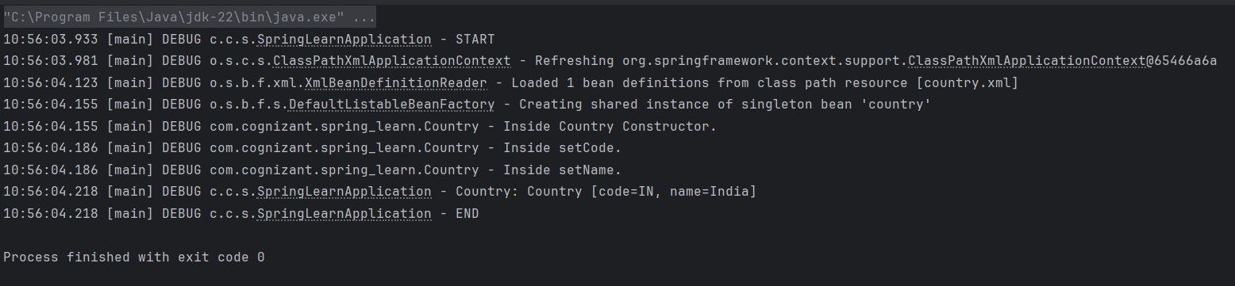

Hello World RESTful Web Service
Write a REST service in the spring learn application created earlier, that returns the text "Hello World!!" using Spring Web Framework. Refer details below:
application.properties:
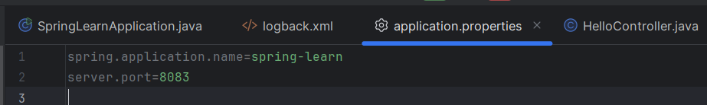
HelloController.java:
package com.cognizant.spring_learn.controller;
import org.slf4j.Logger;
import org.slf4j.LoggerFactory;
import org.springframework.web.bind.annotation.GetMapping;
import org.springframework.web.bind.annotation.RestController;
@RestController
public class HelloController {
private static final Logger LOGGER = LoggerFactory.getLogger(HelloController.class);
@GetMapping("/hello")
public String sayHello() {
LOGGER.debug("START");
String message = "Hello World!!";
LOGGER.debug("END");
return message;
}
}
SpringLearnApplication.java:
package com.cognizant.spring_learn;

import org.slf4j.Logger;
import org.slf4j.LoggerFactory;
import org.springframework.boot.SpringApplication;
import org.springframework.boot.autoconfigure.SpringBootApplication;
@SpringBootApplication
public class SpringLearnApplication {
private static final Logger LOGGER = LoggerFactory.getLogger(SpringLearnApplication.class);
public static void main(String[] args) {
LOGGER.debug("START");
SpringApplication.run(SpringLearnApplication.class, args);
LOGGER.debug("END");
}
}
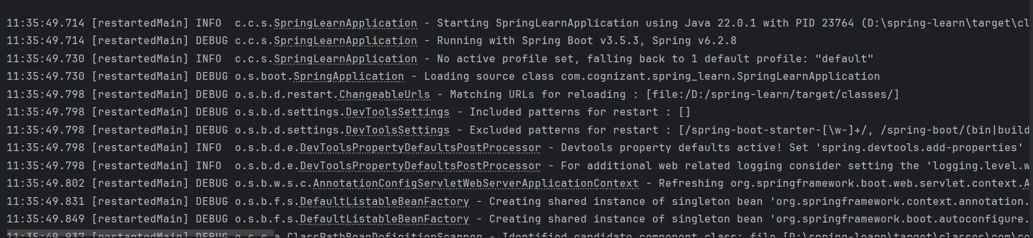

OUTPUT:

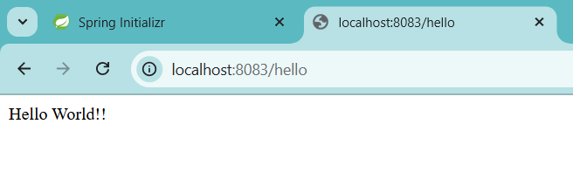
REST - Country Web Service
Write a REST service that returns India country details in the earlier created spring learn application.
country.xml
<beans xmlns="http://www.springframework.org/schema/beans"
xmlns:xsi="http://www.w3.org/2001/XMLSchema-instance"
xsi:schemaLocation="http://www.springframework.org/schema/beans
http://www.springframework.org/schema/beans/spring-beans.xsd">
<bean id="country" class="com.cognizant.spring_learn.Country">
<property name="code" value="IN"/>
<property name="name" value="India"/>
</bean>

</beans>
CountryController.java
package com.cognizant.spring_learn.controller;
import com.cognizant.spring_learn.Country;
import org.slf4j.Logger;
import org.slf4j.LoggerFactory;
import org.springframework.context.ApplicationContext;
import org.springframework.context.support.ClassPathXmlApplicationContext;
import org.springframework.web.bind.annotation.RequestMapping;
import org.springframework.web.bind.annotation.RestController;
@RestController
public class CountryController {
private static final Logger LOGGER = LoggerFactory.getLogger(CountryController.class);
@RequestMapping("/country")
public Country getCountryIndia() {
LOGGER.debug("START");
ApplicationContext context = new ClassPathXmlApplicationContext("country.xml");
Country country = context.getBean("country", Country.class);
LOGGER.debug("END");
return country;
}
}
Country.java
package com.cognizant.spring_learn;
import org.slf4j.Logger;
import org.slf4j.LoggerFactory;
public class Country {
private static final Logger LOGGER = LoggerFactory.getLogger(Country.class);
private String code;
private String name;
public Country() {
LOGGER.debug("Inside Country Constructor.");
}
public String getCode() {
LOGGER.debug("Inside getCode.");
return code;
}
public void setCode(String code) {
LOGGER.debug("Inside setCode.");
this.code = code;
}
public String getName() {
LOGGER.debug("Inside getName.");
return name;
}
public void setName(String name) {
LOGGER.debug("Inside setName.");
this.name = name;
}
@Override
public String toString() {
return "Country [code=" + code + ", name=" + name + "]";
}
}
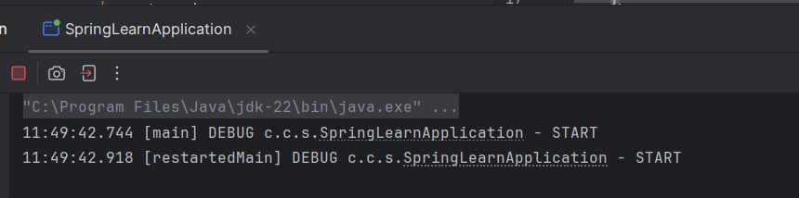
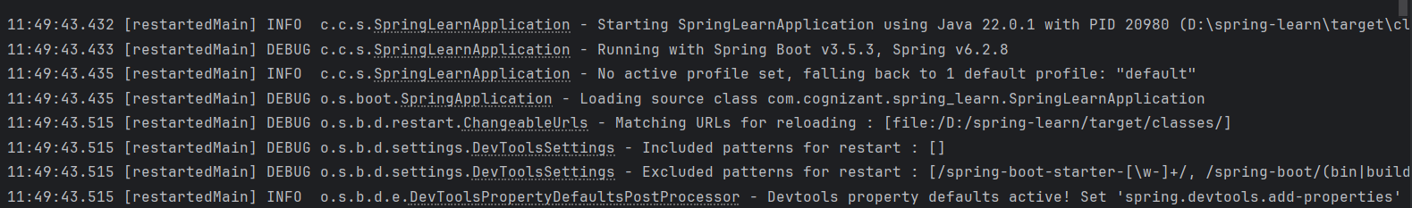
OUTPUT:
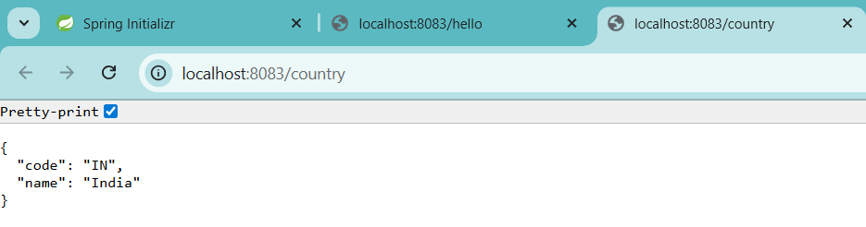
REST - Get country based on country code
Write a REST service that returns a specific country based on country code. The country code should be case insensitive.
country.xml
<?xml version="1.0" encoding="UTF-8"?>
<beans xmlns="http://www.springframework.org/schema/beans"
xmlns:xsi="http://www.w3.org/2001/XMLSchema-instance"
xsi:schemaLocation="http://www.springframework.org/schema/beans
http://www.springframework.org/schema/beans/spring-beans.xsd">
<bean id="countryList" class="java.util.ArrayList">
<constructor-arg>
<list>
<bean class="com.cognizant.spring_learn.Country">
<property name="code" value="IN" />
<property name="name" value="India" />
</bean>
<bean class="com.cognizant.spring_learn.Country">
<property name="code" value="US" />
<property name="name" value="United States" />
</bean>
<bean class="com.cognizant.spring_learn.Country">
<property name="code" value="JP" />
<property name="name" value="Japan" />
</bean>
<bean class="com.cognizant.spring_learn.Country">
<property name="code" value="DE" />
<property name="name" value="Germany" />
</bean>
</list>
</constructor-arg>
</bean>

</beans>
CountryService.java in service package:
package com.cognizant.spring_learn.service;

import com.cognizant.spring_learn.Country;
import org.slf4j.Logger;
import org.slf4j.LoggerFactory;
import org.springframework.context.ApplicationContext;
import org.springframework.context.support.ClassPathXmlApplicationContext;
import org.springframework.stereotype.Service;
import java.util.List;
@Service
public class CountryService {
private static final Logger LOGGER = LoggerFactory.getLogger(CountryService.class);
public Country getCountry(String code) {
LOGGER.debug("START");
ApplicationContext context = new ClassPathXmlApplicationContext("country.xml");
List<Country> countries = (List<Country>) context.getBean("countryList");
return countries.stream()
.filter(c -> c.getCode().equalsIgnoreCase(code))
.findFirst()
.orElse(null); // or throw custom exception
}
}
CountryController.java
package com.cognizant.spring_learn.controller;
import com.cognizant.spring_learn.Country;
import com.cognizant.spring_learn.service.CountryService;
import org.slf4j.Logger;
import org.slf4j.LoggerFactory;
import org.springframework.beans.factory.annotation.Autowired;
import org.springframework.web.bind.annotation.*;
@RestController
public class CountryController {
private static final Logger LOGGER = LoggerFactory.getLogger(CountryController.class);
@Autowired
private CountryService countryService;
@GetMapping("/country/{code}")
public Country getCountry(@PathVariable String code) {
LOGGER.debug("START");
Country country = countryService.getCountry(code);
LOGGER.debug("END");
return country;
}
}
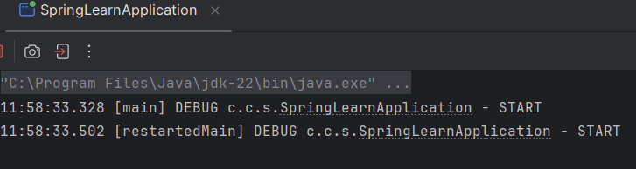
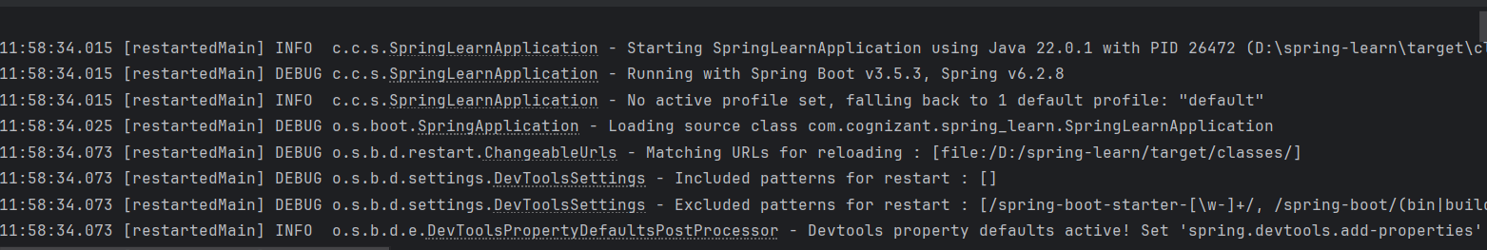

OUTPUT:
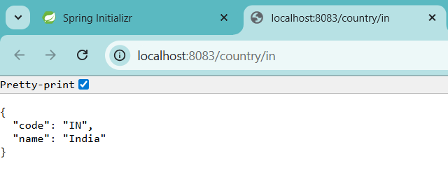
Create authentication service that returns JWT
As part of first step of JWT process, the user credentials needs to be sent to authentication service request that generates and returns the JWT.
SecurityConfig.java:
package com.cognizant.spring_learn.config;
import org.springframework.context.annotation.Bean;
import org.springframework.context.annotation.Configuration;
import org.springframework.security.config.annotation.web.builders.HttpSecurity;
import org.springframework.security.web.SecurityFilterChain;
@Configuration
public class SecurityConfig {
@Bean
public SecurityFilterChain securityFilterChain(HttpSecurity http) throws Exception {
http
.csrf(csrf -> csrf.disable())
.authorizeHttpRequests(auth -> auth
.requestMatchers("/authenticate").permitAll()
.anyRequest().authenticated()
)
.httpBasic();
return http.build();
}
}
AuthenticationController.java:
package com.cognizant.spring_learn.controller;
import com.cognizant.spring_learn.util.JwtUtil;
import org.springframework.beans.factory.annotation.Autowired;
import org.springframework.web.bind.annotation.*;
import jakarta.servlet.http.HttpServletRequest;
import java.util.Base64;
@RestController
public class AuthenticationController {
@Autowired
private JwtUtil jwtUtil;
@RequestMapping(value = "/authenticate", method = RequestMethod.GET)
public String authenticate(HttpServletRequest request) {
String authHeader = request.getHeader("Authorization");
if (authHeader != null && authHeader.startsWith("Basic ")) {
String base64Credentials = authHeader.substring("Basic ".length());
byte[] decoded = Base64.getDecoder().decode(base64Credentials);
String credentials = new String(decoded);
String[] values = credentials.split(":", 2);
if ("user".equals(values[0]) && "pwd".equals(values[1])) {
String token = jwtUtil.generateToken(values[0]);
return "{\"token\":\"" + token + "\"}";
}
}
throw new RuntimeException("Invalid credentials");
}
}
JwtUtil.java:
package com.cognizant.spring_learn.util;
import io.jsonwebtoken.Jwts;
import io.jsonwebtoken.SignatureAlgorithm;
import org.springframework.stereotype.Component;
import java.util.Base64;
import java.util.Date;
@Component
public class JwtUtil {
private final String secretKey = Base64.getEncoder().encodeToString("secret-key".getBytes());
public String generateToken(String username) {
return Jwts.builder()
.setSubject(username)
.setIssuedAt(new Date(System.currentTimeMillis()))
.setExpiration(new Date(System.currentTimeMillis() + 1000 * 60 * 60 * 10)) // 10 hours
.signWith(SignatureAlgorithm.HS256, Base64.getDecoder().decode(secretKey))
.compact();
}
}
pom.xml:
<?xml version="1.0" encoding="UTF-8"?>
<project xmlns="http://maven.apache.org/POM/4.0.0" xmlns:xsi="http://www.w3.org/2001/XMLSchema-instance"
xsi:schemaLocation="http://maven.apache.org/POM/4.0.0 https://maven.apache.org/xsd/maven-4.0.0.xsd">
<modelVersion>4.0.0</modelVersion>
<parent>
<groupId>org.springframework.boot</groupId>
<artifactId>spring-boot-starter-parent</artifactId>
<version>3.5.3</version>
<relativePath/> <!-- lookup parent from repository -->
</parent>
<groupId>com.cognizant</groupId>
<artifactId>spring-learn</artifactId>
<version>0.0.1-SNAPSHOT</version>
<name>spring-learn</name>
<description>Demo project for Spring Boot</description>
<url/>
<licenses>
<license/>
</licenses>
<developers>
<developer/>
</developers>
<scm>
<connection/>
<developerConnection/>
<tag/>
<url/>
</scm>
<properties>
<java.version>17</java.version>
</properties>
<dependencies>
<dependency>
<groupId>org.springframework.boot</groupId>
<artifactId>spring-boot-starter-web</artifactId>
</dependency>
<dependency>
<groupId>org.springframework.boot</groupId>
<artifactId>spring-boot-devtools</artifactId>
<scope>runtime</scope>
<optional>true</optional>
</dependency>
<!-- Required only for Java 11+ with jjwt 0.9.1 -->
<dependency>
<groupId>javax.xml.bind</groupId>
<artifactId>jaxb-api</artifactId>
<version>2.3.1</version>
</dependency>
<dependency>
<groupId>org.springframework.boot</groupId>
<artifactId>spring-boot-starter-test</artifactId>
<scope>test</scope>
</dependency>
<!-- Spring Security -->
<dependency>
<groupId>org.springframework.boot</groupId>
<artifactId>spring-boot-starter-security</artifactId>
</dependency>
<dependency>
<groupId>jakarta.servlet</groupId>
<artifactId>jakarta.servlet-api</artifactId>
<version>6.0.0</version>
<scope>provided</scope>
</dependency>
<dependency>
<groupId>javax.servlet</groupId>
<artifactId>javax.servlet-api</artifactId>
<version>4.0.1</version>
<scope>provided</scope>
</dependency>
<!-- JWT Support -->
<dependency>
<groupId>io.jsonwebtoken</groupId>
<artifactId>jjwt</artifactId>
<version>0.9.1</version>
</dependency>
</dependencies>
<build>
<plugins>
<plugin>
<groupId>org.springframework.boot</groupId>
<artifactId>spring-boot-maven-plugin</artifactId>
</plugin>
</plugins>
</build>
</project>
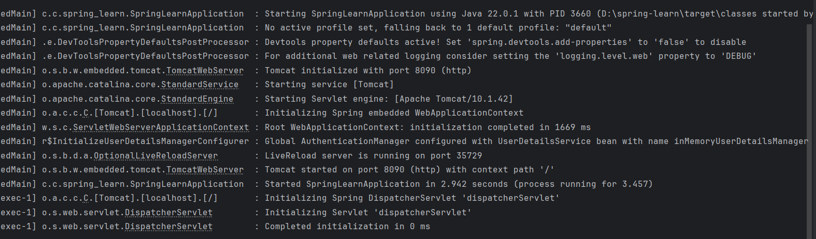

OUTPUT:
