WEEK-3 HANDS-ON
BONDA PRASANTH
6382932
Exercise 1: Configuring a Basic Spring Application
Scenario:
Your company is developing a web application for managing a library. You need to use the Spring Framework to handle the backend operations.
Steps:
- Set Up a Spring Project:
  - Create a Maven project named LibraryManagement.
  - Add Spring Core dependencies in the pom.xml file.
- Configure the Application Context:
  - Create an XML configuration file named applicationContext.xml in the src/main/resources directory.
  - Define beans for BookService and BookRepository in the XML file.
- Define Service and Repository Classes:
  - Create a package com.library.service and add a class BookService.
  - Create a package com.library.repository and add a class BookRepository.
- Run the Application:
  - Create a main class to load the Spring context and test the configuration.

ANS:Add Spring Core Dependencies
<dependencies>
<!-- Spring Core -->
<dependency>
<groupId>org.springframework</groupId>
<artifactId>spring-context</artifactId>
<version>5.3.34</version> <!-- You can use a compatible latest version -->
</dependency>
</dependencies>
applicationContext.xml:
<?xml version="1.0" encoding="UTF-8"?>
<beans xmlns="http://www.springframework.org/schema/beans"
xmlns:xsi="http://www.w3.org/2001/XMLSchema-instance"
xsi:schemaLocation="http://www.springframework.org/schema/beans
http://www.springframework.org/schema/beans/spring-beans.xsd">

<bean id="bookRepository" class="com.library.repository.BookRepository" />
<bean id="bookService" class="com.library.service.BookService">
<property name="bookRepository" ref="bookRepository"/>
</bean>

</beans>
BookRepository.java inside new package com.library.repository:
package com.library.repository;

public class BookRepository {
public void save() {
System.out.println("Book saved to the database.");
}
}
BookService.java inside package com.library.service:
package com.library.service;

import com.library.repository.BookRepository;
public class BookService {
private BookRepository bookRepository;
public void setBookRepository(BookRepository bookRepository) {
this.bookRepository = bookRepository;
}
public void saveBook() {
bookRepository.save();
System.out.println("BookService: Book processed and saved.");
}
}
LibraryApp.java inside com.library package(main class):
package com.library;
import com.library.service.BookService;
import org.springframework.context.ApplicationContext;
import org.springframework.context.support.ClassPathXmlApplicationContext;
public class LibraryApp {
public static void main(String[] args) {
ApplicationContext context = new ClassPathXmlApplicationContext("applicationContext.xml");
BookService bookService = context.getBean("bookService", BookService.class);
bookService.saveBook();
}
}
OUTPUT:
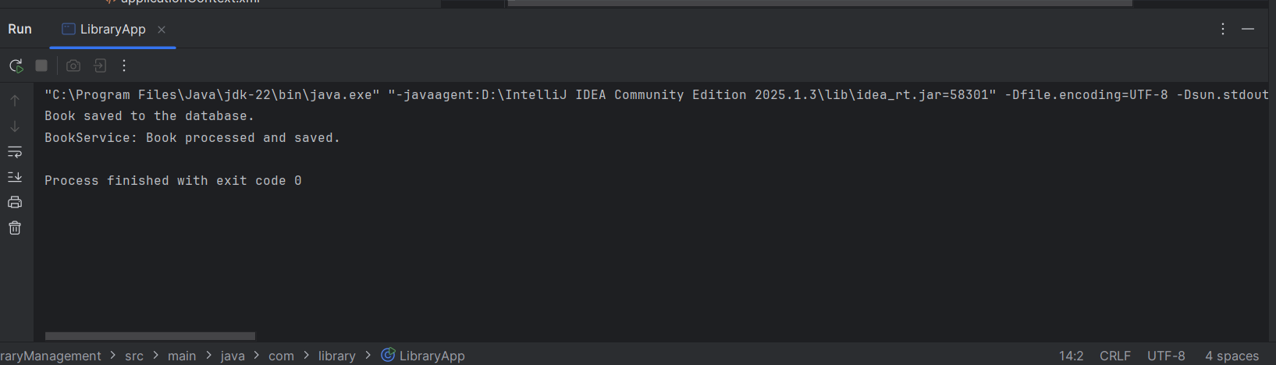

Exercise 2: Implementing Dependency Injection
Scenario:
In the library management application, you need to manage the dependencies between the BookService and BookRepository classes using Spring's IoC and DI.
Steps:
- Modify the XML Configuration:
  - Update applicationContext.xml to wire BookRepository into BookService.
- Update the BookService Class:
  - Ensure that BookService class has a setter method for BookRepository.
- Test the Configuration:
  - Run the LibraryManagementApplication main class to verify the dependency injection.
ANS:
applicationContext.xml:
<?xml version="1.0" encoding="UTF-8"?>
<beans xmlns="http://www.springframework.org/schema/beans"
xmlns:xsi="http://www.w3.org/2001/XMLSchema-instance"
xsi:schemaLocation="
http://www.springframework.org/schema/beans
http://www.springframework.org/schema/beans/spring-beans.xsd">
<bean id="bookRepository" class="com.library.repository.BookRepository" />
<bean id="bookService" class="com.library.service.BookService">
<property name="bookRepository" ref="bookRepository" />
</bean>

</beans>
BookService.java:
package com.library.service;
import com.library.repository.BookRepository;
public class BookService {
private BookRepository bookRepository;
public void setBookRepository(BookRepository bookRepository) {
this.bookRepository = bookRepository;
}
public void displayService() {
System.out.println("BookService is running.");
bookRepository.displayRepository();
}
}
BookRepository.java:
package com.library.repository;
public class BookRepository {
public void displayRepository() {
System.out.println("BookRepository is active.");
}
}
LibraryApp.java:
import org.springframework.context.ApplicationContext;
import org.springframework.context.support.ClassPathXmlApplicationContext;
import com.library.service.BookService;
public class LibraryApp {
public static void main(String[] args) {
ApplicationContext context = new ClassPathXmlApplicationContext("applicationContext.xml");
BookService bookService = (BookService) context.getBean("bookService");
bookService.displayService(); // This should also call BookRepository method
}
}
OUTPUT:
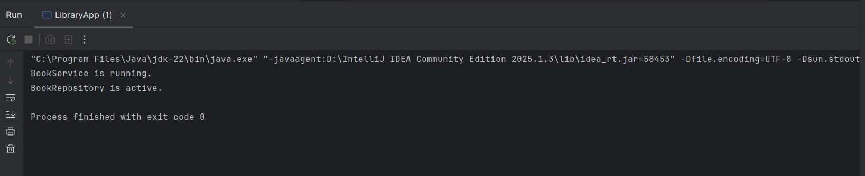
Exercise 4: Creating and Configuring a Maven Project
Scenario:
You need to set up a new Maven project for the library management application and add Spring dependencies.
Steps:
- Create a New Maven Project:
  - Create a new Maven project named LibraryManagement.
- Add Spring Dependencies in pom.xml:
  - Include dependencies for Spring Context, Spring AOP, and Spring WebMVC.
- Configure Maven Plugins:
  - Configure the Maven Compiler Plugin for Java version 1.8 in the pom.xml file.
ANS:
ADDING DEPENDENCIES IN OUR POM.XML:
<project xmlns="http://maven.apache.org/POM/4.0.0"
xmlns:xsi="http://www.w3.org/2001/XMLSchema-instance"
xsi:schemaLocation="http://maven.apache.org/POM/4.0.0
http://maven.apache.org/xsd/maven-4.0.0.xsd">

<modelVersion>4.0.0</modelVersion>

<groupId>com.library</groupId>
<artifactId>LibraryManagement</artifactId>
<version>1.0-SNAPSHOT</version>

<properties>
<maven.compiler.source>1.8</maven.compiler.source>
<maven.compiler.target>1.8</maven.compiler.target>
</properties>

<dependencies>
<dependency>
<groupId>org.springframework</groupId>
<artifactId>spring-context</artifactId>
<version>5.3.34</version>
</dependency>
<dependency>
<groupId>org.springframework</groupId>
<artifactId>spring-aop</artifactId>
<version>5.3.34</version>
</dependency>
<dependency>
<groupId>org.springframework</groupId>
<artifactId>spring-webmvc</artifactId>
<version>5.3.34</version>
</dependency>
</dependencies>
<build>
<plugins>
<plugin>
<groupId>org.apache.maven.plugins</groupId>
<artifactId>maven-compiler-plugin</artifactId>
<version>3.8.1</version>
<configuration>
<source>1.8</source>
<target>1.8</target>
</configuration>
</plugin>
</plugins>
</build>
</project>
LibraryApp.java:
package com.library;
import com.library.service.BookService;
import org.springframework.context.ApplicationContext;
import org.springframework.context.support.ClassPathXmlApplicationContext;
public class LibraryManagementApplication {
public static void main(String[] args) {
ApplicationContext context = new ClassPathXmlApplicationContext("applicationContext.xml");
BookService bookService = (BookService) context.getBean("bookService");
bookService.display();
}
}
OUTPUT:
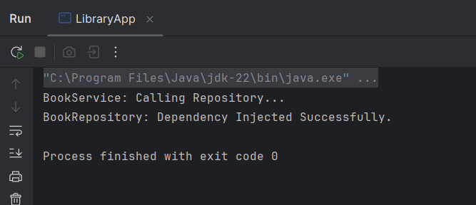
The Spring context is loading correctly.
Dependencies are injected via applicationContext.xml.
Maven and Spring configuration are working.
Spring Data JPA - Quick Example
- Group: com.cognizant
- Artifact: orm-learn
- Description: Demo project for Spring Data JPA and Hibernate
- Packaging: Jar
- Java Version: 17 (recommended)
- Dependencies:
  - Spring Boot DevTools
  - Spring Data JPA
  - MySQL Driver

MySQL Schema in Workbench:

Sql query:

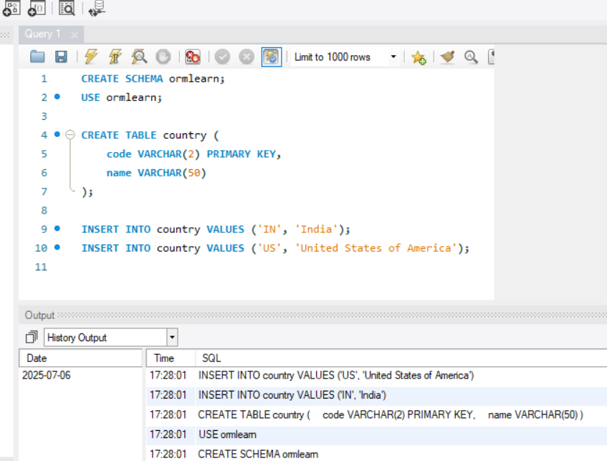
application.properties:
logging.level.org.springframework=info
logging.level.com.cognizant=debug
logging.level.org.hibernate.SQL=trace
logging.level.org.hibernate.type.descriptor.sql=trace
logging.pattern.console=%d{dd-MM-yy} %d{HH:mm:ss.SSS} %-20.20thread %5p %-25.25logger{25} %25M %4L %m%n
spring.datasource.driver-class-name=com.mysql.cj.jdbc.Driver
spring.datasource.url=jdbc:mysql://localhost:3306/ormlearn
spring.datasource.username=root
spring.datasource.password=your_password_here
spring.jpa.hibernate.ddl-auto=validate
spring.jpa.properties.hibernate.dialect=org.hibernate.dialect.MySQL8Dialect

Country.java in model package:
package com.cognizant.ormlearn.model;
import jakarta.persistence.Column;
import jakarta.persistence.Entity;
import jakarta.persistence.Id;
import jakarta.persistence.Table;
@Entity
@Table(name = "country")
public class Country {
@Id
@Column(name = "code")
private String code;
@Column(name = "name")
private String name;
public String getCode() { return code; }
public void setCode(String code) { this.code = code; }
public String getName() { return name; }
public void setName(String name) { this.name = name; }
@Override
public String toString() {
return "Country{" + "code='" + code + '\'' + ", name='" + name + '\'' + '}';
}
}
CountryRepository.java inside repository package:
package com.cognizant.ormlearn.repository;
import com.cognizant.ormlearn.model.Country;
import org.springframework.data.jpa.repository.JpaRepository;
import org.springframework.stereotype.Repository;
@Repository
public interface CountryRepository extends JpaRepository<Country, String> {
}
CountryService.java inside package:
package com.cognizant.ormlearn.service;
import com.cognizant.ormlearn.model.Country;
import com.cognizant.ormlearn.repository.CountryRepository;
import org.springframework.beans.factory.annotation.Autowired;
import org.springframework.stereotype.Service;
import jakarta.transaction.Transactional;
import java.util.List;
@Service
public class CountryService {
@Autowired
private CountryRepository countryRepository;
@Transactional
public List<Country> getAllCountries() {
return countryRepository.findAll();
}
}
OrmLearnApplication.java:
package com.cognizant.ormlearn;
import com.cognizant.ormlearn.model.Country;
import com.cognizant.ormlearn.service.CountryService;
import org.slf4j.Logger;
import org.slf4j.LoggerFactory;
import org.springframework.boot.SpringApplication;
import org.springframework.boot.autoconfigure.SpringBootApplication;
import org.springframework.context.ApplicationContext;
import java.util.List;
@SpringBootApplication
public class OrmLearnApplication {
private static CountryService countryService;
private static final Logger LOGGER = LoggerFactory.getLogger(OrmLearnApplication.class);
public static void main(String[] args) {
ApplicationContext context = SpringApplication.run(OrmLearnApplication.class, args);
LOGGER.info("Inside main");
countryService = context.getBean(CountryService.class);
testGetAllCountries();
}
private static void testGetAllCountries() {
LOGGER.info("Start");
List<Country> countries = countryService.getAllCountries();
LOGGER.debug("countries={}", countries);
LOGGER.info("End");
}
}
Pom.xml:
<?xml version="1.0" encoding="UTF-8"?>
<project xmlns="http://maven.apache.org/POM/4.0.0"
xmlns:xsi="http://www.w3.org/2001/XMLSchema-instance"
xsi:schemaLocation="http://maven.apache.org/POM/4.0.0
http://maven.apache.org/xsd/maven-4.0.0.xsd">
<modelVersion>4.0.0</modelVersion>

<groupId>com.cognizant</groupId>
<artifactId>orm-learn</artifactId>
<version>0.0.1-SNAPSHOT</version>
<name>orm-learn</name>
<description>Demo project for Spring Data JPA and Hibernate</description>
<packaging>jar</packaging>
<parent>
<groupId>org.springframework.boot</groupId>
<artifactId>spring-boot-starter-parent</artifactId>
<version>3.2.4</version> <!-- Or latest stable version -->
<relativePath/>
</parent>
<properties>
<java.version>17</java.version>
</properties>
<dependencies>
<dependency>
<groupId>org.springframework.boot</groupId>
<artifactId>spring-boot-starter</artifactId>
</dependency>
<dependency>
<groupId>org.springframework.boot</groupId>
<artifactId>spring-boot-starter-data-jpa</artifactId>
</dependency>
<dependency>
<groupId>com.mysql</groupId>
<artifactId>mysql-connector-j</artifactId>
<scope>runtime</scope>
</dependency>
<dependency>
<groupId>org.springframework.boot</groupId>
<artifactId>spring-boot-devtools</artifactId>
<scope>runtime</scope>
<optional>true</optional>
</dependency>
<dependency>
<groupId>org.springframework.boot</groupId>
<artifactId>spring-boot-starter-test</artifactId>
<scope>test</scope>
</dependency>
</dependencies>

<build>
<plugins>
<plugin>
<groupId>org.springframework.boot</groupId>
<artifactId>spring-boot-maven-plugin</artifactId>
<version>3.2.4</version>
</plugin>
</plugins>
</build>
</project>
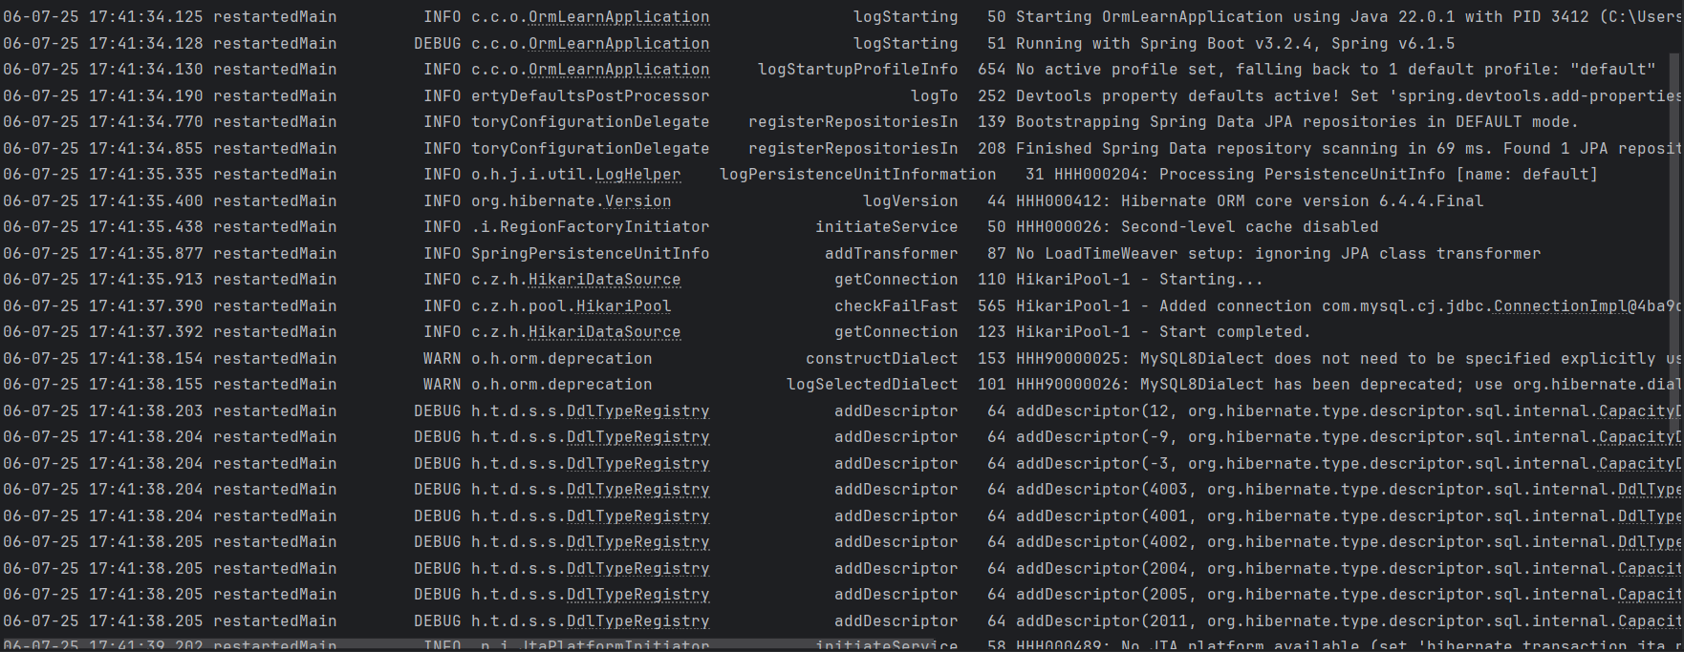
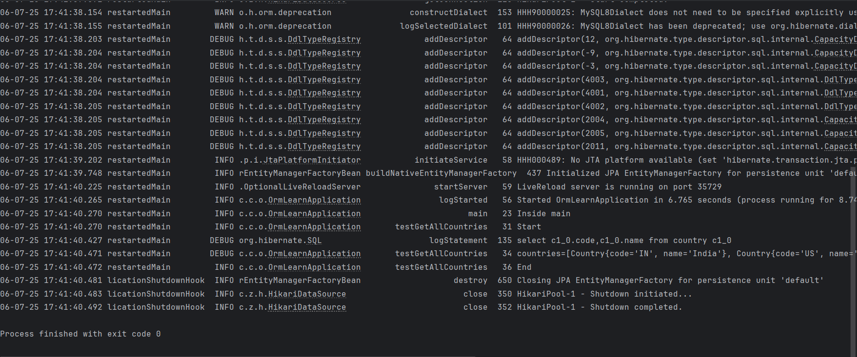
FLOWCHART OF MY DIRECTORY:
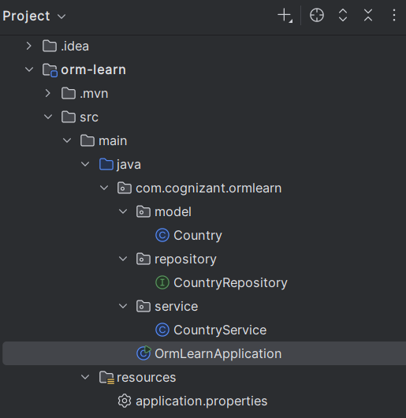
Difference between JPA, Hibernate and Spring Data JPA
Java Persistence API (JPA)
- JPA (Java Persistence API) is a Java specification (JSR 338) for object-relational mapping (ORM).
- It defines standards for persisting, retrieving, and managing data between Java objects and relational databases.
- JPA itself is only a specification — it does not provide a working implementation.
- Implementations of JPA include:
  - Hibernate
  - EclipseLink
  - OpenJPA

Hibernate
- Hibernate is an ORM framework that provides a concrete implementation of the JPA specification.
- It allows developers to map Java classes to database tables using annotations or XML.
- Hibernate handles:
  - Entity management
  - Query generation (HQL/Criteria API)
  - Caching
  - Lazy loading and more

Spring Data JPA
- Spring Data JPA is a Spring project that provides a higher-level abstraction over JPA.
- It does not implement JPA, but simplifies JPA usage by reducing boilerplate code.
- Integrates with JPA providers like Hibernate behind the scenes.
- Automatically manages:
  - Transactions
  - Repository implementations
  - CRUD operations with simple interfaces
Sql query:
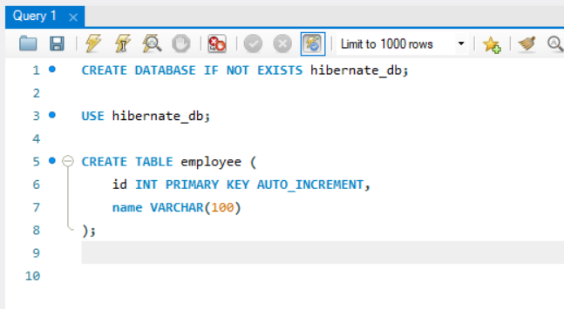
Employee.java:
package com.example.model;

import jakarta.persistence.*;

@Entity
@Table(name = "employee")
public class Employee {
@Id
@GeneratedValue(strategy = GenerationType.IDENTITY)
private int id;

private String name;

public Employee() {}

public Employee(String name) {
this.name = name;
}
public int getId() {
return id;
}

public String getName() {
return name;
}

public void setId(int id) {
this.id = id;
}

public void setName(String name) {
this.name = name;
}
}
HibernateUtil.java:
package com.example.util;

import com.example.model.Employee;
import org.hibernate.SessionFactory;
import org.hibernate.boot.registry.StandardServiceRegistryBuilder;
import org.hibernate.cfg.Configuration;

public class HibernateUtil {
private static final SessionFactory sessionFactory = buildSessionFactory();

private static SessionFactory buildSessionFactory() {
try {
Configuration cfg = new Configuration();
cfg.configure("hibernate.cfg.xml"); // from resources
cfg.addAnnotatedClass(Employee.class);

return cfg.buildSessionFactory(new StandardServiceRegistryBuilder()
.applySettings(cfg.getProperties()).build());
} catch (Exception ex) {
throw new ExceptionInInitializerError("SessionFactory creation failed: " + ex);
}
}
public static SessionFactory getSessionFactory() {
return sessionFactory;
}
}
App.java:
package com.example.main;

import com.example.model.Employee;
import com.example.util.HibernateUtil;
import org.hibernate.Session;
import org.hibernate.Transaction;

public class App {
public static void main(String[] args) {
Employee emp = new Employee("John Doe");

Session session = HibernateUtil.getSessionFactory().openSession();
Transaction tx = null;

try {
tx = session.beginTransaction();
session.save(emp);
tx.commit();
System.out.println("Employee saved with ID: " + emp.getId());
} catch (Exception e) {
if (tx != null) tx.rollback();
e.printStackTrace();
} finally {
session.close();
}

HibernateUtil.getSessionFactory().close();
}
}
hibernate.cfg.xml:
<?xml version="1.0" encoding="UTF-8"?>
<!DOCTYPE hibernate-configuration PUBLIC
"-//Hibernate/Hibernate Configuration DTD 3.0//EN"
"http://www.hibernate.org/dtd/hibernate-configuration-3.0.dtd">

<hibernate-configuration>
<session-factory>
<property name="hibernate.connection.driver_class">com.mysql.cj.jdbc.Driver</property>
<property name="hibernate.connection.url">jdbc:mysql://localhost:3306/hibernate_db</property>
<property name="hibernate.connection.username">root</property>
<property name="hibernate.connection.password">root</property>
<property name="hibernate.dialect">org.hibernate.dialect.MySQLDialect</property>
<property name="hibernate.hbm2ddl.auto">update</property>
<property name="show_sql">true</property>
<mapping class="com.library.model.Employee"/>

</session-factory>
</hibernate-configuration>
Pom.xml:
<?xml version="1.0" encoding="UTF-8"?>
<project xmlns="http://maven.apache.org/POM/4.0.0"
xmlns:xsi="http://www.w3.org/2001/XMLSchema-instance"
xsi:schemaLocation="http://maven.apache.org/POM/4.0.0 http://maven.apache.org/xsd/maven-4.0.0.xsd">
<modelVersion>4.0.0</modelVersion>
<groupId>com.library</groupId>
<artifactId>JPAHIBSJPA</artifactId>
<version>1.0-SNAPSHOT</version>
<dependencies>
<!-- Hibernate Core -->
<dependency>
<groupId>org.hibernate.orm</groupId>
<artifactId>hibernate-core</artifactId>
<version>6.4.4.Final</version>
</dependency>
<!-- MySQL JDBC Driver -->
<dependency>
<groupId>com.mysql</groupId>
<artifactId>mysql-connector-j</artifactId>
<version>8.0.33</version>
</dependency>
<!-- Jakarta Persistence -->
<dependency>
<groupId>jakarta.persistence</groupId>
<artifactId>jakarta.persistence-api</artifactId>
<version>3.1.0</version>
</dependency>
</dependencies>
<properties>
<maven.compiler.source>22</maven.compiler.source>
<maven.compiler.target>22</maven.compiler.target>
<project.build.sourceEncoding>UTF-8</project.build.sourceEncoding>
</properties>
</project>
Output:
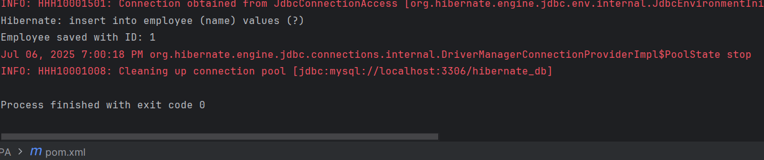
FLOWCHART OF MY PROJECT’S DIRECTORY:
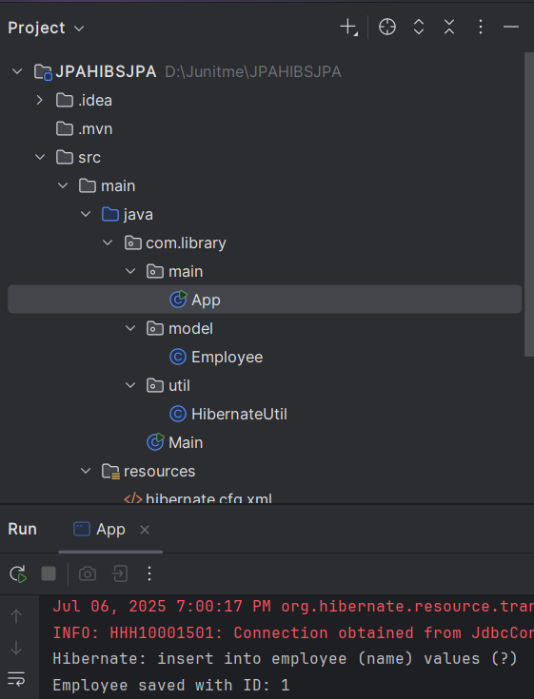
SPRING DATA JPA:
WE CAN COMPARE THIS HIBERNATE PROJECT WITH OUR SPRING DATA JPA PROJECT

application.properties:
logging.level.org.springframework=info
logging.level.com.cognizant=debug
logging.level.org.hibernate.SQL=trace
logging.level.org.hibernate.type.descriptor.sql=trace
logging.pattern.console=%d{dd-MM-yy} %d{HH:mm:ss.SSS} %-20.20thread %5p %-25.25logger{25} %25M %4L %m%n
spring.datasource.driver-class-name=com.mysql.cj.jdbc.Driver
spring.datasource.url=jdbc:mysql://localhost:3306/ormlearn
spring.datasource.username=root
spring.datasource.password=your_password_here
spring.jpa.hibernate.ddl-auto=validate
spring.jpa.properties.hibernate.dialect=org.hibernate.dialect.MySQL8Dialect

Country.java in model package:
package com.cognizant.ormlearn.model;
import jakarta.persistence.Column;
import jakarta.persistence.Entity;
import jakarta.persistence.Id;
import jakarta.persistence.Table;
@Entity
@Table(name = "country")
public class Country {
@Id
@Column(name = "code")
private String code;
@Column(name = "name")
private String name;
public String getCode() { return code; }
public void setCode(String code) { this.code = code; }
public String getName() { return name; }
public void setName(String name) { this.name = name; }
@Override
public String toString() {
return "Country{" + "code='" + code + '\'' + ", name='" + name + '\'' + '}';
}
}
CountryRepository.java inside repository package:
package com.cognizant.ormlearn.repository;
import com.cognizant.ormlearn.model.Country;
import org.springframework.data.jpa.repository.JpaRepository;
import org.springframework.stereotype.Repository;
@Repository
public interface CountryRepository extends JpaRepository<Country, String> {
}
CountryService.java inside package:
package com.cognizant.ormlearn.service;
import com.cognizant.ormlearn.model.Country;
import com.cognizant.ormlearn.repository.CountryRepository;
import org.springframework.beans.factory.annotation.Autowired;
import org.springframework.stereotype.Service;
import jakarta.transaction.Transactional;
import java.util.List;
@Service
public class CountryService {
@Autowired
private CountryRepository countryRepository;
@Transactional
public List<Country> getAllCountries() {
return countryRepository.findAll();
}
}
OrmLearnApplication.java:
package com.cognizant.ormlearn;
import com.cognizant.ormlearn.model.Country;
import com.cognizant.ormlearn.service.CountryService;
import org.slf4j.Logger;
import org.slf4j.LoggerFactory;
import org.springframework.boot.SpringApplication;
import org.springframework.boot.autoconfigure.SpringBootApplication;
import org.springframework.context.ApplicationContext;
import java.util.List;
@SpringBootApplication
public class OrmLearnApplication {
private static CountryService countryService;
private static final Logger LOGGER = LoggerFactory.getLogger(OrmLearnApplication.class);
public static void main(String[] args) {
ApplicationContext context = SpringApplication.run(OrmLearnApplication.class, args);
LOGGER.info("Inside main");
countryService = context.getBean(CountryService.class);
testGetAllCountries();
}
private static void testGetAllCountries() {
LOGGER.info("Start");
List<Country> countries = countryService.getAllCountries();
LOGGER.debug("countries={}", countries);
LOGGER.info("End");
}
}
Pom.xml:
<?xml version="1.0" encoding="UTF-8"?>
<project xmlns="http://maven.apache.org/POM/4.0.0"
xmlns:xsi="http://www.w3.org/2001/XMLSchema-instance"
xsi:schemaLocation="http://maven.apache.org/POM/4.0.0
http://maven.apache.org/xsd/maven-4.0.0.xsd">
<modelVersion>4.0.0</modelVersion>

<groupId>com.cognizant</groupId>
<artifactId>orm-learn</artifactId>
<version>0.0.1-SNAPSHOT</version>
<name>orm-learn</name>
<description>Demo project for Spring Data JPA and Hibernate</description>
<packaging>jar</packaging>
<parent>
<groupId>org.springframework.boot</groupId>
<artifactId>spring-boot-starter-parent</artifactId>
<version>3.2.4</version> <!-- Or latest stable version -->
<relativePath/>
</parent>
<properties>
<java.version>17</java.version>
</properties>
<dependencies>
<dependency>
<groupId>org.springframework.boot</groupId>
<artifactId>spring-boot-starter</artifactId>
</dependency>
<dependency>
<groupId>org.springframework.boot</groupId>
<artifactId>spring-boot-starter-data-jpa</artifactId>
</dependency>
<dependency>
<groupId>com.mysql</groupId>
<artifactId>mysql-connector-j</artifactId>
<scope>runtime</scope>
</dependency>
<dependency>
<groupId>org.springframework.boot</groupId>
<artifactId>spring-boot-devtools</artifactId>
<scope>runtime</scope>
<optional>true</optional>
</dependency>
<dependency>
<groupId>org.springframework.boot</groupId>
<artifactId>spring-boot-starter-test</artifactId>
<scope>test</scope>
</dependency>
</dependencies>

<build>
<plugins>
<plugin>
<groupId>org.springframework.boot</groupId>
<artifactId>spring-boot-maven-plugin</artifactId>
<version>3.2.4</version>
</plugin>
</plugins>
</build>
</project>

What Is the Difference Between Hibernate and Spring Data JPA?
Hibernate is a JPA implementation, while Spring Data JPA is a JPA Data Access Abstraction.
Spring Data offers a solution to GenericDao custom implementations. It can also generate JPA queries on your behalf through method name conventions.
With Spring Data, you may use Hibernate, Eclipse Link, or any other JPA provider. A very interesting benefit is that you can control transaction boundaries declaratively using the @Transactional annotation.
Spring Data JPA is not an implementation or JPA provider, it's just an abstraction used to significantly reduce the amount of boilerplate code required to implement data access layers for various persistence stores.
I hope this article is useful to you. You can find more answers to this question at StackOverflow.
Hibernate provides a reference implementation of the Java Persistence API that makes it a great choice as an ORM tool with the benefits of loose coupling.

