WEEK-6 HANDS-ON
BONDA PRASANTH
6382932
REACT
1.ReactJS-HOL:
Define SPA and Its Benefits
SPA (Single Page Application):
A web application that loads a single HTML page and dynamically updates the content as the user interacts with the app without reloading the entire page.
Benefits:
- Fast loading after the initial load
- Smooth and seamless user experience
- Less bandwidth usage
- Easier to turn into a mobile app (e.g., using React Native)
Define React and Identify Its Working
React:
A JavaScript library developed by Facebook for building user interfaces, especially for single-page applications.
How it Works:
- Uses components to build UI.
- Implements a virtual DOM to efficiently update the real DOM.
- Follows unidirectional data flow.

Difference Between SPA and MPA
Feature | SPA (Single Page App) | MPA (Multi Page App)
Page Reload | No (Dynamic updates) | Yes (Each page reloads)
Speed | Faster once loaded | Slower due to reloads
SEO | Difficult without SSR | Easier
Complexity | More JS logic | Simpler traditional architecture
Examples | Gmail, Facebook | Amazon, Wikipedia

Pros and Cons of SPA
Pros:
- Faster interactions
- Fluid user experience
- Easy to debug using Chrome/React tools
Cons:
- Poor SEO (unless using SSR)
- Initial load might be large
- Can be harder to secure
Explain About React
React is a declarative, component-based library that helps build fast and scalable front-end applications. It promotes reusable UI components and uses JSX (JavaScript + XML) syntax.

Define Virtual DOM:
The Virtual DOM (VDOM) is a lightweight JavaScript representation of the actual DOM. React uses VDOM to:
- Make changes in memory
- Compare (diff) with the previous version
- Efficiently update only the changed parts in the real DOM

Features of React
- Component-based architecture
- JSX Syntax
- Virtual DOM
- One-way data binding
- Reusable components
- Developer tools support
Create a new React Application with the name “myfirstreact”, Run the application to print “welcome to the first session of React” as heading of that page.

App.js:
import React from 'react';
function App() {
return (
<div>
<h1>Welcome to the first session of React</h1>
</div>
);
}
export default App;
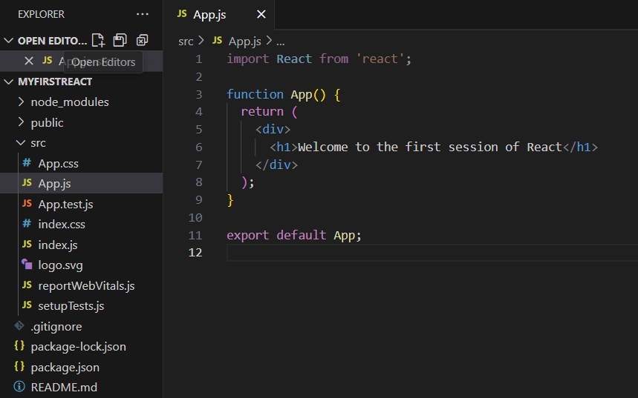
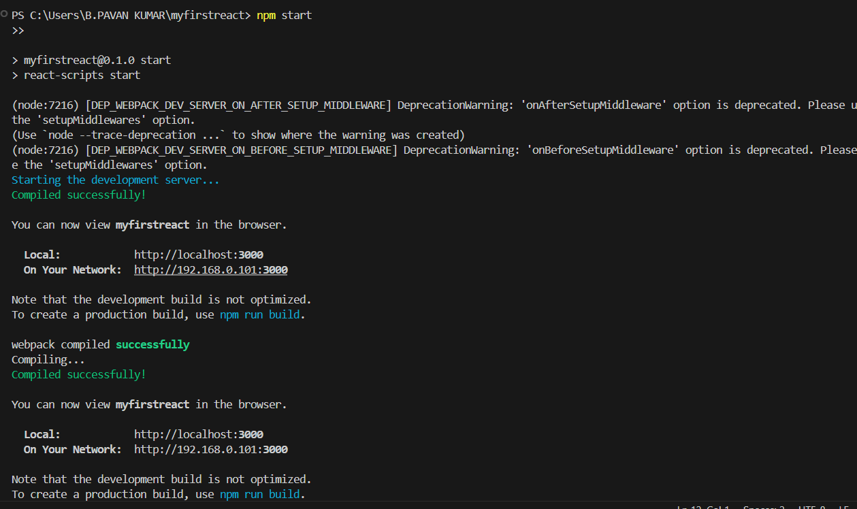
OUTPUT:
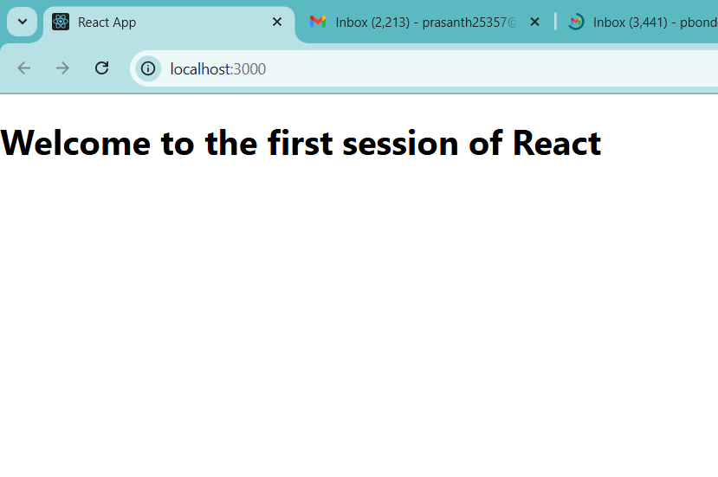
2. ReactJS-HOL
React Components:
A component in React is a reusable, independent piece of UI. Components can be functional or class-based.

React Component vs JavaScript Function
Feature | React Component | JavaScript Function
Purpose | Returns JSX (UI elements) | Returns values (numbers, strings, etc.)
Uses JSX | Yes | No
React Lifecycle | Yes (for class components) | No
State & Props | Yes | Not built-in

Types of Components in React
- Class Components
- Function Components

Class Component
A component defined using ES6 class syntax. Can use state and lifecycle methods.
jsx
CopyEdit
import React, { Component } from 'react';

class Home extends Component {
render() {
return <h1>Welcome to the Home page of Student Management Portal</h1>;
}
}
export default Home;

Function Component
A component defined as a JavaScript function. With React Hooks, they can now manage state and side-effects.
jsx
CopyEdit
import React from 'react';

function Home() {
return <h1>Welcome to the Home page of Student Management Portal</h1>;
}

export default Home;

Component Constructor
Used inside class components to initialize state or bind methods.
jsx
CopyEdit
constructor(props) {
super(props);
this.state = { ... };
}

render() Function
A required method in class components that returns the JSX to render UI.
Create a react app for Student Management Portal named StudentApp and create a component named Home which will display the Message “Welcome to the Home page of Student Management Portal”. Create another component named About and display the Message “Welcome to the About page of the Student Management Portal”. Create a third component named Contact and display the Message “Welcome to the Contact page of the Student Management Portal”. Call all the three components.

Home.js:
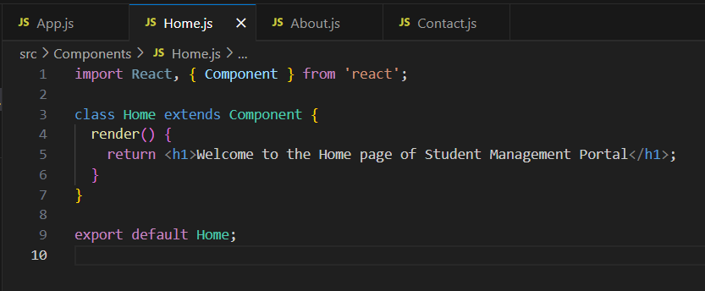
About.js:
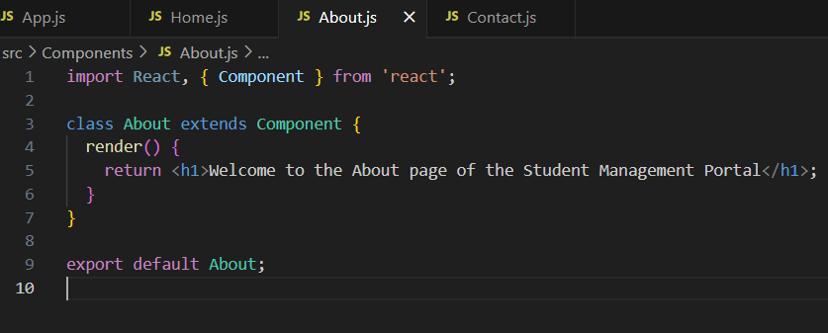
Contact.js:
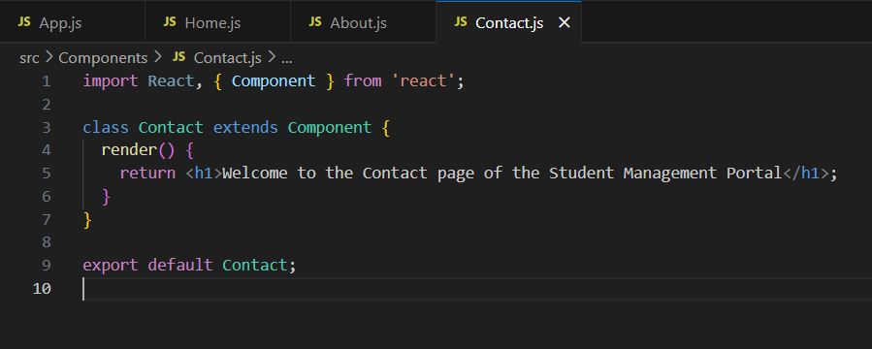
App.js:
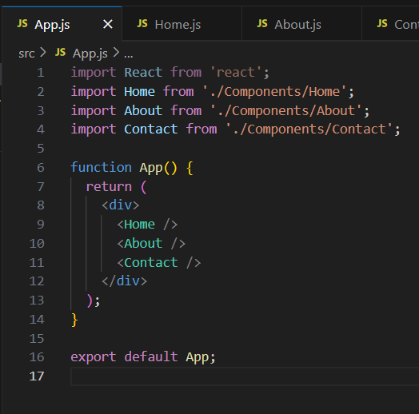
OUTPUT:
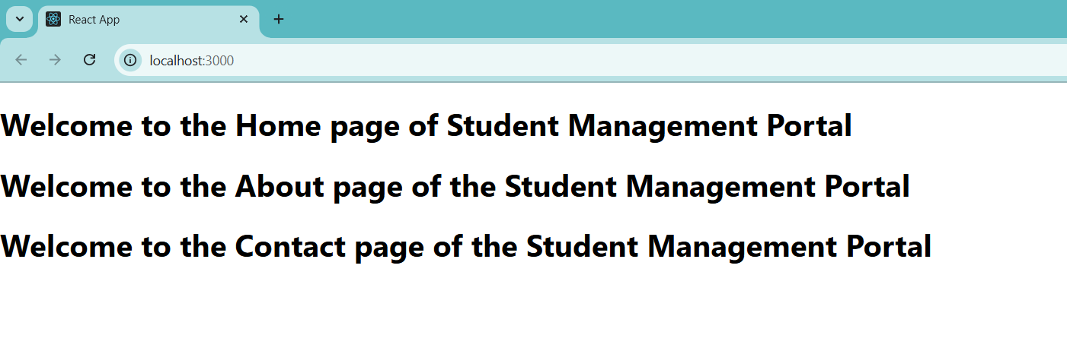

3. ReactJS-HOL:
Create a react app for Student Management Portal named scorecalculatorapp and create a function component named “CalculateScore” which will accept Name, School, Total and goal in order to calculate the average score of a student and display the same.

CalculateScore.js:
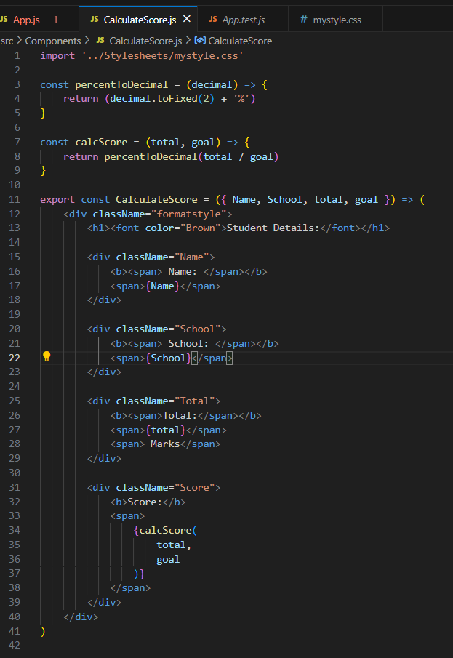
mystyle.css:
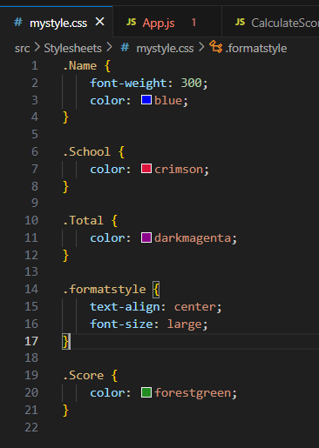
App.js:
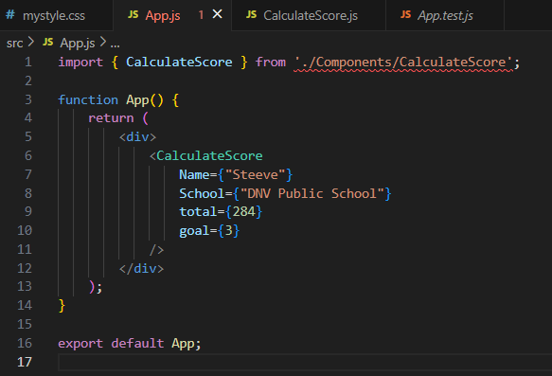
OUTPUT:
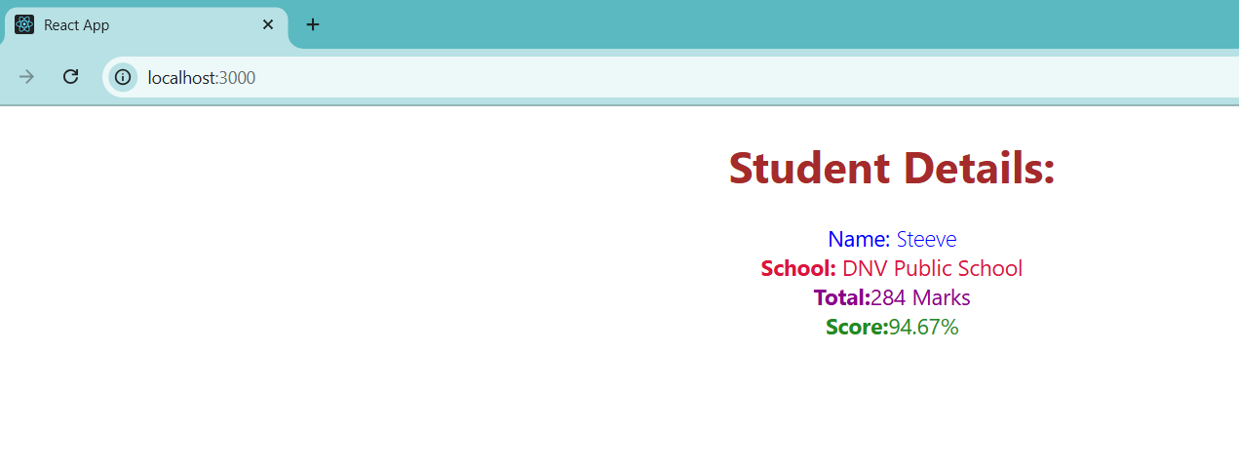
4. ReactJS-HOL:
Create a new react application using create-react-app tool with the name as “blogapp”.
Implement componentDidMount() hook
Implementing componentDidCatch() life cycle hook
Post.js:
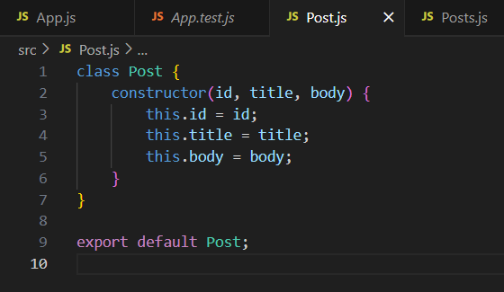
Posts.js:
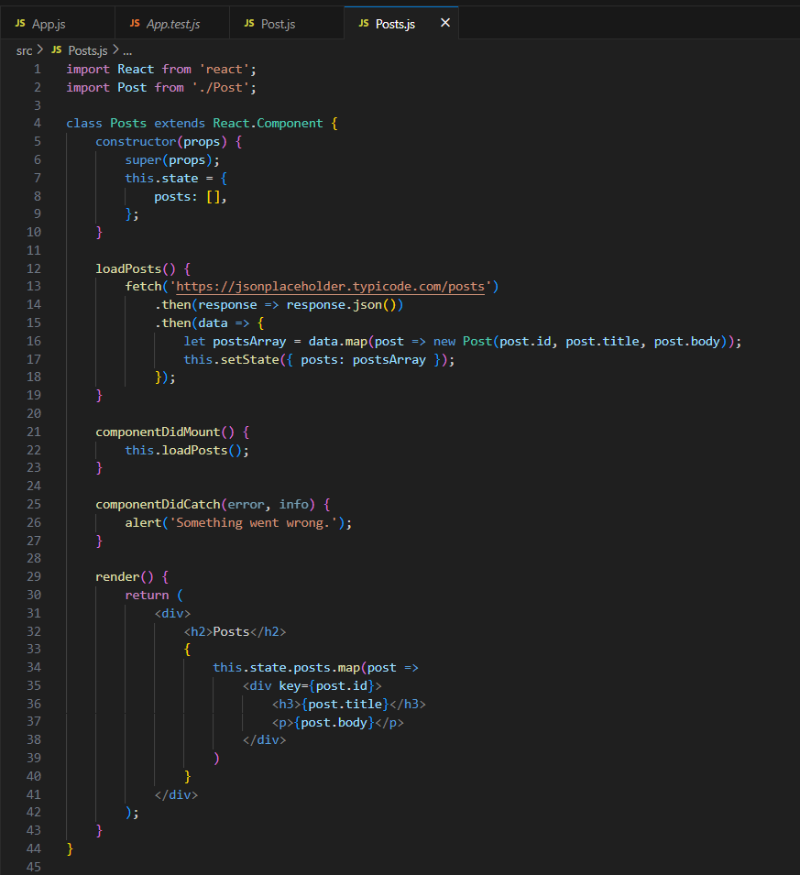
App.js:
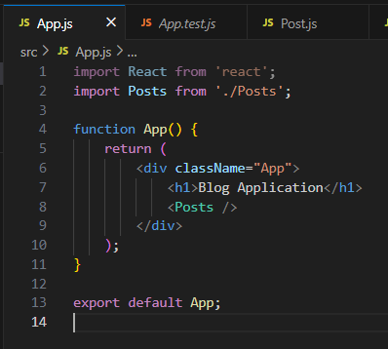
Output:
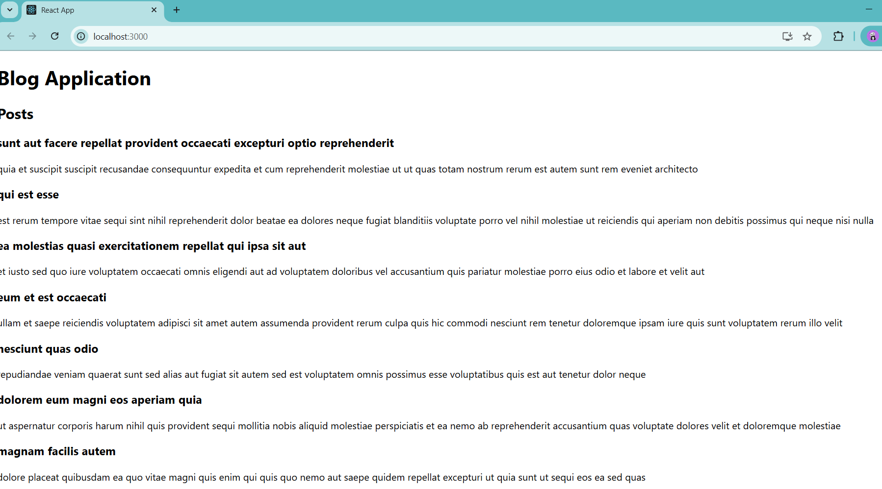

5. ReactJS-HOL:
My Academy team at Cognizant want to create a dashboard containing the details of ongoing and completed cohorts. A react application is created which displays the detail of the cohorts using react component. You are assigned the task of styling these react components.
Cohorttracker.zip:
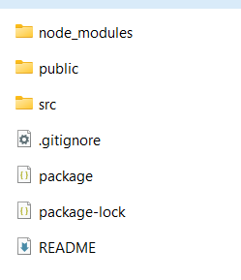
Cohort.js:
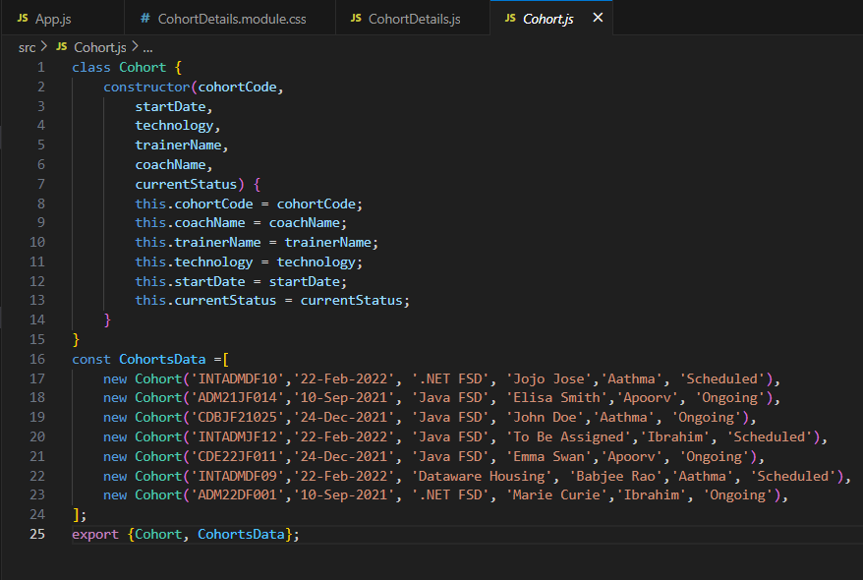
CohortDetails.js:
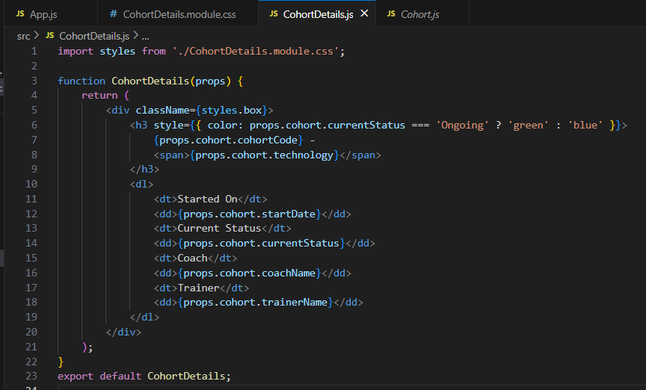
CohortDetails.module.css:
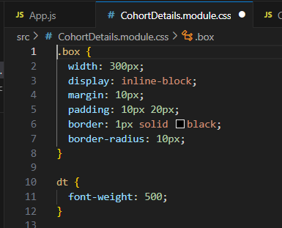
App.js:
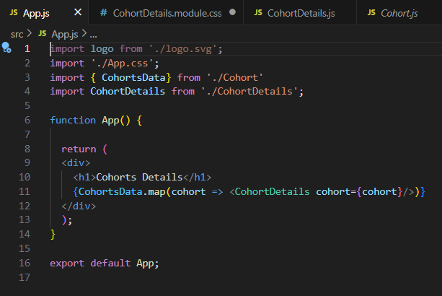
OUTPUT:
