WEEK-7 HANDS-ON
BONDA PRASANTH
6382932
9. ReactJS-HOL
EvenPlayers.js:
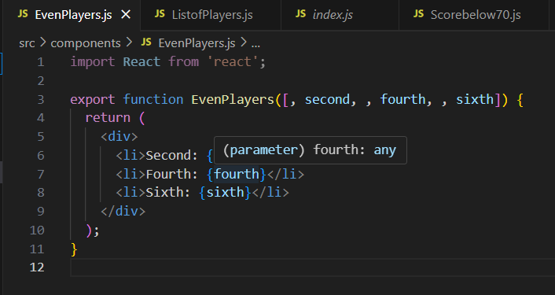
ListofPlayers.js:
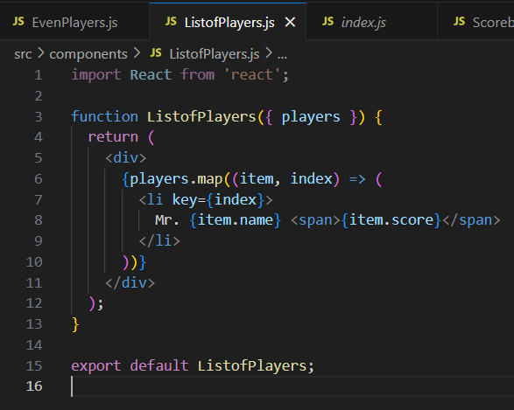
ScoreBelow70.js:
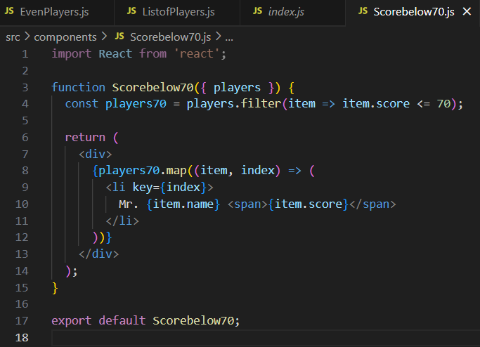
ListofIndianPlayers.js:
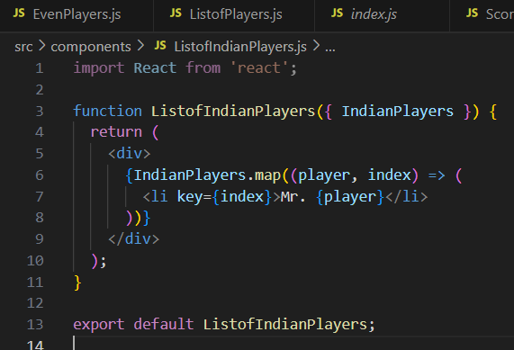
OddPlayers.js:
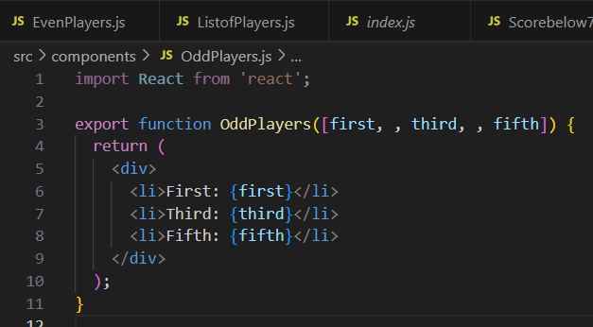
App.js:
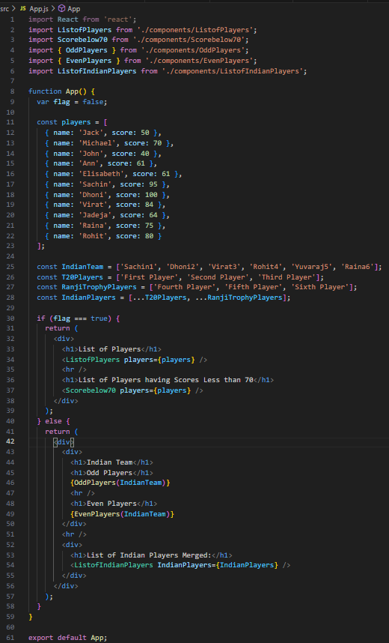
Output:
When Flag=true
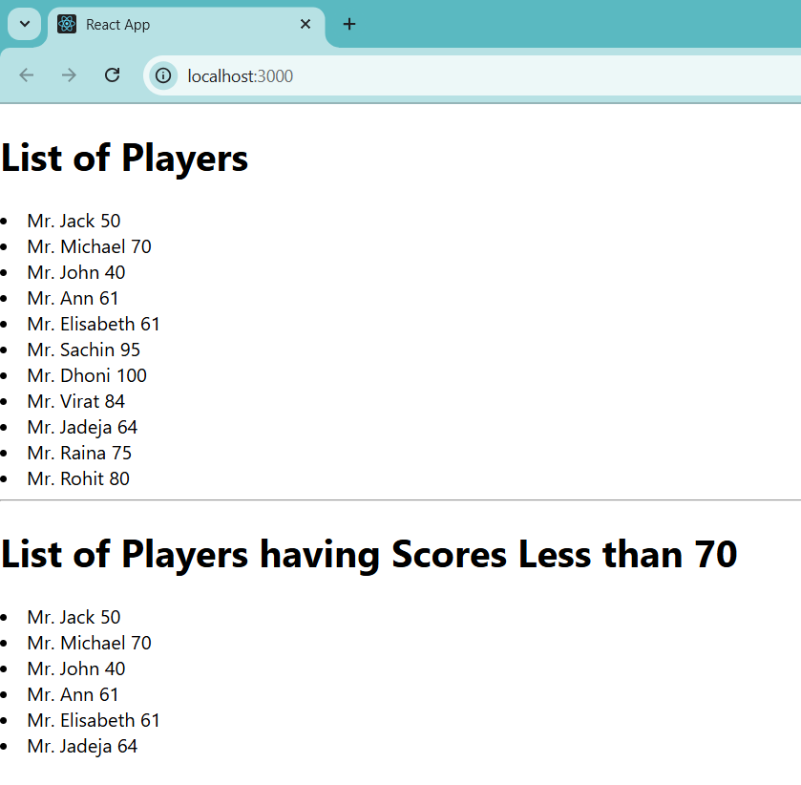

When Flag=false:
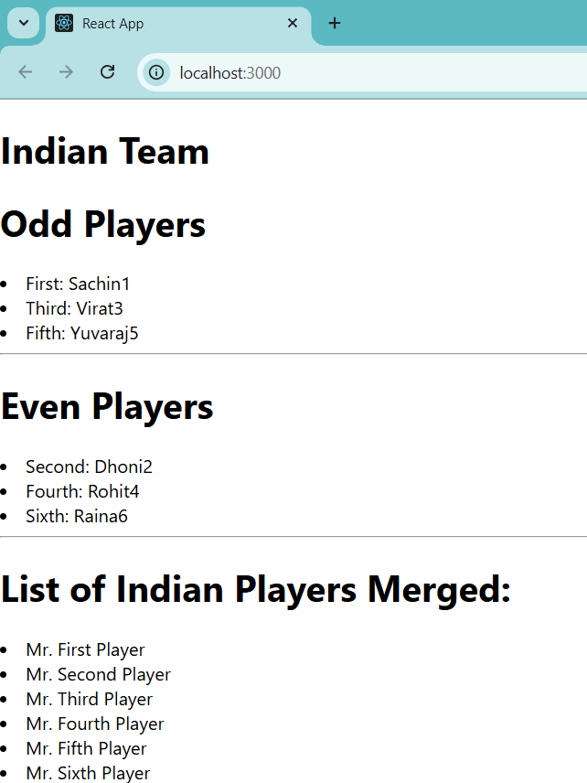

10. ReactJS-HOL
Create a React Application named “officespacerentalapp” which uses React JSX to create elements, attributes and renders DOM to display the page.

App.js:
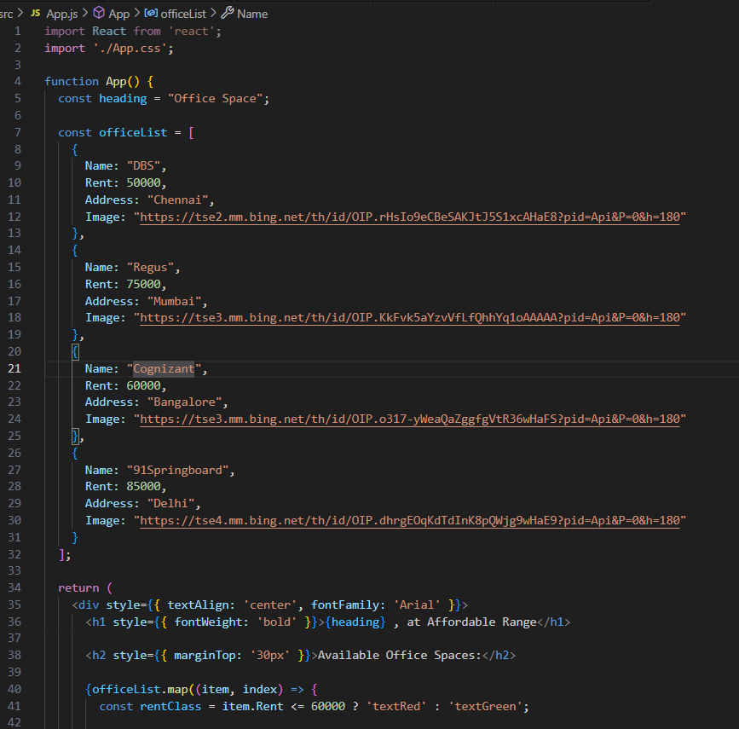
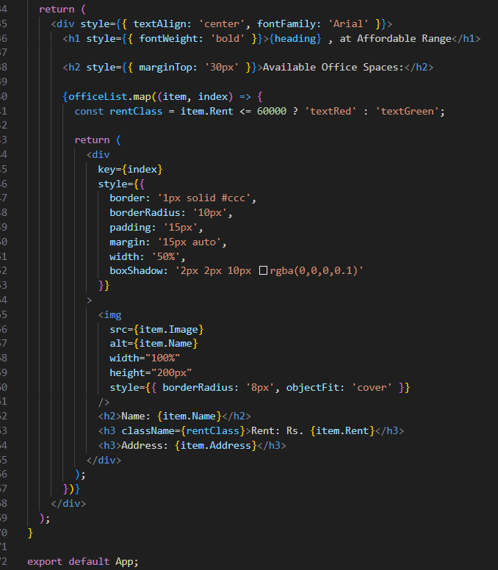
App.css:
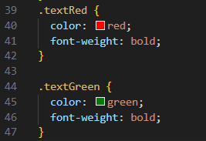
OUTPUT:
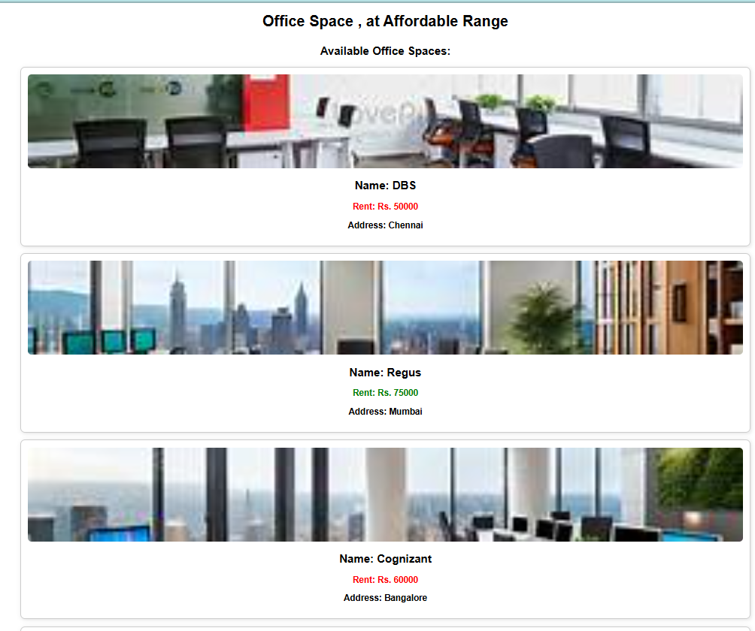

11. ReactJS-HOL
Create a React Application “eventexamplesapp” to handle various events of the form elements in HTML.

App.js:
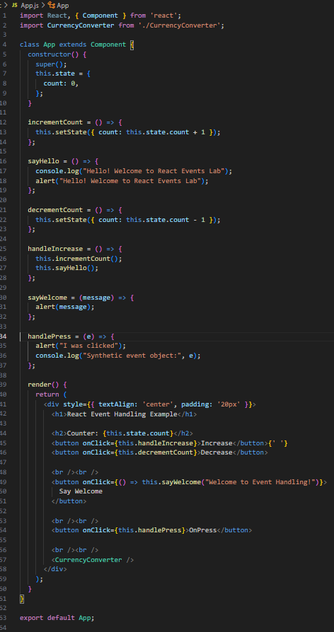

CurrencyConverter.js:
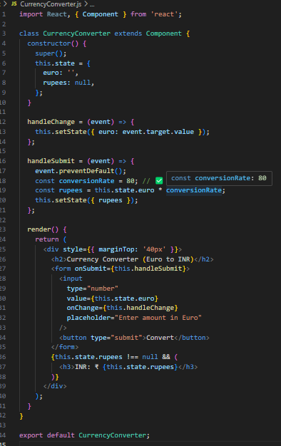
OUTPUT:
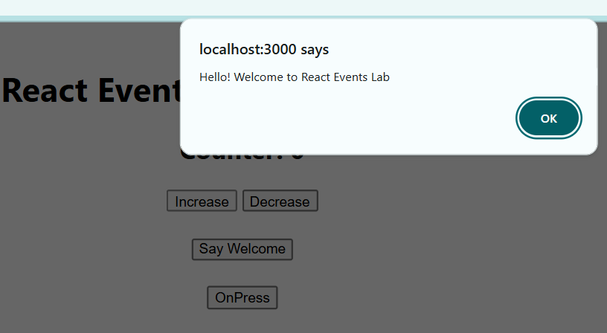
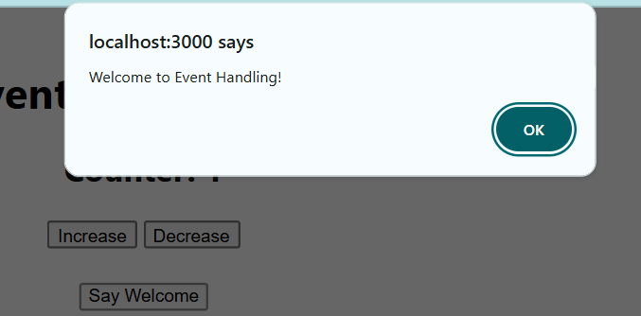
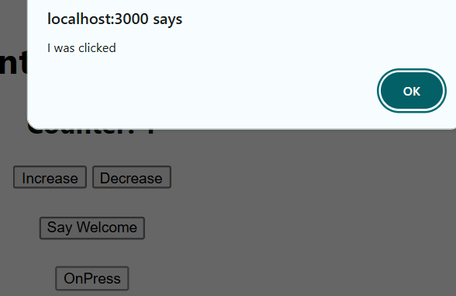
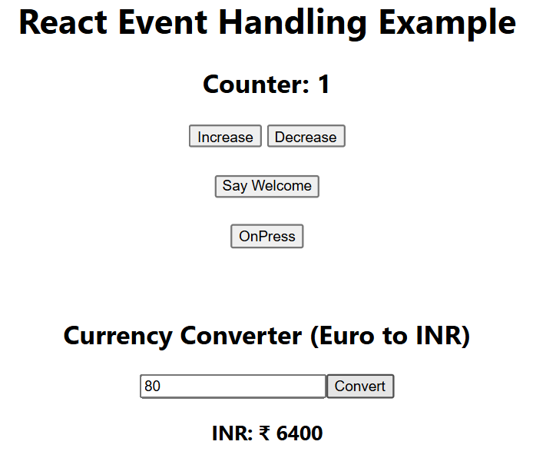
12. ReactJS-HOL
Create a React Application named “ticketbookingapp” where the guest user can browse the page where the flight details are displayed whereas the logged in user only can book tickets.

The Login and Logout buttons should accordingly display different pages. Once the user is logged in the User page should be displayed. When the user clicks on Logout, the Guest page should be displayed.

GuestPage.js:
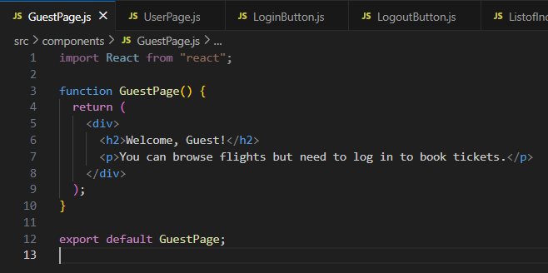
UserPage.js:
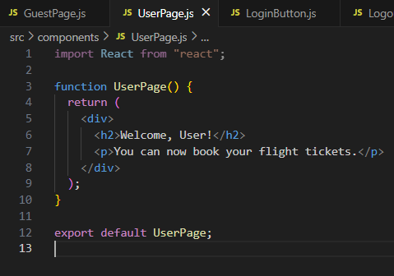

LoginButton.js:
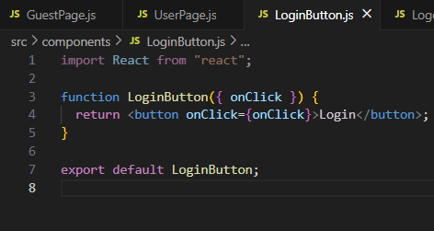
LogoutButton.js:
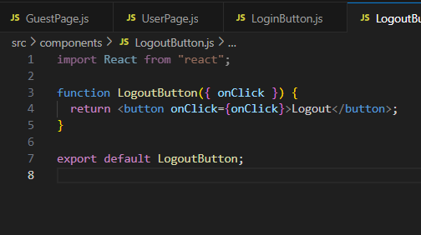

App.js:
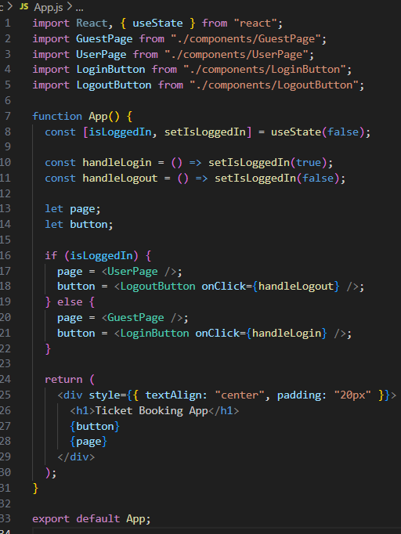
OUTPUT:
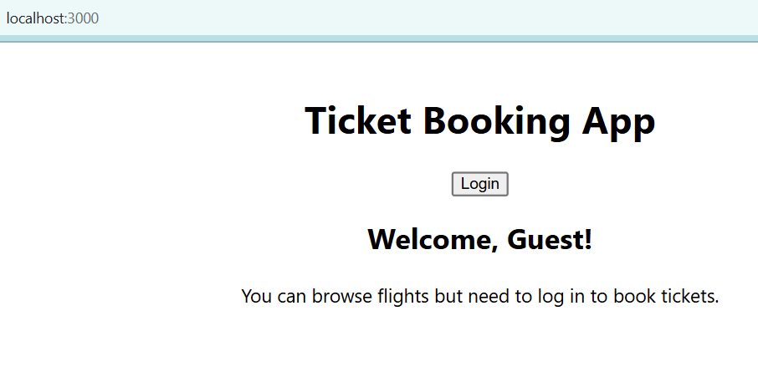
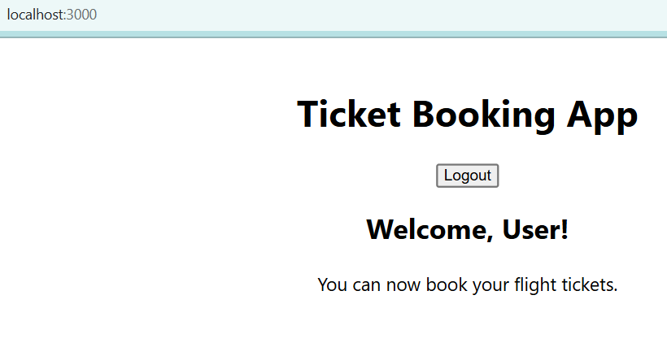
13. ReactJS-HOL:
Create a React App named “bloggerapp” in with 3 components.
- Book Details
- Blog Details
- Course Details
Implement this with as many ways possible of Conditional Rendering.
BookDetails.js:
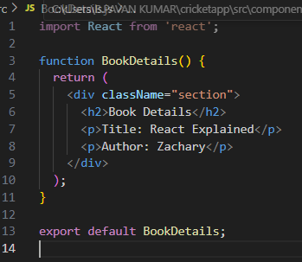
BlogDetails.js:
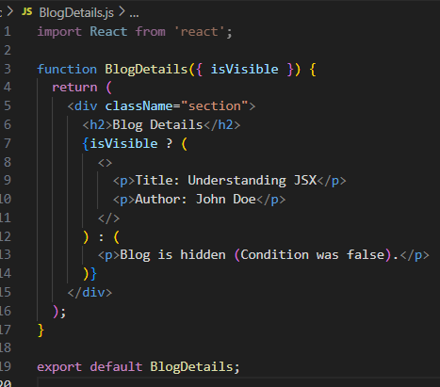
CourseDetails.js:
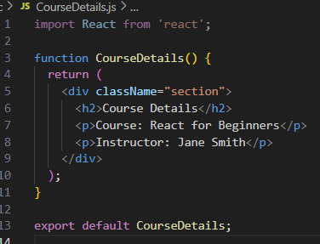
App.js:
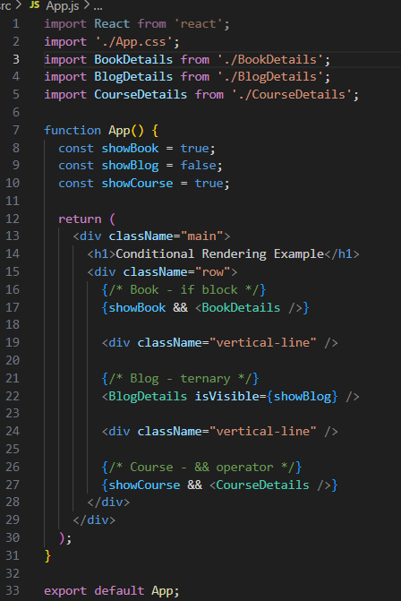
OUTPUT:
