**package** com.pack.test;

**import** java.util.Scanner;

**public** **class** ExcepHandling

{

**public** **static** **void** main(String[] args)

{

Scanner myObj = **new** Scanner(System.***in***);

System.***out***.println("Enter First Value :");

**int** a = myObj.nextInt();

System.***out***.println("Enter Second Value :");

**int** b = myObj.nextInt();

// Output input by user

System.***out***.println("First Value: " + a);

System.***out***.println("Second Value : " + b);

**try**

{

**float** output=a/b;

System.***out***.println ("Result: "+output);

}

**catch**(ArithmeticException e)

{

System.***out***.println("You Shouldn't divide a number by zero");

System.***out***.println( e.getClass().getCanonicalName());

}

}

}

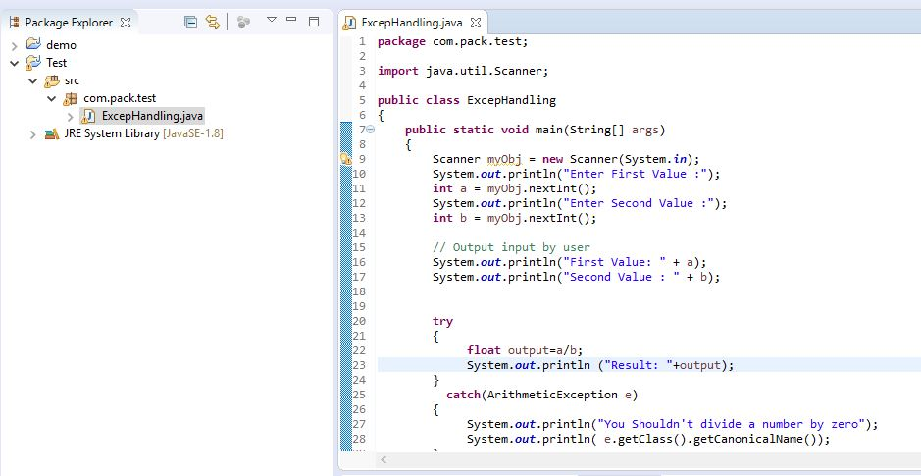

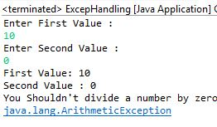 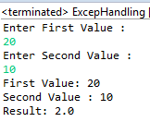

Inheritance **Reference only**:

<https://www.tutorialride.com/java-oops-programs/calculate-employee-salary-by-overriding-method.htm>

**package** com.pack.test;

**public** **class** Manager

{

String name;

**int** salary;

Manager()

{

System.***out***.println("Manager class");

name = **null**;

salary = 0;

}

Manager (String name, **int** salary)

{

**this**.name = name;

**this**.salary = salary;

}

**int** getSalary()

{

**return** salary;

}

}

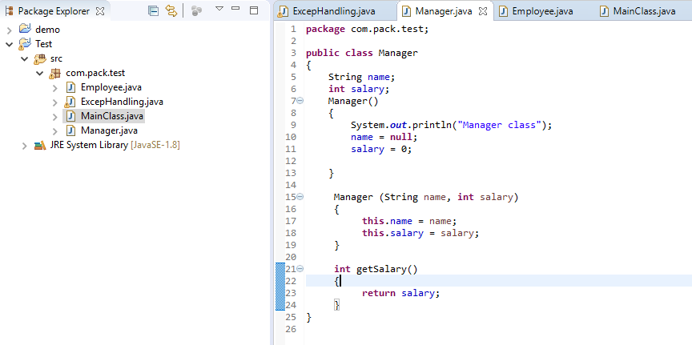

**package** com.pack.test;

**public** **class** Employee **extends** Manager

{

**int** hra, ta;

Employee()

{

System.***out***.println("Employee class");

hra = ta = 0;

}

Employee(String n, **int** sal, **int** h, **int** t)

{

**super**(n, sal);

hra = h;

ta = t;

}

**int** getSalary()

{

**return** (**super**.getSalary()+hra+ta);

}

}

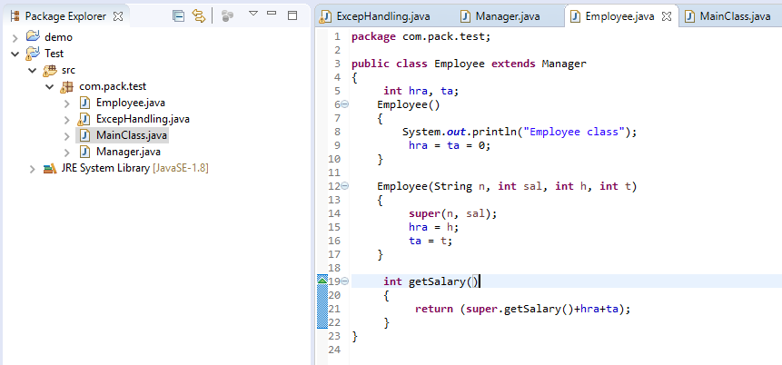

**package** com.pack.test;

**public** **class** MainClass

{

**public** **static** **void** main(String[] args)

{

Employee m1 = **new** Employee("Nikhil",20000,500,1500);

System.***out***.println("Salary of Manager= "+m1.getSalary());

}

}

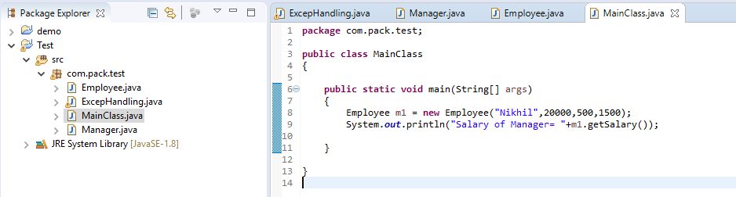

Output:

