# 24. PROBLEM:

Write a program to draw a Human Face.

# SOURCECODE:

import java.applet.Applet;

import java.awt.*;

public class assignment24 extends Applet

{

public void paint(Graphics g)

{

g.drawOval(50,50,120,150);

g.drawOval(30,105,20,30);

g.drawOval(170,105,20,30);

g.drawOval(102,115,20,30);

g.drawOval(75,85,25,25);

g.fillOval(82,92,10,10);

g.drawOval(125,85,25,25);

g.fillOval(132,92,10,10);

g.drawLine(80,160,140,160);

g.fillArc(80,145,60,30,180,180);

}

}

# OUTPUT:

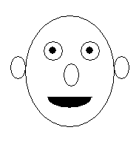

# DISCUSSION:

1.In assignment24 which extends applet class and in paint method we use drawoval,drawline, drawarc respectively with co-ordinate to create the human face.