# 25.PROBLEM:

Write a program to draw a rectangle full of black and white circles.

# SOURCECODE:

import java.applet.Applet;

import java.awt.Graphics;

public class assignment25 extends Applet

{

public void paint(Graphics g)

{

int n=9;

for(int i=0;i<n;i++)

{

for(int j=0;j<n;j++)

{

if((i+j)%2==0)

{

g.drawOval(50+j*20,50+i*30,15,15);

}

else

{

g.fillOval(50+j*20,50+i*30,15,15);

}

}

}

g.drawRect(40,40,40+20*(n-1),40+30*(n-1));

}

}

# OUTPUT:

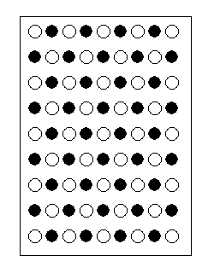

# DISCUSSION:

1.In assignment25 we use for loop for generating white and black circles respectively and then atlast we create a rectangle to hold all the circles.