Software Design Document – E-Ticket Train Booking System

1. Introduction
This Software Design Document (SDD) provides a detailed architecture, design components, and system behavior for the E-Ticket Train Booking System built using ASP.NET, C#, and SQL Server.

2. System Architecture
The system follows a multi-tier architecture with Presentation Layer (ASP.NET UI), Business Logic Layer (C# services), and Data Layer (SQL Server). It integrates with payment gateways and notification services.
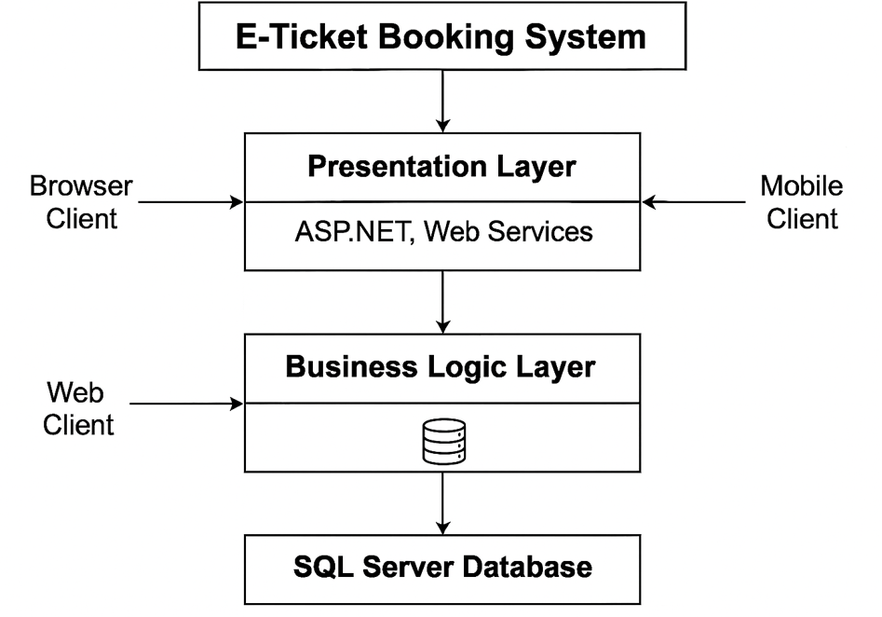
The system architecture diagram represents a three-tier structure used in the E-Ticket Booking System, where the application is organized into separate layers to ensure scalability, security, and efficient processing. At the top is the Presentation Layer, which interacts directly with end-users through browser clients and mobile clients. This layer is built using ASP.NET and web services, handling all user interface activities such as displaying pages, collecting user inputs, and sending requests to the server. Beneath it lies the Business Logic Layer, responsible for processing all core functionalities of the system, including train search, seat allocation, ticket booking, payment validation, cancellation logic, and administrative operations. It acts as the decision-making center and communicates with both the presentation layer and the database. At the lowest level is the SQL Server Database, which stores all essential data such as passenger records, train schedules, seat availability, booking details, payments, and ticket information. The business layer retrieves and updates data from the database, ensuring secure and consistent operations. Together, these layers create a robust, modular architecture that supports high performance and easy future enhancements.

3. Detailed Design
Major modules include User Management, Train Search, Booking Engine, Payment Module, and Admin Management.
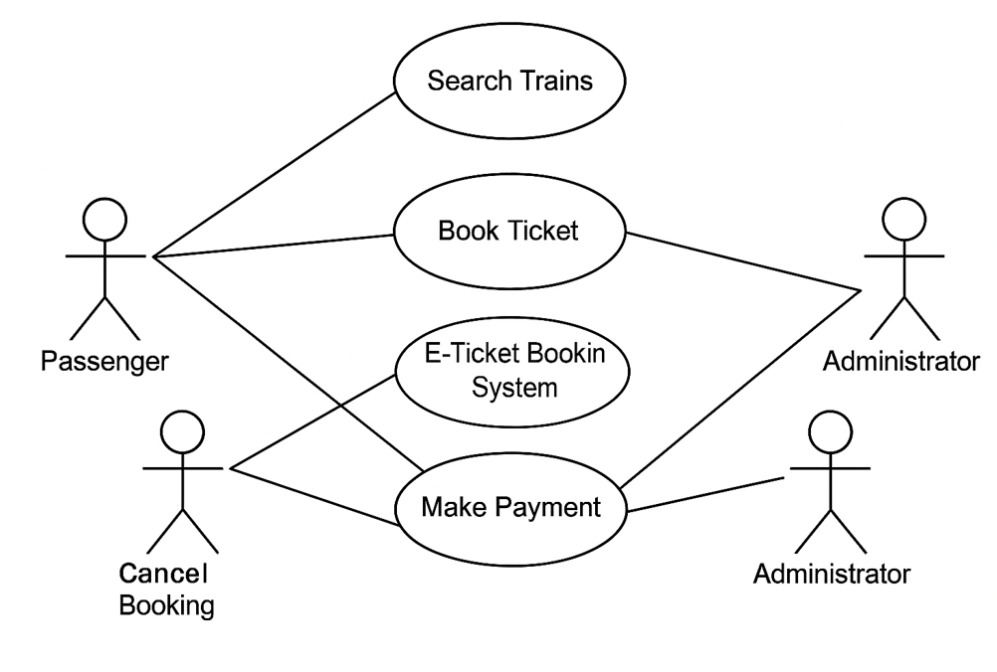
- The Passenger interacts with the system for all travel-related activities: searching trains, booking, payment, and cancellation.
- The Administrator manages critical backend operations like validating payments and monitoring ticketing processes.
- The system acts as the central hub that coordinates all actions and ensures smooth booking operations.

4. Database Design
Core tables include Users, Trains, Routes, Schedules, Availability, Booking, Payment, and Ticket. Constraints ensure data integrity and ACID compliance.
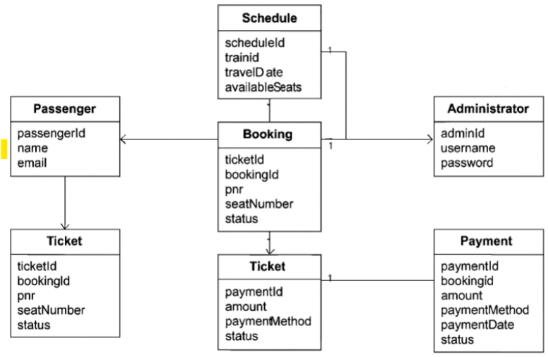
The Entity–Relationship (ER) diagram illustrates the logical structure of the E-Ticket Booking System by showing how data is organized and how different entities interact with one another. The core of the system revolves around the Booking entity, which links passengers, trains, tickets, and payments. A Passenger makes one or more bookings, and each booking is associated with a specific Schedule, which defines when a particular Train operates and how many seats are available on a given date. When a passenger completes a booking, the system generates a corresponding Ticket, which includes details such as PNR, seat number, and ticket status. Similarly, each booking triggers an entry in the Payment entity, storing transaction details such as payment method, amount, and payment status. The Administrator entity is included to represent users with elevated privileges who manage system data such as train schedules, bookings, and reports. The relationships in the diagram reflect real-world constraints: a passenger can create multiple bookings, a train can have multiple schedules and corresponding bookings, and each booking has exactly one ticket and one payment record. This ER model ensures smooth coordination of user information, train operations, seat allocation, financial transactions, and administrative control, forming a robust backend structure for the e-ticket booking platform.

5. Design Constraints
The system uses ASP.NET, SQL Server, and must ensure security, scalability, and performance as per the SRS requirements.

