Отчет:

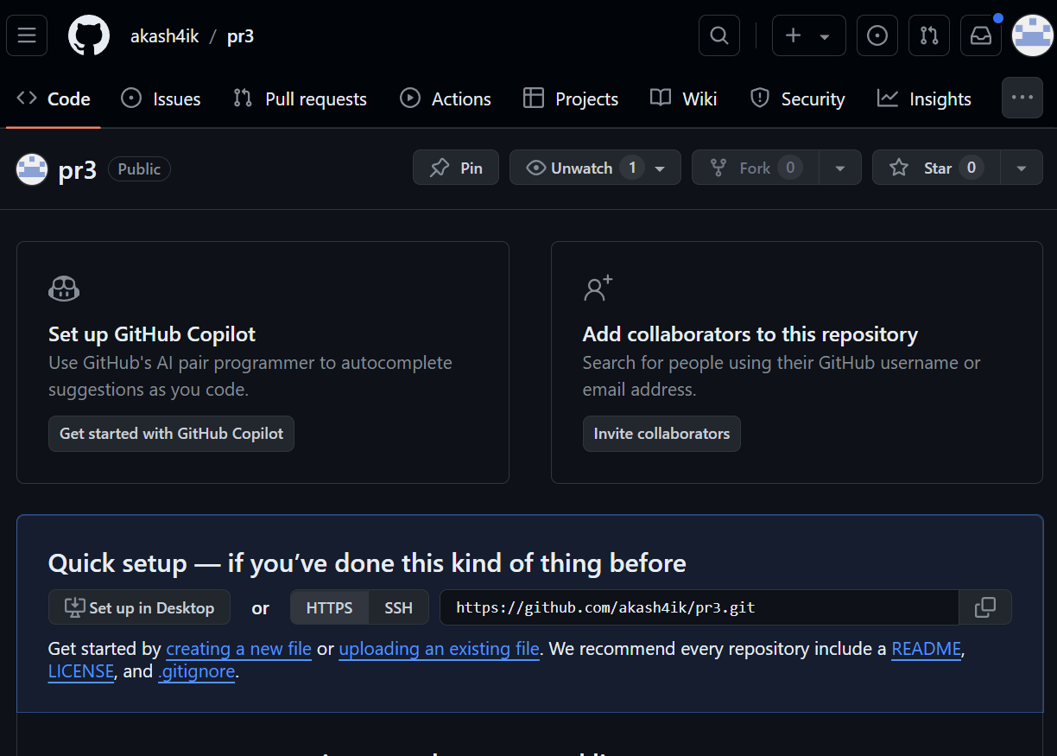



char op;

double first, second, result;

Console.Write("Введите первое число: ");

first = Convert.ToDouble(Console.ReadLine());

Console.Write("Введите второе число: ");

second = Convert.ToDouble(Console.ReadLine());

Console.Write("Введите оператор (+, -, \*, /): ");

op = (char)Console.Read();

switch (op)

{

case '+':

result = first + second;

Console.WriteLine("{0} + {1} = {2}", first, second, result);

break;

case '-':

result = first - second;

Console.WriteLine("{0} - {1} = {2}", first, second, result);

break;

case '\*':

result = first \* second;

Console.WriteLine("{0} \* {1} = {2}", first, second, result);

break;

case '/':

result = first / second;

Console.WriteLine("{0} / {1} = {2}", first, second, result);

break;

default:

Console.WriteLine("Недопустимый оператор");

break;

