Screenshots

Server display with Client detail

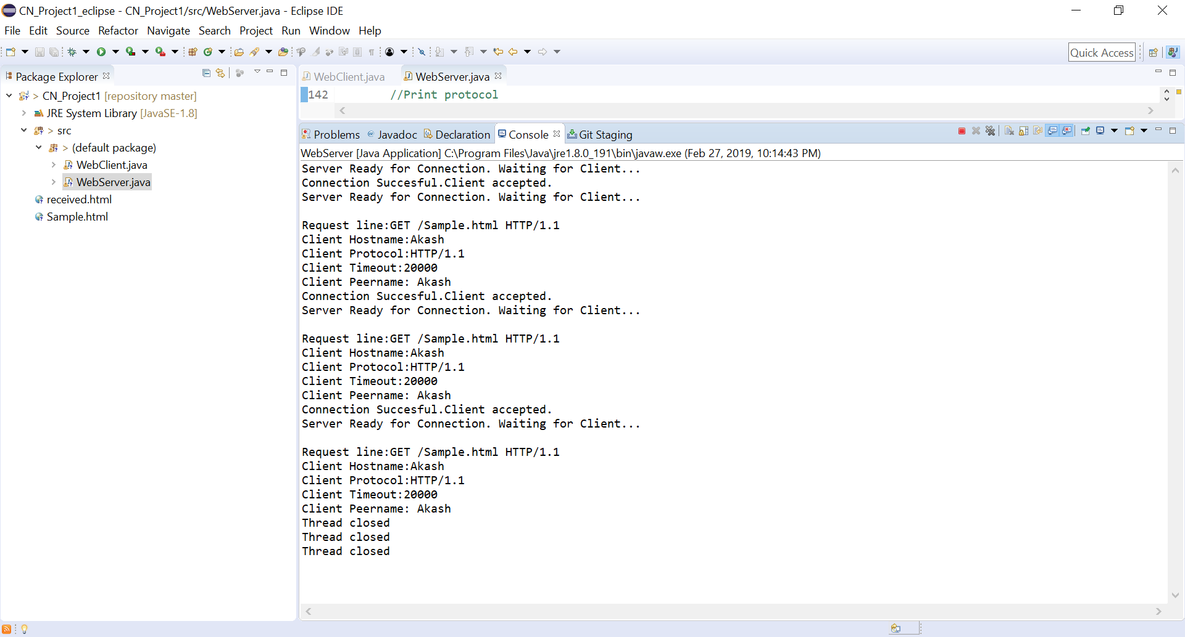

\*\*First and Second Thread closed after successive thread which means WebServer.java is successfully performing as multithreaded server.

Client Display with Server detail

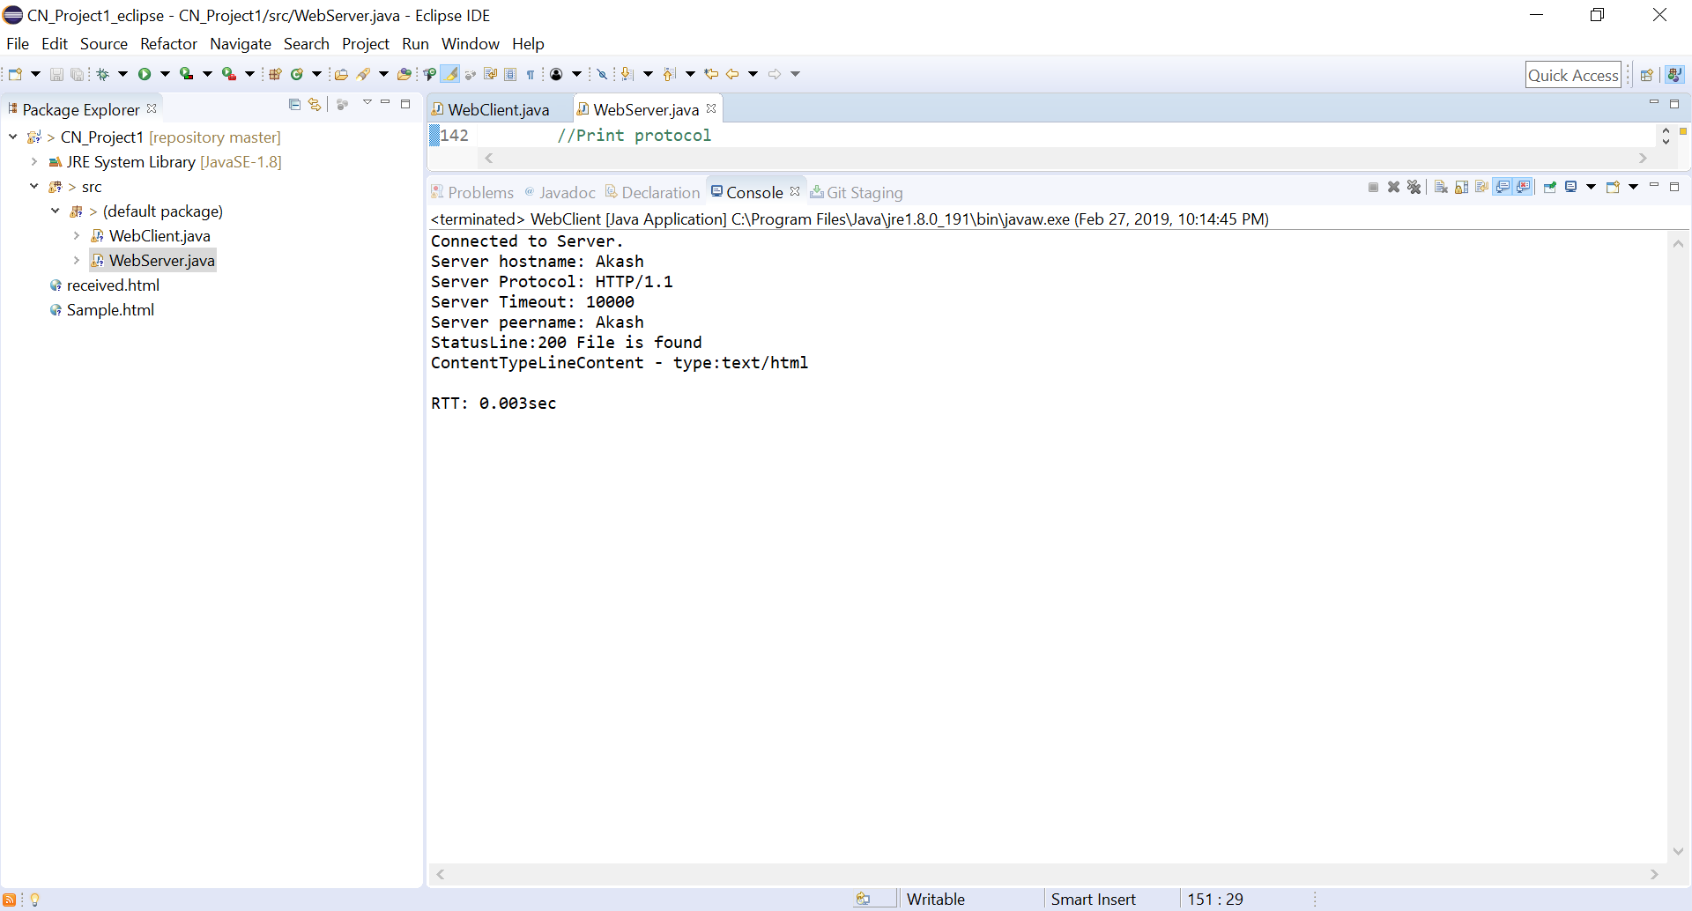

\*\*received.html shows the same html information as Sample.html…