**Insights from data for Netflix production to make a successful TV Show.**

**If genre is unsuccessful or actor is not a good actor , audience of the country is not liking the type , It will not be repeated most number of times with this as baseline consideration below analysis is done and given the insights from data.**

**Popular Genre:**--Most number of times involved genre in TV Series.

TV Dramas, TV Comedies and Crime TV Shows

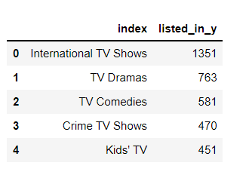

**Country with Biggest film industry and largest audience for TV Show.**

Unites States-- Made most number of TV Shows.

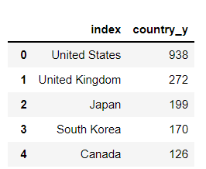

**Popular Actor:** -- Most casted actor in the TV  Shows From US.

Grey Griffin,Mike Colter,Kevin Michael Richardson,Kari Wahlgren and Steven Yeun

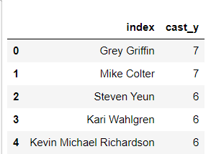

**Best Month to release:--**Most no of releases in a month for a TV Shows.

December and July.

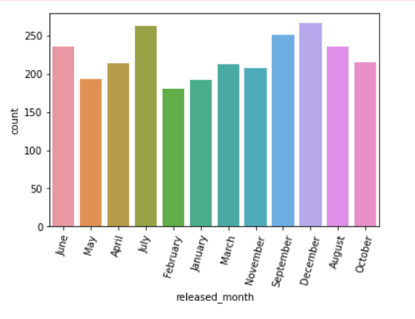

We can involve the cast members mentioned above and storyline with the genres mentioned above in Unites states and release it on December or July , will be the most optimal way to make the TV Show successful.

**Why Select TV Show?**

- Increase in number of release in recent years which shows it is improving field.

- Number of release is less compare to movies which shows it still have more to explore in that TV show field.

