Problem Statement:

Do women spend more on Black Friday than men?

Answer:

No

Explanation:

Spending Male vs Female

- As per below data we can clearly see for per transaction male spend more than female. This might be due to spending age group 51-55 contains more male customers which increases the possibility of male customers to spend more and as well as in all age category group

True mean confidence interval for Male to purchase amount per transaction

- Confidence Interval for 90 percent is (9416.72 , 9446.53)

- Confidence Interval for 95 percent is (9413.87 , 9449.38)

- Confidence Interval for 99 percent is (9408.29 , 9454.96)

True mean confidence interval for Female to purchase amount per transaction

- Confidence Interval for 90 percent is (8718.13 , 8766.94)

- Confidence Interval for 95 percent is (8713.45 , 8771.62)

- Confidence Interval for 99 percent is (8704.32 , 8780.75)

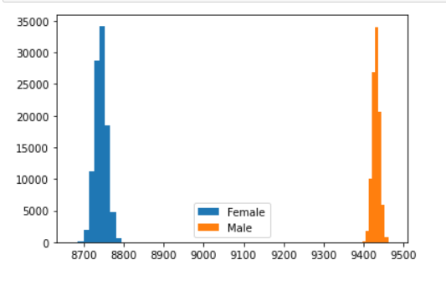

Each age group spending sampling distribution.

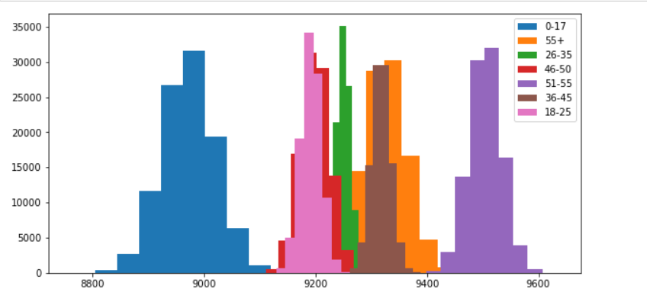

Recommendations:

Our customers mostly are in age category from 18 - 45. As we see below most of our customer base buys  this product id: P00265242 , so its better to focus more on it have different variety as like have more brands product and give more options to customers to choose from which will improve the customer service.

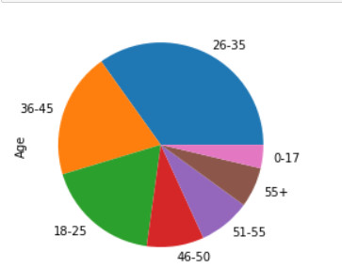

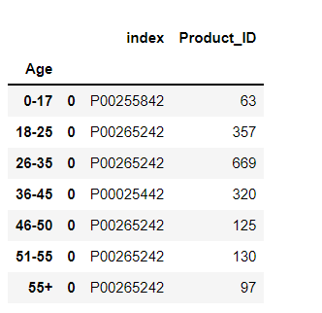

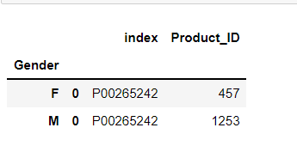

Category B City have high chances to retain their tenets which also increases the chances of having a loyal customer from that category B city as they are going to stay in the long.

