1.Display first 4 characters of passenger name and city name in all capital letters

A.) select upper(city),upper(substr(p_name,1,4)) from PASSENGERS;

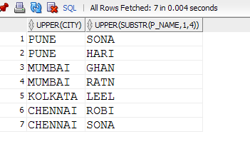

2. Display count of airports by airport type

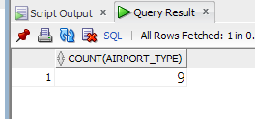

1. select airport_type,count(*)

from airport

group by airport_type;

3.) Display total number of seats available on all flights

a.) select sum(no_of_seats)as "total number of seats" from FLIGHT_SCHEDULE;

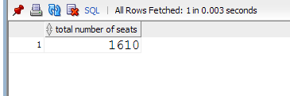

4.)Display total number of passengers whose ticket is not confirmed

a.) select count(*) FROM TICKET_BOOKING WHERE RESERVATION_STATUS='Waiting';

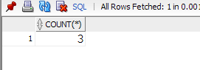

5.)Display total number of passengers who have a ‘.’(dot) appearing in userid

a.) select email from PASSENGERS where email like '%.%.com';

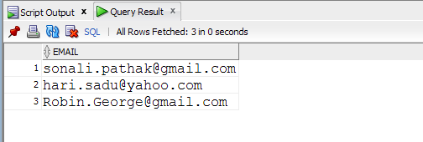

6.) Display the name of passengers who have booked the tickets in the month of October

a.) SELECT DISTINCT

p.p_name,to_char(t.date_reservation_made, 'mon') month

from passengers p,ticket_booking t

where t.p_id=p.p_id and

to_char(t.date_reservation_made, 'mon')= 'oct';

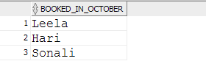

7.) Display total name of passengers who are departing from ‘Mumbai’

a.) SELECT count(city) no_of_passengers,city as departing

from passengers

where city='mumbai'

group by city ;

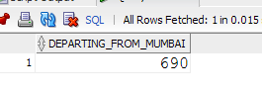

8.) write the SQL commands to represent the schema in the database

a.) create table tour(company varchar2(20),

cost number(10),

number_of_days NUMBER(10),

itinery_of_the_tour varchar(10));

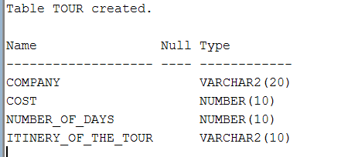

-----------------------------------------------------------------------

CREATE TABLE BATCH(BATCH_NO NUMBER(10)CONSTRAINT pk_p1 PRIMARY KEY,

BATCH_START_DATE DATE,

BATCH_END_DATE DATE,

BATCH_COORDINATOR VARCHAR(20));

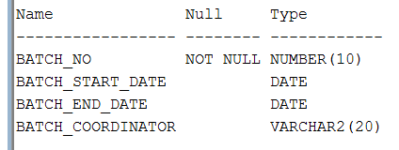

----------------------------------------------------------------

CREATE TABLE BOOKING_TOUR( TOUR_NAME VARCHAR2(20),

NUMBER_OF_SEATS NUMBER(5),

NUMBER_OF_SEATS_ALLOWED NUMBER(5));

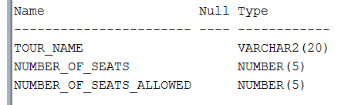

--------------------------------------------------------------------------------

9.)display flight wise reservation count stored in descending order

a.)

select airport_type,COUNT(*)

from airport

group by airport_type

order by count(*) desc;

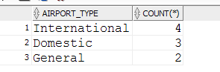

10.a)what is a data file

a.) Database Files and Filegroups. At a minimum, every SQL Server database has two operating system files: a data file and a log file. Data files contain data and objects such as tables, indexes, stored procedures, and views.

b) what is an index?

a.) An index is used to speed up the performance of queries. It does this by reducing the number of database data pages that have to be visited. In SQL Server, a clustered index determines the physical order of data in a table. There can be only one clustered index per table (the clustered index IS the table)

c) what is a view?

a.) A view is a virtual table based on the result-set of an SQL statement.

A view contains rows and columns, just like a real table. The fields in a view are fields from one or more real tables in the database.

You can add SQL functions, WHERE, and JOIN statements to a view and present the data as if the data were coming from one single table.