**1.) SELECT upper(substr(P_name, 1, 4)) NAME, upper(substr(CITY, 1, 4)) CITY**

**FROM passengers;**

**OUTPUT:**

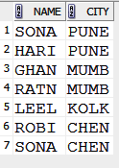

**2.)** **SELECT AIRPORT_TYPE, count(*)AIRPORT_TYPE**

**FROM airport**

**group by airport_type;**

**OUTPUT:**

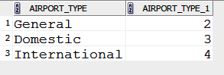

**3.)** **SELECT SUM(NO_OF_SEATS) TOTAL_NO_OF_SEATS**

**FROM flight_schedule;**

**OUTPUT:**

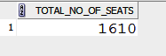

**4.)** **SELECT COUNT(*)TOTAL_NO_OF_PASSENGERS**

**FROM ticket_booking**

**WHERE RESERVATION_STATUS = 'Waiting';**

**OUTPUT:**

C:\Users\techm.sigmundwst5-8\Desktop\sql exm\4.PNG

**5.) SELECT EMAIL**

**FROM PASSENGERS**

**WHERE EMAIL LIKE '%.%@%';**

**OUTPUT:**

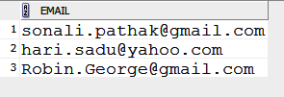

**6.)** **SELECT P_NAME**

**FROM PASSENGERS P,TICKET_BOOKING T**

**WHERE DATE_RESERVATION_MADE='04-OCT-09' AND P.P_ID=T.P_ID;**

**OUTPUT:**

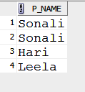

**7.)** **SELECT COUNT(AIRPORT_LOCATION) DEPARTING_FROM_MUMBAI**

**FROM AIRPORT**

**WHERE AIRPORT_LOCATION='Mumbai';**

**OUTPUT:**

**C:\Users\techm.sigmundwst5-8\Desktop\sql exm\7.PNG**

**8.) TOURS TABLE**

**CREATE TABLE TOURS(TOUR_NAME varchar2(25) PRIMARY_KEY,**

**COST_OF_TOUR number(7),**

**NUMBER_OF_DAYS number(2),**

**ITINERY varchar2(25));**

**BATCHES TABLE**

**CREATE TABLE BATCHES(BATCH_NO number(3),**

**NAME_OF_BATCH_COORDINATOR varchar2(25),**

**NO_OF_SEATS number(30),**

**NO_OF_SEATS_BOOKED_BY_BATCH number(30)**

**NO_OF_TOURS_BOOKED_BY_BATCH number(3));**

**BOOKING INFORMATION TABLE**

**CREATE TABLE BOOKING_INFORMATION(**

**TOUR_NAME varchar2(25) REFERENCE TABLE_TOURS,**

**COST_OF_TOUR number(7) REFERENCE TABLE_TOURS**

**NO_OF_SEATS_BOOKED_BY_BATCH number(30) REFERENCE BATCHES , NO_OF_TOURS_BOOKED_BY_BATCH number(3) REFERENCE BATCHES,**

**DATE_OF_STARTING_TOUR DATE(‘DD’, ‘MON’, ‘YY’) );**

**9.)** **SELECT SCHEDULE_ID,COUNT(RESERVATION_ID)**

**FROM TICKET_BOOKING**

**GROUP BY SCHEDULE_ID**

**ORDER BY COUNT(*) DESC;**

**OUTPUT:**

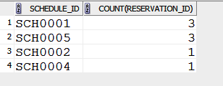

**10.)**

**Date Files:**

**Data files store the data in the database. Data files contain data and objects such as tables, indexes, stored procedures, and views. Only Oracle server can access data files.**

**Index: An index is used to speed up the performance of queries. It does this by reducing the number of database data pages that have to be visited. In SQL Server, a clustered index determines the physical order of data in a table. There can be only one clustered index per .**

**View: In SQL, a view is a virtual table based on the result-set of an SQL statement.A view contains rows and columns, just like a real table. The fields in a view are fields from one or more real tables in the database. We can add SQL functions, WHERE, and JOIN statements to a view and present the data as if the data were coming from one single table.**