Algorithm1: LPT-Seed Greedy Scheduler

Input:

T = {t₁, t₂, …, tₘ} // set of m tasks

N = {n₁, n₂, …, nₖ} // set of k nodes

S[t][n] // execution time (or cost) of task t on node n

Output:

A[n] // for each node n, the ordered list of tasks assigned to it

L[n] // for each node n, the total load after assignment

Procedure LPT_Seed(T, N, S):

1. // 1) Initialize loads and assignment lists

2. for each node n in N do

3. L[n] ← 0.0

4. A[n] ← [] // empty list

5. end for

6. // 2) Precompute each task’s “best possible” (minimum) time

7. Define bestTime(t) = min { S[t][n] : n ∈ N }

8. // 3) Sort tasks by descending bestTime → largest first

9. T_sorted ← sort T by key bestTime(t), in descending order

10. // 4) Greedily assign each task to the least-loaded node

11. for each task t in T_sorted do

12. // find the node with current smallest load

13. n* ← arg min { L[n] : n ∈ N }

14.

15. // assign task t to node n*

16. append t to A[n*]

17.

18. // update that node’s load by the actual execution time on n*

19. L[n*] ← L[n*] + S[t][n*]

20. end for

21. // 5) Return the final assignment and loads

22. return A, L

End Procedure

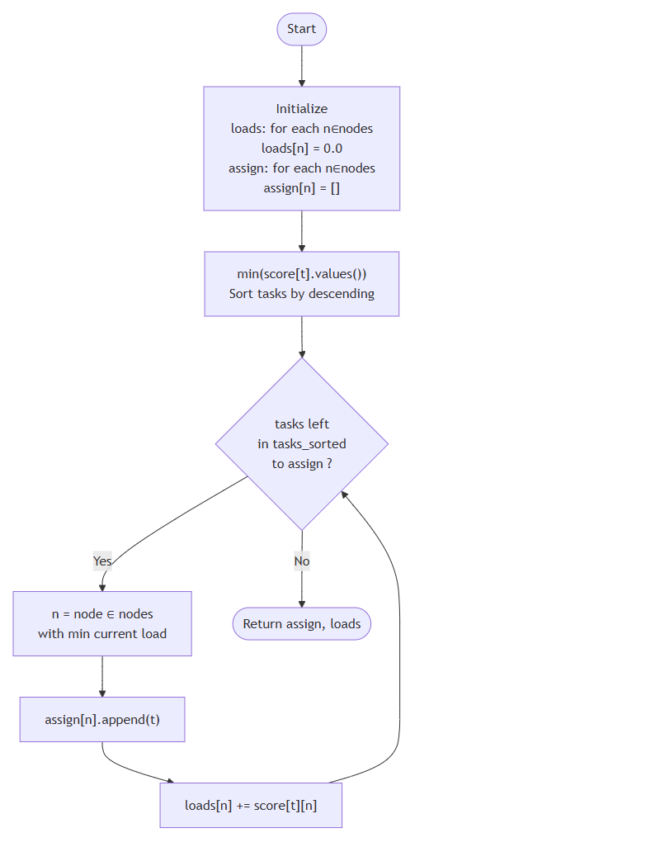

Algorithm2: Local Search Load Balancer

──────────────────────────────────────────

Input:

• A ⟵ initial assignment, a map from each node n ∈ N to a list of tasks

• L ⟵ initial loads, a map from each node n ∈ N to its total load

• S ⟵ score matrix, where S[t][n] is the execution time of task t on node n

• N ⟵ set of all nodes

Output:

• (A, L) ⟵ an improved assignment and corresponding loads

Procedure LOCAL_SEARCH(A, L, S, N)

1. improved ← true

2. while improved do

3. improved ← false

4. ⟶ Identify the two extreme nodes

5. heavy ← arg maxₙ∈N L[n] ⊳ node with largest load

6. light ← arg minₙ∈N L[n] ⊳ node with smallest load

7. gap₀ ← L[heavy] − L[light]

8. best_gain ← 0.0

9. best_op ← None

10. ⟶ Phase 1: single‐task moves from heavy → light

11. for each task t in A[heavy] do

12. new_load_heavy ← L[heavy] − S[t][heavy]

13. new_load_light ← L[light] + S[t][light]

14. other_loads ← { L[n] : n ∈ N ∖ {heavy, light} }

15. gap_new ← max(new_load_heavy, new_load_light, max(other_loads))

16. − min(new_load_heavy, new_load_light, min(other_loads))

17. gain ← gap₀ − gap_new

18. if gain > best_gain then

19. best_gain ← gain

20. best_op ← (“move”, t)

21. end if

22. end for

23. ⟶ Phase 2: two‐task swaps between heavy and light

24. for each t_h in A[heavy] do

25. for each t_l in A[light] do

26. new_load_heavy ← L[heavy] − S[t_h][heavy] + S[t_l][heavy]

27. new_load_light ← L[light] − S[t_l][light] + S[t_h][light]

28. gap_new ← max(new_load_heavy, new_load_light, max(other_loads))

29. − min(new_load_heavy, new_load_light, min(other_loads))

30. gain ← gap₀ − gap_new

31. if gain > best_gain then

32. best_gain ← gain

33. best_op ← (“swap”, t_h, t_l)

34. end if

35. end for

36. end for

37. ⟶ Apply the best local improvement, if any

38. if best_op ≠ None then

39. improved ← true

40. if best_op[0] = “move” then

41. t ← best_op[1]

42. remove t from A[heavy]

43. append t to A[light]

44. L[heavy] ← L[heavy] − S[t][heavy]

45. L[light] ← L[light] + S[t][light]

46. else ⊳ swap

47. (t_h, t_l) ← (best_op[1], best_op[2])

48. replace t_h with t_l in A[heavy]

49. replace t_l with t_h in A[light]

50. L[heavy] ← L[heavy] − S[t_h][heavy] + S[t_l][heavy]

51. L[light] ← L[light] − S[t_l][light] + S[t_h][light]

52. end if

53. end if

54. end while

55. return (A, L)

End Procedure

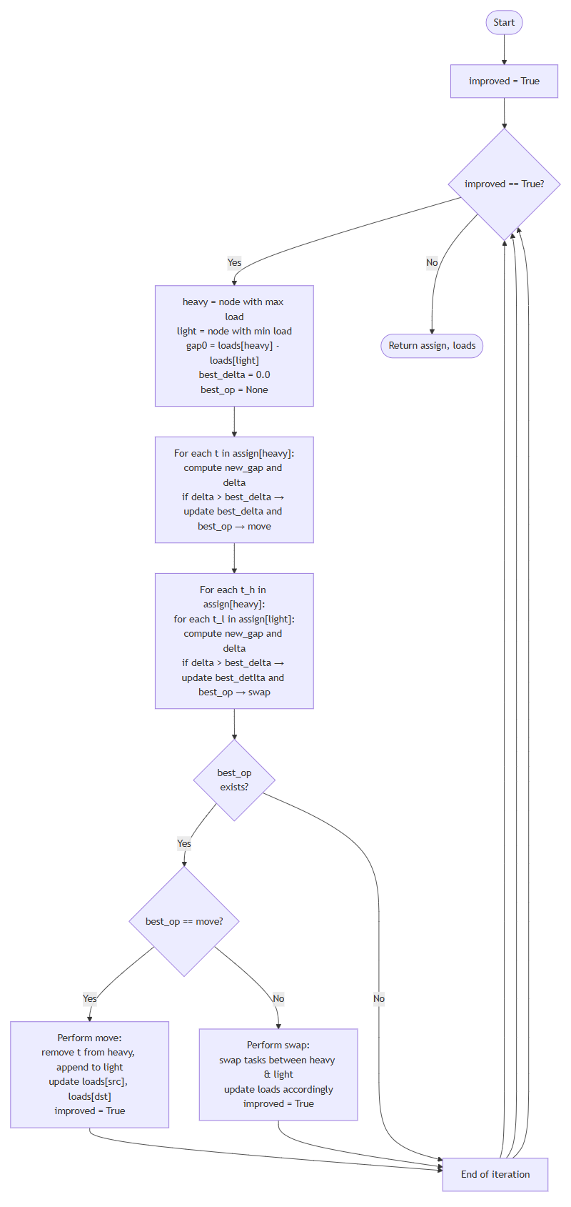

Algorithm 3: Multi-Start Load Balancer

────────────────────────────────────────

Input:

• T ← list of tasks

• N ← set of nodes

• S ← score matrix S[t][n] = cost of running task t on node n

• restarts ← number of random restarts (default 20)

• seed ← RNG seed for reproducibility (default 42)

Output:

• A_best ← assignment map node → list of tasks with smallest gap

• L_best ← corresponding node loads

• gap_best ← load imbalance gap = max(L_best) − min(L_best)

Procedure BALANCE(T, N, S, restarts, seed)

1. Initialize RNG with seed

2. best_gap ← +∞

3. A_best ← None

4. L_best ← None

5. for i from 1 to restarts do

6. shuffle(T) ⊳ randomize task order

7. (A, L) ← LPT_SEED(T, N, S) ⊳ initial greedy assignment

8. (A, L) ← LOCAL_SEARCH(A, L, S, N) ⊳ refine via local moves/swaps

9. gap ← max { L[n] : n ∈ N }

10. − min { L[n] : n ∈ N } ⊳ compute current imbalance

11. if gap < best_gap then

12. best_gap ← gap

13. A_best ← copy of A

14. L_best ← copy of L

15. end if

16. end for

17. return (A_best, L_best, best_gap)

End Procedure

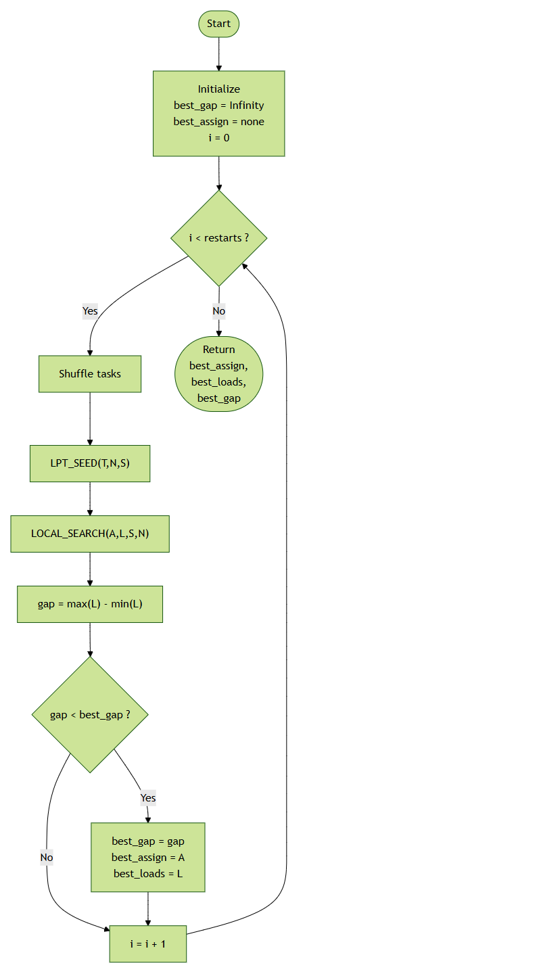

**All in one**

Procedure BALANCE(T, N, S, restarts, seed):

Initialize random(seed)

best_gap ← +∞

best_A ← None

best_L ← None

for i = 1 to restarts do

shuffle(T)

// Stage 1: LPT Seed

(A, L) ← LPT_SEED(T, N, S)

// Stage 2: Local Search

(A, L) ← LOCAL_SEARCH(A, L, S, N)

// Evaluate

gap ← max { L[n] } – min { L[n] }

if gap < best_gap then

best_gap ← gap

best_A ← deepcopy(A)

best_L ← deepcopy(L)

end if

end for

return (best_A, best_L, best_gap)

End Procedure

Procedure LPT_SEED(T, N, S):

for each n in N:

load[n] ← 0

assign[n] ← empty list

end for

// sort tasks by descending “best-case” time

T_sorted ← sort T by key t ↦ min { S[t][n] for n in N }, descending

for each t in T_sorted do

n* ← arg min { load[n] for n in N }

append t to assign[n*]

load[n*] ← load[n*] + S[t][n*]

end for

return (assign, load)

End Procedure

Procedure LOCAL_SEARCH(A, L, S, N):

repeat

improved ← false

heavy ← arg max { L[n] }

light ← arg min { L[n] }

gap0 ← L[heavy] – L[light]

best_gain ← 0

best_op ← None

// Try moving any t from heavy → light

for t in A[heavy]:

compute gain if moved

record if gain > best_gain

end for

// Try swapping any t_h↔t_l between heavy/light

for t_h in A[heavy]:

for t_l in A[light]:

compute gain if swapped

record if gain > best_gain

end for

end for

if best_op exists:

apply best_op to (A, L)

improved ← true

end if

until not improved

return (A, L)

End Procedure