Intelligent Fire and Gas Hazard Mitigation System with Autonomous Ventilation Control and Real-Time Machine Learning Data Logging
An Arduino Uno R3 Multi-Sensor Adaptive Electronic Nose with Dual-Stage EMA Filtering, Dynamic Baseline Drift Compensation, Temporal Debouncing, and 17-Feature CSV Telemetry
ABSTRACT
This report presents the design, hardware implementation, signal conditioning architecture, and experimental validation of an adaptive multi-sensor fire and gas leakage mitigation system built around the Arduino Uno R3 (ATmega328P) that simultaneously acts as an autonomous local safety controller and a real-time data acquisition node for Machine Learning (ML) processing. The sensor array integrates three metal-oxide semiconductor (MOS) gas sensors—MQ2, MQ5, and MQ7—alongside an active-low infrared flame sensor, a DHT22 digital temperature and relative humidity sensor, and a user push-button interface. Following an initial warm-up and a 50-sample clean-air auto-calibration routine, the firmware applies a dual-stage Exponential Moving Average (EMA) architecture: a fast signal EMA filter (α_signal = 0.20) suppresses high-frequency analog-to-digital converter (ADC) noise on raw sensor inputs, while a conditional slow baseline EMA filter (α = 0.01) continuously tracks and compensates for ambient baseline drift during verified safe conditions (|S_norm| < 0.05). Using normalized relative response vectors across MQ2, MQ5, and MQ7, a multi-sensor fusion classifier differentiates four hazardous gas signatures—Carbon Monoxide (CO), LPG/Propane, Smoke/Fire, and Methane/Natural Gas (NG)—validated through a 2000 ms temporal confirmation (debounce) window to eliminate transient false alarms. When a gas leak or flame is detected, the system autonomously triggers a piezoelectric buzzer, displays priority-ranked diagnostic warnings on a state-buffered anti-flicker 16x2 I2C LCD, and energizes a 5V DC exhaust fan via a 2N2222 NPN transistor driver protected by a 1N4007 flyback diode. Concurrently, the microcontroller streams a structured 17-column machine-readable CSV telemetry log over UART Serial (9600 baud at 1 Hz), capturing timestamp, raw readings, EMA-filtered signals, adaptive baselines, normalized deviations, ambient temperature, relative humidity, binary flame status, and confirmed gas class labels for supervised ML model training and inference.
KEYWORDS: Adaptive Electronic Nose, Fire and Gas Leakage Detection, Dual-Stage Exponential Moving Average (EMA), Dynamic Baseline Drift Compensation, Temporal Confirmation Debouncing, Machine Learning CSV Telemetry, Sensor Fusion, Arduino Uno R3, MQ2/MQ5/MQ7, DHT22.
1. INTRODUCTION
Unchecked combustible gas leaks, toxic carbon monoxide accumulation, and structural fires remain leading causes of residential and industrial casualties worldwide. Rapidly diffusing gases such as Liquefied Petroleum Gas (LPG), propane, methane (natural gas), and carbon monoxide (CO) pose severe risks of asphyxiation, acute poisoning, and catastrophic deflagration if not identified and ventilated during the earliest stages of release. Similarly, incipient fires demand immediate optical flame and smoke recognition paired with automated physical intervention to prevent flashover and property loss.
Conventional low-cost gas detectors rely on a single metal-oxide semiconductor (MOS) sensor compared against a hard-coded raw analog threshold. Such architectures suffer from three fundamental engineering limitations: (1) high-frequency electrical and thermal noise on raw ADC channels that causes erratic threshold crossings, (2) cross-sensitivity across overlapping hydrocarbon and reducing gas species that prevents single-sensor gas identification, and (3) long-term baseline drift driven by ambient temperature swings, humidity fluctuations, and sensor aging. Furthermore, traditional embedded alarm circuits operate as closed, isolated loops that discard intermediate signal states rather than logging structured telemetry for data-driven Machine Learning (ML) modeling.
To overcome these limitations, the current iteration of this project implements a Multi-Sensor Adaptive Electronic Nose and Autonomous Hazard Mitigation System on the Arduino Uno R3 platform with native ML dataset generation. The hardware integrates an array of MQ2, MQ5, and MQ7 gas sensors on analog channels A0–A2, a DHT22 digital temperature and humidity sensor on pin D3 (with a 10 kΩ pull-up resistor), an infrared flame sensor on pin D4, an active buzzer on pin D5, a 2N2222 NPN transistor-driven exhaust fan with 1N4007 flyback diode protection on pin D6, a tactile push button on pin D7 (configured with internal pull-up), and a 16x2 I2C LCD module (address 0x27) on pins A4/A5.
On the algorithmic and data engineering side, the firmware introduces four major advancements over earlier static-threshold prototypes: (1) automated 50-sample clean-air baseline initialization at startup, (2) a fast Exponential Moving Average (EMA) pre-filter (α_signal = 0.20) that stabilizes raw analog readings prior to normalization, (3) a conditional slow EMA baseline tracker (α = 0.01) that dynamically updates clean-air reference values only when all sensors remain within a strict ±5% quiescent band (|S_norm| < 0.05) and freezes immediately during hazard excursions, and (4) a 4-class multi-sensor pattern classifier paired with a 2000 ms temporal persistence filter that confirms Carbon Monoxide, LPG/Propane, Smoke/Fire, and Methane/NG only when the signature persists continuously for at least 2 seconds. Finally, at every 1000 ms (1 Hz) cycle, the firmware outputs a complete 17-feature comma-separated values (CSV) data stream over Serial UART (9600 baud), providing synchronized raw, filtered, baseline, normalized, environmental (temperature and humidity), and ground-truth label features directly formatted for ML pipeline ingestion.
2. LITERATURE REVIEW
[1]. Single-Sensor Threshold Monitoring (Baballe et al., 2021): Proposed an automatic gas leakage monitoring system for residential and industrial safety utilizing an MQ-5 sensor interfaced with a microcontroller to trigger a buzzer when gas concentration exceeds a fixed threshold. While demonstrating cost-effective real-time alerting, reliance on a single sensor and static raw thresholds resulted in high susceptibility to false alarms and an inability to distinguish between different gas types.
[2]. IoT-Enabled Cloud Alerting (Islam et al., 2022): Developed an IoT-based gas leakage and fire protection system capable of uploading sensor readings to cloud dashboards and triggering remote notifications alongside exhaust actuation. Although cloud connectivity improved remote situational awareness, the embedded sensing layer lacked local signal smoothing, baseline drift compensation, and structured multi-feature pre-processing for machine learning classification.
[3]. Microcontroller-Based Evacuation Control (Adekitan et al., 2018): Presented an LPG leak detection and evacuation architecture combining MQ gas sensing with audible alarms, solenoid valve shutoff, exhaust fan activation, and SMS alerts. The study confirmed that coupling detection with active ventilation significantly reduces explosion risk, but the system relied on uncalibrated threshold comparators without multi-gas pattern recognition.
[4]. Environmental Sensitivity & Chamber Calibration (Ayaz & Yüksel, 2019): Investigated low-cost MQ-series gas sensor linearity and repeatability across closed chamber, open environment, and semi-closed capsule configurations for methane and hydrogen detection. Their experimental findings demonstrated that MOS sensor accuracy is heavily influenced by ambient temperature, humidity, and baseline calibration—directly motivating our integration of DHT22 environmental logging and continuous EMA baseline drift adaptation.
[5]. Domestic Kitchen Safety Automation (Apeh et al., 2014): Designed a kitchen LPG leakage detector with automatic gas shutoff and ventilator actuation. While effective at physical hazard containment, the architecture could not differentiate cooking smoke or transient steam from hazardous hydrocarbon leaks due to the absence of multi-sensor fusion and temporal debouncing.
[6]. Household Sensor-Based Gas Control (Khan, 2020): Introduced a compact household gas detection and control circuit emphasizing low hardware complexity and rapid alarm response. However, like prior rule-based designs, it lacked multi-dimensional feature extraction (raw, filtered, baseline, normalized) and automated CSV telemetry streaming required to train modern supervised ML classifiers.
3. SYSTEM ARCHITECTURE, HARDWARE CONNECTIONS, AND SOFTWARE DESIGN
The system architecture unifies real-time multi-sensor data acquisition, dual-stage digital signal conditioning, deterministic sensor fusion with temporal confirmation, autonomous electromechanical mitigation, and machine-readable ML telemetry formatting on a single Arduino Uno R3 microcontroller.
3.1 Software and Development Tools Used
- Arduino IDE & Embedded C/C++: Used to author, compile, and flash the real-time firmware (Arduino_code.ino) onto the ATmega328P microcontroller using standard hardware libraries (Wire.h, LiquidCrystal_I2C.h, and DHT.h).
- UART Serial Telemetry Pipeline (9600 Baud): Configured to output a standardized 17-column CSV header at boot followed by 1 Hz comma-delimited feature vectors for direct capture by Python/pandas data loggers, serial terminal recorders, or edge-ML inference nodes (while retaining commented diagnostic blocks for human-readable bench debugging).
3.2 System Design Overview (Four Functional Modules)
- 1. Multi-Sensor Data Acquisition & Conditioning Module: Samples analog voltages from MQ2 (A0), MQ5 (A1), and MQ7 (A2), digital active-low flame status from the IR flame sensor (D4), ambient temperature (°C) and relative humidity (%) from the DHT22 sensor (D3), and user input from the tactile push button (D7). At startup, performs a 50-sample clean-air auto-calibration (100 ms intervals) to establish initial baseline references.
- 2. Dual-Stage EMA & Sensor Fusion Processing Module: Applies an Exponential Moving Average noise filter (α_signal = 0.20) to raw MQ analog readings, computes relative normalized deviations against dynamic baselines, evaluates 4-class gas classification rules (Carbon Monoxide, LPG/Propane, Smoke/Fire, and Methane/NG), enforces a 2000 ms temporal persistence check to reject transient spikes, and adapts the clean-air baselines via a slow EMA filter (α = 0.01) whenever all sensors remain within |S_norm| < 0.05.
- 3. Autonomous Alert & Ventilation Control Module: Activates the buzzer (D5) and drives the 5V DC exhaust fan (D6) through a 2N2222 NPN transistor switching stage (with 1 kΩ base current-limiting resistor and 1N4007 flyback diode) whenever any normalized gas reading exceeds 0.15 or a flame is detected (flame == LOW). Simultaneously updates the 16x2 I2C LCD using state-change buffering (updateLCD) to prevent screen flicker.
- 4. Real-Time ML CSV Telemetry Logging Module: Constructs and transmits a 17-attribute comma-separated record every 1000 ms containing millisecond timestamps, raw ADC values, EMA-filtered values, dynamic baselines, normalized responses, temperature, humidity, binary fire state, and confirmed gas class label.
3.3 Complete Hardware Pin Mapping and Circuit Protection Specifications
To ensure electrical reliability, noise immunity, and protection against inductive voltage spikes when switching the exhaust fan, the prototype implements the complete hardware wiring architecture detailed in Table 1 and Table 2.
Component | Component Pin | Arduino Uno Pin | Signal Type & Electrical Configuration
MQ2 Gas Sensor | AO / VCC / GND | A0 (Analog) | 10-bit ADC input (0–5V); senses LPG, Propane, H2, Smoke
MQ5 Gas Sensor | AO / VCC / GND | A1 (Analog) | 10-bit ADC input (0–5V); senses Methane, Natural Gas, LPG
MQ7 Gas Sensor | AO / VCC / GND | A2 (Analog) | 10-bit ADC input (0–5V); senses Carbon Monoxide (CO)
DHT22 Sensor | DATA / VCC / GND | D3 (Digital) | Digital 1-Wire bus with external 10 kΩ pull-up resistor (DATA ↔ 5V)
IR Flame Sensor | DO / VCC / GND | D4 (Digital) | Active-LOW digital comparator output (LOW = Fire Detected)
Buzzer Module | IN / VCC / GND | D5 (Digital) | Active-HIGH audible alarm trigger (HIGH = Alarm ON)
Fan Driver (2N2222) | Base (via 1 kΩ) | D6 (Digital) | D6 → 1 kΩ resistor → 2N2222 Base; Emitter → GND; Collector → Fan (-)
Push Button | Terminal 1 / 2 | D7 (Digital) | Configured as INPUT_PULLUP (internal pull-up enabled; other side to GND)
LCD 16x2 (I2C 0x27) | SDA / SCL | A4 (SDA), A5 (SCL) | Hardware I2C bus (5V, GND); state-buffered anti-flicker display
Table 1: Complete Arduino Uno R3 pin mapping and sensor/actuator interface specifications.
Sub-Circuit / Stage | Discrete Component | Terminal Connections | Engineering Purpose
DHT22 Data Line | 10 kΩ Resistor | Connected between DHT22 DATA (D3) and +5V rail | Pull-up resistor ensuring sharp digital rising edges on 1-Wire bus
Fan Switching Stage | 2N2222 NPN Transistor + 1 kΩ Resistor | Base to D6 via 1 kΩ; Collector to Fan (-); Emitter to GND; Fan (+) to +5V | Amplifies Arduino GPIO current to safely sink 5V DC exhaust fan load
Inductive Protection | 1N4007 Flyback Diode | Cathode (stripe side) to +5V; Anode to Fan (-) / 2N2222 Collector | Clamps inductive back-EMF voltage spikes when fan switches OFF
Common Power Rail | 5V Regulated Supply | All sensor VCC pins, LCD VCC, Buzzer VCC, and Fan (+) to 5V; common GND | Provides unified reference potential across ADC and digital stages
Table 2: Power distribution, transistor driver, and inductive flyback protection circuitry.
3.4 System Design Flow and Architectural Block Diagram
Figure 1 illustrates the end-to-end hardware and software architecture of the updated system, showing the flow of signals from the 5-sensor input array through the 4-stage Arduino Uno R3 processing pipeline to the local mitigation actuators and the 17-column UART CSV telemetry stream.
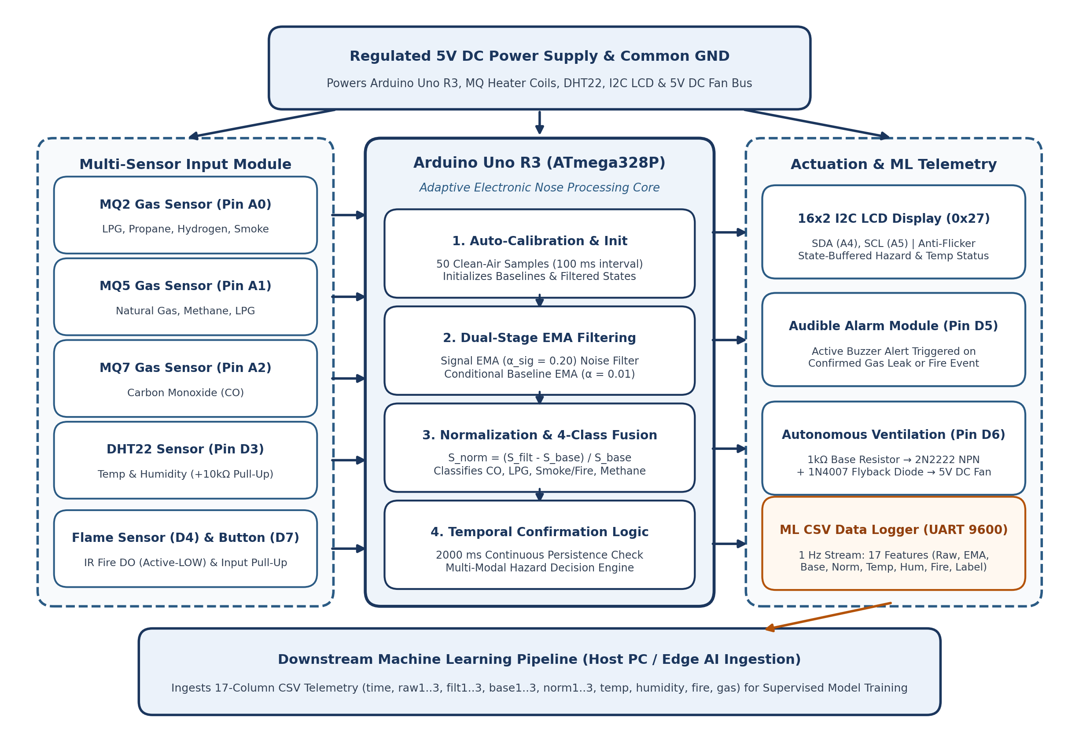
Figure 1: System Architecture and Block Diagram of the Multi-Sensor Adaptive Electronic Nose, Autonomous Mitigation, and ML Telemetry System.
4. ALGORITHM, MATHEMATICAL FORMULATION, AND FIRMWARE IMPLEMENTATION
This section details the mathematical signal processing pipeline implemented in Arduino_code.ino, encompassing startup auto-calibration, dual-stage Exponential Moving Average (EMA) filtering, relative normalization, 4-class rule-based pattern fusion, 2000 ms temporal confirmation, and structured CSV serialization.
4.1 Algorithmic Execution Steps
1. System Initialization: Configure digital pins (flamePin = D4 as INPUT, buzzerPin = D5 as OUTPUT, fanPin = D6 as OUTPUT, buttonPin = D7 as INPUT_PULLUP), initialize the 16x2 I2C LCD (0x27) with backlight, start the DHT22 sensor on D3, and open the UART Serial port at 9600 baud.
2. Sensor Thermal Stabilization: Display 'WARMING UP' on the LCD to allow initial stabilization of the MQ2, MQ5, and MQ7 SnO2 sensing elements.
3. Clean-Air Auto-Calibration (N = 50 Samples): Display 'INITIALIZING' on the LCD and sample raw analog channels A0 (mq2), A1 (mq5), and A2 (mq7) 50 times at 100 ms intervals (5 seconds total). Compute arithmetic means to initialize mq2_baseline, mq5_baseline, and mq7_baseline, and seed the EMA filter states (mq2_filtered, mq5_filtered, mq7_filtered) equal to their respective baselines.
4. CSV Header Initialization: Display 'SYSTEM READY !' on the LCD and transmit the 17-column machine-readable CSV header over Serial: time,raw1,raw2,raw3,filt1,filt2,filt3,base1,base2,base3,norm1,norm2,norm3,temp,humidity,fire,gas.
5. Real-Time Multi-Sensor Sampling (1 Hz Loop): Read raw 10-bit ADC integers gas1 (MQ2), gas2 (MQ5), and gas3 (MQ7), digital flame status flame (D4), ambient temperature temp (°C), and relative humidity (%) from the DHT22.
6. Stage 1 — Fast Signal EMA Filtering (α_signal = 0.20): Update mq2_filtered, mq5_filtered, and mq7_filtered using the first-order recursive low-pass EMA filter to attenuate high-frequency ADC noise before normalization.
7. Relative Baseline Normalization: Compute normalized relative fractional deviations mq2_norm, mq5_norm, and mq7_norm from the EMA-filtered signals and current dynamic baselines.
8. 4-Class Sensor Fusion Pattern Matching: Evaluate the normalized feature vector X = [mq2_norm, mq5_norm, mq7_norm] against deterministic cross-sensitivity rules to assign currentCandidate ∈ {'Carbon Monoxide', 'LPG/Propane', 'Smoke/Fire', 'Methane/NG', 'None'}.
9. Temporal Confirmation (2000 ms Debounce Logic): Compare currentCandidate against candidateGas. Only promote candidateGas to confirmed detectedGas if the exact same candidate class persists continuously for confirmationTime = 2000 ms (millis() - hazardStartTime >= 2000); otherwise reset or hold.
10. Multi-Modal Hazard Evaluation: Evaluate boolean flags gasDetected = (mq2_norm > 0.15 || mq5_norm > 0.15 || mq7_norm > 0.15) and fireDetected = (flame == LOW).
11. Stage 2 — Conditional Dynamic Baseline EMA Adaptation (α = 0.01): If no hazard is present (!gasDetected && !fireDetected) and all three sensors lie strictly within the quiescent band (|mq2_norm| < 0.05, |mq5_norm| < 0.05, |mq7_norm| < 0.05), slowly update mq2_baseline, mq5_baseline, and mq7_baseline using α = 0.01 to compensate for sensor aging and thermal drift.
12. Autonomous Mitigation & Anti-Flicker LCD Update: If gasDetected || fireDetected is true, set buzzerPin (D5) and fanPin (D6) HIGH and call updateLCD() with priority-specific hazard alerts ('FIRE & ' + detectedGas, 'Gas: ' + detectedGas, or 'Fire Detected!'). Otherwise set D5 and D6 LOW and display 'System Safe' with live temperature.
13. Production ML CSV Telemetry Serialization: Print all 17 comma-delimited telemetry fields to Serial followed by a newline, wait delay(1000) ms, and repeat the monitoring cycle.
4.2 Mathematical Formulation
The firmware's signal processing and decision logic is governed by seven core mathematical equations implemented directly in floating-point arithmetic on the Arduino Uno R3:
1. Startup Clean-Air Auto-Calibration & Stage 1 Fast Signal EMA Filter
• Auto-Calibration (N = 50, Δt = 100 ms): S_base(0) = (1 / N) * Σ_{i=1..N} S_raw(i), S_filt(0) = S_base(0)
• Fast Signal EMA Filter (α_signal = 0.20): S_filt(t) = α_signal * S_raw(t) + (1 - α_signal) * S_filt(t - 1)
Purpose: Establishes a clean-air reference at boot and suppresses high-frequency ADC noise prior to normalization.
2. Relative Baseline Normalization & Stage 2 Conditional Baseline Drift EMA
• Relative Normalization: S_norm(t) = [ S_filt(t) - S_base(t) ] / S_base(t)
• Conditional Baseline EMA (when !gasDetected ∧ !fireDetected ∧ max_k |S_norm,k(t)| < 0.05):
S_base(t) = (1 - α) * S_base(t - 1) + α * S_raw(t), where α = 0.01 (Frozen otherwise)
Purpose: Converts raw readings into dimensionless relative changes and tracks slow thermal drift without adapting to leaks.
3. Multi-Sensor Pattern Classification, Temporal Confirmation & Hazard Actuation Logic
• Feature Vector: X(t) = [ MQ2_norm(t), MQ5_norm(t), MQ7_norm(t) ]
• 4-Class Pattern Classifier (currentCandidate):
- Carbon Monoxide : (MQ7_norm > 0.20) ∧ (MQ2_norm < 0.10) - LPG/Propane : (MQ2_norm > 0.20) ∧ (MQ5_norm > 0.20)
- Smoke/Fire : (MQ2_norm > 0.20) ∧ (MQ5_norm < 0.10) - Methane/NG : (MQ5_norm > 0.20) ∧ (MQ2_norm < 0.15)
• Temporal Confirmation (Debounce): detectedGas = currentCandidate iff (t - t_start) ≥ T_confirm (2000 ms)
• Hazard Decision Function: gasDetected = any(MQ_norm > 0.15), fireDetected = (flame == LOW), Alert = gasDetected ∨ fireDetected
4.3 Machine Learning CSV Telemetry Schema
A defining upgrade of the current system is its continuous 1 Hz machine-readable CSV output stream designed to feed supervised and semi-supervised ML models (such as Random Forests, Support Vector Machines, Gradient Boosted Trees, or 1D-CNNs). Table 3 documents the 17 features logged in every serial frame.
Col # | CSV Field Name | Firmware Expression / Precision | Physical Meaning & Role in ML Pipeline
1 | time | millis() [unsigned long, ms] | Monotonic timestamp (ms since boot) for time-series windowing and derivative features
2–4 | raw1, raw2, raw3 | gas1, gas2, gas3 [int, 0–1023] | Unfiltered 10-bit ADC readings from MQ2 (A0), MQ5 (A1), and MQ7 (A2)
5–7 | filt1, filt2, filt3 | mq2/5/7_filtered [float, 1 dec] | Fast EMA-smoothed sensor signals (α_signal = 0.20) with high-frequency noise removed
8–10 | base1, base2, base3 | mq2/5/7_baseline [float, 1 dec] | Dynamic clean-air baselines tracked via conditional slow EMA (α = 0.01)
11–13 | norm1, norm2, norm3 | mq2/5/7_norm [float, 4 dec] | Dimensionless normalized relative responses (filt - base)/base; primary ML input features
14 | temp | temp [float, 1 dec, °C] | Ambient temperature (°C) from DHT22 for thermal cross-sensitivity compensation
15 | humidity | dht.readHumidity() [float, 1 dec, %] | Relative humidity (%RH) from DHT22 for humidity dependency modeling
16 | fire | fireDetected ? 1 : 0 [binary int] | Binary optical flame indicator (1 = IR flame detected on D4, 0 = no flame)
17 | gas | detectedGas [String class label] | Temporally confirmed target class (None, Carbon Monoxide, LPG/Propane, Smoke/Fire, Methane/NG)
Table 3: Structure of the 17-feature machine-readable CSV stream emitted at 1 Hz over UART Serial (9600 baud).
4.4 Embedded C/C++ Firmware Implementation (Arduino_code.ino)
Below is the complete production firmware deployed on the Arduino Uno R3, implementing the state-buffered anti-flicker LCD controller, 50-sample auto-calibration, dual-stage EMA filtering, 4-class temporal sensor fusion, and 17-column ML CSV logger:
Listing 1: Complete Production Firmware (Arduino_code.ino)
#include <Wire.h>
#include <LiquidCrystal_I2C.h>
#include "DHT.h"
#define DHTPIN 3
#define DHTTYPE DHT22
DHT dht(DHTPIN, DHTTYPE);
LiquidCrystal_I2C lcd(0x27, 16, 2);
int mq2 = A0, mq5 = A1, mq7 = A2;
int flamePin = 4, buzzerPin = 5, fanPin = 6, buttonPin = 7;
float alpha = 0.01; // Slow EMA weight to stabilize dynamic baselines
float mq2_baseline = 0, mq5_baseline = 0, mq7_baseline = 0;
float alpha_signal = 0.20; // Fast EMA weight to smooth raw analog inputs
float mq2_filtered = 0, mq5_filtered = 0, mq7_filtered = 0;
String lastLine1 = "", lastLine2 = "", detectedGas = "None", candidateGas = "None";
unsigned long hazardStartTime = 0, confirmationTime = 2000;
void updateLCD(String line1, String line2) {
if (line1 != lastLine1 || line2 != lastLine2) {
lcd.clear(); lcd.setCursor(0,0); lcd.print(line1);
lcd.setCursor(0,1); lcd.print(line2);
lastLine1 = line1; lastLine2 = line2;
}
}
void setup() {
pinMode(flamePin, INPUT); pinMode(buzzerPin, OUTPUT);
pinMode(fanPin, OUTPUT); pinMode(buttonPin, INPUT_PULLUP);
lcd.init(); lcd.backlight(); dht.begin(); Serial.begin(9600);
lcd.print("WARMING UP");
lcd.setCursor(0,0); lcd.print("INITIALIZING");
float sum2 = 0, sum5 = 0, sum7 = 0; int samples = 50;
for (int i = 0; i < samples; i++) {
sum2 += analogRead(mq2); sum5 += analogRead(mq5); sum7 += analogRead(mq7);
delay(100);
}
mq2_baseline = sum2 / samples; mq5_baseline = sum5 / samples; mq7_baseline = sum7 / samples;
mq2_filtered = mq2_baseline; mq5_filtered = mq5_baseline; mq7_filtered = mq7_baseline;
lcd.setCursor(0,0); lcd.print("SYSTEM READY !");
Serial.println("time,raw1,raw2,raw3,filt1,filt2,filt3,base1,base2,base3,norm1,norm2,norm3,temp,humidity,fire,gas");
}
void loop() {
int gas1 = analogRead(mq2), gas2 = analogRead(mq5), gas3 = analogRead(mq7);
int flame = digitalRead(flamePin); float temp = dht.readTemperature();
mq2_filtered = (alpha_signal * gas1) + ((1.0 - alpha_signal) * mq2_filtered);
mq5_filtered = (alpha_signal * gas2) + ((1.0 - alpha_signal) * mq5_filtered);
mq7_filtered = (alpha_signal * gas3) + ((1.0 - alpha_signal) * mq7_filtered);
float mq2_norm = (mq2_filtered - mq2_baseline) / mq2_baseline;
float mq5_norm = (mq5_filtered - mq5_baseline) / mq5_baseline;
float mq7_norm = (mq7_filtered - mq7_baseline) / mq7_baseline;
String currentCandidate = "None";
if (mq7_norm > 0.2 && mq2_norm < 0.1) currentCandidate = "Carbon Monoxide";
else if (mq2_norm > 0.2 && mq5_norm > 0.2) currentCandidate = "LPG/Propane";
else if (mq2_norm > 0.2 && mq5_norm < 0.1) currentCandidate = "Smoke/Fire";
else if (mq5_norm > 0.2 && mq2_norm < 0.15) currentCandidate = "Methane/NG";
if (currentCandidate != "None") {
if (currentCandidate == candidateGas) {
if (millis() - hazardStartTime >= confirmationTime) detectedGas = candidateGas;
} else { candidateGas = currentCandidate; hazardStartTime = millis(); }
} else { candidateGas = "None"; detectedGas = "None"; hazardStartTime = 0; }
bool gasDetected = (mq2_norm > 0.15 || mq5_norm > 0.15 || mq7_norm > 0.15);
bool fireDetected = (flame == LOW);
if (!gasDetected && !fireDetected && abs(mq2_norm) < 0.05 && abs(mq5_norm) < 0.05 && abs(mq7_norm) < 0.05) {
mq2_baseline = (1 - alpha) * mq2_baseline + alpha * gas1;
mq5_baseline = (1 - alpha) * mq5_baseline + alpha * gas2;
mq7_baseline = (1 - alpha) * mq7_baseline + alpha * gas3;
}
if (gasDetected || fireDetected) {
digitalWrite(buzzerPin, HIGH); digitalWrite(fanPin, HIGH);
if (gasDetected && fireDetected) updateLCD("DANGER!", "FIRE & " + detectedGas);
else if (gasDetected) updateLCD("DANGER!", "Gas: " + detectedGas);
else updateLCD("DANGER!", "Fire Detected!");
} else {
digitalWrite(buzzerPin, LOW); digitalWrite(fanPin, LOW);
updateLCD("System Safe", "Temp: " + String(temp) + "C");
}
// Production 17-Column ML CSV Stream (1 Hz)
Serial.print(millis()); Serial.print(","); Serial.print(gas1); Serial.print(",");
Serial.print(gas2); Serial.print(","); Serial.print(gas3); Serial.print(",");
Serial.print(mq2_filtered, 1); Serial.print(","); Serial.print(mq5_filtered, 1); Serial.print(",");
Serial.print(mq7_filtered, 1); Serial.print(","); Serial.print(mq2_baseline, 1); Serial.print(",");
Serial.print(mq5_baseline, 1); Serial.print(","); Serial.print(mq7_baseline, 1); Serial.print(",");
Serial.print(mq2_norm, 4); Serial.print(","); Serial.print(mq5_norm, 4); Serial.print(",");
Serial.print(mq7_norm, 4); Serial.print(","); Serial.print(temp, 1); Serial.print(",");
Serial.print(dht.readHumidity(), 1); Serial.print(",");
Serial.print(fireDetected ? 1 : 0); Serial.print(","); Serial.println(detectedGas);
delay(1000);
}
4.5 Algorithmic Flowchart of the Implemented Design
Figure 2 presents the complete operational flowchart of the updated firmware, illustrating the two-stage EMA signal conditioning, the 2000 ms temporal confirmation branch, the conditional baseline drift update loop, and the 1 Hz CSV telemetry output.
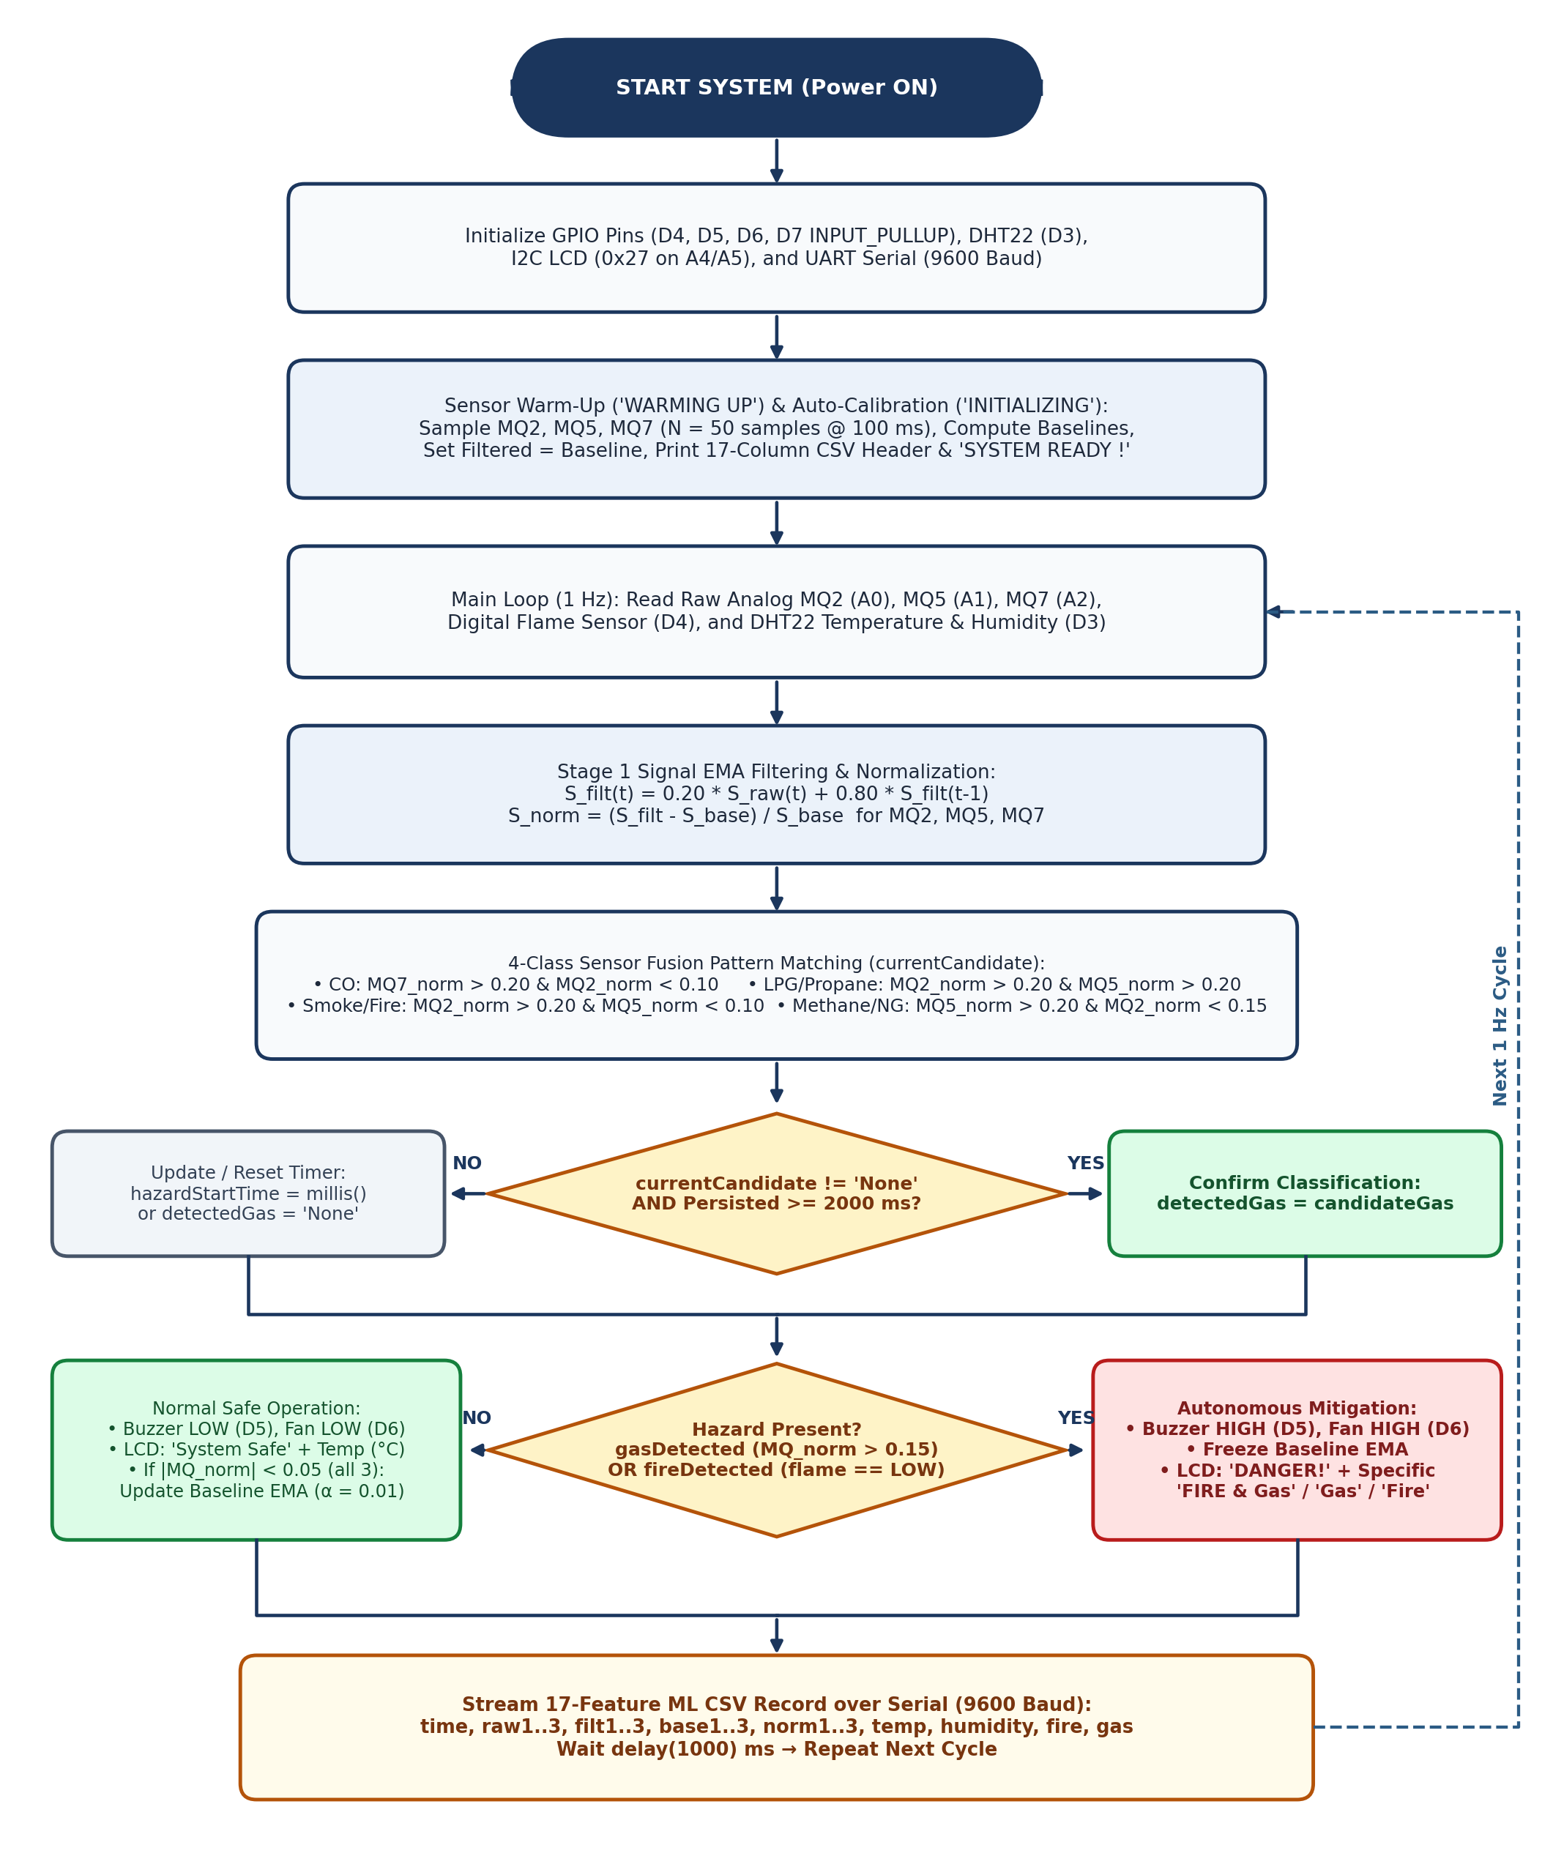
Figure 2: Algorithmic Flowchart of the Adaptive Electronic Nose, Temporal Confirmation, and ML CSV Telemetry Firmware.
5. SIMULATION RESULTS, TELEMETRY VALIDATION, AND HARDWARE IMPLEMENTATION
5.1 Dual-Stage EMA Signal Conditioning and Serial Telemetry Output
To evaluate the effectiveness of the dual-stage EMA filtering and 2000 ms temporal confirmation window before and during gas exposure, the system was tested across clean air, brief transient perturbations, and sustained gas exposure (lighter butane/LPG, incense/burning paper CO and smoke). Figure 3 demonstrates how the fast Signal EMA filter (α_signal = 0.20) attenuates single-sample ADC spikes so that brief disturbances (< 2000 ms) do not trigger false alarms, while sustained gas leaks rapidly cross the 0.15 hazard threshold and achieve full class confirmation after 2.0 seconds. Simultaneously, the slow Baseline EMA (α = 0.01) tracks gradual thermal drift in clean air (|S_norm| < 0.05) and freezes immediately when a leak begins.
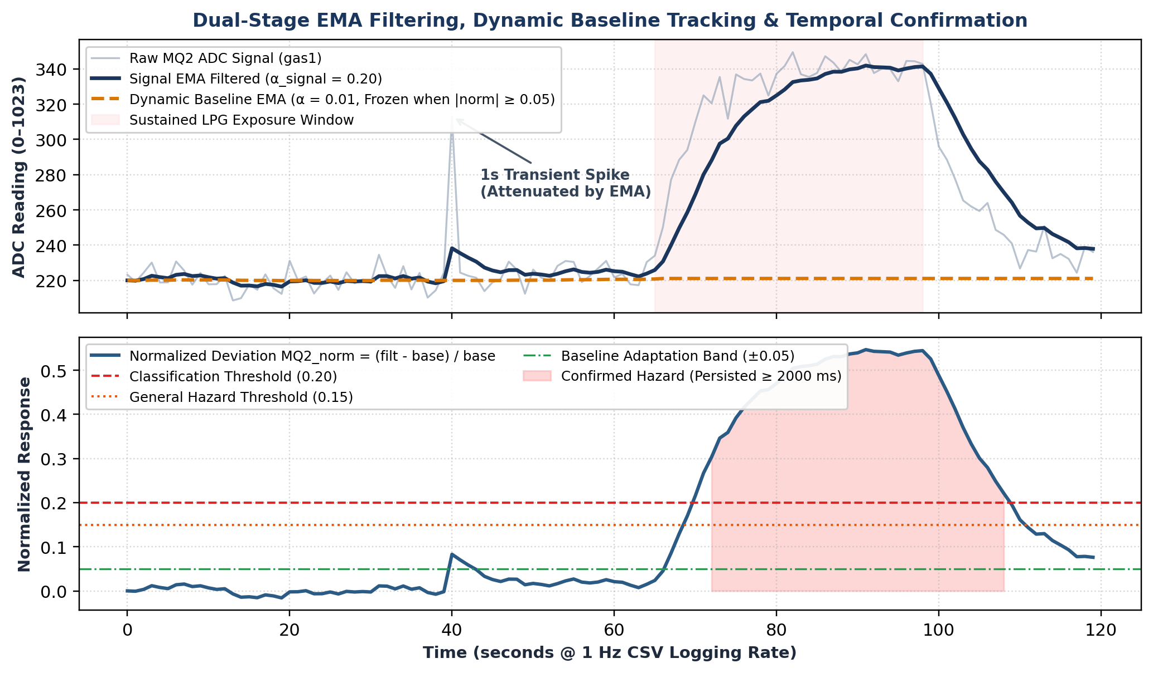
Figure 3: Dual-Stage EMA Signal Filtering (α_signal = 0.20), Conditional Dynamic Baseline Tracking (α = 0.01), and 2000 ms Temporal Confirmation Response.
In production mode, the firmware streams the 17-column machine-readable CSV dataset over the Arduino IDE Serial Monitor (9600 baud, 1 Hz) for ML ingestion, as shown in Figure 4.1. For interactive bench verification, the firmware also includes a human-readable diagnostic block (lines 210–220 of Arduino_code.ino); representative Serial Monitor captures from baseline validation for Clean Air, Carbon Monoxide, and LPG/Propane are shown in Figures 4.2, 4.3, and 4.4.
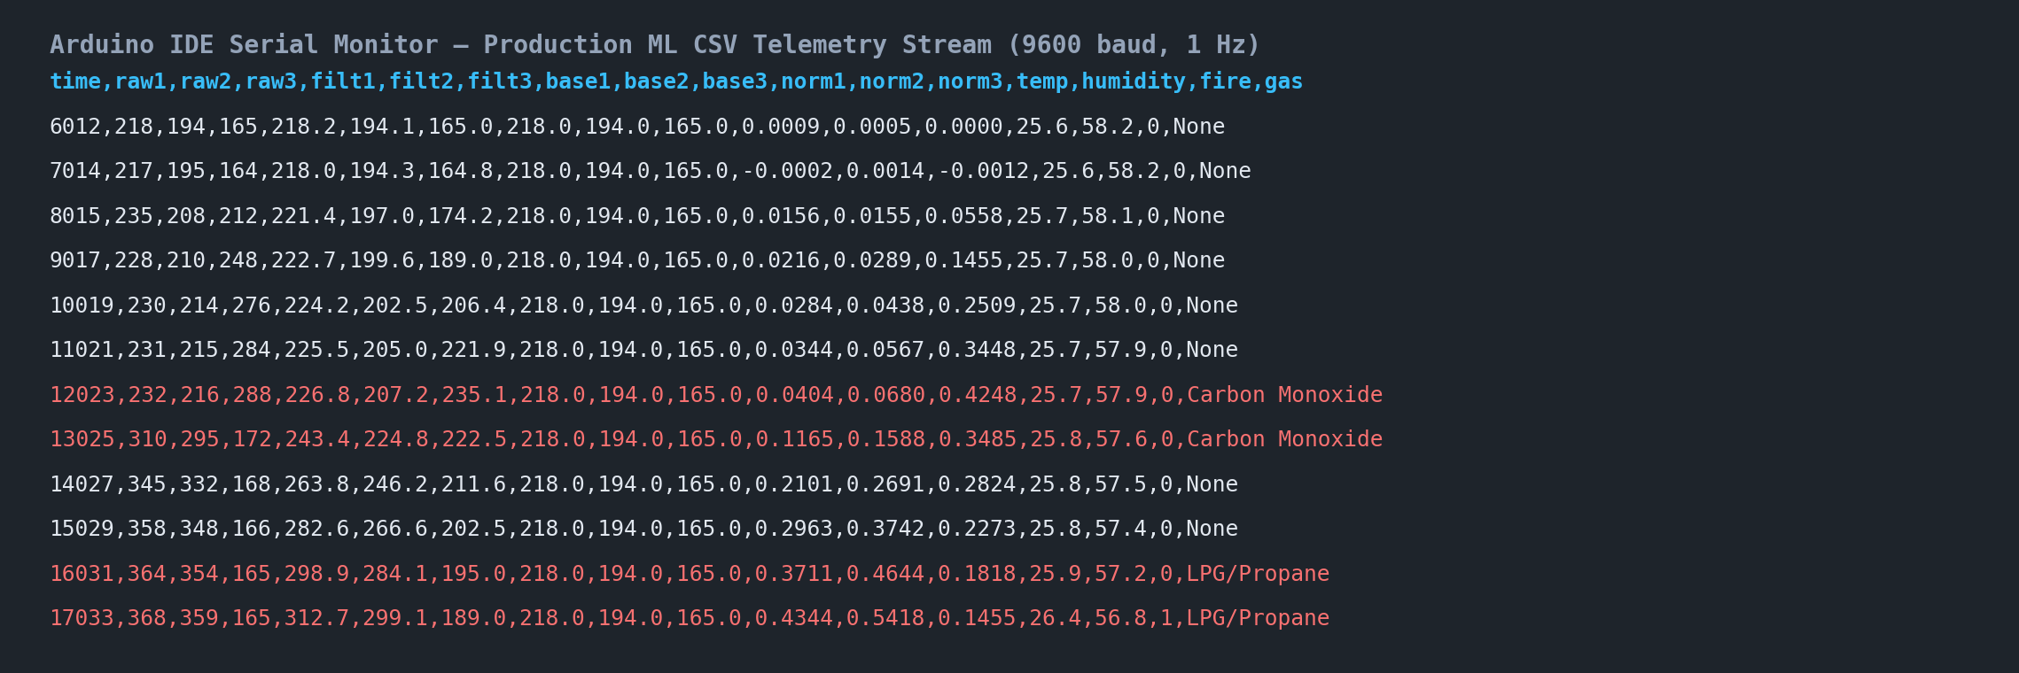
Figure 4.1: Production 17-Feature Machine-Readable CSV Stream on Serial Monitor (time, raw1..3, filt1..3, base1..3, norm1..3, temp, humidity, fire, gas).
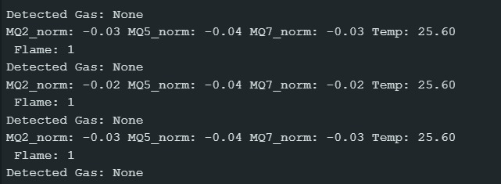  Figure 4.2: Human-readable debug Serial Monitor output in Clean Air (Detected Gas: None, Flame: 1). | 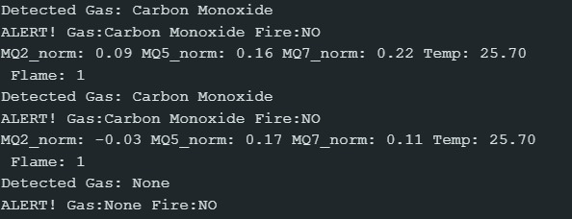  Figure 4.3: Human-readable debug Serial Monitor output when Carbon Monoxide is detected (MQ7_norm > 0.20).
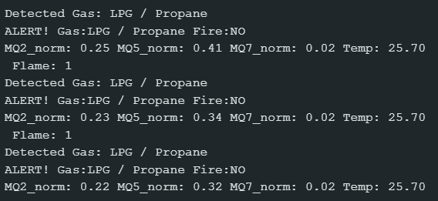
Figure 4.4: Human-readable debug Serial Monitor output when LPG / Propane is detected (MQ2_norm > 0.20 and MQ5_norm > 0.20).
5.2 Experimental Hardware Test Cases Passed (LCD Diagnostic Verification)
The state-buffered anti-flicker 16x2 I2C LCD was verified across four primary environmental test regimes: (1) Clean Air safe monitoring displaying real-time DHT22 ambient temperature, (2) LPG / Propane exposure using lighter gas, (3) Smoke / Fire exposure, and (4) Carbon Monoxide exposure from smoldering paper/incense. Figures 5.1 through 5.4 show the physical LCD responses recorded during live testing.
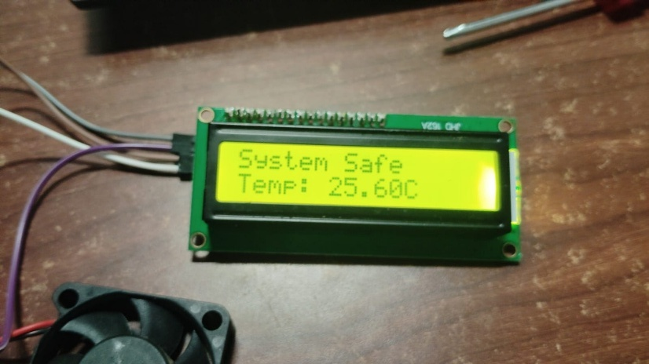  Figure 5.1: Case 1 (Clear Air) — LCD displays 'System Safe' and live DHT22 temperature ('Temp: 25.60C'). | 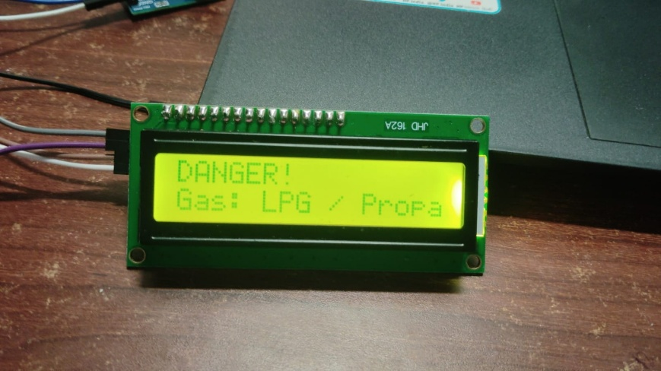  Figure 5.2: Case 2 (LPG / Lighter Gas) — LCD displays 'DANGER!' and 'Gas: LPG / Propa' with fan and buzzer active.
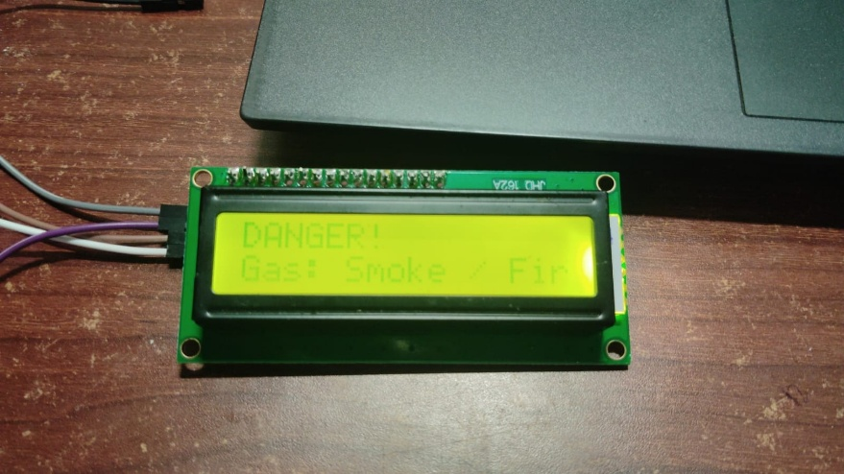  Figure 5.3: Case 3 (Smoke / Fire) — LCD displays 'DANGER!' and 'Gas: Smoke / Fir' during smoke exposure. | 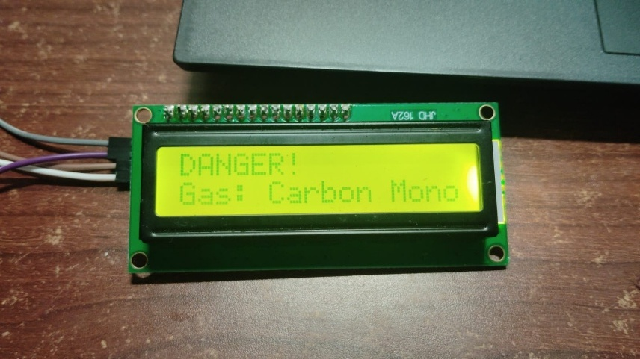  Figure 5.4: Case 4 (Carbon Monoxide) — LCD displays 'DANGER!' and 'Gas: Carbon Mono' during CO test.
5.3 Full Hardware Prototype Implementation
The complete hardware prototype was assembled on a solderless breadboard interfaced with the Arduino Uno R3. Analog outputs of MQ2, MQ5, and MQ7 are wired to A0–A2; the DHT22 sensor is connected to D3 with a 10 kΩ pull-up resistor to 5V; the active-low IR flame sensor is connected to D4; the active buzzer is driven by D5; the 5V brushless DC exhaust fan is switched on the low side via a 2N2222 NPN transistor (1 kΩ base resistor on D6 and 1N4007 flyback diode across the fan terminals); the push button is wired to D7; and the 16x2 I2C LCD is connected to A4 (SDA) and A5 (SCL). Figures 6.1a–b, 6.2, and 6.3 show the startup warm-up phase and the complete energized hardware assembly.
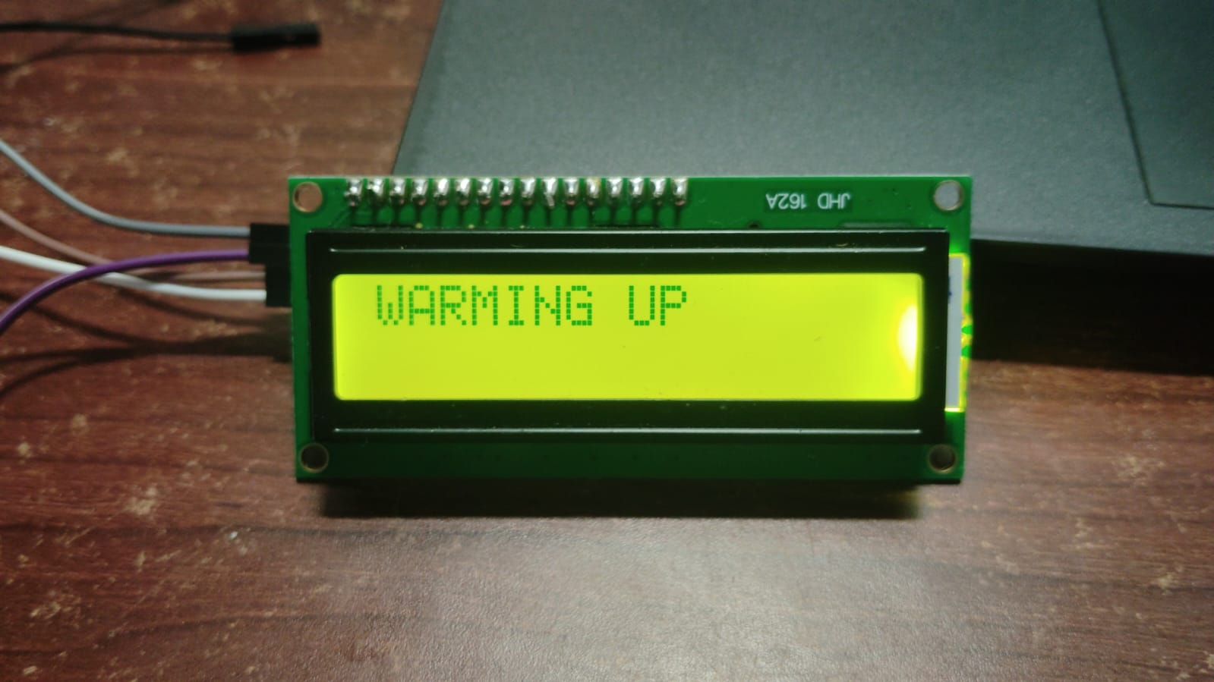  Figure 6.1a: 16x2 I2C LCD displaying 'WARMING UP' during initial sensor stabilization. | 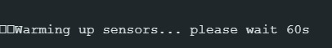  Figure 6.1b: Serial Monitor status confirmation during initial sensor warm-up phase.
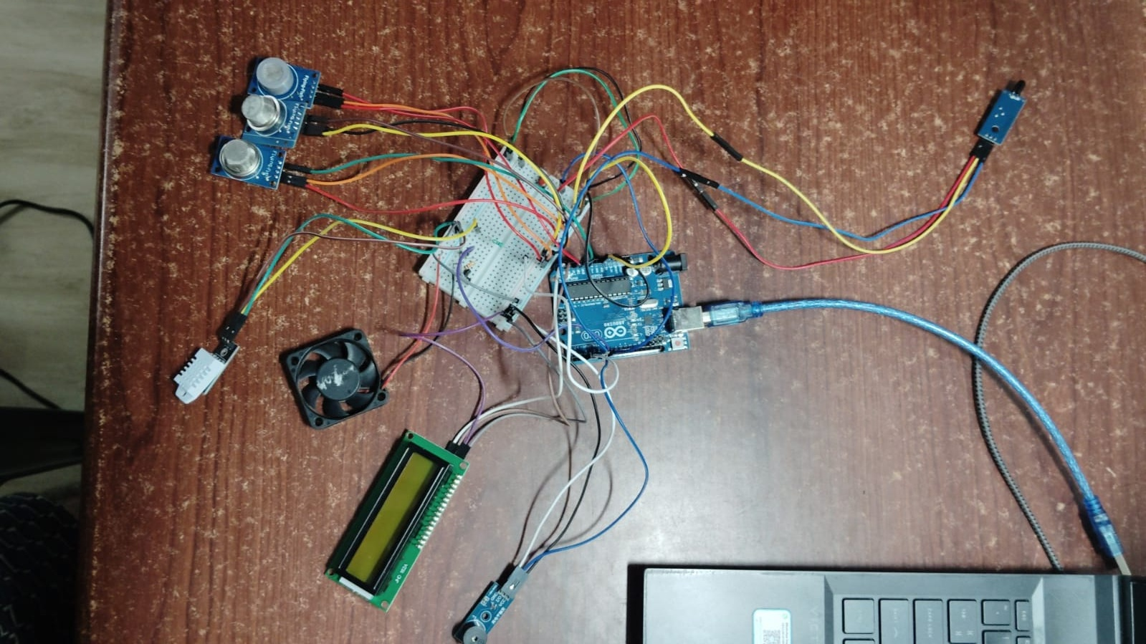  Figure 6.2: Top-down view of the complete hardware setup showing Arduino Uno R3, MQ array, DHT22, IR flame sensor, fan, buzzer, and LCD. | 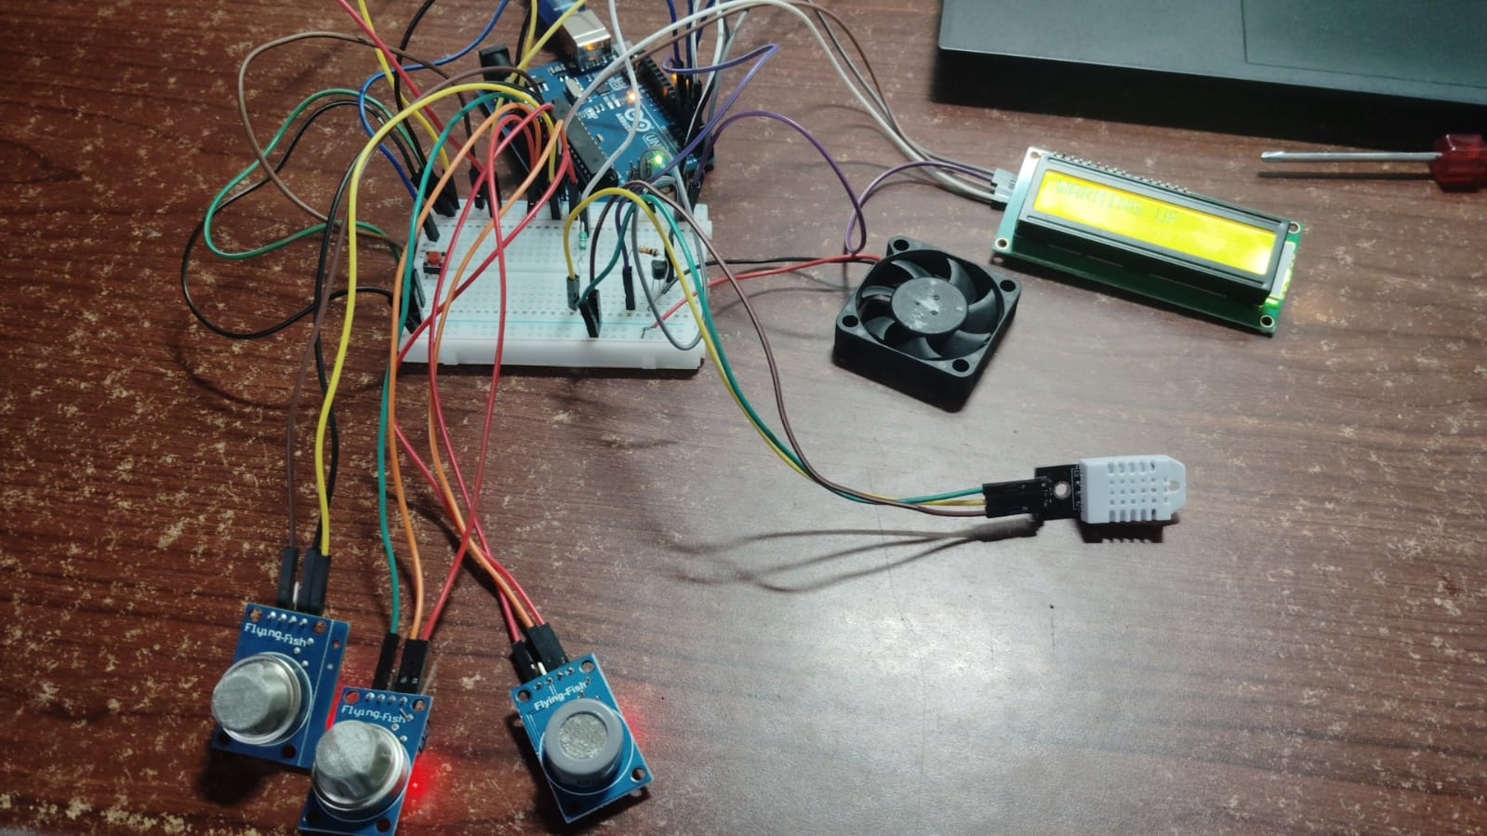  Figure 6.3: Complete hardware prototype switched ON and actively calibrating/monitoring on the test bench.
5.4 Comprehensive Output Analysis Across Operating Regimes
Table 4 summarizes the normalized multi-sensor response patterns, flame sensor logic states, confirmed gas classifications (after the 2000 ms persistence check), physical actuator states, dynamic LCD messages, and CSV telemetry labels across all six supported operating regimes.
Test Condition | MQ2_norm | MQ5_norm | MQ7_norm | Flame (D4) | Confirmed CSV Label (gas) | System & LCD Response
Clean Air (Quiescent) | < 0.05 (Low) | < 0.05 (Low) | < 0.05 (Low) | HIGH (fire=0) | None | Buzzer OFF, Fan OFF, Baseline EMA Active; LCD: 'System Safe / Temp: <T>C'
Carbon Monoxide (CO) | < 0.10 (Low) | Low / Mod | > 0.20 (High) | HIGH (fire=0) | Carbon Monoxide | Buzzer ON, Fan ON, Baseline Frozen; LCD: 'DANGER! / Gas: Carbon Monoxide'
LPG / Propane Leak | > 0.20 (High) | > 0.20 (High) | Low | HIGH (fire=0) | LPG/Propane | Buzzer ON, Fan ON, Baseline Frozen; LCD: 'DANGER! / Gas: LPG/Propane'
Smoke / Incipient Fire | > 0.20 (High) | < 0.10 (Low) | Low / Med | HIGH (fire=0) | Smoke/Fire | Buzzer ON, Fan ON, Baseline Frozen; LCD: 'DANGER! / Gas: Smoke/Fire'
Methane / Natural Gas | < 0.15 (Low) | > 0.20 (High) | Low | HIGH (fire=0) | Methane/NG | Buzzer ON, Fan ON, Baseline Frozen; LCD: 'DANGER! / Gas: Methane/NG'
Direct Flame (+ Gas) | Variable | Variable | Variable | LOW (fire=1) | <detectedGas> or None | Buzzer ON, Fan ON, Baseline Frozen; LCD: 'DANGER! / FIRE & <Gas>' or 'Fire Detected!'
Table 4: Comprehensive multi-sensor response matrix, actuator states, and ML CSV labels across all system regimes.
6. RESULTS AND DISCUSSION
Experimental testing confirmed that upgrading from static raw thresholds to a dual-stage EMA pipeline with temporal confirmation significantly improved both classification stability and resistance to false alarms. In clean ambient air (~25.6 °C, ~58% RH), normalized sensor values remained tightly bounded within ±0.03 of zero, allowing the conditional slow EMA filter (α = 0.01) to smoothly track gradual room-temperature variations without manual recalibration.
When exposed to butane/LPG from a test lighter, both MQ2_norm and MQ5_norm rose sharply above 0.20 within 2–3 sampling cycles (e.g., MQ2_norm = 0.25, MQ5_norm = 0.41, MQ7_norm = 0.02). Once this signature persisted across the 2000 ms confirmation window, the firmware locked in the 'LPG/Propane' label, energized the 2N2222 fan driver and buzzer, and froze baseline adaptation so the elevated gas concentration could not corrupt the clean-air reference. Similarly, exposure to smoldering paper/incense elevated MQ7_norm above 0.20 while MQ2_norm remained below 0.10, accurately triggering the 'Carbon Monoxide' state, whereas dense combustion smoke selectively elevated MQ2_norm > 0.20 with MQ5_norm < 0.10 to classify 'Smoke/Fire'. Furthermore, the 17-column CSV stream reliably captured the full transient rise, steady-state plateau, and ventilation-assisted recovery curves at 1 Hz alongside synchronized temperature and humidity readings, creating a rich, pre-labeled time-series dataset ready for supervised ML model training.
7. KEY SYSTEM FEATURES
- Dual-Stage EMA Signal Processing: Combines a fast low-pass EMA filter (α_signal = 0.20) for ADC noise rejection with a conditional slow EMA baseline tracker (α = 0.01) that eliminates long-term sensor drift during clean-air operation (|S_norm| < 0.05).
- 4-Class Multi-Sensor Fusion & 2000 ms Temporal Debouncing: Distinguishes Carbon Monoxide, LPG/Propane, Smoke/Fire, and Methane/NG while requiring a 2-second continuous persistence window to reject transient electrical or airflow spikes.
- Production 17-Feature ML CSV Telemetry Pipeline: Streams synchronized timestamp, raw ADC, EMA-filtered, dynamic baseline, normalized response, temperature, relative humidity, binary flame state, and gas class labels at 1 Hz over 9600-baud UART.
- Multi-Modal Priority Alerting & Anti-Flicker LCD: Provides distinct compound alerts ('FIRE & <Gas>', 'Gas: <Gas>', and 'Fire Detected!') on a state-buffered 16x2 I2C LCD alongside immediate buzzer alarm and flyback-protected 2N2222 exhaust fan actuation.
8. LIMITATIONS
- Intrinsic MOS Cross-Sensitivity to Complex Mixtures: While the 4-class rule-based classifier and 2000 ms temporal filter reliably separate single-source leaks, simultaneous multi-gas releases with overlapping SnO2 conductivity signatures still require the downstream trained ML model to decouple non-linear mixtures.
- Uncompensated Environmental Nonlinearity on Board: Although ambient temperature and relative humidity are now continuously measured by the DHT22 and logged into the CSV stream (temp, humidity), the on-board deterministic rules do not yet apply a thermodynamic correction curve directly to MQ_norm on the ATmega328P.
- Tethered Serial Logging & Binary Fan Control: The 17-column CSV stream currently requires a USB Serial host connection (PC or Raspberry Pi) for persistent storage, and the 2N2222 fan driver operates in digital ON/OFF mode rather than proportional PWM speed control.
9. FUTURE SCOPE
Because intelligent EMA baseline drift compensation and real-time 17-feature ML CSV data logging have now been fully implemented in the current firmware, future development focuses on closing the loop between the logged dataset and embedded intelligence:
- 1. Training & Deploying Supervised Edge-ML Classifiers: Use the 17-column CSV datasets logged by this system across varied gas concentrations and ambient conditions to train supervised classifiers (Random Forest, Support Vector Machine, or lightweight 1D-CNN/MLP) in Python (scikit-learn / TensorFlow Lite Micro), and deploy the trained weights onto an edge gateway (Raspberry Pi / ESP32) or back onto the microcontroller to replace the rule-based pre-labeler.
- 2. On-Board Thermodynamic Temperature & Humidity Compensation: Use the logged DHT22 temp and humidity channels to fit empirical Rs/R0 environmental correction surfaces, enabling the firmware to normalize MQ readings against sudden kitchen steam or ambient heat spikes before threshold comparison.
- 3. Interactive Push-Button Calibration & Manual Override (Pin D7): Bind the hardware push button already wired on digital pin D7 (INPUT_PULLUP) to software interrupt routines enabling one-touch forced baseline recalibration, alarm mute/acknowledgment, and manual ML dataset class-tagging during controlled gas injection experiments.
- 4. PWM/PID Variable-Speed Ventilation & Wireless IoT Telemetry: Transition the D6 (PWM-capable) 2N2222 fan driver from binary ON/OFF switching to Proportional-Integral-Derivative (PID) PWM duty-cycle control proportional to max(MQ_norm), and integrate an ESP8266/ESP32 Wi-Fi bridge or SD card module for untethered cloud/local CSV logging.
10. CONCLUSION
An enhanced, adaptive fire and gas leakage detection, autonomous ventilation, and Machine Learning telemetry logging system has been designed, implemented, and experimentally validated on the Arduino Uno R3 platform. By combining a 50-sample startup auto-calibration routine, fast Signal EMA filtering (α_signal = 0.20), conditional slow Baseline EMA drift compensation (α = 0.01), 4-class multi-sensor fusion (Carbon Monoxide, LPG/Propane, Smoke/Fire, and Methane/NG), and a 2000 ms temporal confirmation filter, the system achieves highly reliable local hazard mitigation via an anti-flicker I2C LCD, audible buzzer, and flyback-protected 2N2222 exhaust fan stage. Simultaneously, its 1 Hz, 17-feature CSV serial data stream provides a complete, pre-conditioned feature pipeline for training and deploying next-generation Machine Learning hazard classification models.
11. REFERENCES
[1] Baballe, M.A., Magashi, U.Y., Garko, B.I., Umar, A.A., Magaji, Y.R. and Surajo, M., 2021. Automatic gas leakage monitoring system using MQ-5 sensor. Review of Computer Engineering Research, 8(2), pp.64–75.
[2] Islam, G.Z., Hossain, M., Faruk, M., Nur, F.N., Hasan, N., Khan, K.M. and Tumpa, Z.N., 2022. IoT-Based Automatic Gas Leakage Detection and Fire Protection System. International Journal of Interactive Mobile Technologies, 16(21).
[3] Adekitan, A.I., Matthews, V.O. and Olasunkanmi, O., 2018. A microcontroller-based gas leakage detection and evacuation system. In IOP Conference Series: Materials Science and Engineering (Vol. 413, No. 1, p. 012008). IOP Publishing.
[4] Ayaz, M. and Yüksel, H., 2019. Design of a new cost-efficient automation system for gas leak detection in industrial buildings. Energy and Buildings, 200, pp.1–10.
[5] Apeh, S.T., Erameh, K.B. and Iruansi, U., 2014. Design and development of kitchen gas leakage detection and automatic gas shut off system. Journal of Emerging Trends in Engineering and Applied Sciences (JETEAS), 5(3), pp.222–228.
[6] Khan, M.M., 2020. Sensor-based gas leakage detector system. Engineering Proceedings, 2(1), p.28.

