Video & Voice Calling Feature
Technical overview for demo review
Freelancing App -- React Native / Web + FastAPI + MongoDB + self-hosted WebRTC

What this is
A 1:1 voice and video calling feature for the freelancing app, so a client and freelancer can talk face-to-face without leaving the app. It is self-hosted: our own FastAPI backend handles call signaling and our own React Native / web clients handle the actual audio and video via WebRTC, rather than depending on a paid third-party calling SDK (Twilio, Agora, etc.). That trades a bit more engineering work for no per-minute usage costs and full control over the protocol.
Three things ship together and all speak the same signaling protocol: the backend (WebSocket signaling relay + REST auth/user endpoints), the React Native mobile app, and a browser-based test client that mirrors the mobile app's logic -- built specifically so the feature can be demoed and verified in an ordinary browser without needing a phone, emulator, or app store build.

Architecture
The backend never sees or touches audio/video -- its only job is introducing the two callers to each other. Once WebRTC negotiation finishes, media flows directly between the two devices (peer-to-peer), which is why call quality and latency don't depend on our server's bandwidth.
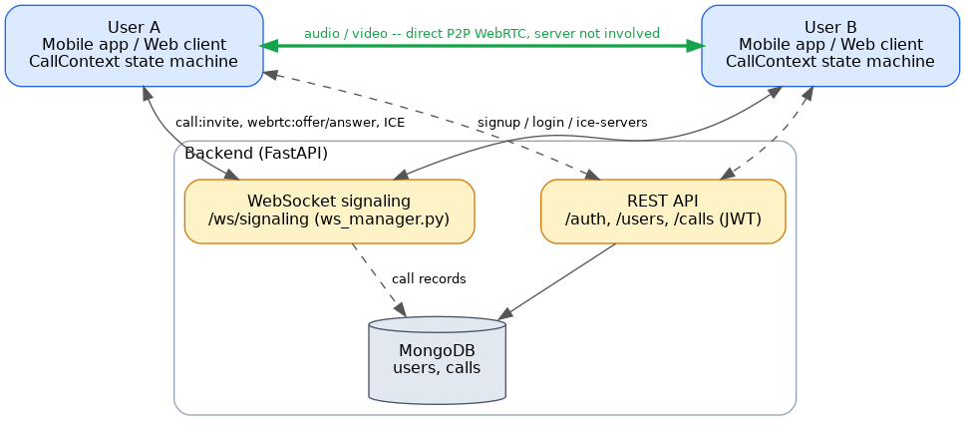
- WebSocket signaling (ws_manager.py) relays small JSON messages -- call invites, "SDP" offers/answers, network candidates -- between the two callers in real time.
- REST API handles everything that isn't time-sensitive: signup/login (JWT-based), listing who's online, and handing out ICE server config (the STUN/TURN servers used to establish a direct connection across NATs and firewalls).
- MongoDB stores users and a record of every call (who called whom, when, how long, whether it was voice or video).

How a call connects
Placing a call is a short back-and-forth of signaling messages, followed by the actual WebRTC handshake. The diagram below also covers the newer capability: switching between voice and video mid-call, which is the more interesting engineering problem in this feature.
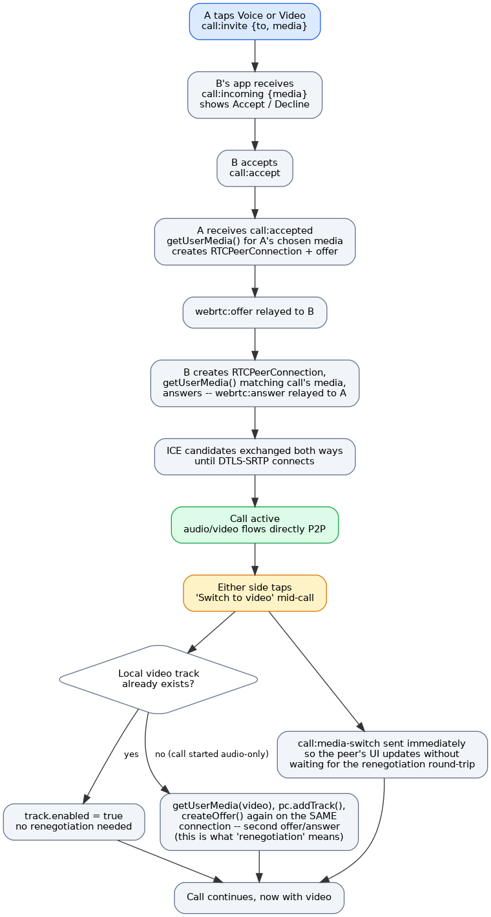

Why switching modes mid-call is non-trivial
A WebRTC connection is negotiated once via an "offer/answer" exchange (an SDP -- a text description of what audio/video the two sides will send and how). Adding a capability that wasn't there at connection time -- like turning a voice call into a video call -- means running a second offer/answer exchange on the same, already-connected connection. This is called renegotiation, and it's where most of the risk in this feature lives: get the sequencing wrong and the whole call drops instead of gracefully adding video.
The design that shipped keeps this as cheap as possible:
- Turning video off never renegotiates -- it just disables the local video track (track.enabled = false) and tells the peer so their UI can react. The track stays reserved in the connection, so turning it back on is instant.
- Turning video on only renegotiates the *first* time a given call adds video (i.e. it started as voice-only) -- grab the camera, add the track, run a second offer/answer. After that, it behaves like the bullet above.
That means a call renegotiates at most once, ever, no matter how many times someone toggles their camera -- deliberately avoiding the more fragile "remove the track and renegotiate down" pattern, which turned out not to even be supported by every WebRTC implementation we tested against (see below).

How this was verified
Code review alone doesn't catch WebRTC bugs -- most of the real failure modes only show up when two real peer connections actually try to negotiate. Before this was considered done, it was tested against the real, unmodified backend using aiortc, a genuine WebRTC implementation in Python, standing in for two app instances placing an actual call: real SDP offers/answers, real ICE negotiation, real audio and video frames decoded on both ends -- not a mocked handshake.
That process caught three real bugs that code review had missed, including one that would have silently broken every outgoing call from any caller in production:
- The caller never recorded the server-generated call ID, so the outgoing connection offer would have carried a null ID and never reached the other side.
- A timezone-handling bug in the database layer that crashed call-duration calculation the moment a call ended.
- A signaling error-handling gap where one bad message could silently disconnect the sender from the whole call system, not just fail that one message.
All three are fixed and covered by the same automated check (scripts/verify_video_call.py), which places a full simulated call end-to-end and can be re-run any time as a regression test.

What's in scope today, and what isn't yet

Working now
- 1:1 voice and video calls, with the ability to switch between them mid-call, verified end-to-end against the real backend.
- Real-time presence (who's online) and call history with duration.
- A browser test client for demos and manual QA without needing a mobile build.

Needed before a production launch
- TURN server: the current setup only reliably connects calls where a direct network path exists. Real mobile networks need a TURN relay for a meaningful fraction of calls to connect at all -- this is infrastructure, not app code, and isn't deployed yet.
- Production MongoDB: development/demo runs against either a real local MongoDB or an in-memory mock -- production needs a managed, backed-up instance.
- Native mobile builds: the React Native app has not yet been built and signed for the App Store / Play Store (see the separate build guide) or tested on a real device.
- Group calls: out of scope for this phase -- the current design is 1:1 only.

