FCR AI Application
Azure Infrastructure Proposal — Current State, Caching Solution & Scaling Plan
Prepared for review with Azaz (Infrastructure) — August 12, 2026

Purpose of this Document
This document lays out the current Azure deployment of the FCR AI application, the solution we are implementing to improve query response times, and the infrastructure support we need to execute it reliably at our current scale (~50 users) and as usage grows. This is a proposal for execution, not an open discussion — the direction is decided; what follows are the specific infra asks needed to deliver it well.

Context
- FCR AI currently serves ~50 users and must remain scalable as usage grows.
- Backend database is Redshift. Redshift's scalability is not a concern here — this proposal is scoped to the application/App Service layer.
- We are implementing an in-memory cache (a JavaScript Map on the Node.js server) to avoid hitting Redshift on every request for frequently-run queries.
- This document captures current state, our solution design, and the concrete infrastructure asks required to ship it well.

1. Current State — Azure Deployment
The FCR AI app is deployed as an Azure App Service (Linux) web app. Key configuration, taken directly from the Azure Portal, is summarized below.

App Service — Overview
App Name | azr-iay-fcr-ai-appsrvce-dev
Resource Group | AZR-IAY-Appservice-Development
Region | East US
Operating System | Linux
Runtime Stack | Node - 22 LTS
Status / Health | Running — Healthy (100% — 2/2 instances healthy)
App Service Plan | azr-iay-fcrai-asp-dev (P1v3, tier 2)
Instance Count | 2
Default Domain | azr-iay-fcr-ai-appsrvce-dev.azurewebsites.net

Networking
Inbound IP Addresses | 20.119.16.40, 20.119.8.111, 2603:1030:210:6::2a
Private Endpoint Connections | 1 private endpoint
VNet Integration | AZR-IAY-eastus / hybridsubnet-appservice-fcrai-dev
Custom Domain | Not configured
Application Insights | Not enabled

Deployment
- Publishing model: Code (not container-based).
- Deployment provider: None configured (no CI/CD pipeline wired into Deployment Center yet).
- Database: Redshift (external to this App Service resource, accessed over the network / private endpoint).
Reference — Azure Portal Overview screen:
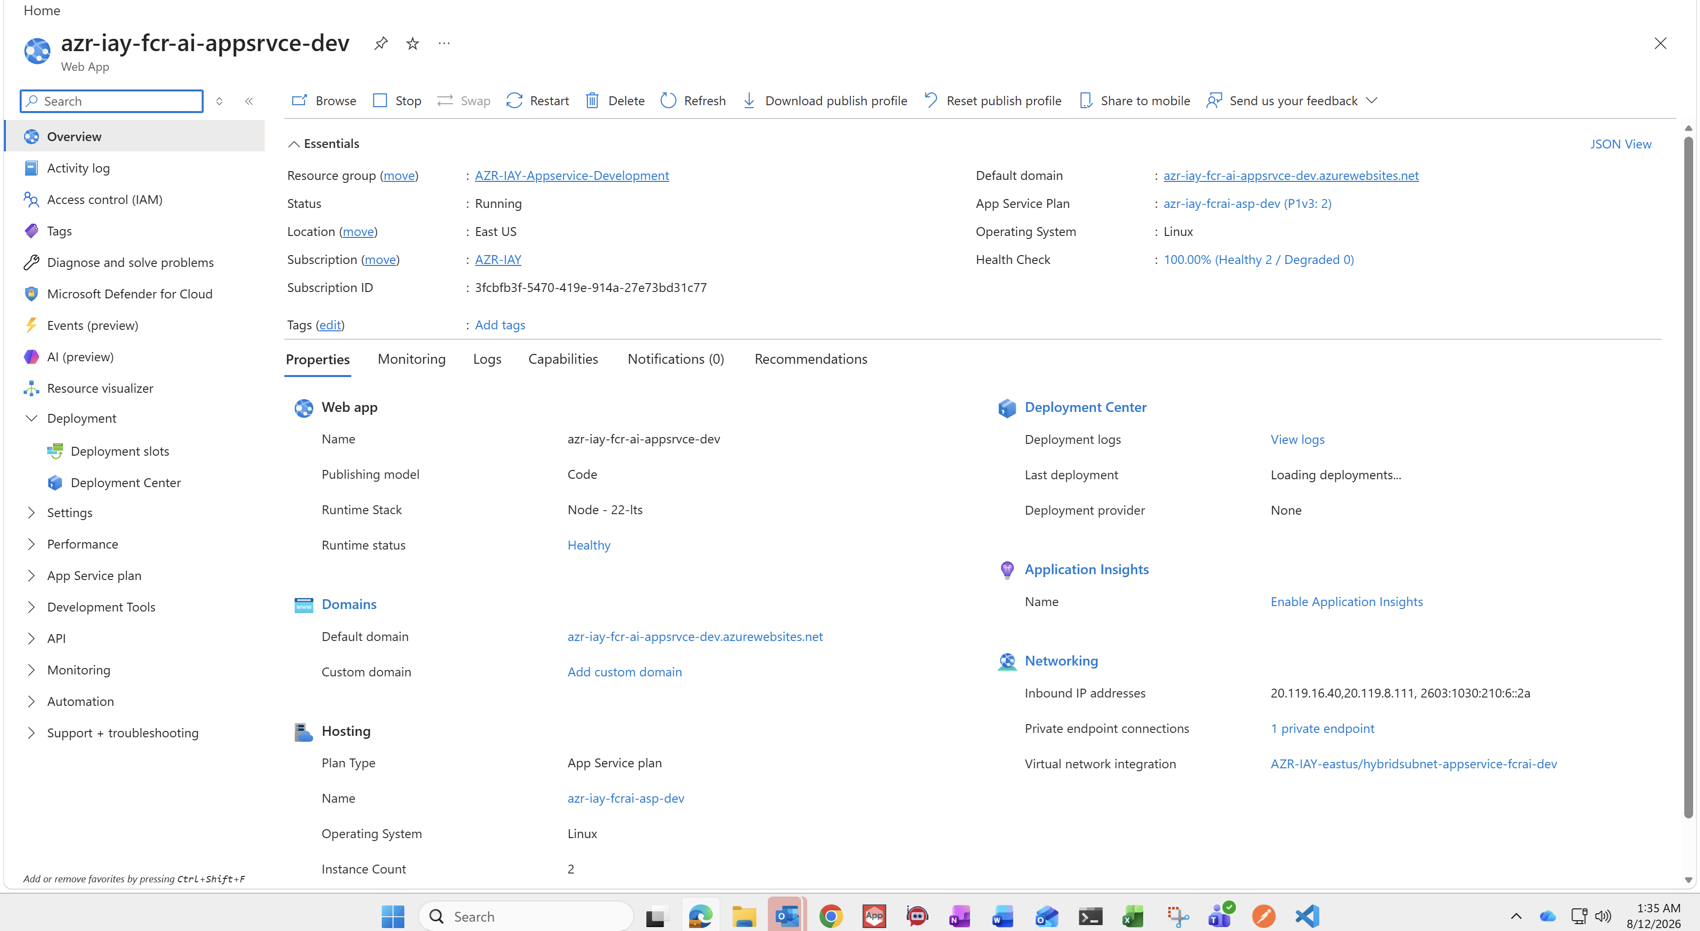

2. Problem Statement
Certain queries are run frequently by users and currently go to Redshift on every single request. Even though Redshift itself is scalable, repeated round-trips for the same frequently-used data add latency and unnecessary load, and this becomes more noticeable as concurrent usage grows.
Goal: return results for these frequently-used queries in seconds, without depending on a fresh Redshift round-trip every time, while keeping the solution simple enough to ship now and scale later.

3. Our Solution — In-Memory Caching
We are implementing an in-memory cache on the Node.js App Service layer using a JavaScript Map. This is the agreed and final direction for the current phase; the sections below describe how it works and what we need from infrastructure to run it well.

3.1 Architecture
User Requests  (~50 users) | →  HTTPS | App Service (Linux)  Node 22 — 2 instances  JS Map cache in-process | →  cache miss only | Redshift  (private endpoint)

Requests continue to flow through App Service as they do today. The only change is at the data-access layer inside the Node.js process: before querying Redshift, the app checks its in-memory Map for a cached result. On a hit, it returns immediately from memory. On a miss, it queries Redshift as normal, returns the result, and populates the cache for next time.

3.2 What Gets Cached
- We will identify the queries that run most frequently across users (by request volume in logs) and scope the cache to that defined set — not a blanket cache-everything approach.
- Each cache entry is keyed by the query and its parameters, so different filter/parameter combinations are cached independently.
- Anything outside the defined high-frequency set continues to query Redshift directly, so behavior for long-tail queries is unchanged.

3.3 Cache Lifecycle
- Population: cache entries are populated lazily on first request (cache-aside pattern), so no separate pre-warm job is required for launch.
- Expiry: entries will carry a TTL so data doesn't go stale indefinitely; exact TTL will be tuned per query based on how often the underlying data changes.
- Reset: the cache is naturally cleared on instance restart, deploy, or scale event — acceptable for this phase, since the cache re-warms quickly under real traffic.

3.4 Expected Impact
- Significant reduction in response time for the highest-frequency queries — served in-memory instead of round-tripping to Redshift.
- Reduced load on Redshift from repeated identical queries.
- No change to the app's external footprint — same App Service, same network path, same private endpoint to Redshift for cache misses.

4. Scaling Plan & Trade-offs We're Accounting For
We've factored the following implications of the current infrastructure into this rollout, and they inform the asks in Section 5:

4.1 Per-Instance Cache (Instance Count = 2)
The App Service Plan runs 2 instances today. A plain in-process Map is local to each instance, so each one builds its own copy independently. For this phase, we're accepting that trade-off deliberately:
- Scoped cache + short TTLs keep any cross-instance inconsistency window small and low-impact.
- If usage grows enough that this becomes a real problem, the natural next step is a shared cache (e.g., Azure Cache for Redis) — same pattern, shared state across instances. That's a planned v2, not a blocker for this rollout.

4.2 Memory & Restarts
- We're scoping the cached dataset deliberately (Section 3.2) to stay well within available memory on the P1v3 plan.
- Cache resets on restart/deploy are expected and acceptable — the app functions correctly with a cold cache, just slower until it re-warms.

4.3 Forward Path
- Phase 1 (now): Map-based in-process cache, scoped to defined high-frequency queries, on the current 2-instance setup.
- Phase 2 (if/when needed): move to a shared cache (Redis) if instance count grows or cross-instance consistency becomes a measurable issue — same interface at the app layer, so this is a low-risk swap later.

5. Infrastructure Asks
To execute this rollout properly and be able to prove it's working, we need the following from infrastructure:
1. Confirm current and planned autoscale settings on azr-iay-fcrai-asp-dev, so we can validate our per-instance caching assumption holds at the instance counts we'll actually run at.
2. Enable Application Insights on this App Service so we can measure cache hit rate and response-time improvement post-rollout with real data, not anecdotal feedback.
3. Confirm available memory headroom on the P1v3 plan so we can finalize how much data we cache without risking memory-pressure restarts.
4. Set up a CI/CD pipeline in Deployment Center (currently “None”) so cache-affecting deploys are consistent and don't rely on manual publishing.
5. Sign off on the current architecture as sufficient for the ~50-user scale we're targeting, and align with us on the trigger point (user count / latency threshold) for moving to Phase 2 (Redis).
6. Confirm no additional guardrails are needed for caching query results in memory, given all data continues to flow through the existing private endpoint and VNet integration for cache misses.

Summary Ask
We're proceeding with the Map-based in-memory cache described in Section 3 on the current 2-instance App Service setup. We need infra sign-off on the six items above to execute cleanly and to have visibility into whether it's working as intended.

