Insights from Interview Questions

Executive Summary
Twenty-one senior professionals from insurance, reinsurance, consulting and the regulator were interviewed using a 20-question instrument approved by the Golden Gate University Institutional Review Board. Between them they hold roughly 525 years of experience (about 25 years each). The study tested two ideas: first, that machine-learning (ML) investment models can improve how insurers and reinsurers manage their assets; and second, that ML-generated “synthetic” data can improve the pricing of rare but severe risks such as climate catastrophes and cyber attacks.
The few key findings include, agreement on what drives Return on Capital Employed (ROCE): pricing accuracy, underwriting discipline and risk selection matter most, while marketing, CRM and product design matter less. A formal test confirms this agreement (Kendall's W = 0.36, p < 0.001). Secondly, views on ML are positive but cautious: every single respondent insisted on explainability, regulatory acceptance, enough skilled people, and keeping humans in the loop; people more familiar with ML were more receptive to it (ρ = 0.47, p = 0.03). Third thing which emerged was that the preferred future is hybrid — established firms adding ML to their existing methods under regulator-led governance, rather than being replaced by brand-new "AI-native" competitors.
Both hypotheses are supported, but only with conditions — and those conditions are the study’s main contribution.

How the study was done
The interview had 20 questions in four parts: background (role, experience, ML familiarity), asset-side questions (Q5–Q10), liability-side questions (Q11–Q17), and future-outlook questions (Q18–Q20). Question 4 asked each person to rank ten possible drivers of ROCE from 1 (most important) to 10 (least).
The 21 participants were 13 from insurers, 4 from reinsurers, 3 independent consultants, and 1 former regulator (an ex-IRDAI Whole Time Member, Actuary). No one had fewer than 15 years’ experience. On ML familiarity, roughly a third rated themselves high and the rest split across moderate, basic and low — though even the “basic” group engaged thoughtfully with the topic.
The analysis mixed numbers and text. Rankings were turned into a table and tested statistically. Interview text was coded into 25 recurring themes (Appendix A), and each answer was scored for attitude on a 1–to–5 scale. One consultant gave written comments instead of numeric rankings, so the ranking calculations use the other 20 people. All coding was done by the dissertation candidate; having a second coder check about 30% of transcripts is recommended for the full dissertation.

What were the key driver ROCE
When asked to rank the ten drivers of profitability, respondents produced a clear three-tier pattern. The top tier is pricing accuracy (average rank 2.8) and underwriting discipline (3.2). The middle tier is risk selection (4.2), investment / float management (4.5), technology maturity (5.4) and operating efficiency (5.6). The bottom tier is digital onboarding (6.6), product design (6.8), marketing (7.9) and CRM (8.0).
This matches classic insurance economics: profit per unit of capital comes mainly from underwriting margin and investment spread, so the levers closest to those sit at the top, while marketing, CRM and product design are seen as downstream of getting the core right.

Table 1 — ROCE driver rankings (the 20 respondents who gave numeric rankings).
Driver | Mean rank | Median | Std dev | Top-3 frequency
Pricing accuracy | 2.80 | 2.0 | 2.31 | 15 / 20 (75%)
Underwriting discipline | 3.20 | 3.0 | 1.91 | 13 / 20 (65%)
Risk selection & diversification | 4.17 | 3.0 | 2.29 | 12 / 20 (60%)
Investment returns / float | 4.45 | 4.0 | 1.57 | 3 / 20 (15%)
Technology maturity (AI / auto.) | 5.42 | 5.0 | 2.28 | 3 / 20 (15%)
Operating efficiency / cost | 5.58 | 6.0 | 2.03 | 3 / 20 (15%)
Digital onboarding / STP | 6.58 | 7.8 | 2.65 | 4 / 20 (20%)
Innovative product design | 6.78 | 7.0 | 2.76 | 4 / 20 (20%)
Marketing & brand visibility | 7.88 | 9.0 | 2.69 | 1 / 20 (5%)
CRM & retention | 7.97 | 9.0 | 2.39 | 2 / 20 (10%)

Figure 1 — The same rankings as a picture. Shorter bars (dark) are the most critical drivers; the three tiers are colour-coded.

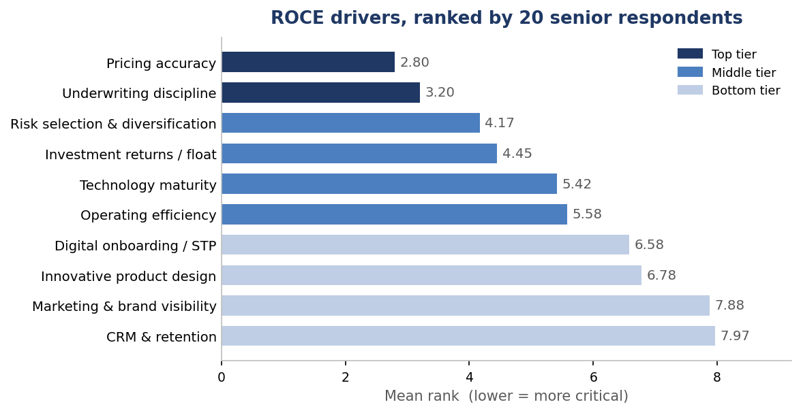

Asset side: can ML improve investing? (Hypothesis 1)
Hypothesis 1 was on whether ML investment models can improve asset returns. Six questions were posed on this aspect and covered current float management, the limits of asset-liability management (ALM), ML-driven allocation, risk-adjusted returns, capital efficiency, and constraints.
On today’s practice, respondents agreed that insurer investing is tightly shaped by IRDAI rules — mostly long-duration government and high-grade debt matched to liabilities, with limited equity (mainly in unit-linked funds). They also agreed on the main weakness of traditional ALM: it is backward-looking and rule-based, reviewed only quarterly, and captures simple interest-rate moves but not more complex shifts or changing customer behaviour. A recurring point was that investment and underwriting teams work in silos, so a single shock can hit both sides of the balance sheet at once while the models assume they are independent.
On ML’s potential, the mood was positive but conditional. Respondents saw ML as good at reading large and unstructured data, spotting non-linear patterns, detecting shifts in market conditions, and rebalancing dynamically — including by using liability signals such as claims seasonality. The most common view was that ML should support human judgment, not replace it. The most technical respondent compared modern methods (Random Forests, Gradient Boosting, Hierarchical Risk Parity) with traditional optimisation, while warning about two dangers: financial data is noisy, so models can “overfit” and look good in testing but fail in live use; and complex models are hard to explain.
On capital efficiency, agreement was strongest. Because a small yield gain on a very large pool of float flows straight into ROCE — and because better cash-flow forecasting frees up spare cash while tighter ALM lowers the capital charge for mismatches — most respondents linked ML to real ROCE gains. Reinsurers were the most positive here, as they carry the largest float; one concrete example was using ML for dynamic currency hedging in multi-currency reinsurance books.
The views which emerged show 18 of 21 respondents (86%) agreed that ML can improve allocation, stock selection or float management, and thereby improve the ROCE. But the gains are bounded — by regulation, by data quality, and by the need for human oversight and explainability. In short, ML strengthens ALM, with a measurable but limited upside due to regulatory restrictions on asset allocation.

Liability side questions related to find whether synthetic data improve pricing? (Hypothesis 2)
Hypothesis 2 asks whether ML-generated synthetic data can improve the pricing of rare, high-severity risks. Seven questions covered pricing challenges, how traditional models perform, synthetic data (from GANs and VAEs), regulatory concerns, ML’s effect on accuracy, explainability, and adoption barriers.
Everyone agreed on the core problem: rare but severe events — climate catastrophes, cyber, pandemics, produce too few data points for traditional frequency-severity models to work reliably. Three issues came up repeatedly. First, the world is changing faster than the data: the climate is shifting, cyber threats evolve quickly, and even global data may not fit the Indian market. Second, traditional actuarial and catastrophe models can give a “false sense of precision” when built on thin data. Third, on synthetic data, respondents were interested but cautious.
The common view which emerged was that synthetic data can help by filling in the "tail" of the loss distribution and stabilising prices — but only as a supplement, not as a replacement, and only where the underlying process can be partly modelled. The concerns highlighted were also coomon across many participants and mainly around the aspect of model not being able to invent information which it was never given, so it may produce realistic-looking but misleading scenarios for completely unseen risks; it can also amplify hidden biases and create false kind of confidence; extreme tail scenarios cannot be back-tested; and there is a risk of circular logic when synthetic data is being built from the same thin data which is used to check it. It was also mentioned that synthetic data can carry forward discrimination hidden in the original data.
The most uniform result related to the concerns on explainability. All 21 respondents (100%) said ML pricing tools must be explainable and transparent. The practical implication is that pricing should use interpretable models (such as GLMs, or gradient-boosted trees with SHAP explanations) rather than opaque deep-learning "black boxes."
The views on second hypothesis H2 show that 19 of 21 (90%) saw a lot of promise in synthetic data, but 20 of 21 (95%) raised concerns and all 21 demanded explainability. So Hypothesis 2 holds under stricter conditions than Hypothesis 1: the data-generating process must be partly understood; synthetic data must augment (not replace) expert judgment; the whole chain from data to price must be auditable; and explainability limits which methods can be used. Notably, on the "fairness" part several respondents were worried that synthetic data could reduce fairness rather than improve it.

The road ahead (on adoption and the "AI-native" question)
The final questions asked were related to what will drive or slow down the ML adoption, and whether a brand-new "AI-native" reinsurer could succeed across both assets and liabilities.
The dominant answer was a hybrid approach. Most respondents agreed an AI-native firm would have real advantages — clean data from day one, staff built around the model, governance designed in — but reinsurance is a trust- and capital-intensive, relationship business that takes years to build. So the more likely path is established firms adopting AI-native ways of working (and partnering with or acquiring AI capability) rather than being displaced. Reinsurers were the most optimistic about AI-native models; consultants were the most cautious, stressing how long it takes to build rating-agency credibility. The regulator's stance is technology-neutral — it does not mandate any specific method and is concerned more with the outcomes on solvency, fairness and transparency which means a new AI-native entrant would face higher scrutiny on the computation of risk based capital and other disclosures.

Cross-cutting findings, and do the hypotheses hold?
Across all 21 interviews, eight themes were raised by every respondent (100%): data quality and availability, explainability, regulatory acceptance, talent scarcity, the regulator’s decisive role, keeping humans in the loop, emerging risks (cyber and climate), and having a proper model-risk-management framework. On average, each interview touched 22 of the 25 themes — showing people engaged with almost every part of the topic.

Figure 2 — How often each of the 25 themes was raised. The eight dark bars at the top were raised by every respondent.
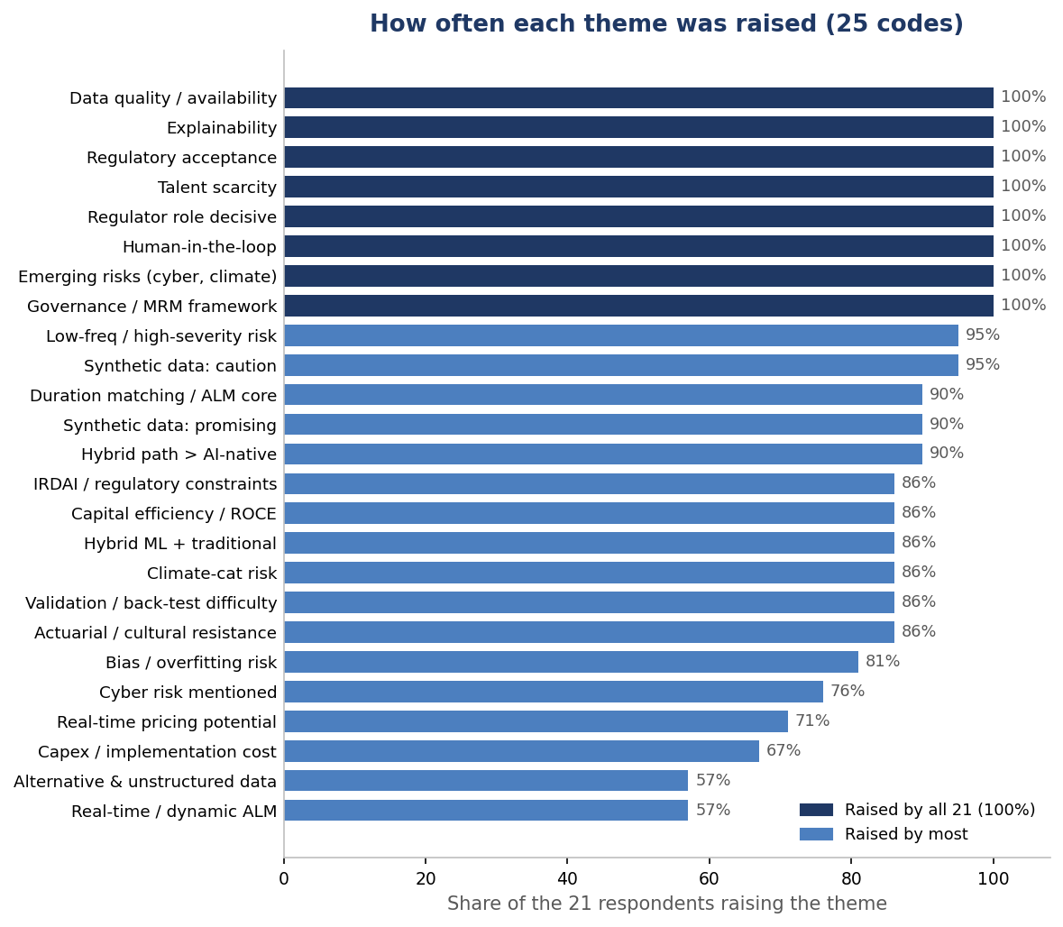
One useful relationship emerged: the more familiar someone was with ML, the more receptive they were to it (Spearman ρ = 0.47, p = 0.03; the weaker Pearson r = 0.43 points the same way). In plain terms, some resistance is really unfamiliarity — so training is itself a way to speed adoption, not just a pre-condition. This supports the calls from several respondents for actuarial-society and university-led ML training. The themes also cluster: people who raised talent scarcity also tended to raise cultural resistance, cost and the hybrid path, suggesting practitioners see the adoption barrier as one connected system rather than separate problems.
On the two hypotheses, the evidence is consistent. Hypothesis 1 (asset-side ML) is supported by 86% (18 of 21), who back ML for allocation, selection or float and link it to ROCE — but with the upside capped by regulation, data and oversight needs. Hypothesis 2 (synthetic data for rare-risk pricing) is supported by 90% (19 of 21) on promise, but with heavier conditions: 95% raised concerns, 100% required explainability, and 86% flagged that tail events cannot be back-tested. Both are therefore supported in conditional form — and the precise conditions around regulation, governance, talent and explainability are the real contribution of the research.

Limitations and conclusion
Limitations
The sample is concentrated in the Indian market, so the regulatory comments are more IRDAI-specific. It had more participants from long-duration life and health business rather than short-tail general insurance. All coding was done by one person and the attitude scores are interpretive rather than directly observed behaviour. Also the study is a snapshot in time, so it cannot show whether views are already shifting.
The important implications include, adoption of a Hybrid model rather a full AI-native disruption, thus more in favour of established firms adopting ML rather than new ones with complete AI adoption. Explainability and model-risk governance need to be given equal importance vis-a-vis the technical performance. It also came out clealry that reinsurers need to treat the asset side and liability side as one integrated balance-sheet problem, and several respondents saw this as the most powerful use of ML.

Conclusion
Experienced professionals agree that ROCE is driven by pricing, underwriting and risk selection; that ML can improve both the asset and liability sides; and — with complete unanimity — that any deployment must be explainable, well-governed, within regulation, human-supervised, and staffed by scarce specialist talent. The favoured route is hybrid: established firms upgrading their methods rather than being replaced. Together these findings give the dissertation a strong basis to argue that ML and synthetic data are a legitimate, achievable and capital-efficient evolution of insurance practice — provided the conditions the industry’s most experienced people have identified are respected.

Appendix A — Theme codebook (25 codes)
Each theme was coded present / absent per interview. Frequency = number of interviews (of 21) in which it appeared.
Code | Theme | Frequency
T01 | Duration matching / ALM core | 19 / 21 (90%)
T02 | IRDAI / regulatory constraints | 18 / 21 (86%)
T03 | Capital efficiency / ROCE uplift | 18 / 21 (86%)
T04 | Data quality / availability gap | 21 / 21 (100%)
T05 | Alternative & unstructured data | 12 / 21 (57%)
T06 | Real-time / dynamic ALM | 12 / 21 (57%)
T07 | Hybrid ML + traditional approach | 18 / 21 (86%)
T08 | Low-frequency / high-severity risk | 20 / 21 (95%)
T09 | Climate-cat risk mentioned | 18 / 21 (86%)
T10 | Cyber risk mentioned | 16 / 21 (76%)
T11 | Synthetic data: promising | 19 / 21 (90%)
T12 | Synthetic data: caution / concerns | 20 / 21 (95%)
T13 | Explainability / interpretability | 21 / 21 (100%)
T14 | Regulatory acceptance hurdle | 21 / 21 (100%)
T15 | Bias / overfitting risk | 17 / 21 (81%)
T16 | Validation / back-testing difficulty | 18 / 21 (86%)
T17 | Talent scarcity | 21 / 21 (100%)
T18 | Actuarial / cultural resistance | 18 / 21 (86%)
T19 | Hybrid path > pure AI-native | 19 / 21 (90%)
T20 | Regulator role decisive | 21 / 21 (100%)
T21 | Human-in-the-loop required | 21 / 21 (100%)
T22 | Real-time pricing potential | 15 / 21 (71%)
T23 | Emerging risks (cyber, climate) | 21 / 21 (100%)
T24 | Capex / implementation cost | 14 / 21 (67%)
T25 | Governance / MRM framework | 21 / 21 (100%)

Note: eight themes (T04, T13, T14, T17, T20, T21, T23, T25) were mentioned by every respondent — the study’s hard, non-negotiable conditions.

Appendix B — ROCE ranking matrix
Each respondent’s Q4 ranks (1 = most critical). One consultant gave narrative comments and is omitted. PA pricing accuracy · UD underwriting discipline · RS risk selection · IR investment/float · TM technology maturity · OE operating efficiency · DO digital onboarding · PD product design · MB marketing · CRM retention. * = ties resolved by mean rank.
Participant | Type | PA | UD | RS | IR | TM | OE | DO | PD | MB | CRM
Pradeep | Insurer | 1 | 2 | 10 | 4 | 5 | 7 | 6 | 3 | 8 | 9
Pawan | Insurer | 6 | 4 | 3 | 5 | 1 | 7 | 2 | 7 | 9 | 8
G. Joshi | Insurer | 3 | 5 | 7 | 1 | 6 | 2 | 8 | 9 | 4 | 10
S. Sindhi | Reinsurer | 6 | 4 | 3 | 8 | 2 | 7 | 1 | 5 | 9 | 10
Sombit | Insurer | 1 | 2 | 3 | 5 | 4 | 6 | 8 | 7 | 10 | 9
Saddam | Insurer | 1 | 3 | 2 | 4 | 5 | 6 | 7 | 9 | 10 | 8
Mohit | Insurer | 2 | 3 | 5 | 4 | 6 | 8 | 9 | 1 | 7 | 10
Sai S. | Cons. | 3* | 3* | 3* | 3* | 3* | 3* | 8* | 10* | 3* | 8*
Ranabir | Insurer | 6 | 1 | 5 | 7 | 2 | 9 | 4 | 10 | 8 | 3
G. Kumar | Cons. | 1 | 6 | 5 | 2 | 4 | 3 | 9 | 7 | 8 | 10
Suri | Insurer | 3 | 1 | 2 | 4 | 5 | 6 | 7 | 9 | 10 | 8
Sreekumar | Insurer | 1 | 2 | 3 | 4 | 7 | 6 | 8 | 9 | 10 | 5
Sanjeev | Insurer | 2 | 1 | 3 | 4 | 5 | 6 | 8 | 7 | 10 | 9
Sanjeeb | Reinsurer | 9 | 7 | 4 | 6 | 10 | 6 | 3 | 1 | 6 | 2
Sandeep K. | Insurer | 1 | 2 | 3 | 4 | 6 | 5 | 8 | 7 | 10 | 9
Pramod | Regulator | 4 | 6 | 8 | 5 | 7 | 1 | 9 | 3 | 2 | 10
Asfa | Insurer | 3 | 1 | 2 | 4 | 8 | 6 | 9 | 7 | 10 | 5
Mahaveer | Reinsurer | 1 | 6 | 3 | 4 | 5 | 7 | 2 | 9 | 10 | 8
Arindam | Insurer | 1 | 2 | 3 | 6 | 5 | 7 | 9 | 8 | 4 | 10
Vinayak | Reinsurer | 1 | 3 | 2 | 5 | 6 | 4 | 7 | 8 | 10 | 9

Appendix C — Participant roster
The 21 participants (replacing the full person-by-person write-ups, whose analytical points are already covered in Sections 2–6).
Participant | Role / organisation | Domain | Exp. (yrs)
Pradeep | Chief Actuary | Insurer | 25
Pawan | Appointed Actuary | Insurer | 18
Gopal Joshi | Head of Products | Insurer | 20
Suresh Sindhi | Appointed Actuary | Reinsurer | 25
Sombit | Investor Relations Head | Insurer | 15
Saddam | Chief Risk Officer | Insurer | 18
Mohit | Chief Strategy Officer | Insurer | 25
Sai Srinivas | Consulting Actuary | Consultant | 30
Ranabir | EVP, Actuarial | Insurer | 17
Gopal Kumar | Practicing Actuary | Consultant | 22
Suri | Senior VP, Sales Strategy | Insurer | 25
Sreekumar | Senior Operations Leader | Insurer | 40
Sanjeev Srinivasan | Senior Insurance Executive | Insurer | 30
Sanjeeb | Chairman, Gallagher India (reinsurance broking) | Reinsurer | 36
Sandeep Kumar | Senior Strategy Executive | Insurer | 25
Pramod | Former Member (Actuary), IRDAI | Regulator | 40
Asfa | Appointed Actuary | Insurer | 20
Mahaveer | Deputy Chief Underwriter, Munich Re | Reinsurer | 25
Arindam | Chief Distribution Officer | Insurer | 25
Vinayak | Reinsurance Intermediary Lead | Reinsurer | 22
Saket Singhal | Proprietor, Actuarial Consultancy | Consultant | 23

