**To-Do List**

**Design Document**

Project 2, Team 6

**Introduction**

The software Product which we are working on is titled “To-Do List for Android”.

The To-do List allows users to manage tasks that they have to accomplish. The user can add tasks, set the priorities of each task, set the due date for each task, check-off items in the list and hide/show the checked items. The application will support multiple users and will be developed using Android Developer Tools. This document describes the architectural design, low-level design and User-interface of the Android application being created.

**Design Consideration**

**Assumptions**

This Android application has few assumptions being considered like:

a) The application is being developed using Android SDK 2.2 and API 8 which has upward scalability.

b) Security – the application must be able to prevent a user’s list from being viewed and edited by another user.

c) The user should have an android mobile phone or should be able to use the software through Eclipse on his system.

c) The user should possess basic knowledge about how to use an Android application’s interface.

**Constraints**

This Android application comes with a few constraints like:

a) The user-interface might change slightly based on the version of Android OS being installed on user’s mobile

b) The user’s To-Do list is private and password protected,thus it cannot be accessed on loss of password.

**System Environment**

The user should have an android phone to exploit the application to its maximum advantage. The software application can be executed on any Android OS based device with Android SDK 2.2 and API 8 or above.

**Architectural Design**

**Overview**

The main ToDo-List program has various functionalities. These subroutines/programs get called based on specific input data and customer requirement. This section provides a high level overview of the structural and functional decomposition of the system.

**Rationale**

Since this program has various functionalities, each getting called based on satisfaction of certain conditions or requirement of user,we have a multi-component model to implement.

**Conceptual (Logical) View:**

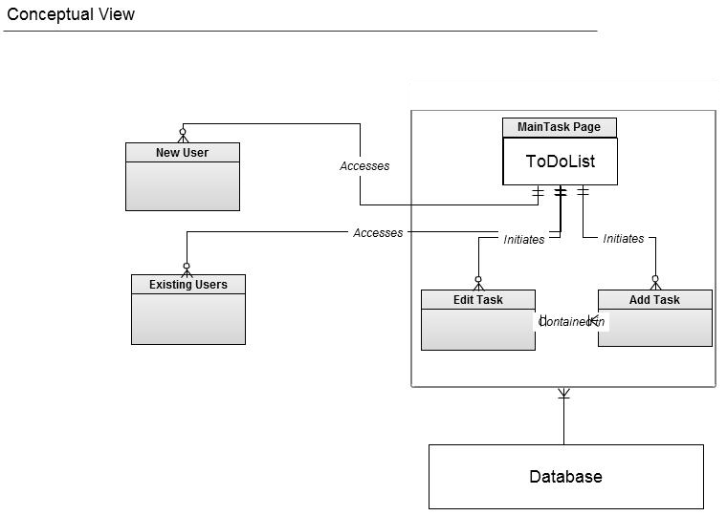

**Low Level Design**

**Class Diagram**

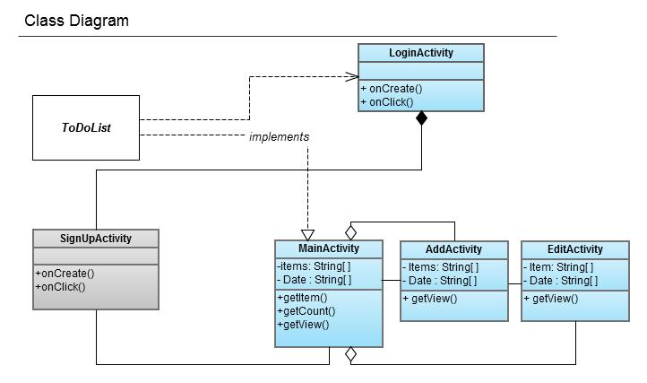

**Sequence Diagram**

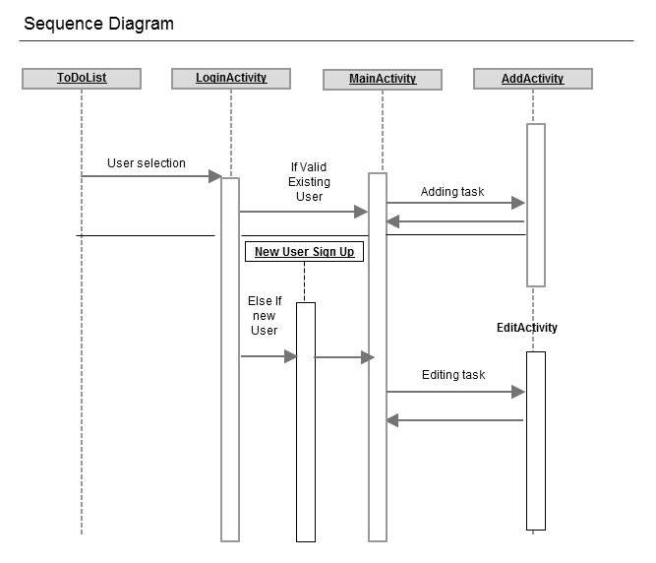

**Component Diagram**

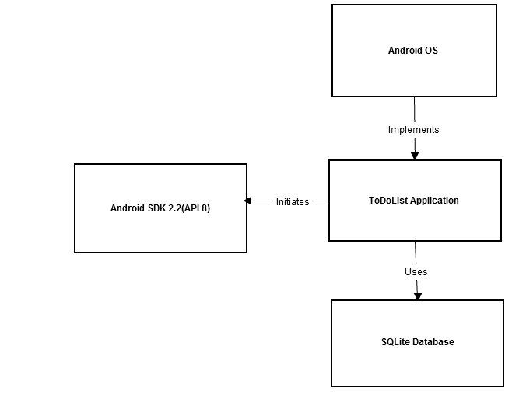

**User Interface Design**

