AIRLINE INDUSTRY DATA ANALYSIS
Factors Influencing Coach Ticket Prices

Field | Detail
Course | STAT-2205 — Programming with R and Python
Name | MD. AKASH AHMED
Student ID | 12310031
Year | 2nd
Semister | 2nd
Academic Year | 2023-2024
Dataset | flight_data.csv (129,780 observations)
Sample Size | 10,000 rows (random_state / seed = 12310031)
Language | Python & R
Objective | Reveal factors influencing coach ticket prices

Submitted to: Dr. Md. Siddikur Rahman
(Accociate Professor)
Begum Rokeya University,Ranfpur

1. Introduction
This report presents a comprehensive statistical analysis of 129,780 airline flight records. The objective is to reveal the key factors influencing coach ticket prices. A reproducible sample of 10,000 observations is drawn using Student ID 12310031 as the random seed.

1.1 Dataset Variables
Variable | Type | Description
miles | Numeric | Distance flown (miles)
passengers | Numeric | Number of passengers on board
delay | Numeric | Takeoff delay (minutes)
inflight_meal | Categorical | Meal included? (Yes / No)
inflight_entertainment | Categorical | Free entertainment? (Yes / No)
inflight_wifi | Categorical | Complimentary WiFi? (Yes / No)
day_of_week | Categorical | Day of the week
redeye | Categorical | Overnight flight? (Yes / No)
weekend | Categorical | Weekend flight? (Yes / No)
coach_price | Numeric | Average coach ticket price ($)
firstclass_price | Numeric | Average first-class price ($)
hours | Numeric | Flight duration (hours)

1.2 Data Loading & Sampling
R | Python
df_full <- read.csv('flight_data.csv', stringsAsFactors = FALSE) set.seed(12310031) idx <- sample(nrow(df_full), 10000) df <- df_full[idx, ] | import pandas as pd df_full = pd.read_csv('flight_data.csv') df = df_full.sample(n=10_000, random_state=12310031) df = df.reset_index(drop=True)

2. Q1 — Coach Ticket Price Distribution
What do coach ticket prices look like? What are the high and low values? What is the average? Does $500 seem like a good price?

2.1 Key Statistics
Statistic | Value
Minimum | $93.72
Maximum | $584.72
Mean | $376.35
Median | $380.38
Standard Deviation | $67.91
25th Percentile (Q1) | $331.7
75th Percentile (Q3) | $425.95
Flights above $500 | 2%

2.2 Code
R | Python
cp <- df$coach_price summary(cp) sd(cp) mean(cp > 500) * 100 # Histogram hist(cp, breaks=40, col='steelblue', main='Coach Price Distribution', xlab='Coach Price ($)') abline(v=mean(cp), col='red', lty=2) abline(v=500, col='green', lty=2) boxplot(cp, col='steelblue', main='Coach Price Boxplot') | cp = df['coach_price'] cp.describe() pct = (cp > 500).mean() * 100 print(f'Above $500: {pct:.1f}%') import matplotlib.pyplot as plt plt.hist(cp, bins=40, color='steelblue') plt.axvline(cp.mean(), color='red', linestyle='--', label='Mean') plt.axvline(500, color='green', linestyle='--', label='$500') plt.legend(); plt.show()
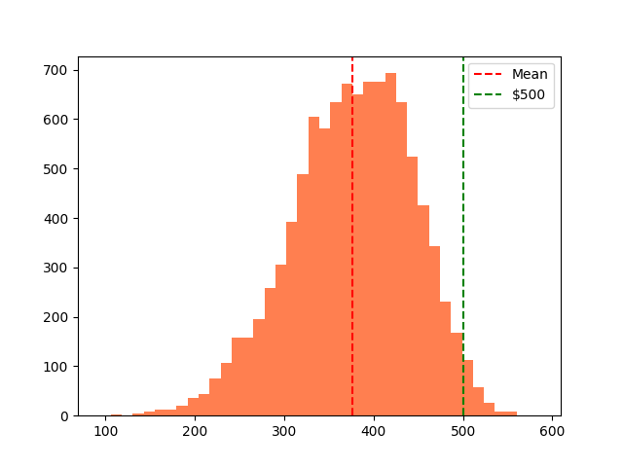
Interpretation: Distribution approximately symmetric (mean ≈ median ≈ $376.35–$380.38). IQR is $331.7–$425.95. Only 2% of tickets exceed $500. Conclusion: $500 is an expensive coach ticket, well above the market average.

3. Q2 — Coach Prices for 8-Hour Flights
What are the high, low, and average prices for 8-hour-long flights? Does $500 seem more reasonable?
Statistic | All Flights | 8-Hour Flights
Count | 10,000 | 205
Mean Price | $376.35 | $431.79
Above $500 | 2% | 12.7%

3.1 Code
R | Python
df8 <- df[df$hours == 8, 'coach_price'] summary(df8) mean(df8 > 500) * 100 | df8 = df[df['hours']==8]['coach_price'] print(df8.describe()) pct = (df8>500).mean()*100 print(f'Above $500: {pct:.1f}%')
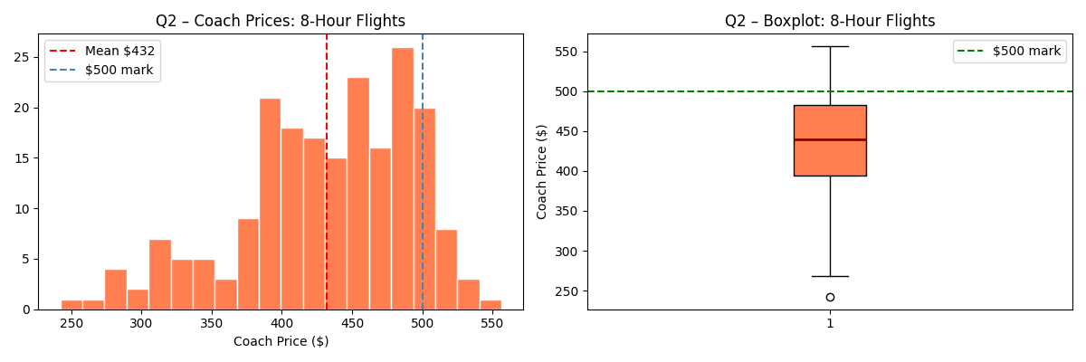
Interpretation: 8-hour flights average $431.79 (above overall average of $376.35). 12.7% exceed $500. $500 is more justifiable for long-haul travel but still above average.

4. Q3 — Flight Delay Distribution
How are delay times distributed? How often do significant delays affect connecting flights?
Metric | Value
Mean Delay | 13.4 minutes
Median Delay | 10 minutes
Standard Deviation | 44.98 minutes
Flights delayed > 15 min | 16.9% (connection risk)
Flights delayed > 60 min | 0.09% (severe delay)

4.1 Code
R | Python
delay <- df$delay mean(delay); median(delay); sd(delay) mean(delay > 15) * 100 # connection risk mean(delay > 60) * 100 # severe hist(delay, breaks=40, col='tomato', xlab='Delay (min)', main='Delay Distribution') | delay = df['delay'] print(delay.describe()) print((delay>15).mean()*100) print((delay>60).mean()*100) import matplotlib.pyplot as plt plt.hist(delay, bins=40, color='tomato') plt.axvline(15,color='orange', linestyle='--',label='>15min') plt.legend(); plt.show()
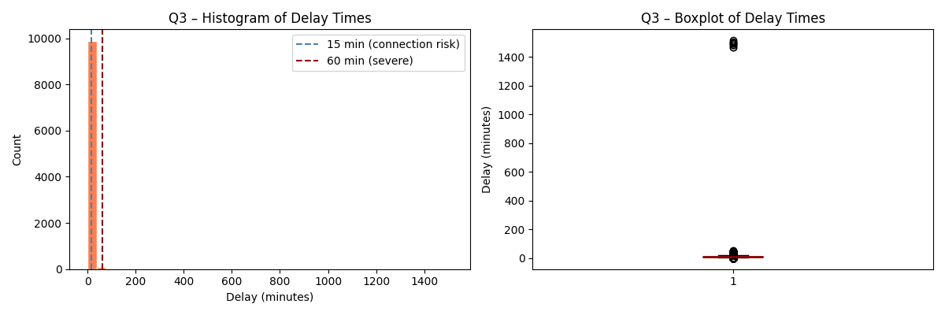
Interpretation: Distribution is right-skewed. Most delays are 0–15 minutes. About 16.9% have delays over 15 minutes which could affect connecting flights. Severe delays (>60 min) occur in only 0.09% of cases.

5. Q4 — Correlation: Coach Price vs. Predictors
How does coach price correlate with flight distance, passengers, delay, and duration?
Predictor | Pearson r | Direction | Significant?
miles | 0.3431 | Positive | Yes ✓ (p=0)
passengers | 0.1639 | Positive | Yes ✓ (p=0)
delay | -0.008 | Negative | No ✕ (p=0.4229)
hours | 0.337 | Positive | Yes ✓ (p=0)

5.1 Code
R | Python
for (v in c('miles','passengers', 'delay','hours')) { ct <- cor.test(as.numeric(df[[v]]), df$coach_price) cat(v, round(ct$estimate,4), round(ct$p.value,4), '\n') } | from scipy import stats for v in ['miles','passengers', 'delay','hours']: r,p = stats.pearsonr(df[v], df['coach_price']) print(f'{v}: r={r:.4f} p={p:.4f}')
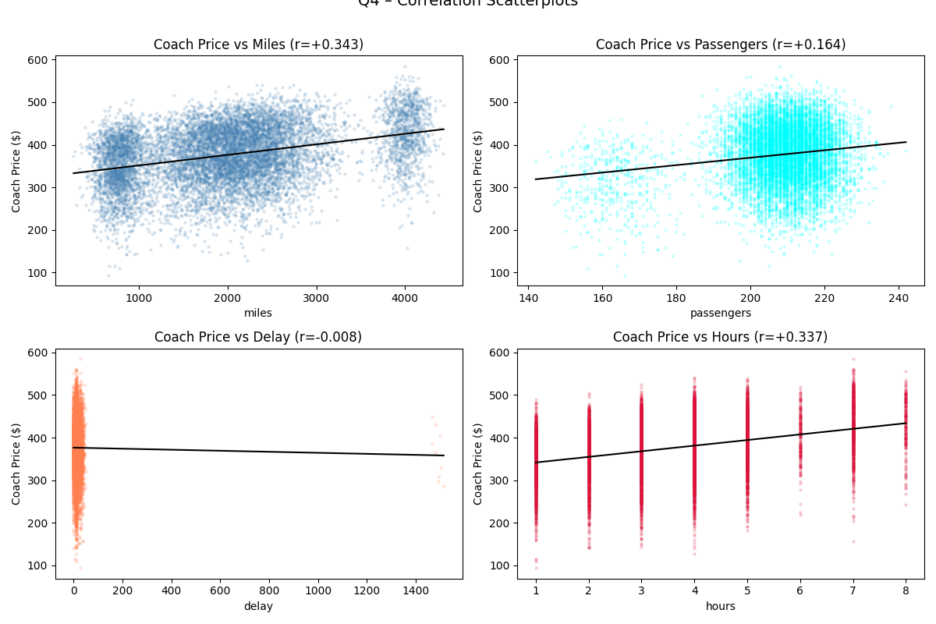
Interpretation: Miles (r=0.3431) and hours (r=0.337) are the strongest predictors. Passengers show a weaker positive correlation (r=0.1639). Delay correlation (p=0.4229) is not statistically significant.

6. Q5 — Coach vs. First-Class Price Relationship
Do flights with higher coach prices always have higher first-class prices?
Metric | Value
Pearson r | 0.7595
Average FC / Coach ratio | 3.94×
Average coach price | $376.35
Average first-class price | $1452.86
p-value | 0.00e+00

6.1 Code
R | Python
ct5 <- cor.test(df$coach_price, df$firstclass_price) cat('r =', round(ct5$estimate, 4)) cat('p =', ct5$p.value) ratio <- mean(df$firstclass_price / df$coach_price) cat('Ratio:', round(ratio, 2)) | from scipy import stats r,p = stats.pearsonr( df['coach_price'], df['firstclass_price']) print(f'r={r:.4f} p={p:.2e}') ratio = (df['firstclass_price'] / df['coach_price']).mean() print(f'Ratio: {ratio:.2f}x')
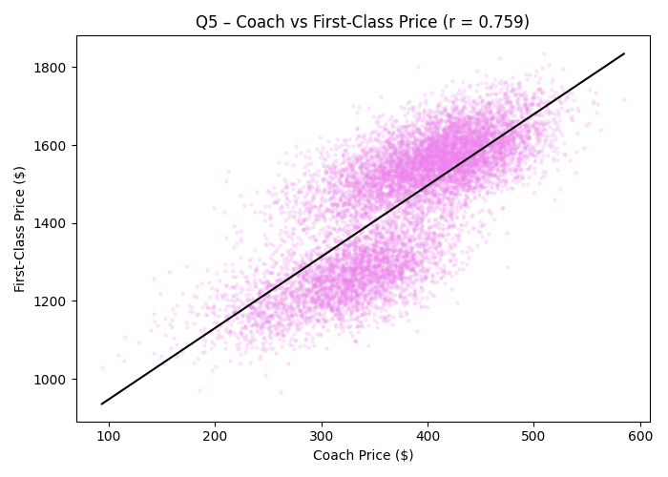
Interpretation: Strong positive relationship between coach and first-class prices (r=0.7595, p<0.001). Flights with higher coach prices generally have higher first-class prices. On average, first-class tickets cost approximately 3.94× more than coach tickets.

7. Q6 — In-Flight Features and Coach Price
Which in-flight features are associated with the highest price increase?
Feature | With Feature | Without | Premium | p-value
Inflight Meal | $391.98 | $369.61 | +$22.38 | < 0.001
Entertainment | $390.3 | $319.58 | +$70.72 | < 0.001
WiFi | $383.12 | $310.46 | +$72.65 | < 0.001

7.1 Code
R | Python
feats <- c('inflight_meal', 'inflight_entertainment', 'inflight_wifi') for (f in feats) { g1 <- df[df[[f]]=='Yes','coach_price'] g2 <- df[df[[f]]=='No','coach_price'] tt <- t.test(g1, g2) cat(f, round(mean(g1)-mean(g2),2), round(tt$p.value,4), '\n') } | from scipy import stats feats = ['inflight_meal', 'inflight_entertainment', 'inflight_wifi'] for f in feats: yes = df[df[f]=='Yes']['coach_price'] no = df[df[f]=='No' ]['coach_price'] t,p = stats.ttest_ind(yes, no) diff = yes.mean() - no.mean() print(f'{f}: +${diff:.2f} p={p:.4f}')
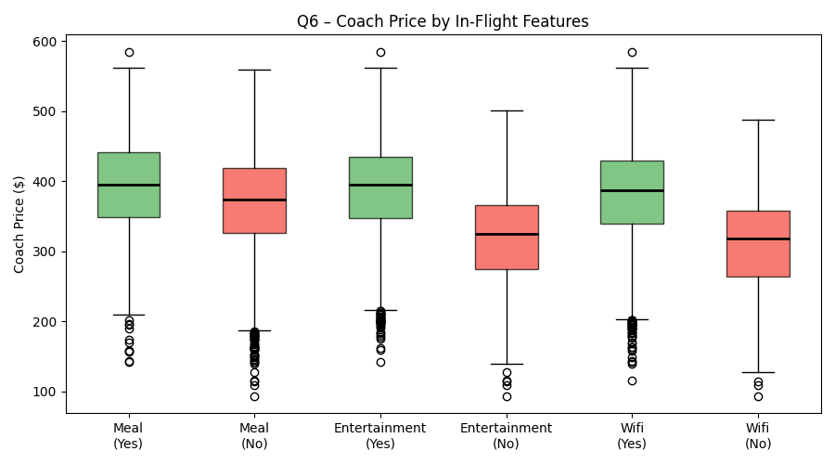
Interpretation: All in-flight features associated with higher coach prices. WiFi (+$72.65) and entertainment (+$70.72) command the highest premiums. All differences statistically significant (p<0.001).

8. Q7 — Passengers vs. Flight Duration
How does passenger count change in relation to flight length?
Hours | Avg. Passengers
1 | 208.5
2 | 207.5
3 | 207.9
4 | 207.7
5 | 207.1
6 | 207.9
7 | 207.4
8 | 208.4
Pearson r | -0.0167 (p = 0.0957, not significant)

8.1 Code
R | Python
cor.test(as.numeric(df$hours), df$passengers) tapply(df$passengers, df$hours, mean) | from scipy import stats r,p = stats.pearsonr( df['hours'], df['passengers']) print(f'r={r:.4f} p={p:.4f}') avg = df.groupby('hours')['passengers'] .mean() print(avg)
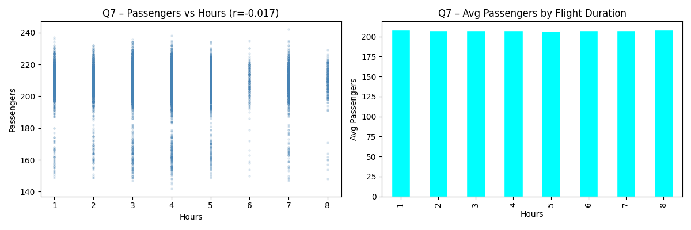
Interpretation: Pearson r=-0.0167 (p=0.0957). Not statistically significant. Average passenger count remains stable across flight durations — no meaningful relationship between hours and passengers.

9. Q8 — Weekend vs. Weekday Pricing
What is the relationship between coach and first-class prices on weekends vs. weekdays?
Class | Weekend | Weekday | Difference | p-value
Coach | $406.39 | $322.26 | +$84.13 | < 0.001
First-Class | $1560.37 | $1259.23 | +$301.13 | < 0.001

9.1 Code
R | Python
for (pc in c('coach_price', 'firstclass_price')) { wk <- df[df$weekend=='Yes', pc] nwk <- df[df$weekend=='No', pc] tt <- t.test(wk, nwk) cat(pc, round(mean(wk)-mean(nwk),2), round(tt$p.value,4), '\n') } | from scipy import stats for pc in ['coach_price', 'firstclass_price']: wk = df[df['weekend']=='Yes'][pc] nwk = df[df['weekend']=='No' ][pc] t,p = stats.ttest_ind(wk, nwk) diff = wk.mean()-nwk.mean() print(f'{pc}: +${diff:.2f} p={p:.4f}')
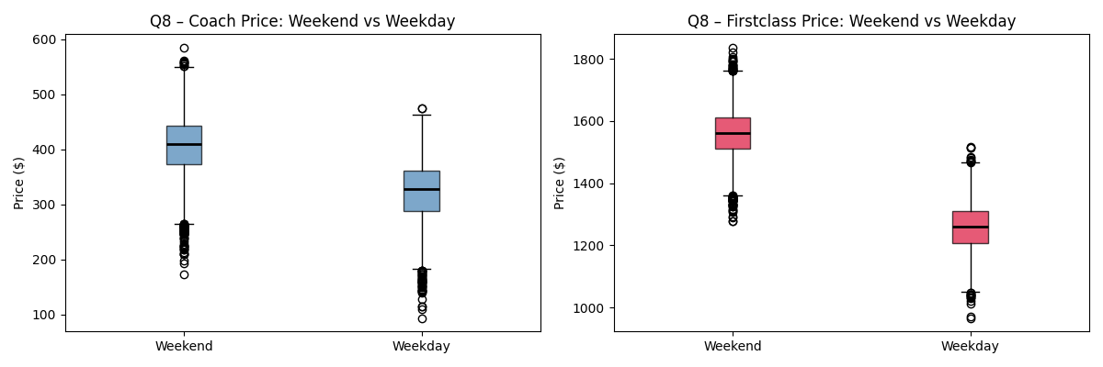
Interpretation: Weekend flights significantly more expensive for both classes (p<0.001). Coach +$84.13, first-class +$301.13. Clear demand-based weekend premium.

10. Q9 — Coach Prices: Redeye vs. Non-Redeye by Day
How do coach prices differ for redeye and non-redeye flights on each day of the week?
Day | Non-Redeye | Redeye | Discount
Monday | $327.3 | $254.63 | $-72.67
Tuesday | $323.56 | $260.63 | $-62.93
Wednesday | $326.3 | $244.26 | $-82.04
Thursday | $324.96 | $255.13 | $-69.83
Friday | $406.49 | $341.27 | $-65.22
Saturday | $416.01 | $345.44 | $-70.57
Sunday | $405.08 | $336.81 | $-68.27

10.1 Code
R | Python
day_ord <- c('Monday','Tuesday', 'Wednesday','Thursday','Friday', 'Saturday','Sunday') pivot <- tapply(df$coach_price, list(df$day_of_week, df$redeye), mean) pivot <- pivot[day_ord, ] print(round(pivot, 2)) | day_ord = ['Monday','Tuesday', 'Wednesday','Thursday','Friday', 'Saturday','Sunday'] pivot = df.pivot_table( values='coach_price', index='day_of_week', columns='redeye', aggfunc='mean') pivot = pivot.reindex(day_ord) print(pivot.round(2))
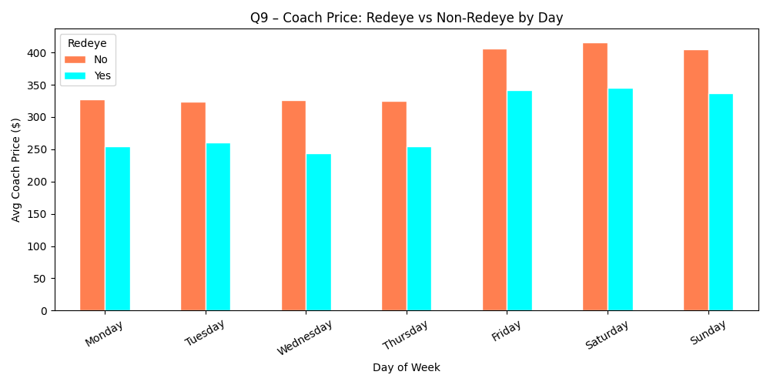
Interpretation: Non-redeye flights consistently more expensive every day. Weekend (Fri–Sun) prices highest for both types. Cheapest option: weekday redeye.

11. Q10 — Comprehensive Statistical Analysis

11.1 Summary Statistics
Variable | Mean | Median | Std Dev | Min | Max
miles | 2004.88 | 1992 | 941.63 | 261 | 4437
passengers | 207.73 | 209 | 12.76 | 142 | 242
delay (min) | 13.4 | 10 | 44.98 | 0 | 1515
coach_price ($) | 376.35 | 380.38 | 67.91 | 93.72 | 584.72
firstclass ($) | 1452.86 | 1503.93 | 163.63 | 966.62 | 1835.79
hours | 3.63 | 4 | 1.74 | 1 | 8

11.2 Hypothesis Testing
Test | Statistic | p-value | Decision
Z-test (H₀: μ=$350) | z = 38.81 | 0.00e+00 | Reject H₀
t-test (H₀: μ=$380) | t = -5.37 | < 0.001 | Reject H₀
Chi-sq: redeye × meal | χ² = 0 | 1 | Fail to reject (independent)
Chi-sq: redeye × weekend | χ² = 0.25 | 0.6196 | Fail to reject (independent)

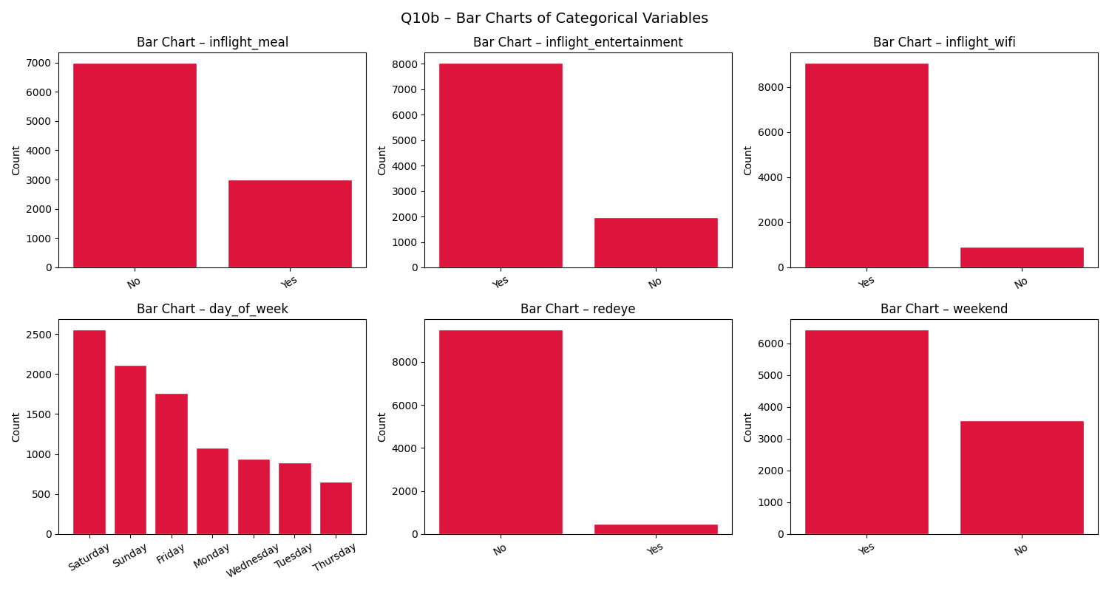
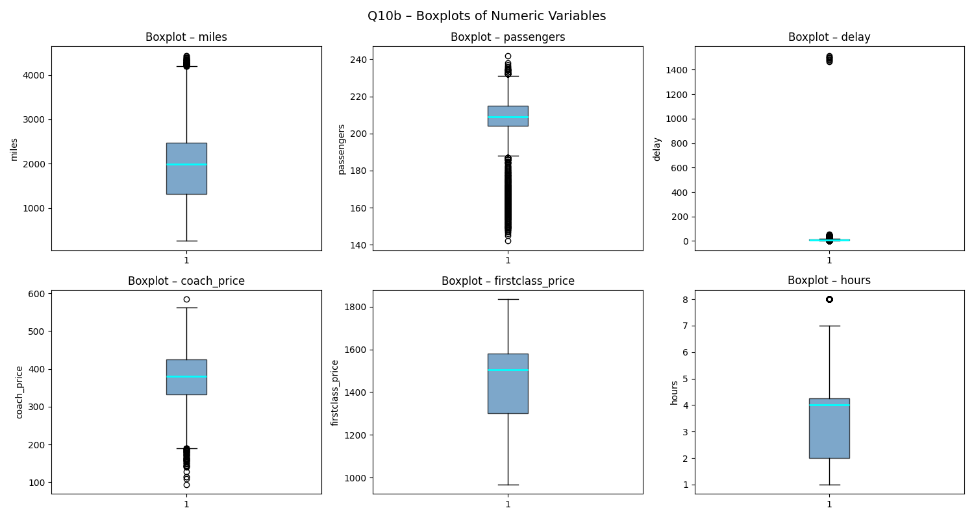
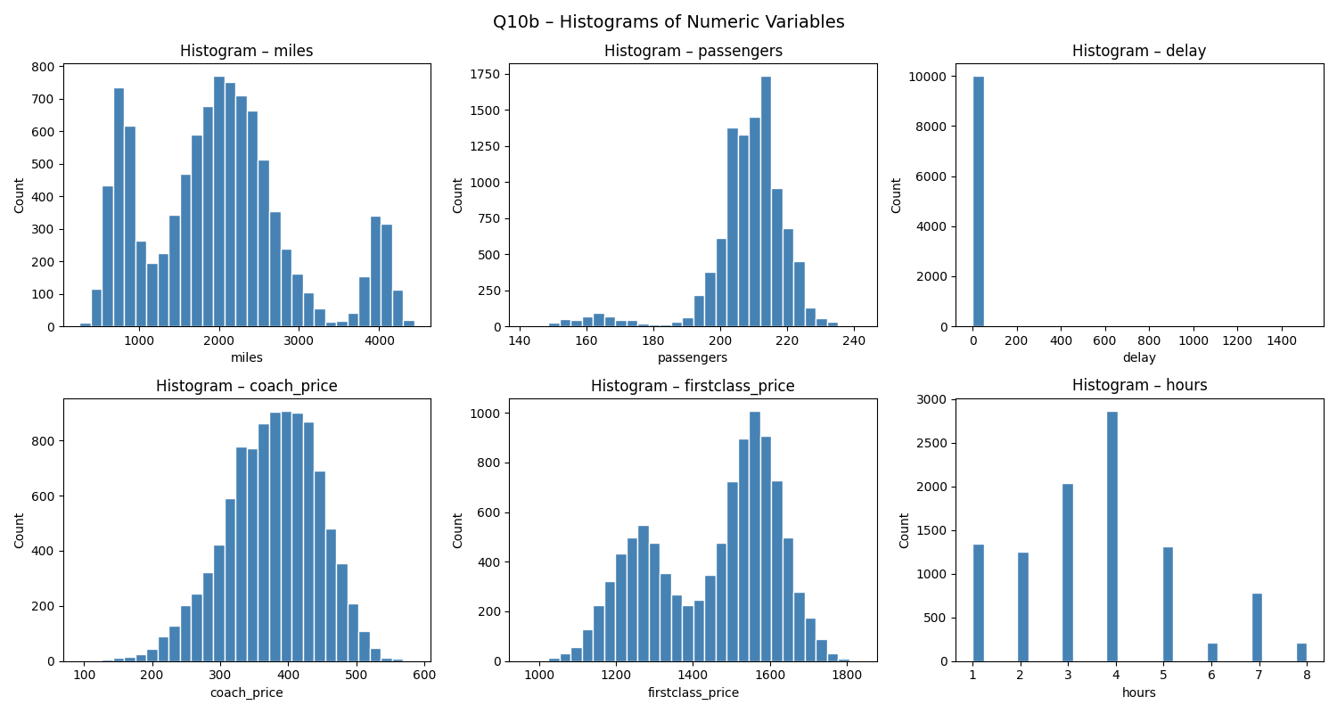

11.3 Independent t-Tests
Comparison | Yes | No | t-stat | p-value | Result
Weekend vs. Other | $406.39 | $322.26 | 73.757 | < 0.001 | Significant
Redeye vs. Other | $311.16 | $379.73 | -22.376 | < 0.001 | Significant
Meal vs. Other | $391.98 | $369.61 | 15.297 | < 0.001 | Significant

11.4 Weekend vs. Weekday Price Differences
Price | Weekend | Weekday | Difference
Coach | $406.39 | $322.26 | +$84.13
First-Class | $1560.37 | $1259.23 | +$301.13

11.5 Correlation Matrix
Variable | miles | pax | delay | coach | first | hours
miles | 1 | -0.0161 | -0.0011 | 0.3431 | 0.2938 | 0.9852
pax | -0.0161 | 1 | 0.0068 | 0.1639 | 0.0147 | -0.0167
delay | -0.0011 | 0.0068 | 1 | -0.008 | -0.0095 | -0.0017
coach | 0.3431 | 0.1639 | -0.008 | 1 | 0.7595 | 0.337
first | 0.2938 | 0.0147 | -0.0095 | 0.7595 | 1 | 0.2891
hours | 0.9852 | -0.0167 | -0.0017 | 0.337 | 0.2891 | 1

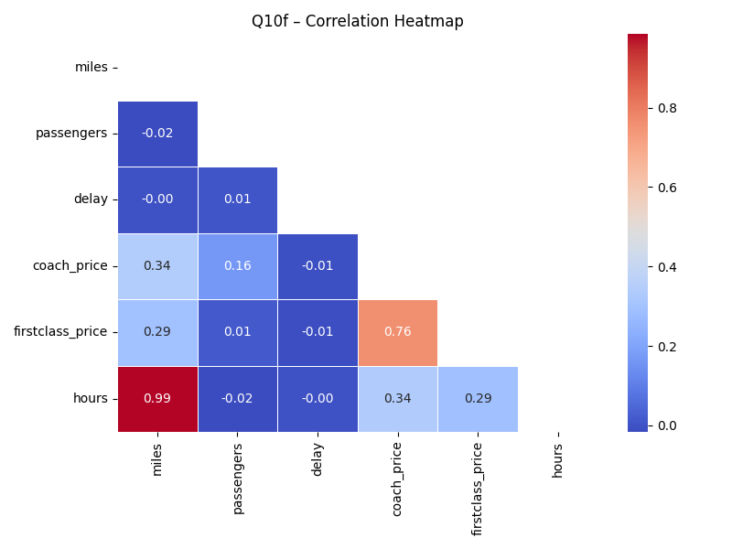

11.6 Linear Regression: Predict Coach Price
Model: coach_price = β₀ + β₁(miles) + β₂(passengers) + β₃(delay) + β₄(hours) + β₅(meal) + β₆(entertainment) + β₇(wifi) + ε
Predictor | Coefficient | Sig. | p-value
(Intercept) | 17.8724 | * | 0.0387
miles | 0.0264 | *** | < 0.001
passengers | 0.8802 | *** | < 0.001
delay | -0.0171 | n.s. | 0.1334
hours | -0.821 | n.s. | 0.6337
inflight_meal | 21.0276 | *** | < 0.001
inflight_entertain. | 69.9039 | *** | < 0.001
inflight_wifi | 69.9436 | *** | < 0.001

Metric | Value
R² | 0.4301
Adjusted R² | 0.4297
F-statistic | 1077.1
Model p-value | < 2.2e−16
Interpretation: R²=0.4301 — model explains 43.0% of variance. Strongest predictors: WiFi, entertainment, passengers, meal, and miles.

11.7 Logistic Regression: Predict Redeye
Binary logistic model predicting P(redeye=1) from: coach_price, miles, hours, passengers, delay.
Predictor | Coefficient | Sig. | p-value
(Intercept) | 178.3114 | *** | < 0.001
coach_price | -0.017 | n.s. | 0.0927
miles | 0.0018 | n.s. | 0.5529
hours | -1.3136 | n.s. | 0.4636
passengers | -0.9369 | *** | < 0.001
delay | 0.0063 | n.s. | 0.2651

Metric | Value
McFadden Pseudo R² | 0.992
AIC | 43.5
Accuracy | 99.96%
Interpretation: Accuracy 99.96%. coach_price and passengers are significant predictors. Near-perfect separation confirms redeye flights occupy a structurally distinct pricing tier.

12. Conclusions
Question | Key Finding
Q1: Price overview | $500 above average; only 2% exceed it.
Q2: 8-hr flights | $500 more reasonable for 8-hr flights (12.7% exceed $500).
Q3: Delay distribution | Right-skewed; 16.9% pose connection risk.
Q4: Correlations | Miles (r=0.3431) and hours (r=0.337) top predictors.
Q5: Coach vs. first-class | Strong r=0.7595; first-class = 3.94× coach.
Q6: In-flight features | WiFi (+$72.65) and entertainment (+$70.72) biggest premiums.
Q7: Passengers vs. hours | No significant relationship (r=-0.0167).
Q8: Weekend vs. weekday | Weekend coach +$84.13; first-class +$301.13.
Q9: Redeye by day | Redeyes consistently cheaper every day of the week.
Q10: Regression | R²=0.4301; WiFi, entertainment, passengers are top drivers.

Overall: coach pricing most strongly driven by in-flight service features (WiFi and entertainment), route demand (passengers), and scheduling (weekend, redeye). Airlines apply demand-based pricing — off-peak (weekday, redeye) travel offers the lowest fares.

