SIT 210
Embedded System
Task 3.2C
Introduction
In this task, I created an MQTT-based system using an Arduino Nano 33 IoT, an ultrasonic sensor and two LEDs. The ultrasonic sensor detects the distance of my hand and identifies it as a wave or pat based on the distance. The Arduino connects to Wi-Fi and the EMQX MQTT broker and publishes my name to the ES/Wave or ES/Pat topic. It also subscribes to both topics to receive messages. When a wave message is received, both LEDs turn ON, and when a pat message is received, both LEDs turn OFF. I tested the system using MQTTX and the Serial Monitor to check the MQTT messages and LED responses.
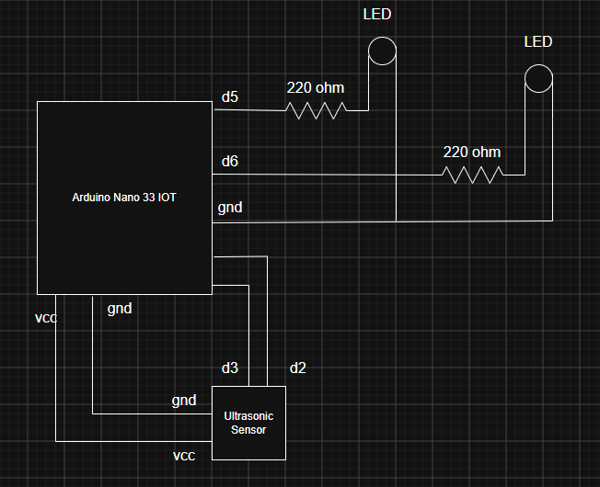

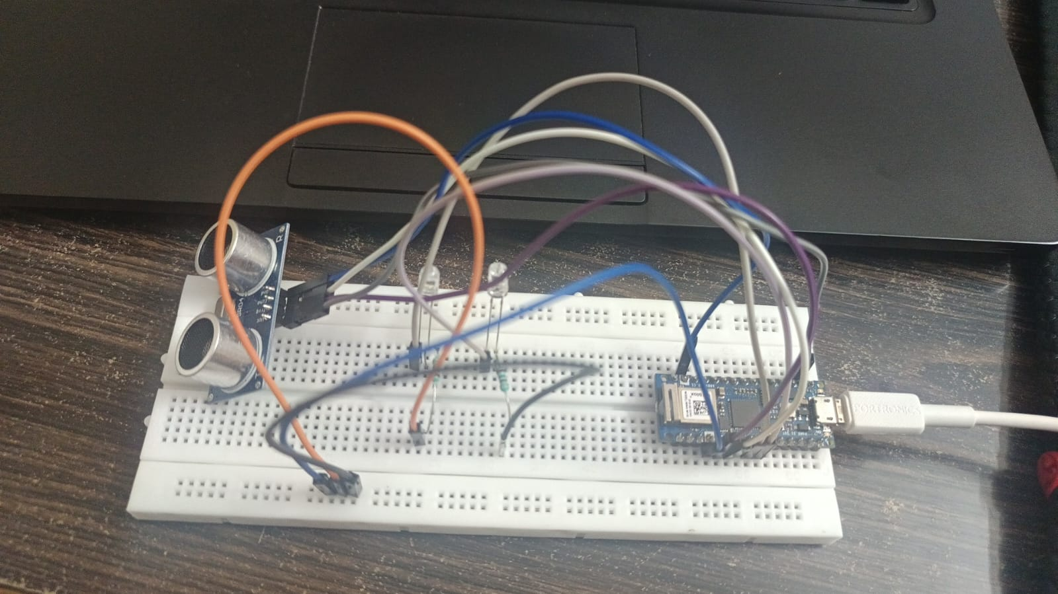
MQTTX
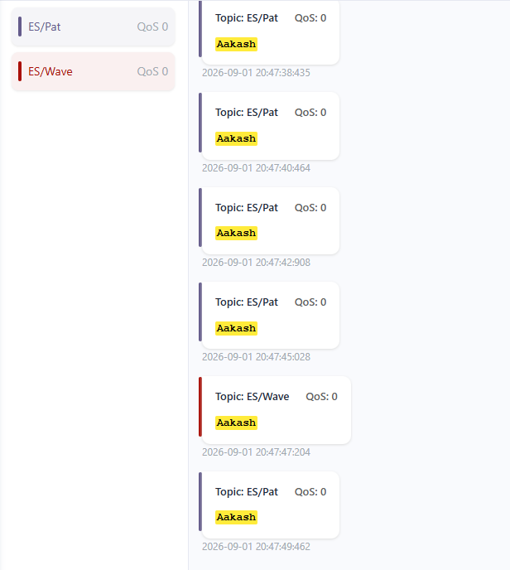

Serial Monitor
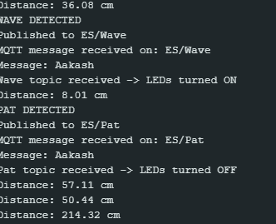
GITHUB Link:

