SIT 210
Embedded Systems Development
Task 3.1P
Summary
In this task, I created a system to monitor the light level of a terrarium using an Arduino Nano 33 IoT and BH1750 light sensor. The sensor was connected using the I2C pins, including VCC, GND, SDA and SCL. The Arduino reads the light intensity in lux and checks if it is above or below the selected threshold of 50 lux.
When the light level goes above 50 lux, the Arduino sends a SUNLIGHT_START message. When the light level goes below 50 lux, it sends a SUNLIGHT_STOP message. These messages are published to the MQTT topic terrarium/light.
For communication, I installed Mosquitto on my Windows laptop and used it as the MQTT broker. I also found my laptop IPv4 address and used it in the Arduino code so the Arduino could connect to the broker through Wi-Fi. One difficulty was understanding how MQTT works and connecting the Arduino to the correct broker IP and port. We also had to make sure Mosquitto was running and allow port 1883 through the Windows Firewall.
After uploading the code, I tested the sensor by covering it and exposing it to light. The Serial Monitor showed different lux values and successfully displayed SUNLIGHT_STOP sent! when the light was low and SUNLIGHT_START sent! when the light increased. After this, the next step was connecting Mosquitto to Node-RED using an MQTT input node and checking whether the messages were received in the Debug panel.

Block Diagram
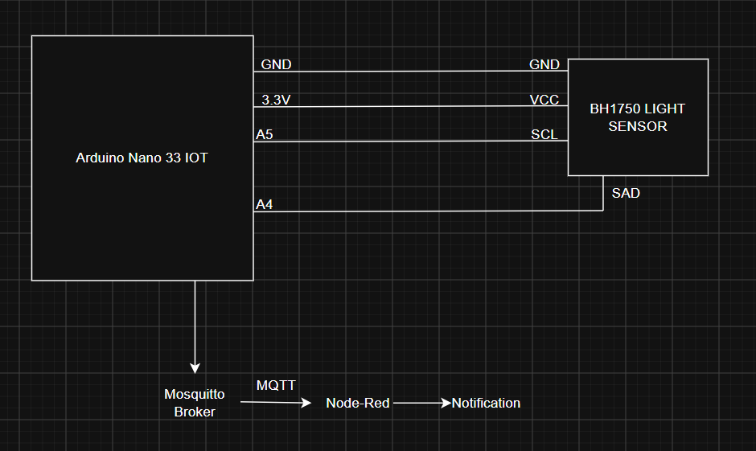
Code for showing readings and connectivity
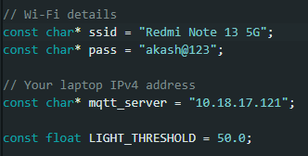
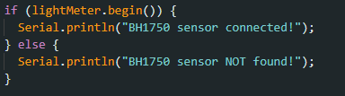
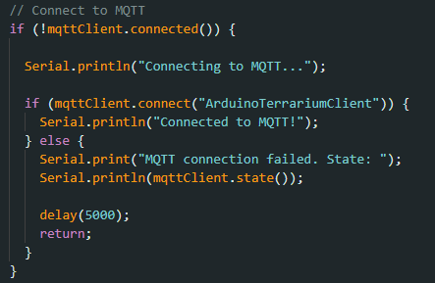
Trigger Mechanism
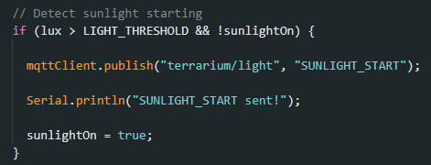
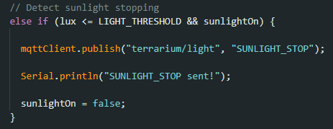
Arduino IDE readings
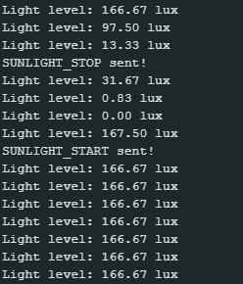

Node-red Readings
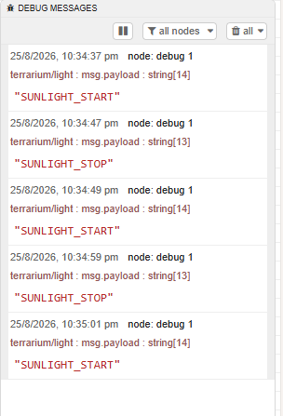
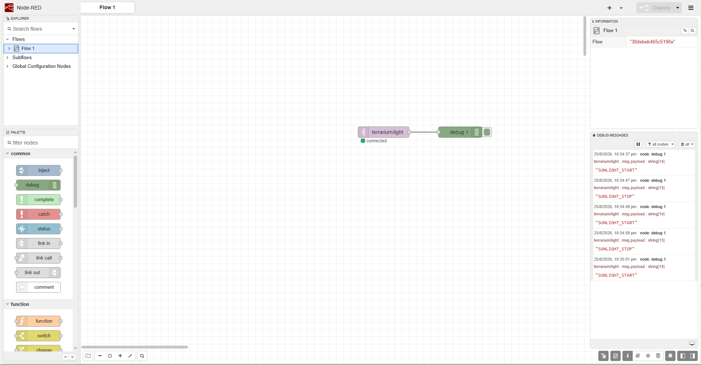

Physical Circuit
