SIT313 C1 New Post Page Report

Introduction
This task adds a New Post page to the DEV@Deakin website. Users can choose to write a question or an article. The form uses React state and conditional rendering to display the fields needed for the selected post type.

Implementation
The Post link in the navigation bar opens the new form. The useState hook stores the selected post type, the form values and validation errors. Separate drafts preserve the entered text when switching between Question and Article.
The Question form includes Title, Describe your problem and Tags. The Article form includes Title, Abstract, Article Text and Tags. The Post button checks the inputs and displays a success or error popup. Posting is simulated; no post is saved or published.

Question form
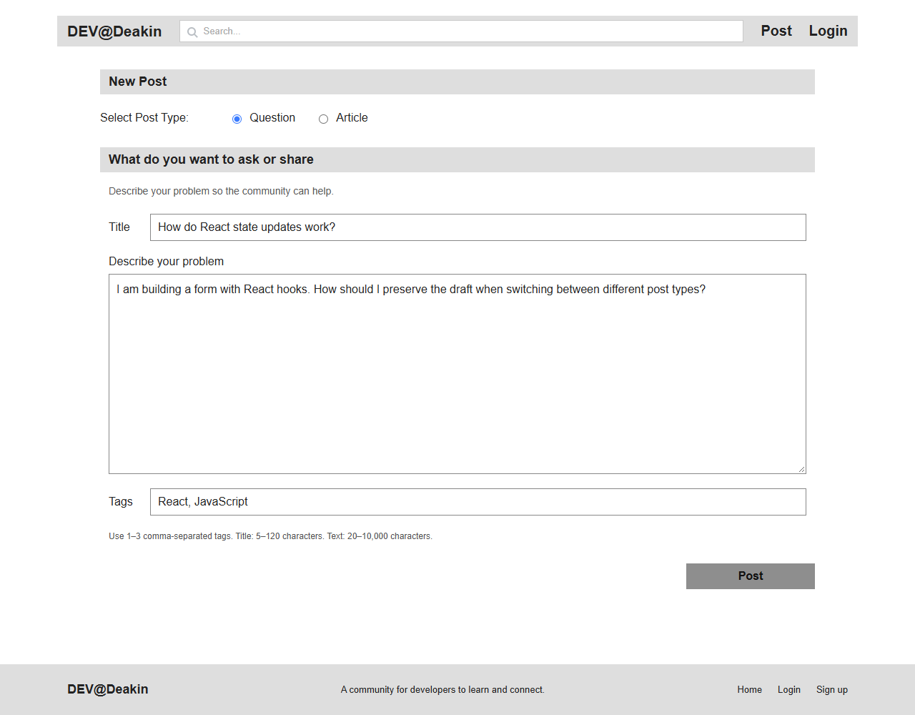

Article form
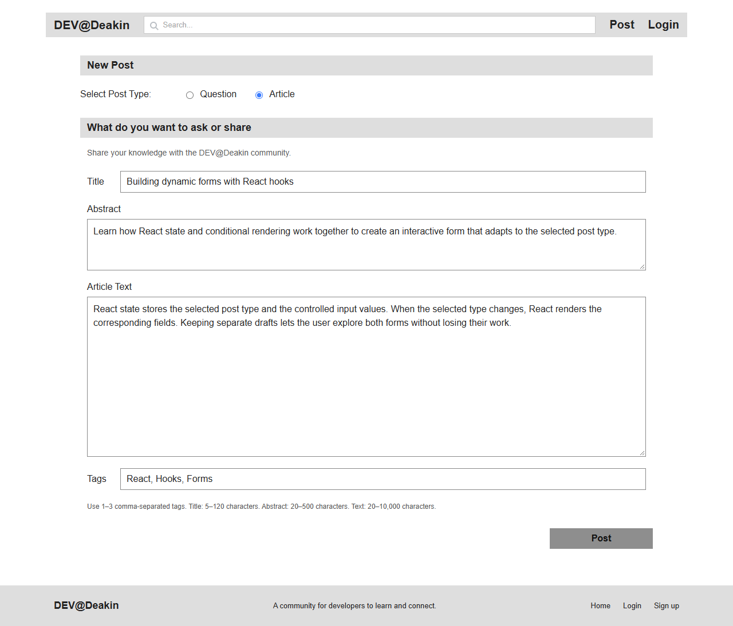

Validation and testing
Validation checks required fields, text length and one to three unique tags. Articles also require a single-paragraph abstract. Invalid submissions show field errors and move focus to the first invalid field.
The production build and all five validation tests passed. Browser checks confirmed navigation, conditional fields, success and error popups, draft preservation and a mobile layout without horizontal scrolling.

Conclusion
The page demonstrates how React state and hooks can create a dynamic form. Both post types work with validation and simulated submission feedback.

GitHub repository
https://github.com/akashapple1107-rgb/SIT313-FullStack-

